[](https://www.comsol.com/)

Final humman application

|  |  |
| --- | --- |
| Report date | Dec 18, 2024, 12:08:33 AM |

Contents

1. Global Definitions

1.1. Parameters

2. Component 1

2.1. Definitions

2.2. Geometry 1

2.3. Multibody Dynamics

2.4. Mesh 1

3. Study 1: Eigenfrequency

3.1. Parametric Sweep

3.2. Eigenfrequency

3.3. Solver Configurations

4. Study 2

4.1. Frequency Response

4.2. Solver Configurations

5. Results

5.1. Datasets

5.2. Plot Groups

5.3. Evaluation Groups

# Global Definitions

|  |  |
| --- | --- |
| Date | Dec 18, 2024, 12:02:50 AM |

Global settings

|  |  |
| --- | --- |
| Name | Final humman application.mph |
| Path | C:\Users\10\Downloads\Final humman application.mph |
| Version | COMSOL Multiphysics 6.2 (Build: 290) |
| Unit system | SI |

Used products

|  |
| --- |
| Multibody Dynamics Module |
| COMSOL Multiphysics |

Computer information

|  |  |
| --- | --- |
| CPU | Intel64 Family 6 Model 142 Stepping 12, 4 cores, 7.77 GB RAM |
| Operating system | Windows 10 |

## Parameters

Parameters 1

| **Name** | **Expression** | **Value** | **Description** |
| --- | --- | --- | --- |
| m_head | 7.24[kg] | 7.24 kg | Mass of head |
| I_head | 0.411[kg*m^2] | 0.411 kg·m² | Moment of inertia of head |
| m_torso | 19.9[kg] | 19.9 kg | Mass of torso |
| I_torso | 1.627[kg*m^2] | 1.627 kg·m² | Moment of inertia of torso |
| m_pelvis | 11.01[kg] | 11.01 kg | Mass of pelvis |
| I_pelvis | 0.692[kg*m^2] | 0.692 kg·m² | Moment of inertia of pelvis |
| m_thigh | 20.35[kg] | 20.35 kg | Mass of thigh |
| I_thigh | 1.18[kg*m^2] | 1.18 kg·m² | Moment of inertia of thigh |
| m_viscera | 12.92[kg] | 12.92 kg | Mass of viscera |
| k_head_torso_trans | 113.7 | 113.7 | [kN/m] Translational stiffness: Head-Torso |
| c_head_torso_trans | 0.066 | 0.066 | [kN·s/m] Translational damping: Head-Torso |
| k_torso_pelvis_trans | 0.299 | 0.299 | [kN/m] Translational stiffness: Torso-Pelvis |
| c_torso_pelvis_trans | 1.79 | 1.79 | [kN·s/m] Translational damping: Torso-Pelvis |
| k_pelvis_thigh_trans | 6.40 | 6.4 | [kN/m] Translational stiffness: Pelvis-Thigh |
| c_pelvis_thigh_trans | 0.061 | 0.061 | [kN·s/m] Translational damping: Pelvis-Thigh |
| k_thigh_leg_trans | 23.55 | 23.55 | [kN/m] Translational stiffness: Thigh-Leg |
| c_thigh_leg_trans | 0.154 | 0.154 | [kN·s/m] Translational damping: Thigh-Leg |
| k_head_torso_rot | 0.915 | 0.915 | [kN·m/rad] Rotational stiffness: Head-Torso |
| c_head_torso_rot | 0.340 | 0.34 | [kN·m·s/rad] Rotational damping: Head-Torso |
| k_torso_pelvis_rot | 0.328 | 0.328 | [kN·m/rad] Rotational stiffness: Torso-Pelvis |
| c_torso_pelvis_rot | 0.724 | 0.724 | [kN·m·s/rad] Rotational damping: Torso-Pelvis |
| k_pelvis_thigh_rot | 0.162 | 0.162 | [kN·m/rad] Rotational stiffness: Pelvis-Thigh |
| c_pelvis_thigh_rot | 0.030 | 0.03 | [kN·m·s/rad] Rotational damping: Pelvis-Thigh |
| k_thigh_leg_rot | 0.220 | 0.22 | [kN·m/rad] Rotational stiffness: Thigh-Leg |
| c_thigh_leg_rot | 0.104 | 0.104 | [kN·m·s/rad] Rotational damping: Thigh-Leg |
| k_viscera_torso_trans | 1.93 | 1.93 | [kN/m] Translational stiffness: Viscera-Torso |
| c_viscera_torso_trans | 0.079 | 0.079 | [kN·s/m] Translational damping: Viscera-Torso |
| k_viscera_pelvis_trans | 18.37 | 18.37 | [kN/m] Translational stiffness: Viscera-Pelvis |
| c_viscera_pelvis_trans | 0.197 | 0.197 | [kN·s/m] Translational damping: Viscera-Pelvis |
| k_seat_pelvis_trans | 121.3 | 121.3 | [kN/m] Translational stiffness: Seat-Pelvis |
| c_seat_pelvis_trans | 0.047 | 0.047 | [kN·s/m] Translational damping: Seat-Pelvis |
| k_seat_thigh_trans | 16.71 | 16.71 | [kN/m] Translational stiffness: Seat-Thigh |
| c_seat_thigh_trans | 8.01 | 8.01 | [kN·s/m] Translational damping: Seat-Thigh |
| k1 | 113.7[kN/m] | 1.137E5 N/m | Translational stiffness, head-torso joint |
| c1 | 0.066[kN/(m/s)] | 66 N·s/m | Translational damping coefficient, head-torso joint |
| kr1 | 0.915[kN*m/rad] | 915 N·m/rad | Rotational stiffness, head-torso joint |
| cr1 | 0.340[kN*m/(rad/s)] | 340 N·m·s/rad | Rotational damping coefficient, head-torso joint |
| k2 | 0.299[kN/m] | 299 N/m | Translational stiffness, torso-pelvis joint |
| c2 | 1.79[kN/(m/s)] | 1790 N·s/m | Translational damping coefficient, torso-pelvis joint |
| kr2 | 0.328[kN*m/rad] | 328 N·m/rad | Rotational stiffness, torso-pelvis joint |
| cr2 | 0.724[kN*m/(rad/s)] | 724 N·m·s/rad | Rotational damping coefficient, torso-pelvis joint |
| k3 | 6.40[kN/m] | 6400 N/m | Translational stiffness, pelvis-thigh joint |
| c3 | 0.061[kN/(m/s)] | 61 N·s/m | Translational damping coefficient, pelvis-thigh joint |
| kr3 | 0.162[kN*m/rad] | 162 N·m/rad | Rotational stiffness, pelvis-thigh joint |
| cr3 | 0.030[kN*m/(rad/s)] | 30 N·m·s/rad | Rotational damping coefficient, pelvis-thigh joint |
| k4 | 23.55[kN/m] | 23550 N/m | Translational stiffness, thigh-leg joint |
| c4 | 0.154[kN/(m/s)] | 154 N·s/m | Translational damping coefficient, thigh-leg joint |
| kr4 | 0.220[kN*m/rad] | 220 N·m/rad | Rotational stiffness, thigh-leg joint |
| cr4 | 0.104[kN*m/(rad/s)] | 104 N·m·s/rad | Rotational damping coefficient, thigh-leg joint |
| kh5 | 1.93[kN/m] | 1930 N/m | Horizontal stiffness, viscera-torso joint |
| ch5 | 0.079[kN/(m/s)] | 79 N·s/m | Horizontal damping coefficient, viscera-torso joint |
| kv6 | 18.37[kN/m] | 18370 N/m | Vertical stiffness, viscera-pelvis joint |
| cv6 | 0.197[kN/(m/s)] | 197 N·s/m | Vertical damping coefficient, viscera-pelvis joint |
| kh7 | 0.905[kN/m] | 905 N/m | Horizontal stiffness, seat-pelvis joint |
| ch7 | 0.015[kN/(m/s)] | 15 N·s/m | Horizontal damping coefficient, seat-pelvis joint |
| kv7 | 121.3[kN/m] | 1.213E5 N/m | Vertical stiffness, seat-pelvis joint |
| cv7 | 0.047[kN/(m/s)] | 47 N·s/m | Vertical damping coefficient, seat-pelvis joint |
| kh8 | 0.614[kN/m] | 614 N/m | Horizontal stiffness, seat-thigh joint |
| ch8 | 0.014[kN/(m/s)] | 14 N·s/m | Horizontal damping coefficient, seat-thigh joint |
| kv8 | 16.71[kN/m] | 16710 N/m | Vertical stiffness, seat-thigh joint |
| cv8 | 8.01[kN/(m/s)] | 8010 N·s/m | Vertical damping coefficient, seat-thigh joint |
| vtt_in | 1[m/s^2] | 1 m/s² | Input acceleration |
| i_c | 1 | 1 | Damping controller |

# Component 1

|  |  |
| --- | --- |
| Date | Dec 11, 2024, 10:32:22 PM |

Settings

| **Description** | **Value** |
| --- | --- |
| Unit system | Same as global system (SI) |
| Geometry shape function | Automatic |

Spatial frame coordinates

| **First** | **Second** | **Third** |
| --- | --- | --- |
| x | y | z |

Material frame coordinates

| **First** | **Second** | **Third** |
| --- | --- | --- |
| X | Y | Z |

Geometry frame coordinates

| **First** | **Second** | **Third** |
| --- | --- | --- |
| Xg | Yg | Zg |

Mesh frame coordinates

| **First** | **Second** | **Third** |
| --- | --- | --- |
| Xm | Ym | Zm |

## Definitions

### Variables

#### Variables 1

Selection

|  |  |
| --- | --- |
| Geometric entity level | Entire model |

| **Name** | **Expression** | **Unit** | **Description** |
| --- | --- | --- | --- |
| H_vert | abs(mbd.rd2.u_tty)/vtt_in |  | Vertical transmissibility |
| H_rot | abs(mbd.rd2.th_ttz)/vtt_in | rad/m | Rotational transmissibility |
| M_a | abs(mbd.fxj7.Fy + mbd.fxj8.Fy)/vtt_in | kg | Apparent mass |

### Variable Utilities

#### Participation Factors 1

|  |  |
| --- | --- |
| Tag | mpf1 |

Center of rotation

| **Description** | **Value** |
| --- | --- |
| Center of rotation | Center of mass |

### Coordinate Systems

#### Boundary System 1

|  |  |
| --- | --- |
| Coordinate system type | Boundary system |
| Tag | sys1 |

Coordinate names

| **First** | **Second** | **Third** |
| --- | --- | --- |
| t1 | n | to |

## Geometry 1

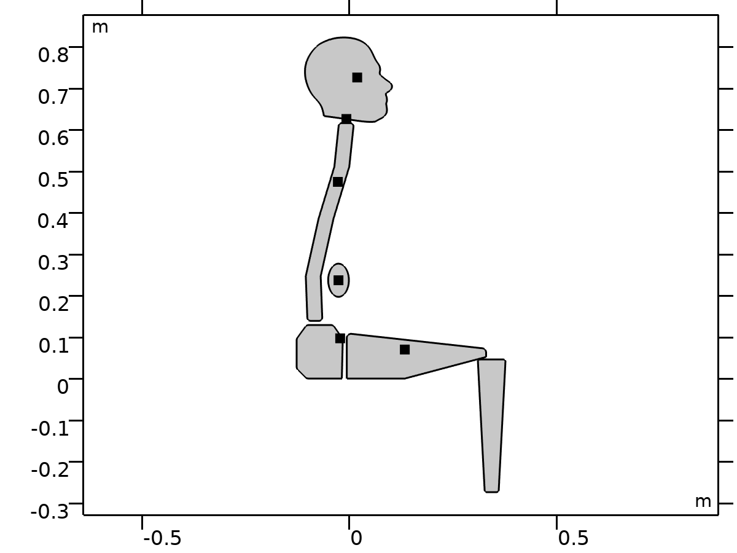

Geometry 1

Units

|  |  |
| --- | --- |
| Length unit | m |
| Angular unit | deg |

Geometry statistics

| **Description** | **Value** |
| --- | --- |
| Space dimension | 2 |
| Number of domains | 6 |
| Number of boundaries | 67 |
| Number of vertices | 73 |

### Import 1 (imp1)

Domain net selections

| **Description** | **Value** |
| --- | --- |
| Source | COMSOL Multiphysics file |

Settings

| **Description** | **Value** |
| --- | --- |
| Filename | C:\Users\10\Downloads\seated_human_body.mphbin |

Information

| **Description** | **Value** |
| --- | --- |
| Details | Imported 6 solid objects from C:\Users\10\Downloads\seated_human_body.mphbin. |
| Last build time | < 1 second |
| Built with | COMSOL 6.2.0.290 (win64), Dec 11, 2024, 10:43:49 PM |

### Form Assembly (fin)

Settings

| **Description** | **Value** |
| --- | --- |
| Action | Form an assembly |

Information

| **Description** | **Value** |
| --- | --- |
| Details | {Formed assembly of 6 solid objects., Assembly has 6 domains, 67 boundaries, and 73 vertices.} |
| Last build time | < 1 second |
| Built with | COMSOL 6.2.0.290 (win64), Dec 11, 2024, 10:46:55 PM |

## Multibody Dynamics

Used products

|  |
| --- |
| Multibody Dynamics Module |
| COMSOL Multiphysics |

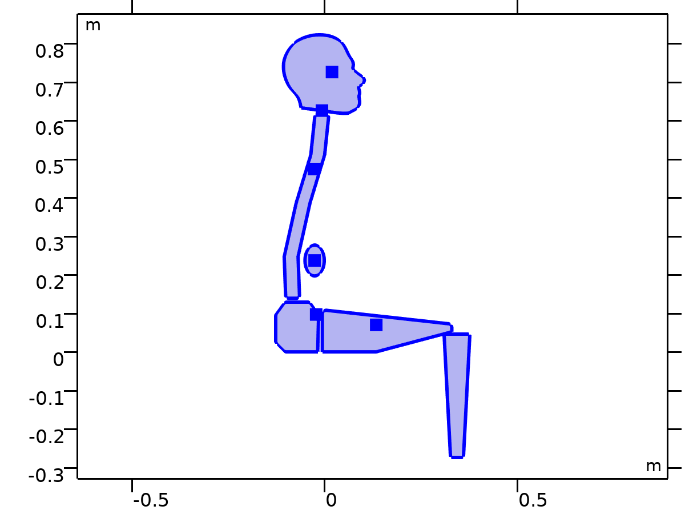

Multibody Dynamics

Selection

|  |  |
| --- | --- |
| Geometric entity level | Domain |
| Selection | Geometry geom1: Dimension 2: All domains |

Equations



### Interface Settings

#### Physics Symbols

Settings

| **Description** | **Value** |
| --- | --- |
| Enable physics symbols | Off |

#### Discretization

Settings

| **Description** | **Value** |
| --- | --- |
| Displacement field | Linear |

Settings

| **Description** | **Value** |
| --- | --- |
| Equation form | Study controlled |

#### 2D Approximation

Settings

| **Description** | **Value** |
| --- | --- |
| 2D approximation | Plane strain |
| Out-of-plane mode extension (time-harmonic) | Off |

Settings

| **Description** | **Value** | **Unit** |
| --- | --- | --- |
| Thickness | 1 | m |

#### Structural Transient Behavior

Settings

| **Description** | **Value** |
| --- | --- |
| Structural transient behavior | Include inertial terms |

#### Initial Values

Settings

| **Description** | **Value** | **Unit** |
| --- | --- | --- |
| Center of rotation, x-component | 0 | m |
| Center of rotation, y-component | 0 | m |
| Center of rotation, z-component | 0 | m |
| Displacement at center of rotation, x-component | 0 | m |
| Displacement at center of rotation, y-component | 0 | m |
| Displacement at center of rotation, z-component | 0 | m |
| Velocity at center of rotation, x-component | 0 | m/s |
| Velocity at center of rotation, y-component | 0 | m/s |
| Velocity at center of rotation, z-component | 0 | m/s |
| Angle of rotation | 0 | rad |
| Angular velocity | 0 | rad/s |

#### Automated Model Setup

Settings

| **Description** | **Value** |
| --- | --- |
| Rigid domains selection | From physics interface |
| Include mass and moment of inertia node | On |
| Straight boundaries | Prismatic joint |
| Circular boundaries | Hinge joint |

#### Results

Settings

| **Description** | **Value** |
| --- | --- |
| Body defining reference frame | None |

#### Joints Summary

| **Joints** | **Source** | **Destination** |
| --- | --- | --- |
| Head-Torso | Head | Torso |
| Torso-Pelvis | Torso | Pelvis |
| Pelvis-Thigh | Pelvis | Thigh |
| Thigh-Leg | Thigh | Leg |
| Viscera-Torso | Viscera | Torso |
| Viscera-Pelvis | Viscera | Pelvis |
| Seat-Pelvis | Seat | Pelvis |
| Seat-Thigh | Seat | Thigh |
| Seat-Leg | Seat | Leg |

#### Rigid Body DOF Summary

|  | **N** | **DOF** | **Prescribed** | **Constraints** |
| --- | --- | --- | --- | --- |
| Rigid bodies | 6 | 18 | 0 | 1 |
| Fixed joints | 9 | 24 | 0 | 27 |
| Total | - | 42 | 0 | 28 |
| Net | - | 14 | - | - |

### Variables

| **Name** | **Expression** | **Unit** | **Description** | **Selection** | **Details** |
| --- | --- | --- | --- | --- | --- |
| mbd.X | X | m | Material coordinates, X-component | Domains 1–6 |  |
| mbd.Y | Y | m | Material coordinates, Y-component | Domains 1–6 |  |
| mbd.Z | 0 | m | Material coordinates, Z-component | Domains 1–6 |  |
| mbd.X | X | m | Material coordinates, X-component | Boundaries 1–67 |  |
| mbd.Y | Y | m | Material coordinates, Y-component | Boundaries 1–67 |  |
| mbd.Z | 0 | m | Material coordinates, Z-component | Boundaries 1–67 |  |
| mbd.x | x | m | Spatial coordinates, x-component | Domains 1–6 |  |
| mbd.y | y | m | Spatial coordinates, y-component | Domains 1–6 |  |
| mbd.z | 0 | m | Spatial coordinates, z-component | Domains 1–6 |  |
| mbd.x | x | m | Spatial coordinates, x-component | Boundaries 1–67 |  |
| mbd.y | y | m | Spatial coordinates, y-component | Boundaries 1–67 |  |
| mbd.z | 0 | m | Spatial coordinates, z-component | Boundaries 1–67 |  |
| mbd.uf | u | m | Displacement field, X-component | Domains 1–6 |  |
| mbd.vf | v | m | Displacement field, Y-component | Domains 1–6 |  |
| mbd.wf | 0 | m | Displacement field, Z-component | Domains 1–6 |  |
| mbd.uf | u | m | Displacement field, X-component | Boundaries 1–67 |  |
| mbd.vf | v | m | Displacement field, Y-component | Boundaries 1–67 |  |
| mbd.wf | 0 | m | Displacement field, Z-component | Boundaries 1–67 |  |
| mbd.nX | dnX | 1 | Normal vector, X-component | Boundaries 1–67 |  |
| mbd.nY | dnY | 1 | Normal vector, Y-component | Boundaries 1–67 |  |
| mbd.nZ | 0 | 1 | Normal vector, Z-component | Boundaries 1–67 |  |
| mbd.nx | dnx | 1 | Normal vector, x-component | Boundaries 1–67 |  |
| mbd.ny | dny | 1 | Normal vector, y-component | Boundaries 1–67 |  |
| mbd.nz | 0 | 1 | Normal vector, z-component | Boundaries 1–67 |  |
| mbd.nXmesh | dnXmesh | 1 | Normal vector (mesh), X-component | Boundaries 1–67 |  |
| mbd.nYmesh | dnYmesh | 1 | Normal vector (mesh), Y-component | Boundaries 1–67 |  |
| mbd.nZmesh | 0 | 1 | Normal vector (mesh), Z-component | Boundaries 1–67 |  |
| mbd.nxmesh | dnxmesh | 1 | Normal vector (mesh), x-component | Boundaries 1–67 |  |
| mbd.nymesh | dnymesh | 1 | Normal vector (mesh), y-component | Boundaries 1–67 |  |
| mbd.nzmesh | 0 | 1 | Normal vector (mesh), z-component | Boundaries 1–67 |  |
| mbd.freq | 0.5*mbd.omega/pi | Hz | Frequency | Global |  |
| mbd.omega | mbd.iomega/i | rad/s | Angular frequency | Global |  |
| mbd.d | 1 | m | Thickness | Domains 1–6 |  |
| u_ref | u | m | Displacement field, reference frame, x-component | Domains 1–6 |  |
| v_ref | v | m | Displacement field, reference frame, y-component | Domains 1–6 |  |
| w_ref | 0 | m | Displacement field, reference frame, z-component | Domains 1–6 |  |
| mbd.disp_ref | sqrt(u_ref^2+v_ref^2+w_ref^2+eps) | m | Displacement magnitude, reference frame | Domains 1–6 |  |
| mbd.x_ref | X+u_ref | m | Spatial coordinate, reference frame, x-component | Domains 1–6 |  |
| mbd.y_ref | Y+v_ref | m | Spatial coordinate, reference frame, y-component | Domains 1–6 |  |
| mbd.z_ref | 0 | m | Spatial coordinate, reference frame, z-component | Domains 1–6 |  |
| mbd.ut_ref | d(u_ref,TIME) | m/s | Velocity, reference frame, x-component | Domains 1–6 |  |
| mbd.vt_ref | d(v_ref,TIME) | m/s | Velocity, reference frame, y-component | Domains 1–6 |  |
| mbd.wt_ref | d(w_ref,TIME) | m/s | Velocity, reference frame, z-component | Domains 1–6 |  |
| mbd.vel_ref | sqrt(mbd.ut_ref^2+mbd.vt_ref^2+mbd.wt_ref^2+eps) | m/s | Velocity magnitude, reference frame | Domains 1–6 |  |
| mbd.diag | 1.2066654877709018 | m | Bounding Box Diagonal | Global |  |
| mbd.isGeomNon | 0 | 1 | Geometric nonlinearity variable | Global |  |
| mbd.an | real(mbd.accX)*mbd.nX+real(mbd.accY)*mbd.nY+real(mbd.accZ)*mbd.nZ | m/s² | Normal acceleration | Boundaries 1–67 |  |
| mbd.RFtotalx | mbd.sumreaction(mbd.RFx)+mbd.RFfsx+mbd.RFfdx | N | Total reaction force, x-component | Global | + operation |
| mbd.RFtotaly | mbd.sumreaction(mbd.RFy)+mbd.RFfsy+mbd.RFfdy | N | Total reaction force, y-component | Global | + operation |
| mbd.RFtotalz | mbd.sumreaction(mbd.RFz)+mbd.RFfsz+mbd.RFfdz | N | Total reaction force, z-component | Global | + operation |
| mbd.RMtotalx | mbd.sumreaction(mbd.RMx)+mbd.RMmsx+mbd.RMmdx | N·m | Total reaction moment, x-component | Global | + operation |
| mbd.RMtotaly | mbd.sumreaction(mbd.RMy)+mbd.RMmsy+mbd.RMmdy | N·m | Total reaction moment, y-component | Global | + operation |
| mbd.RMtotalz | mbd.sumreaction(mbd.RMz)+mbd.RMmsz+mbd.RMmdz | N·m | Total reaction moment, z-component | Global | + operation |
| mbd.activation_multiplier | 1 | 1 | Activation multiplier | Domains 1–6 |  |
| mbd.geomsize | 1.2066654877709018 | m | Bounding box | Global |  |
| mbd.timestep | 0 | s | Time step | Domains 1–6 |  |
| xt | d(x,TIME) | m/s | Mesh velocity, x-component | Global |  |
| yt | d(y,TIME) | m/s | Mesh velocity, y-component | Global |  |
| zt | 0 | m/s | Mesh velocity, z-component | Global |  |
| mbd.iomega | -root.lambda | rad/s | Complex angular frequency | Global |  |

### Linear Elastic Material 1



Linear Elastic Material 1

Selection

|  |  |
| --- | --- |
| Geometric entity level | Domain |
| Selection | Geometry geom1: Dimension 2: All domains |

Equations

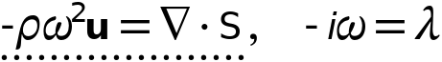









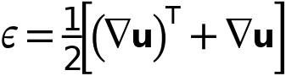



#### Linear Elastic Material

Settings

| **Description** | **Value** |
| --- | --- |
| Material symmetry | Isotropic |
| Specify | Young's modulus and Poisson's ratio |
| Young's modulus | From material |
| Poisson's ratio | From material |
| Density | From material |
| Use mixed formulation | None |

#### Geometric Nonlinearity

Settings

| **Description** | **Value** |
| --- | --- |
| Formulation | From study step |
| Strain decomposition | Automatic |

#### Quadrature Settings

Settings

| **Description** | **Value** |
| --- | --- |
| Reduced integration | Off |

#### Coordinate System Selection

Settings

| **Description** | **Value** |
| --- | --- |
| Coordinate system | Global coordinate system |

#### Shape functions

| **Name** | **Shape function** | **Unit** | **Description** | **Shape frame** | **Selection** |
| --- | --- | --- | --- | --- | --- |
| u | Lagrange (Linear) | m | Displacement field, X-component | Material | No domains |
| v | Lagrange (Linear) | m | Displacement field, Y-component | Material | No domains |

### Free 1

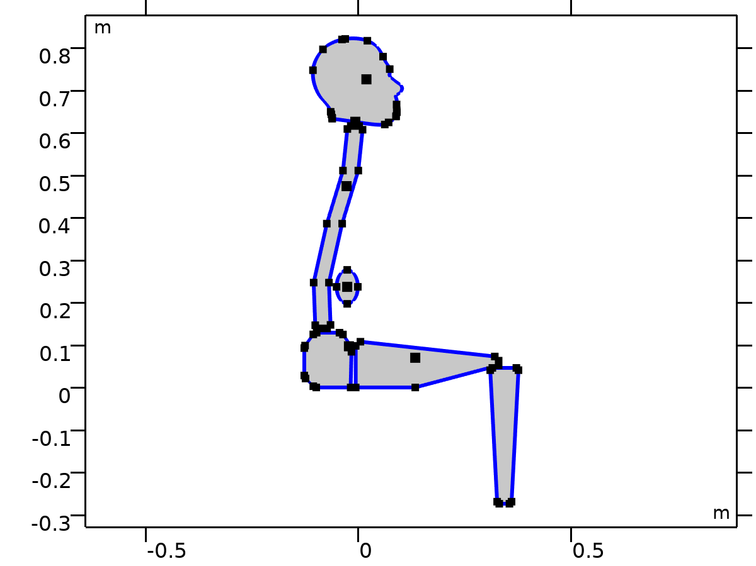

Free 1

Selection

|  |  |
| --- | --- |
| Geometric entity level | Boundary |
| Selection | Geometry geom1: Dimension 1: All boundaries |

### Initial Values 1



Initial Values 1

Selection

|  |  |
| --- | --- |
| Geometric entity level | Domain |
| Selection | Geometry geom1: Dimension 2: All domains |

Equations



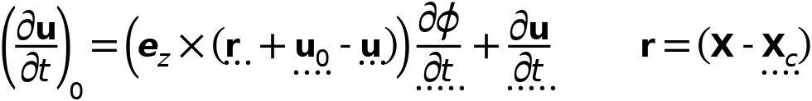

#### Initial Values

Settings

| **Description** | **Value** |
| --- | --- |
| Initial values | From physics interface node |
| Consistent initialization | Default |

#### Coordinate System Selection

Settings

| **Description** | **Value** |
| --- | --- |
| Coordinate system | Global coordinate system |

### Pelvis

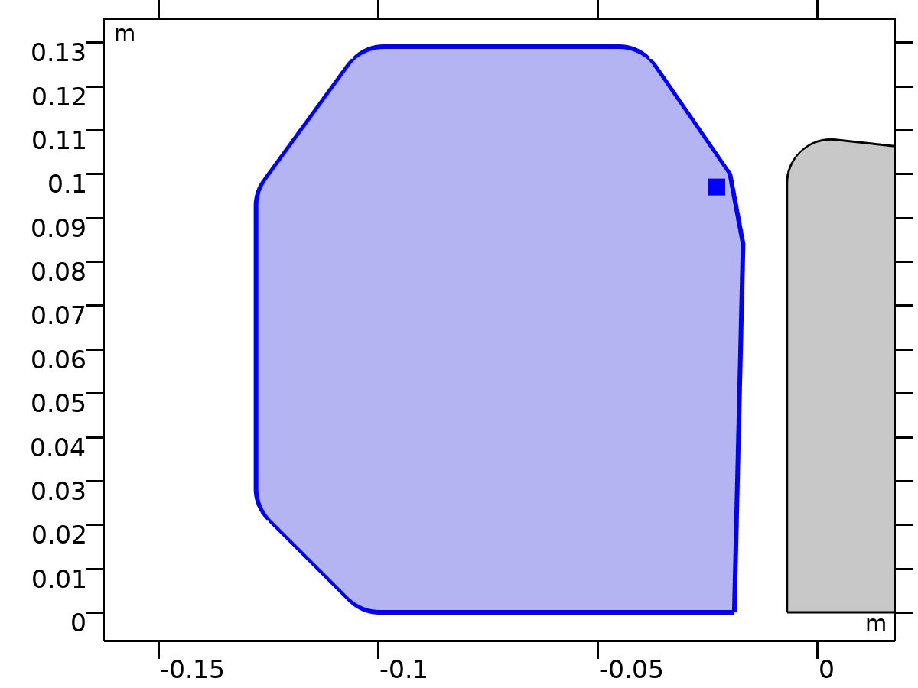

Pelvis

Selection

|  |  |
| --- | --- |
| Geometric entity level | Domain |
| Selection | Geometry geom1: Dimension 2: Domain 1 |

Equations





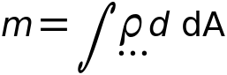

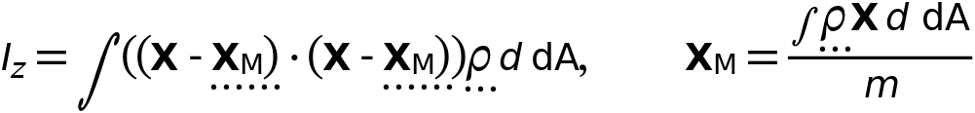







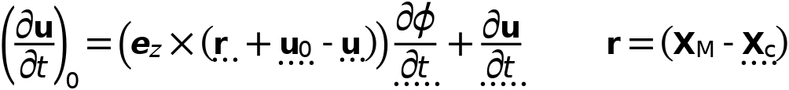



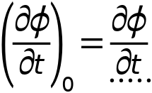

#### Density

Settings

| **Description** | **Value** | **Unit** |
| --- | --- | --- |
| Density | User defined |  |
| Density | 0 | kg/m³ |

#### Center of Rotation

Settings

| **Description** | **Value** |
| --- | --- |
| Center of rotation | Center of mass |
| Offset | Off |

#### Initial Values

Settings

| **Description** | **Value** |
| --- | --- |
| Initial values | From physics interface node |
| Consistent initialization | Default |

#### Variables

| **Name** | **Expression** | **Unit** | **Description** | **Selection** | **Details** |
| --- | --- | --- | --- | --- | --- |
| u | mbd.rd1.Udx | m | Displacement field, X-component | Domain 1 |  |
| v | mbd.rd1.Udy | m | Displacement field, Y-component | Domain 1 |  |
| w | mbd.rd1.Udz | m | Displacement field, Z-component | Domain 1 |  |
| mbd.Wk_tot | 0.25*(mbd.rd1.m*(realdot(mbd.rd1.u*mbd.iomega,mbd.rd1.u*mbd.iomega)+realdot(mbd.rd1.v*mbd.iomega,mbd.rd1.v*mbd.iomega)+realdot(mbd.rd1.w*mbd.iomega,mbd.rd1.w*mbd.iomega))+realdot(mbd.rd1.Iz*mbd.rd1.thx*mbd.iomega,mbd.rd1.thx*mbd.iomega)+realdot(mbd.rd1.Iz*mbd.rd1.thy*mbd.iomega,mbd.rd1.thy*mbd.iomega)+realdot(mbd.rd1.Iz*mbd.rd1.thz*mbd.iomega,mbd.rd1.thz*mbd.iomega)) | J | Total kinetic energy | Global | + operation |
| mbd.RFtotalx | reacf(mbd.rd1.U) | N | Total reaction force, x-component | Global | + operation |
| mbd.RFtotaly | reacf(mbd.rd1.V) | N | Total reaction force, y-component | Global | + operation |
| mbd.RFtotalz | 0 | N | Total reaction force, z-component | Global | + operation |
| mbd.RMtotalx | -reacf(mbd.rd1.V)*mbd.rd1.RMmaz | N·m | Total reaction moment, x-component | Global | + operation |
| mbd.RMtotaly | reacf(mbd.rd1.U)*mbd.rd1.RMmaz | N·m | Total reaction moment, y-component | Global | + operation |
| mbd.RMtotalz | reacf(mbd.rd1.V)*mbd.rd1.RMmax-reacf(mbd.rd1.U)*mbd.rd1.RMmay+reacf(mbd.rd1.Phi) | N·m | Total reaction moment, z-component | Global | + operation |
| mbd.disp | sqrteps(real(u)^2+real(v)^2) | m | Displacement magnitude | Domain 1 |  |
| mbd.disp_rms | sqrt(0.5*(realdot(u,u)+realdot(v,v))) | m | Displacement, RMS | Domain 1 |  |
| mbd.gradUxX | -1+mbd.FdxX | 1 | Displacement gradient, xX-component | Domain 1 |  |
| mbd.gradUyX | mbd.FdyX | 1 | Displacement gradient, yX-component | Domain 1 |  |
| mbd.gradUzX | mbd.FdzX | 1 | Displacement gradient, zX-component | Domain 1 |  |
| mbd.gradUxY | mbd.FdxY | 1 | Displacement gradient, xY-component | Domain 1 |  |
| mbd.gradUyY | -1+mbd.FdyY | 1 | Displacement gradient, yY-component | Domain 1 |  |
| mbd.gradUzY | mbd.FdzY | 1 | Displacement gradient, zY-component | Domain 1 |  |
| mbd.gradUxZ | mbd.FdxZ | 1 | Displacement gradient, xZ-component | Domain 1 |  |
| mbd.gradUyZ | mbd.FdyZ | 1 | Displacement gradient, yZ-component | Domain 1 |  |
| mbd.gradUzZ | -1+mbd.FdzZ | 1 | Displacement gradient, zZ-component | Domain 1 |  |
| mbd.FdxX | mbd.rd1.rotxx | 1 | Deformation gradient, xX-component | Domain 1 |  |
| mbd.FdyX | mbd.rd1.rotyx | 1 | Deformation gradient, yX-component | Domain 1 |  |
| mbd.FdzX | mbd.rd1.rotzx | 1 | Deformation gradient, zX-component | Domain 1 |  |
| mbd.FdxY | mbd.rd1.rotxy | 1 | Deformation gradient, xY-component | Domain 1 |  |
| mbd.FdyY | mbd.rd1.rotyy | 1 | Deformation gradient, yY-component | Domain 1 |  |
| mbd.FdzY | mbd.rd1.rotzy | 1 | Deformation gradient, zY-component | Domain 1 |  |
| mbd.FdxZ | mbd.rd1.rotxz | 1 | Deformation gradient, xZ-component | Domain 1 |  |
| mbd.FdyZ | mbd.rd1.rotyz | 1 | Deformation gradient, yZ-component | Domain 1 |  |
| mbd.FdzZ | mbd.rd1.rotzz | 1 | Deformation gradient, zZ-component | Domain 1 |  |
| mbd.FdiXx | (mbd.FdyY*mbd.FdzZ-mbd.FdyZ*mbd.FdzY)/mbd.J | 1 | Deformation gradient inverse, Xx-component | Domain 1 |  |
| mbd.FdiYx | (mbd.FdyZ*mbd.FdzX-mbd.FdyX*mbd.FdzZ)/mbd.J | 1 | Deformation gradient inverse, Yx-component | Domain 1 |  |
| mbd.FdiZx | (mbd.FdyX*mbd.FdzY-mbd.FdyY*mbd.FdzX)/mbd.J | 1 | Deformation gradient inverse, Zx-component | Domain 1 |  |
| mbd.FdiXy | (mbd.FdxZ*mbd.FdzY-mbd.FdxY*mbd.FdzZ)/mbd.J | 1 | Deformation gradient inverse, Xy-component | Domain 1 |  |
| mbd.FdiYy | (mbd.FdxX*mbd.FdzZ-mbd.FdxZ*mbd.FdzX)/mbd.J | 1 | Deformation gradient inverse, Yy-component | Domain 1 |  |
| mbd.FdiZy | (mbd.FdxY*mbd.FdzX-mbd.FdxX*mbd.FdzY)/mbd.J | 1 | Deformation gradient inverse, Zy-component | Domain 1 |  |
| mbd.FdiXz | (mbd.FdxY*mbd.FdyZ-mbd.FdxZ*mbd.FdyY)/mbd.J | 1 | Deformation gradient inverse, Xz-component | Domain 1 |  |
| mbd.FdiYz | (mbd.FdxZ*mbd.FdyX-mbd.FdxX*mbd.FdyZ)/mbd.J | 1 | Deformation gradient inverse, Yz-component | Domain 1 |  |
| mbd.FdiZz | (mbd.FdxX*mbd.FdyY-mbd.FdxY*mbd.FdyX)/mbd.J | 1 | Deformation gradient inverse, Zz-component | Domain 1 |  |
| mbd.J | 1 | 1 | Volume ratio | Domain 1 |  |
| mbd.Ws | 0 | J/m³ | Elastic strain energy density | Domain 1 | + operation |
| mbd.Ws_tot | 0 | J | Total elastic strain energy | Global | + operation |
| mbd.Wk | 0.25*mbd.rho*(realdot(u*mbd.iomega,u*mbd.iomega)+realdot(v*mbd.iomega,v*mbd.iomega)) | J/m³ | Kinetic energy density | Domain 1 | + operation |
| mbd.Eequ | Inf | Pa | Equivalent Young's modulus | Domain 1 |  |
| mbd.nuequ | 0 | 1 | Equivalent Poisson's ratio | Domain 1 |  |
| mbd.Eequtot | mbd.Eequ | Pa | Total equivalent Young's modulus | Domain 1 | + operation |
| mbd.rho | 0 | kg/m³ | Density | Domain 1 | * operation |
| mbd.u_ttX | material.dt(material.dt(mbd.rd1.Udx)) | m/s² | Acceleration, X-component | Domain 1 |  |
| mbd.u_ttY | material.dt(material.dt(mbd.rd1.Udy)) | m/s² | Acceleration, Y-component | Domain 1 |  |
| mbd.u_ttZ | material.dt(material.dt(mbd.rd1.Udz)) | m/s² | Acceleration, Z-component | Domain 1 |  |
| mbd.u_tX | material.dt(mbd.rd1.Udx) | m/s | Velocity, X-component | Domain 1 |  |
| mbd.u_tY | material.dt(mbd.rd1.Udy) | m/s | Velocity, Y-component | Domain 1 |  |
| mbd.u_tZ | material.dt(mbd.rd1.Udz) | m/s | Velocity, Z-component | Domain 1 |  |
| mbd.vel_rms | sqrt(0.5*(realdot(mbd.u_tX,mbd.u_tX)+realdot(mbd.u_tY,mbd.u_tY)+realdot(mbd.u_tZ,mbd.u_tZ))) | m/s | Velocity magnitude, RMS | Domain 1 |  |
| mbd.acc_rms | sqrt(0.5*(realdot(mbd.u_ttX,mbd.u_ttX)+realdot(mbd.u_ttY,mbd.u_ttY)+realdot(mbd.u_ttZ,mbd.u_ttZ))) | m/s² | Acceleration magnitude, RMS | Domain 1 |  |
| mbd.afX | 0 | m/s² | Frame acceleration, X-component | Domain 1 | + operation |
| mbd.afY | 0 | m/s² | Frame acceleration, Y-component | Domain 1 | + operation |
| mbd.afZ | 0 | m/s² | Frame acceleration, Z-component | Domain 1 | + operation |
| mbd.accX | mbd.u_ttX | m/s² | Effective acceleration, X-component | Domain 1 | + operation |
| mbd.accY | mbd.u_ttY | m/s² | Effective acceleration, Y-component | Domain 1 | + operation |
| mbd.accZ | mbd.u_ttZ | m/s² | Effective acceleration, Z-component | Domain 1 | + operation |
| mbd.vel | sqrteps(real(mbd.u_tX)^2+real(mbd.u_tY)^2+real(mbd.u_tZ)^2) | m/s | Velocity magnitude | Domain 1 |  |
| mbd.acc | sqrteps(real(mbd.accX)^2+real(mbd.accY)^2+real(mbd.accZ)^2) | m/s² | Effective acceleration magnitude | Domain 1 |  |
| mbd.u_tt | sqrteps(real(mbd.u_ttX)^2+real(mbd.u_ttY)^2+real(mbd.u_ttZ)^2) | m/s² | Acceleration magnitude | Domain 1 |  |
| mbd.rd1.xcx | mbd.rd1.xmx | m | Center of rotation, x-component | Global | + operation |
| mbd.rd1.xcy | mbd.rd1.xmy | m | Center of rotation, y-component | Global | + operation |
| mbd.rd1.xcz | mbd.rd1.xmz | m | Center of rotation, z-component | Global | + operation |
| mbd.rd1.phi | mbd.rd1.Phi | rad | Rigid body rotation | Global |  |
| mbd.rd1.rotxx | 1 | 1 | Rotation matrix, xx-component | Global |  |
| mbd.rd1.rotyx | mbd.rd1.phi*exp(-(j*mbd.phase)) | 1 | Rotation matrix, yx-component | Global |  |
| mbd.rd1.rotzx | 0 | 1 | Rotation matrix, zx-component | Global |  |
| mbd.rd1.rotxy | -mbd.rd1.phi*exp(-(j*mbd.phase)) | 1 | Rotation matrix, xy-component | Global |  |
| mbd.rd1.rotyy | 1 | 1 | Rotation matrix, yy-component | Global |  |
| mbd.rd1.rotzy | 0 | 1 | Rotation matrix, zy-component | Global |  |
| mbd.rd1.rotxz | 0 | 1 | Rotation matrix, xz-component | Global |  |
| mbd.rd1.rotyz | 0 | 1 | Rotation matrix, yz-component | Global |  |
| mbd.rd1.rotzz | 1 | 1 | Rotation matrix, zz-component | Global |  |
| mbd.phase | if(isdefined(phase),phase,0) | 1 | Phase | Global |  |
| mbd.rd1.RMmax | mbd.rd1.xcx-mbd.refpntx | m | Moment arm, x-component | Global |  |
| mbd.rd1.RMmay | mbd.rd1.xcy-mbd.refpnty | m | Moment arm, y-component | Global |  |
| mbd.rd1.RMmaz | 0 | m | Moment arm, z-component | Global |  |
| mbd.rd1.u | mbd.rd1.U | m | Rigid body displacement, x-component | Global |  |
| mbd.rd1.v | mbd.rd1.V | m | Rigid body displacement, y-component | Global |  |
| mbd.rd1.w | 0 | m | Rigid body displacement, z-component | Global |  |
| mbd.rd1.xmx | mbd.rd1.int((mbd.rho+eps)*mbd.d*X)/mbd.rd1.int((mbd.rho+eps)*mbd.d) | m | Center of mass, x-component | Global |  |
| mbd.rd1.xmy | mbd.rd1.int((mbd.rho+eps)*mbd.d*Y)/mbd.rd1.int((mbd.rho+eps)*mbd.d) | m | Center of mass, y-component | Global |  |
| mbd.rd1.xmz | 0 | m | Center of mass, z-component | Global |  |
| mbd.rd1.Iz | mbd.rd1.int(((X-mbd.rd1.xmx)^2+(Y-mbd.rd1.xmy)^2+mbd.rd1.xmz^2)*mbd.rho*mbd.d) | kg·m² | Moment of inertia | Global |  |
| mbd.rd1.um | mbd.rd1.u | m | Rigid body displacement, x-component | Global |  |
| mbd.rd1.vm | mbd.rd1.v | m | Rigid body displacement, y-component | Global |  |
| mbd.rd1.wm | 0 | m | Rigid body displacement, z-component | Global |  |
| mbd.rd1.m | mbd.rd1.int(mbd.rho*mbd.d) | kg | Mass | Global |  |
| mbd.rd1.Udx | (mbd.rd1.rotxx*(X-mbd.rd1.xcx)+mbd.rd1.rotxy*(Y-mbd.rd1.xcy)-mbd.rd1.rotxz*mbd.rd1.xcz-X+mbd.rd1.xcx)*exp(j*mbd.phase)+mbd.rd1.u | m | Domain displacement, x-component | Domain 1 | + operation |
| mbd.rd1.Udy | (mbd.rd1.rotyx*(X-mbd.rd1.xcx)+mbd.rd1.rotyy*(Y-mbd.rd1.xcy)-mbd.rd1.rotyz*mbd.rd1.xcz-Y+mbd.rd1.xcy)*exp(j*mbd.phase)+mbd.rd1.v | m | Domain displacement, y-component | Domain 1 | + operation |
| mbd.rd1.Udz | (mbd.rd1.rotzx*(X-mbd.rd1.xcx)+mbd.rd1.rotzy*(Y-mbd.rd1.xcy)-mbd.rd1.rotzz*mbd.rd1.xcz+mbd.rd1.xcz)*exp(j*mbd.phase)+mbd.rd1.w | m | Domain displacement, z-component | Domain 1 | + operation |
| mbd.rd1.thx | 0 | rad | Rigid body rotation, x-component | Global |  |
| mbd.rd1.thy | 0 | rad | Rigid body rotation, y-component | Global |  |
| mbd.rd1.thz | mbd.rd1.phi | rad | Rigid body rotation, z-component | Global |  |
| mbd.rd1.u_tx | mbd.iomega*mbd.rd1.u | m/s | Rigid body velocity, x-component | Global |  |
| mbd.rd1.u_ty | mbd.iomega*mbd.rd1.v | m/s | Rigid body velocity, y-component | Global |  |
| mbd.rd1.u_tz | mbd.iomega*mbd.rd1.w | m/s | Rigid body velocity, z-component | Global |  |
| mbd.rd1.u_ttx | mbd.iomega*mbd.rd1.u_tx | m/s² | Rigid body acceleration, x-component | Global |  |
| mbd.rd1.u_tty | mbd.iomega*mbd.rd1.u_ty | m/s² | Rigid body acceleration, y-component | Global |  |
| mbd.rd1.u_ttz | mbd.iomega*mbd.rd1.u_tz | m/s² | Rigid body acceleration, z-component | Global |  |
| mbd.rd1.um_ttx | mbd.iomega^2*mbd.rd1.um | m/s² | Rigid body acceleration, x-component | Global |  |
| mbd.rd1.um_tty | mbd.iomega^2*mbd.rd1.vm | m/s² | Rigid body acceleration, y-component | Global |  |
| mbd.rd1.um_ttz | mbd.iomega^2*mbd.rd1.wm | m/s² | Rigid body acceleration, z-component | Global |  |
| mbd.rd1.th_tx | mbd.iomega*mbd.rd1.thx | rad/s | Rigid body angular velocity, x-component | Global |  |
| mbd.rd1.th_ty | mbd.iomega*mbd.rd1.thy | rad/s | Rigid body angular velocity, y-component | Global |  |
| mbd.rd1.th_tz | mbd.iomega*mbd.rd1.thz | rad/s | Rigid body angular velocity, z-component | Global |  |
| mbd.rd1.th_ttx | mbd.iomega*mbd.rd1.th_tx | rad/s² | Rigid body angular acceleration, x-component | Global |  |
| mbd.rd1.th_tty | mbd.iomega*mbd.rd1.th_ty | rad/s² | Rigid body angular acceleration, y-component | Global |  |
| mbd.rd1.th_ttz | mbd.iomega*mbd.rd1.th_tz | rad/s² | Rigid body angular acceleration, z-component | Global |  |
| mbd.rd1.FIx | -mbd.rd1.m*mbd.rd1.um_ttx | N | Inertial force, x-component | Global |  |
| mbd.rd1.FIy | -mbd.rd1.m*mbd.rd1.um_tty | N | Inertial force, y-component | Global |  |
| mbd.rd1.FIz | 0 | N | Inertial force, z-component | Global |  |
| mbd.rd1.MIz | -mbd.rd1.Iz*mbd.iomega^2*mbd.rd1.phi | N·m | Inertial moment | Global |  |
| mbd.rd1.i_rot | 1 | 1 | Free rotation indicator | Global | * operation |

#### Shape functions

| **Name** | **Shape function** | **Unit** | **Description** | **Shape frame** | **Selection** |
| --- | --- | --- | --- | --- | --- |
| mbd.rd1.U | ODE | m | Rigid body displacement, x-component |  | Global |
| mbd.rd1.V | ODE | m | Rigid body displacement, y-component |  | Global |
| mbd.rd1.Phi | ODE | rad | Rigid body rotation |  | Global |

#### Weak Expressions

| **Weak expression** | **Integration order** | **Integration frame** | **Selection** |
| --- | --- | --- | --- |
| mbd.rd1.FIx*test(mbd.rd1.um)+mbd.rd1.FIy*test(mbd.rd1.vm)+mbd.rd1.FIz*test(mbd.rd1.wm) | 2 |  | Global |
| mbd.rd1.MIz*test(mbd.rd1.phi) | 2 |  | Global |

#### Constraints

| **Constraint** | **Constraint force** | **Shape function** | **Selection** | **Details** |
| --- | --- | --- | --- | --- |
| up(u)-down(u) | test(up(u)-down(u)) | Lagrange (Linear) | No boundaries | Elemental |
| up(v)-down(v) | test(up(v)-down(v)) | Lagrange (Linear) | No boundaries | Elemental |
| 0 | 0 |  | No boundaries | Elemental |

#### Mass and Moment of Inertia 1

Selection

|  |  |
| --- | --- |
| Geometric entity level | Entire model |

Equations

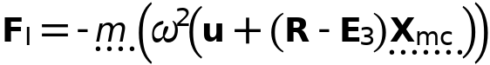

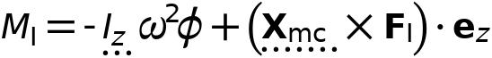



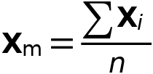

##### Center of Mass

Settings

| **Description** | **Value** |
| --- | --- |
| Center of mass | Centroid of selected entities |
| Entity level | Point |
| Offset | Off |

##### Mass and Moment of Inertia

Settings

| **Description** | **Value** | **Unit** |
| --- | --- | --- |
| Mass | m_pelvis | kg |
| Moment of inertia | I_pelvis | kg·m² |

##### Frame Acceleration Forces

Settings

| **Description** | **Value** |
| --- | --- |
| Exclude contribution | Off |

##### Variables

| **Name** | **Expression** | **Unit** | **Description** | **Selection** | **Details** |
| --- | --- | --- | --- | --- | --- |
| mbd.Wk_tot | 0.25*(mbd.rd1.mmi1.mt*(realdot((mbd.rd1.u+mbd.rd1.mmi1.dMrotx-mbd.rd1.mmi1.dMx)*mbd.iomega,(mbd.rd1.u+mbd.rd1.mmi1.dMrotx-mbd.rd1.mmi1.dMx)*mbd.iomega)+realdot((mbd.rd1.v+mbd.rd1.mmi1.dMroty-mbd.rd1.mmi1.dMy)*mbd.iomega,(mbd.rd1.v+mbd.rd1.mmi1.dMroty-mbd.rd1.mmi1.dMy)*mbd.iomega)+realdot((mbd.rd1.w+mbd.rd1.mmi1.dMrotz-mbd.rd1.mmi1.dMz)*mbd.iomega,(mbd.rd1.w+mbd.rd1.mmi1.dMrotz-mbd.rd1.mmi1.dMz)*mbd.iomega))+mbd.rd1.mmi1.Iz*realdot(mbd.rd1.phi*mbd.iomega,mbd.rd1.phi*mbd.iomega)) | J | Total kinetic energy | Global | + operation |
| mbd.rd1.mmi1.mt | m_pelvis | kg | Mass | Global |  |
| mbd.rd1.mmi1.Iz | I_pelvis | kg·m² | Moment of inertia | Global |  |
| mbd.rd1.mmi1.xmsx | mbd.rd1.xcx+mbd.rd1.u+mbd.rd1.rotxx*(mbd.rd1.mmi1.xmx-mbd.rd1.xcx)+mbd.rd1.rotxy*(mbd.rd1.mmi1.xmy-mbd.rd1.xcy)+mbd.rd1.rotxz*(mbd.rd1.mmi1.xmz-mbd.rd1.xcz) | m | Global coordinates of center of mass, x-component | Global |  |
| mbd.rd1.mmi1.xmsy | mbd.rd1.xcy+mbd.rd1.v+mbd.rd1.rotyx*(mbd.rd1.mmi1.xmx-mbd.rd1.xcx)+mbd.rd1.rotyy*(mbd.rd1.mmi1.xmy-mbd.rd1.xcy)+mbd.rd1.rotyz*(mbd.rd1.mmi1.xmz-mbd.rd1.xcz) | m | Global coordinates of center of mass, y-component | Global |  |
| mbd.rd1.mmi1.xmsz | mbd.rd1.xcz+mbd.rd1.w+mbd.rd1.rotzx*(mbd.rd1.mmi1.xmx-mbd.rd1.xcx)+mbd.rd1.rotzy*(mbd.rd1.mmi1.xmy-mbd.rd1.xcy)+mbd.rd1.rotzz*(mbd.rd1.mmi1.xmz-mbd.rd1.xcz) | m | Global coordinates of center of mass, z-component | Global |  |
| mbd.rd1.mmi1.umx | mbd.rd1.u+mbd.rd1.rotxx*(mbd.rd1.mmi1.xmx-mbd.rd1.xcx)+mbd.rd1.rotxy*(mbd.rd1.mmi1.xmy-mbd.rd1.xcy)+mbd.rd1.rotxz*(mbd.rd1.mmi1.xmz-mbd.rd1.xcz)-mbd.rd1.mmi1.xmx+mbd.rd1.xcx | m | Displacement at center of mass, x-component | Global |  |
| mbd.rd1.mmi1.umy | mbd.rd1.v+mbd.rd1.rotyx*(mbd.rd1.mmi1.xmx-mbd.rd1.xcx)+mbd.rd1.rotyy*(mbd.rd1.mmi1.xmy-mbd.rd1.xcy)+mbd.rd1.rotyz*(mbd.rd1.mmi1.xmz-mbd.rd1.xcz)-mbd.rd1.mmi1.xmy+mbd.rd1.xcy | m | Displacement at center of mass, y-component | Global |  |
| mbd.rd1.mmi1.umz | mbd.rd1.w+mbd.rd1.rotzx*(mbd.rd1.mmi1.xmx-mbd.rd1.xcx)+mbd.rd1.rotzy*(mbd.rd1.mmi1.xmy-mbd.rd1.xcy)+mbd.rd1.rotzz*(mbd.rd1.mmi1.xmz-mbd.rd1.xcz)-mbd.rd1.mmi1.xmz+mbd.rd1.xcz | m | Displacement at center of mass, z-component | Global |  |
| mbd.rd1.mmi1.FIx | -mbd.rd1.mmi1.mt*mbd.iomega^2*(mbd.rd1.u+mbd.rd1.mmi1.dMrotx-mbd.rd1.mmi1.dMx) | N | Inertial force, x-component | Global |  |
| mbd.rd1.mmi1.FIy | -mbd.rd1.mmi1.mt*mbd.iomega^2*(mbd.rd1.v+mbd.rd1.mmi1.dMroty-mbd.rd1.mmi1.dMy) | N | Inertial force, y-component | Global |  |
| mbd.rd1.mmi1.FIz | -mbd.rd1.mmi1.mt*mbd.iomega^2*(mbd.rd1.w+mbd.rd1.mmi1.dMrotz-mbd.rd1.mmi1.dMz) | N | Inertial force, z-component | Global |  |
| mbd.rd1.mmi1.MIz | -mbd.rd1.mmi1.Iz*mbd.iomega^2*mbd.rd1.phi | N·m | Inertial moment | Global |  |
| mbd.rd1.mmi1.dMx | mbd.rd1.mmi1.xmx-mbd.rd1.xcx | m | Mass offset from CoR, Original, x-component | Global |  |
| mbd.rd1.mmi1.dMy | mbd.rd1.mmi1.xmy-mbd.rd1.xcy | m | Mass offset from CoR, Original, y-component | Global |  |
| mbd.rd1.mmi1.dMz | mbd.rd1.mmi1.xmz-mbd.rd1.xcz | m | Mass offset from CoR, Original, z-component | Global |  |
| mbd.rd1.mmi1.dMrotx | mbd.rd1.rotxx*mbd.rd1.mmi1.dMx+mbd.rd1.rotxy*mbd.rd1.mmi1.dMy+mbd.rd1.rotxz*mbd.rd1.mmi1.dMz | m | Mass offset from CoR, Rotated, x-component | Global |  |
| mbd.rd1.mmi1.dMroty | mbd.rd1.rotyx*mbd.rd1.mmi1.dMx+mbd.rd1.rotyy*mbd.rd1.mmi1.dMy+mbd.rd1.rotyz*mbd.rd1.mmi1.dMz | m | Mass offset from CoR, Rotated, y-component | Global |  |
| mbd.rd1.mmi1.dMrotz | mbd.rd1.rotzx*mbd.rd1.mmi1.dMx+mbd.rd1.rotzy*mbd.rd1.mmi1.dMy+mbd.rd1.rotzz*mbd.rd1.mmi1.dMz | m | Mass offset from CoR, Rotated, z-component | Global |  |
| mbd.rd1.mmi1.Fx | mbd.rd1.mmi1.FIx | N | Applied force, x-component | Global |  |
| mbd.rd1.mmi1.Fy | mbd.rd1.mmi1.FIy | N | Applied force, y-component | Global |  |
| mbd.rd1.mmi1.Fz | mbd.rd1.mmi1.FIz | N | Applied force, z-component | Global |  |
| mbd.rd1.mmi1.F_Mag | sqrt(real(mbd.rd1.mmi1.Fx)^2+real(mbd.rd1.mmi1.Fy)^2+real(mbd.rd1.mmi1.Fz)^2) | N | Load magnitude | Global |  |
| mbd.rd1.mmi1.Mx | 0 | N·m | Applied moment, x-component | Global |  |
| mbd.rd1.mmi1.My | 0 | N·m | Applied moment, y-component | Global |  |
| mbd.rd1.mmi1.Mz | mbd.rd1.mmi1.MIz | N·m | Applied moment, z-component | Global |  |
| mbd.rd1.mmi1.M_Mag | sqrt(real(mbd.rd1.mmi1.Mx)^2+real(mbd.rd1.mmi1.My)^2+real(mbd.rd1.mmi1.Mz)^2) | N·m | Moment magnitude | Global |  |
| mbd.rd1.mmi1.loadposx | mbd.rd1.mmi1.xmx | m | Load position, x-component | Global |  |
| mbd.rd1.mmi1.loadposy | mbd.rd1.mmi1.xmy | m | Load position, y-component | Global |  |
| mbd.rd1.mmi1.loadposz | mbd.rd1.mmi1.xmz | m | Load position, z-component | Global |  |
| mbd.rd1.mmi1.momposx | mbd.rd1.mmi1.xmx | m | Moment position, x-component | Global |  |
| mbd.rd1.mmi1.momposy | mbd.rd1.mmi1.xmy | m | Moment position, y-component | Global |  |
| mbd.rd1.mmi1.momposz | mbd.rd1.mmi1.xmz | m | Moment position, z-component | Global |  |

##### Weak Expressions

| **Weak expression** | **Integration order** | **Integration frame** | **Selection** |
| --- | --- | --- | --- |
| mbd.rd1.mmi1.FIx*test(mbd.rd1.u+mbd.rd1.mmi1.dMrotx)+mbd.rd1.mmi1.FIy*test(mbd.rd1.v+mbd.rd1.mmi1.dMroty)+mbd.rd1.mmi1.FIz*test(mbd.rd1.w+mbd.rd1.mmi1.dMrotz) | 2 |  | Global |
| mbd.rd1.mmi1.MIz*test(mbd.rd1.phi) | 2 |  | Global |

##### Center of Mass: Point 1

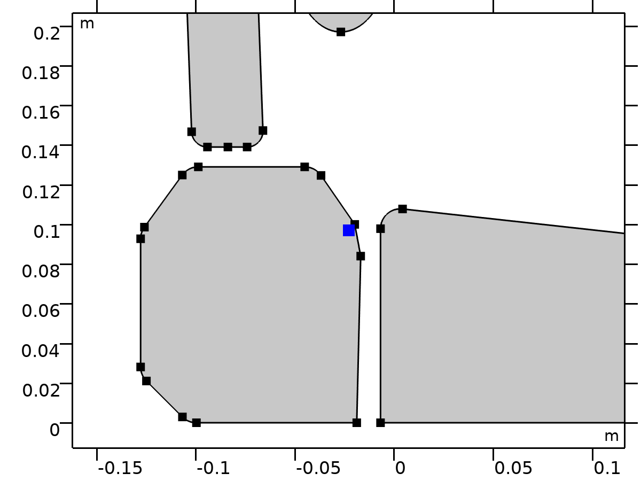

Center of Mass: Point 1

Selection

|  |  |
| --- | --- |
| Geometric entity level | Point |
| Selection | Geometry geom1: Dimension 0: Point 11 |

###### Variables

| **Name** | **Expression** | **Unit** | **Description** | **Selection** | **Details** |
| --- | --- | --- | --- | --- | --- |
| mbd.rd1.mmi1.xmx | mbd.rd1.mmi1.cmp1.int(X)/mbd.rd1.mmi1.cmp1.int(1) | m | Global coordinates of center of mass, x-component | Global | + operation |
| mbd.rd1.mmi1.xmy | mbd.rd1.mmi1.cmp1.int(Y)/mbd.rd1.mmi1.cmp1.int(1) | m | Global coordinates of center of mass, y-component | Global | + operation |
| mbd.rd1.mmi1.xmz | mbd.rd1.mmi1.cmp1.int(0)/mbd.rd1.mmi1.cmp1.int(1) | m | Global coordinates of center of mass, z-component | Global | + operation |

### Head

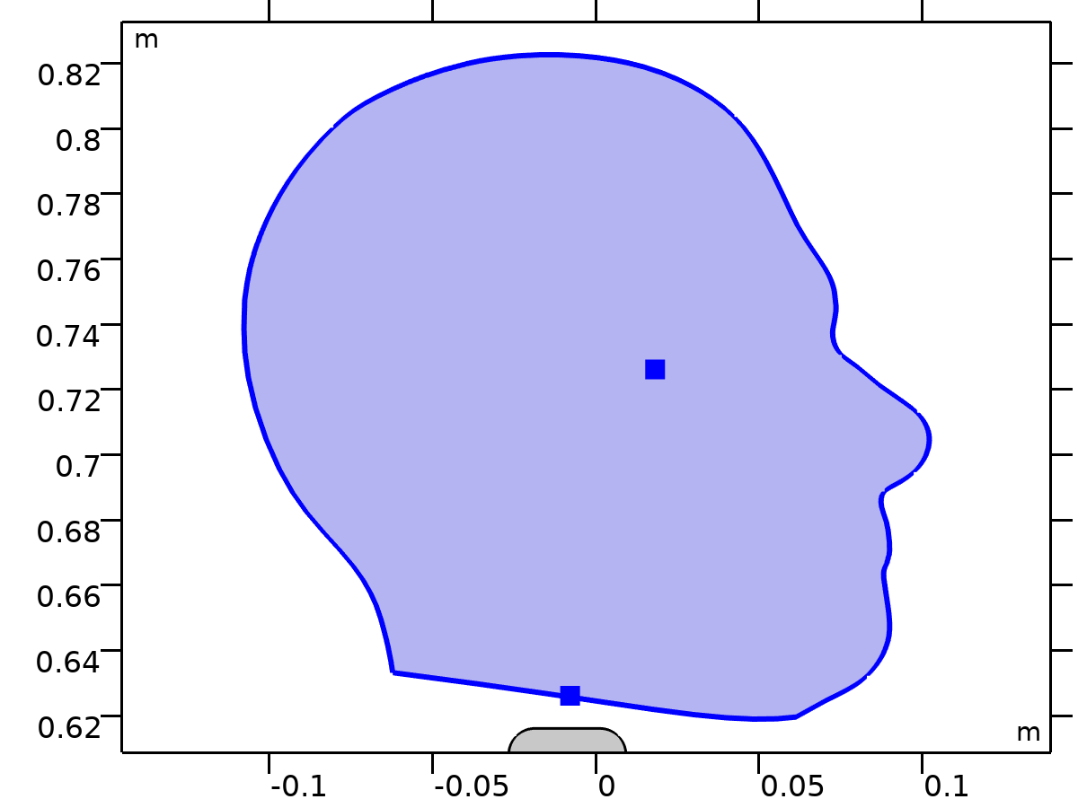

Head

Selection

|  |  |
| --- | --- |
| Geometric entity level | Domain |
| Selection | Geometry geom1: Dimension 2: Domain 2 |

Equations





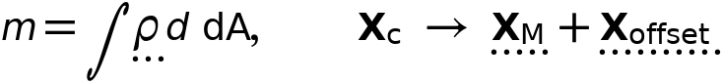















#### Density

Settings

| **Description** | **Value** | **Unit** |
| --- | --- | --- |
| Density | User defined |  |
| Density | 0 | kg/m³ |

#### Center of Rotation

Settings

| **Description** | **Value** | **Unit** |
| --- | --- | --- |
| Center of rotation | Center of mass |  |
| Offset | On |  |
| Offset coordinates, x-component | 0 | m |
| Offset coordinates, y-component | 0 | m |
| Offset coordinates, z-component | 0 | m |

#### Initial Values

Settings

| **Description** | **Value** |
| --- | --- |
| Initial values | From physics interface node |
| Consistent initialization | Default |

#### Variables

| **Name** | **Expression** | **Unit** | **Description** | **Selection** | **Details** |
| --- | --- | --- | --- | --- | --- |
| u | mbd.rd2.Udx | m | Displacement field, X-component | Domain 2 |  |
| v | mbd.rd2.Udy | m | Displacement field, Y-component | Domain 2 |  |
| w | mbd.rd2.Udz | m | Displacement field, Z-component | Domain 2 |  |
| mbd.Wk_tot | 0.25*(mbd.rd2.m*(realdot(mbd.rd2.u*mbd.iomega,mbd.rd2.u*mbd.iomega)+realdot(mbd.rd2.v*mbd.iomega,mbd.rd2.v*mbd.iomega)+realdot(mbd.rd2.w*mbd.iomega,mbd.rd2.w*mbd.iomega))+realdot(mbd.rd2.Iz*mbd.rd2.thx*mbd.iomega,mbd.rd2.thx*mbd.iomega)+realdot(mbd.rd2.Iz*mbd.rd2.thy*mbd.iomega,mbd.rd2.thy*mbd.iomega)+realdot(mbd.rd2.Iz*mbd.rd2.thz*mbd.iomega,mbd.rd2.thz*mbd.iomega)) | J | Total kinetic energy | Global | + operation |
| mbd.RFtotalx | reacf(mbd.rd2.U) | N | Total reaction force, x-component | Global | + operation |
| mbd.RFtotaly | reacf(mbd.rd2.V) | N | Total reaction force, y-component | Global | + operation |
| mbd.RFtotalz | 0 | N | Total reaction force, z-component | Global | + operation |
| mbd.RMtotalx | -reacf(mbd.rd2.V)*mbd.rd2.RMmaz | N·m | Total reaction moment, x-component | Global | + operation |
| mbd.RMtotaly | reacf(mbd.rd2.U)*mbd.rd2.RMmaz | N·m | Total reaction moment, y-component | Global | + operation |
| mbd.RMtotalz | reacf(mbd.rd2.V)*mbd.rd2.RMmax-reacf(mbd.rd2.U)*mbd.rd2.RMmay+reacf(mbd.rd2.Phi) | N·m | Total reaction moment, z-component | Global | + operation |
| mbd.disp | sqrteps(real(u)^2+real(v)^2) | m | Displacement magnitude | Domain 2 |  |
| mbd.disp_rms | sqrt(0.5*(realdot(u,u)+realdot(v,v))) | m | Displacement, RMS | Domain 2 |  |
| mbd.gradUxX | -1+mbd.FdxX | 1 | Displacement gradient, xX-component | Domain 2 |  |
| mbd.gradUyX | mbd.FdyX | 1 | Displacement gradient, yX-component | Domain 2 |  |
| mbd.gradUzX | mbd.FdzX | 1 | Displacement gradient, zX-component | Domain 2 |  |
| mbd.gradUxY | mbd.FdxY | 1 | Displacement gradient, xY-component | Domain 2 |  |
| mbd.gradUyY | -1+mbd.FdyY | 1 | Displacement gradient, yY-component | Domain 2 |  |
| mbd.gradUzY | mbd.FdzY | 1 | Displacement gradient, zY-component | Domain 2 |  |
| mbd.gradUxZ | mbd.FdxZ | 1 | Displacement gradient, xZ-component | Domain 2 |  |
| mbd.gradUyZ | mbd.FdyZ | 1 | Displacement gradient, yZ-component | Domain 2 |  |
| mbd.gradUzZ | -1+mbd.FdzZ | 1 | Displacement gradient, zZ-component | Domain 2 |  |
| mbd.FdxX | mbd.rd2.rotxx | 1 | Deformation gradient, xX-component | Domain 2 |  |
| mbd.FdyX | mbd.rd2.rotyx | 1 | Deformation gradient, yX-component | Domain 2 |  |
| mbd.FdzX | mbd.rd2.rotzx | 1 | Deformation gradient, zX-component | Domain 2 |  |
| mbd.FdxY | mbd.rd2.rotxy | 1 | Deformation gradient, xY-component | Domain 2 |  |
| mbd.FdyY | mbd.rd2.rotyy | 1 | Deformation gradient, yY-component | Domain 2 |  |
| mbd.FdzY | mbd.rd2.rotzy | 1 | Deformation gradient, zY-component | Domain 2 |  |
| mbd.FdxZ | mbd.rd2.rotxz | 1 | Deformation gradient, xZ-component | Domain 2 |  |
| mbd.FdyZ | mbd.rd2.rotyz | 1 | Deformation gradient, yZ-component | Domain 2 |  |
| mbd.FdzZ | mbd.rd2.rotzz | 1 | Deformation gradient, zZ-component | Domain 2 |  |
| mbd.FdiXx | (mbd.FdyY*mbd.FdzZ-mbd.FdyZ*mbd.FdzY)/mbd.J | 1 | Deformation gradient inverse, Xx-component | Domain 2 |  |
| mbd.FdiYx | (mbd.FdyZ*mbd.FdzX-mbd.FdyX*mbd.FdzZ)/mbd.J | 1 | Deformation gradient inverse, Yx-component | Domain 2 |  |
| mbd.FdiZx | (mbd.FdyX*mbd.FdzY-mbd.FdyY*mbd.FdzX)/mbd.J | 1 | Deformation gradient inverse, Zx-component | Domain 2 |  |
| mbd.FdiXy | (mbd.FdxZ*mbd.FdzY-mbd.FdxY*mbd.FdzZ)/mbd.J | 1 | Deformation gradient inverse, Xy-component | Domain 2 |  |
| mbd.FdiYy | (mbd.FdxX*mbd.FdzZ-mbd.FdxZ*mbd.FdzX)/mbd.J | 1 | Deformation gradient inverse, Yy-component | Domain 2 |  |
| mbd.FdiZy | (mbd.FdxY*mbd.FdzX-mbd.FdxX*mbd.FdzY)/mbd.J | 1 | Deformation gradient inverse, Zy-component | Domain 2 |  |
| mbd.FdiXz | (mbd.FdxY*mbd.FdyZ-mbd.FdxZ*mbd.FdyY)/mbd.J | 1 | Deformation gradient inverse, Xz-component | Domain 2 |  |
| mbd.FdiYz | (mbd.FdxZ*mbd.FdyX-mbd.FdxX*mbd.FdyZ)/mbd.J | 1 | Deformation gradient inverse, Yz-component | Domain 2 |  |
| mbd.FdiZz | (mbd.FdxX*mbd.FdyY-mbd.FdxY*mbd.FdyX)/mbd.J | 1 | Deformation gradient inverse, Zz-component | Domain 2 |  |
| mbd.J | 1 | 1 | Volume ratio | Domain 2 |  |
| mbd.Ws | 0 | J/m³ | Elastic strain energy density | Domain 2 | + operation |
| mbd.Ws_tot | 0 | J | Total elastic strain energy | Global | + operation |
| mbd.Wk | 0.25*mbd.rho*(realdot(u*mbd.iomega,u*mbd.iomega)+realdot(v*mbd.iomega,v*mbd.iomega)) | J/m³ | Kinetic energy density | Domain 2 | + operation |
| mbd.Eequ | Inf | Pa | Equivalent Young's modulus | Domain 2 |  |
| mbd.nuequ | 0 | 1 | Equivalent Poisson's ratio | Domain 2 |  |
| mbd.Eequtot | mbd.Eequ | Pa | Total equivalent Young's modulus | Domain 2 | + operation |
| mbd.rho | 0 | kg/m³ | Density | Domain 2 | * operation |
| mbd.u_ttX | material.dt(material.dt(mbd.rd2.Udx)) | m/s² | Acceleration, X-component | Domain 2 |  |
| mbd.u_ttY | material.dt(material.dt(mbd.rd2.Udy)) | m/s² | Acceleration, Y-component | Domain 2 |  |
| mbd.u_ttZ | material.dt(material.dt(mbd.rd2.Udz)) | m/s² | Acceleration, Z-component | Domain 2 |  |
| mbd.u_tX | material.dt(mbd.rd2.Udx) | m/s | Velocity, X-component | Domain 2 |  |
| mbd.u_tY | material.dt(mbd.rd2.Udy) | m/s | Velocity, Y-component | Domain 2 |  |
| mbd.u_tZ | material.dt(mbd.rd2.Udz) | m/s | Velocity, Z-component | Domain 2 |  |
| mbd.vel_rms | sqrt(0.5*(realdot(mbd.u_tX,mbd.u_tX)+realdot(mbd.u_tY,mbd.u_tY)+realdot(mbd.u_tZ,mbd.u_tZ))) | m/s | Velocity magnitude, RMS | Domain 2 |  |
| mbd.acc_rms | sqrt(0.5*(realdot(mbd.u_ttX,mbd.u_ttX)+realdot(mbd.u_ttY,mbd.u_ttY)+realdot(mbd.u_ttZ,mbd.u_ttZ))) | m/s² | Acceleration magnitude, RMS | Domain 2 |  |
| mbd.afX | 0 | m/s² | Frame acceleration, X-component | Domain 2 | + operation |
| mbd.afY | 0 | m/s² | Frame acceleration, Y-component | Domain 2 | + operation |
| mbd.afZ | 0 | m/s² | Frame acceleration, Z-component | Domain 2 | + operation |
| mbd.accX | mbd.u_ttX | m/s² | Effective acceleration, X-component | Domain 2 | + operation |
| mbd.accY | mbd.u_ttY | m/s² | Effective acceleration, Y-component | Domain 2 | + operation |
| mbd.accZ | mbd.u_ttZ | m/s² | Effective acceleration, Z-component | Domain 2 | + operation |
| mbd.vel | sqrteps(real(mbd.u_tX)^2+real(mbd.u_tY)^2+real(mbd.u_tZ)^2) | m/s | Velocity magnitude | Domain 2 |  |
| mbd.acc | sqrteps(real(mbd.accX)^2+real(mbd.accY)^2+real(mbd.accZ)^2) | m/s² | Effective acceleration magnitude | Domain 2 |  |
| mbd.u_tt | sqrteps(real(mbd.u_ttX)^2+real(mbd.u_ttY)^2+real(mbd.u_ttZ)^2) | m/s² | Acceleration magnitude | Domain 2 |  |
| mbd.phase | if(isdefined(phase),phase,0) | 1 | Phase | Global |  |
| mbd.rd2.xcx | mbd.rd2.x_offx+mbd.rd2.xmx | m | Center of rotation, x-component | Global | + operation |
| mbd.rd2.xcy | mbd.rd2.x_offy+mbd.rd2.xmy | m | Center of rotation, y-component | Global | + operation |
| mbd.rd2.xcz | mbd.rd2.x_offz+mbd.rd2.xmz | m | Center of rotation, z-component | Global | + operation |
| mbd.rd2.phi | mbd.rd2.Phi | rad | Rigid body rotation | Global |  |
| mbd.rd2.rotxx | 1 | 1 | Rotation matrix, xx-component | Global |  |
| mbd.rd2.rotyx | mbd.rd2.phi*exp(-(j*mbd.phase)) | 1 | Rotation matrix, yx-component | Global |  |
| mbd.rd2.rotzx | 0 | 1 | Rotation matrix, zx-component | Global |  |
| mbd.rd2.rotxy | -mbd.rd2.phi*exp(-(j*mbd.phase)) | 1 | Rotation matrix, xy-component | Global |  |
| mbd.rd2.rotyy | 1 | 1 | Rotation matrix, yy-component | Global |  |
| mbd.rd2.rotzy | 0 | 1 | Rotation matrix, zy-component | Global |  |
| mbd.rd2.rotxz | 0 | 1 | Rotation matrix, xz-component | Global |  |
| mbd.rd2.rotyz | 0 | 1 | Rotation matrix, yz-component | Global |  |
| mbd.rd2.rotzz | 1 | 1 | Rotation matrix, zz-component | Global |  |
| mbd.rd2.x_offx | 0 | m | Offset coordinates, x-component | Global |  |
| mbd.rd2.x_offy | 0 | m | Offset coordinates, y-component | Global |  |
| mbd.rd2.x_offz | 0 | m | Offset coordinates, z-component | Global |  |
| mbd.rd2.RMmax | mbd.rd2.xcx-mbd.refpntx | m | Moment arm, x-component | Global |  |
| mbd.rd2.RMmay | mbd.rd2.xcy-mbd.refpnty | m | Moment arm, y-component | Global |  |
| mbd.rd2.RMmaz | 0 | m | Moment arm, z-component | Global |  |
| mbd.rd2.u | mbd.rd2.U | m | Rigid body displacement, x-component | Global |  |
| mbd.rd2.v | mbd.rd2.V | m | Rigid body displacement, y-component | Global |  |
| mbd.rd2.w | 0 | m | Rigid body displacement, z-component | Global |  |
| mbd.rd2.xmx | mbd.rd2.int((mbd.rho+eps)*mbd.d*X)/mbd.rd2.int((mbd.rho+eps)*mbd.d) | m | Center of mass, x-component | Global |  |
| mbd.rd2.xmy | mbd.rd2.int((mbd.rho+eps)*mbd.d*Y)/mbd.rd2.int((mbd.rho+eps)*mbd.d) | m | Center of mass, y-component | Global |  |
| mbd.rd2.xmz | 0 | m | Center of mass, z-component | Global |  |
| mbd.rd2.Iz | mbd.rd2.int(((X-mbd.rd2.xmx)^2+(Y-mbd.rd2.xmy)^2+mbd.rd2.xmz^2)*mbd.rho*mbd.d) | kg·m² | Moment of inertia | Global |  |
| mbd.rd2.um | mbd.rd2.rotxx*(mbd.rd2.xmx-mbd.rd2.xcx)+mbd.rd2.rotxy*(mbd.rd2.xmy-mbd.rd2.xcy)+mbd.rd2.rotxz*(mbd.rd2.xmz-mbd.rd2.xcz)-mbd.rd2.xmx+mbd.rd2.xcx+mbd.rd2.u | m | Rigid body displacement, x-component | Global |  |
| mbd.rd2.vm | mbd.rd2.rotyx*(mbd.rd2.xmx-mbd.rd2.xcx)+mbd.rd2.rotyy*(mbd.rd2.xmy-mbd.rd2.xcy)+mbd.rd2.rotyz*(mbd.rd2.xmz-mbd.rd2.xcz)-mbd.rd2.xmy+mbd.rd2.xcy+mbd.rd2.v | m | Rigid body displacement, y-component | Global |  |
| mbd.rd2.wm | 0 | m | Rigid body displacement, z-component | Global |  |
| mbd.rd2.m | mbd.rd2.int(mbd.rho*mbd.d) | kg | Mass | Global |  |
| mbd.rd2.Udx | (mbd.rd2.rotxx*(X-mbd.rd2.xcx)+mbd.rd2.rotxy*(Y-mbd.rd2.xcy)-mbd.rd2.rotxz*mbd.rd2.xcz-X+mbd.rd2.xcx)*exp(j*mbd.phase)+mbd.rd2.u | m | Domain displacement, x-component | Domain 2 | + operation |
| mbd.rd2.Udy | (mbd.rd2.rotyx*(X-mbd.rd2.xcx)+mbd.rd2.rotyy*(Y-mbd.rd2.xcy)-mbd.rd2.rotyz*mbd.rd2.xcz-Y+mbd.rd2.xcy)*exp(j*mbd.phase)+mbd.rd2.v | m | Domain displacement, y-component | Domain 2 | + operation |
| mbd.rd2.Udz | (mbd.rd2.rotzx*(X-mbd.rd2.xcx)+mbd.rd2.rotzy*(Y-mbd.rd2.xcy)-mbd.rd2.rotzz*mbd.rd2.xcz+mbd.rd2.xcz)*exp(j*mbd.phase)+mbd.rd2.w | m | Domain displacement, z-component | Domain 2 | + operation |
| mbd.rd2.thx | 0 | rad | Rigid body rotation, x-component | Global |  |
| mbd.rd2.thy | 0 | rad | Rigid body rotation, y-component | Global |  |
| mbd.rd2.thz | mbd.rd2.phi | rad | Rigid body rotation, z-component | Global |  |
| mbd.rd2.u_tx | mbd.iomega*mbd.rd2.u | m/s | Rigid body velocity, x-component | Global |  |
| mbd.rd2.u_ty | mbd.iomega*mbd.rd2.v | m/s | Rigid body velocity, y-component | Global |  |
| mbd.rd2.u_tz | mbd.iomega*mbd.rd2.w | m/s | Rigid body velocity, z-component | Global |  |
| mbd.rd2.u_ttx | mbd.iomega*mbd.rd2.u_tx | m/s² | Rigid body acceleration, x-component | Global |  |
| mbd.rd2.u_tty | mbd.iomega*mbd.rd2.u_ty | m/s² | Rigid body acceleration, y-component | Global |  |
| mbd.rd2.u_ttz | mbd.iomega*mbd.rd2.u_tz | m/s² | Rigid body acceleration, z-component | Global |  |
| mbd.rd2.um_ttx | mbd.iomega^2*mbd.rd2.um | m/s² | Rigid body acceleration, x-component | Global |  |
| mbd.rd2.um_tty | mbd.iomega^2*mbd.rd2.vm | m/s² | Rigid body acceleration, y-component | Global |  |
| mbd.rd2.um_ttz | mbd.iomega^2*mbd.rd2.wm | m/s² | Rigid body acceleration, z-component | Global |  |
| mbd.rd2.th_tx | mbd.iomega*mbd.rd2.thx | rad/s | Rigid body angular velocity, x-component | Global |  |
| mbd.rd2.th_ty | mbd.iomega*mbd.rd2.thy | rad/s | Rigid body angular velocity, y-component | Global |  |
| mbd.rd2.th_tz | mbd.iomega*mbd.rd2.thz | rad/s | Rigid body angular velocity, z-component | Global |  |
| mbd.rd2.th_ttx | mbd.iomega*mbd.rd2.th_tx | rad/s² | Rigid body angular acceleration, x-component | Global |  |
| mbd.rd2.th_tty | mbd.iomega*mbd.rd2.th_ty | rad/s² | Rigid body angular acceleration, y-component | Global |  |
| mbd.rd2.th_ttz | mbd.iomega*mbd.rd2.th_tz | rad/s² | Rigid body angular acceleration, z-component | Global |  |
| mbd.rd2.FIx | -mbd.rd2.m*mbd.rd2.um_ttx | N | Inertial force, x-component | Global |  |
| mbd.rd2.FIy | -mbd.rd2.m*mbd.rd2.um_tty | N | Inertial force, y-component | Global |  |
| mbd.rd2.FIz | 0 | N | Inertial force, z-component | Global |  |
| mbd.rd2.MIz | -mbd.rd2.Iz*mbd.iomega^2*mbd.rd2.phi | N·m | Inertial moment | Global |  |
| mbd.rd2.i_rot | 1 | 1 | Free rotation indicator | Global | * operation |

#### Shape functions

| **Name** | **Shape function** | **Unit** | **Description** | **Shape frame** | **Selection** |
| --- | --- | --- | --- | --- | --- |
| mbd.rd2.U | ODE | m | Rigid body displacement, x-component |  | Global |
| mbd.rd2.V | ODE | m | Rigid body displacement, y-component |  | Global |
| mbd.rd2.Phi | ODE | rad | Rigid body rotation |  | Global |

#### Weak Expressions

| **Weak expression** | **Integration order** | **Integration frame** | **Selection** |
| --- | --- | --- | --- |
| mbd.rd2.FIx*test(mbd.rd2.um)+mbd.rd2.FIy*test(mbd.rd2.vm)+mbd.rd2.FIz*test(mbd.rd2.wm) | 2 |  | Global |
| mbd.rd2.MIz*test(mbd.rd2.phi) | 2 |  | Global |

#### Constraints

| **Constraint** | **Constraint force** | **Shape function** | **Selection** | **Details** |
| --- | --- | --- | --- | --- |
| up(u)-down(u) | test(up(u)-down(u)) | Lagrange (Linear) | No boundaries | Elemental |
| up(v)-down(v) | test(up(v)-down(v)) | Lagrange (Linear) | No boundaries | Elemental |
| 0 | 0 |  | No boundaries | Elemental |

#### Mass and Moment of Inertia 2

Selection

|  |  |
| --- | --- |
| Geometric entity level | Entire model |

Equations









##### Center of Mass

Settings

| **Description** | **Value** |
| --- | --- |
| Center of mass | Centroid of selected entities |
| Entity level | Point |
| Offset | Off |

##### Mass and Moment of Inertia

Settings

| **Description** | **Value** | **Unit** |
| --- | --- | --- |
| Mass | m_head | kg |
| Moment of inertia | I_head | kg·m² |

##### Frame Acceleration Forces

Settings

| **Description** | **Value** |
| --- | --- |
| Exclude contribution | Off |

##### Variables

| **Name** | **Expression** | **Unit** | **Description** | **Selection** | **Details** |
| --- | --- | --- | --- | --- | --- |
| mbd.Wk_tot | 0.25*(mbd.rd2.mmi1.mt*(realdot((mbd.rd2.u+mbd.rd2.mmi1.dMrotx-mbd.rd2.mmi1.dMx)*mbd.iomega,(mbd.rd2.u+mbd.rd2.mmi1.dMrotx-mbd.rd2.mmi1.dMx)*mbd.iomega)+realdot((mbd.rd2.v+mbd.rd2.mmi1.dMroty-mbd.rd2.mmi1.dMy)*mbd.iomega,(mbd.rd2.v+mbd.rd2.mmi1.dMroty-mbd.rd2.mmi1.dMy)*mbd.iomega)+realdot((mbd.rd2.w+mbd.rd2.mmi1.dMrotz-mbd.rd2.mmi1.dMz)*mbd.iomega,(mbd.rd2.w+mbd.rd2.mmi1.dMrotz-mbd.rd2.mmi1.dMz)*mbd.iomega))+mbd.rd2.mmi1.Iz*realdot(mbd.rd2.phi*mbd.iomega,mbd.rd2.phi*mbd.iomega)) | J | Total kinetic energy | Global | + operation |
| mbd.rd2.mmi1.mt | m_head | kg | Mass | Global |  |
| mbd.rd2.mmi1.Iz | I_head | kg·m² | Moment of inertia | Global |  |
| mbd.rd2.mmi1.xmsx | mbd.rd2.xcx+mbd.rd2.u+mbd.rd2.rotxx*(mbd.rd2.mmi1.xmx-mbd.rd2.xcx)+mbd.rd2.rotxy*(mbd.rd2.mmi1.xmy-mbd.rd2.xcy)+mbd.rd2.rotxz*(mbd.rd2.mmi1.xmz-mbd.rd2.xcz) | m | Global coordinates of center of mass, x-component | Global |  |
| mbd.rd2.mmi1.xmsy | mbd.rd2.xcy+mbd.rd2.v+mbd.rd2.rotyx*(mbd.rd2.mmi1.xmx-mbd.rd2.xcx)+mbd.rd2.rotyy*(mbd.rd2.mmi1.xmy-mbd.rd2.xcy)+mbd.rd2.rotyz*(mbd.rd2.mmi1.xmz-mbd.rd2.xcz) | m | Global coordinates of center of mass, y-component | Global |  |
| mbd.rd2.mmi1.xmsz | mbd.rd2.xcz+mbd.rd2.w+mbd.rd2.rotzx*(mbd.rd2.mmi1.xmx-mbd.rd2.xcx)+mbd.rd2.rotzy*(mbd.rd2.mmi1.xmy-mbd.rd2.xcy)+mbd.rd2.rotzz*(mbd.rd2.mmi1.xmz-mbd.rd2.xcz) | m | Global coordinates of center of mass, z-component | Global |  |
| mbd.rd2.mmi1.umx | mbd.rd2.u+mbd.rd2.rotxx*(mbd.rd2.mmi1.xmx-mbd.rd2.xcx)+mbd.rd2.rotxy*(mbd.rd2.mmi1.xmy-mbd.rd2.xcy)+mbd.rd2.rotxz*(mbd.rd2.mmi1.xmz-mbd.rd2.xcz)-mbd.rd2.mmi1.xmx+mbd.rd2.xcx | m | Displacement at center of mass, x-component | Global |  |
| mbd.rd2.mmi1.umy | mbd.rd2.v+mbd.rd2.rotyx*(mbd.rd2.mmi1.xmx-mbd.rd2.xcx)+mbd.rd2.rotyy*(mbd.rd2.mmi1.xmy-mbd.rd2.xcy)+mbd.rd2.rotyz*(mbd.rd2.mmi1.xmz-mbd.rd2.xcz)-mbd.rd2.mmi1.xmy+mbd.rd2.xcy | m | Displacement at center of mass, y-component | Global |  |
| mbd.rd2.mmi1.umz | mbd.rd2.w+mbd.rd2.rotzx*(mbd.rd2.mmi1.xmx-mbd.rd2.xcx)+mbd.rd2.rotzy*(mbd.rd2.mmi1.xmy-mbd.rd2.xcy)+mbd.rd2.rotzz*(mbd.rd2.mmi1.xmz-mbd.rd2.xcz)-mbd.rd2.mmi1.xmz+mbd.rd2.xcz | m | Displacement at center of mass, z-component | Global |  |
| mbd.rd2.mmi1.FIx | -mbd.rd2.mmi1.mt*mbd.iomega^2*(mbd.rd2.u+mbd.rd2.mmi1.dMrotx-mbd.rd2.mmi1.dMx) | N | Inertial force, x-component | Global |  |
| mbd.rd2.mmi1.FIy | -mbd.rd2.mmi1.mt*mbd.iomega^2*(mbd.rd2.v+mbd.rd2.mmi1.dMroty-mbd.rd2.mmi1.dMy) | N | Inertial force, y-component | Global |  |
| mbd.rd2.mmi1.FIz | -mbd.rd2.mmi1.mt*mbd.iomega^2*(mbd.rd2.w+mbd.rd2.mmi1.dMrotz-mbd.rd2.mmi1.dMz) | N | Inertial force, z-component | Global |  |
| mbd.rd2.mmi1.MIz | -mbd.rd2.mmi1.Iz*mbd.iomega^2*mbd.rd2.phi | N·m | Inertial moment | Global |  |
| mbd.rd2.mmi1.dMx | mbd.rd2.mmi1.xmx-mbd.rd2.xcx | m | Mass offset from CoR, Original, x-component | Global |  |
| mbd.rd2.mmi1.dMy | mbd.rd2.mmi1.xmy-mbd.rd2.xcy | m | Mass offset from CoR, Original, y-component | Global |  |
| mbd.rd2.mmi1.dMz | mbd.rd2.mmi1.xmz-mbd.rd2.xcz | m | Mass offset from CoR, Original, z-component | Global |  |
| mbd.rd2.mmi1.dMrotx | mbd.rd2.rotxx*mbd.rd2.mmi1.dMx+mbd.rd2.rotxy*mbd.rd2.mmi1.dMy+mbd.rd2.rotxz*mbd.rd2.mmi1.dMz | m | Mass offset from CoR, Rotated, x-component | Global |  |
| mbd.rd2.mmi1.dMroty | mbd.rd2.rotyx*mbd.rd2.mmi1.dMx+mbd.rd2.rotyy*mbd.rd2.mmi1.dMy+mbd.rd2.rotyz*mbd.rd2.mmi1.dMz | m | Mass offset from CoR, Rotated, y-component | Global |  |
| mbd.rd2.mmi1.dMrotz | mbd.rd2.rotzx*mbd.rd2.mmi1.dMx+mbd.rd2.rotzy*mbd.rd2.mmi1.dMy+mbd.rd2.rotzz*mbd.rd2.mmi1.dMz | m | Mass offset from CoR, Rotated, z-component | Global |  |
| mbd.rd2.mmi1.Fx | mbd.rd2.mmi1.FIx | N | Applied force, x-component | Global |  |
| mbd.rd2.mmi1.Fy | mbd.rd2.mmi1.FIy | N | Applied force, y-component | Global |  |
| mbd.rd2.mmi1.Fz | mbd.rd2.mmi1.FIz | N | Applied force, z-component | Global |  |
| mbd.rd2.mmi1.F_Mag | sqrt(real(mbd.rd2.mmi1.Fx)^2+real(mbd.rd2.mmi1.Fy)^2+real(mbd.rd2.mmi1.Fz)^2) | N | Load magnitude | Global |  |
| mbd.rd2.mmi1.Mx | 0 | N·m | Applied moment, x-component | Global |  |
| mbd.rd2.mmi1.My | 0 | N·m | Applied moment, y-component | Global |  |
| mbd.rd2.mmi1.Mz | mbd.rd2.mmi1.MIz | N·m | Applied moment, z-component | Global |  |
| mbd.rd2.mmi1.M_Mag | sqrt(real(mbd.rd2.mmi1.Mx)^2+real(mbd.rd2.mmi1.My)^2+real(mbd.rd2.mmi1.Mz)^2) | N·m | Moment magnitude | Global |  |
| mbd.rd2.mmi1.loadposx | mbd.rd2.mmi1.xmx | m | Load position, x-component | Global |  |
| mbd.rd2.mmi1.loadposy | mbd.rd2.mmi1.xmy | m | Load position, y-component | Global |  |
| mbd.rd2.mmi1.loadposz | mbd.rd2.mmi1.xmz | m | Load position, z-component | Global |  |
| mbd.rd2.mmi1.momposx | mbd.rd2.mmi1.xmx | m | Moment position, x-component | Global |  |
| mbd.rd2.mmi1.momposy | mbd.rd2.mmi1.xmy | m | Moment position, y-component | Global |  |
| mbd.rd2.mmi1.momposz | mbd.rd2.mmi1.xmz | m | Moment position, z-component | Global |  |

##### Weak Expressions

| **Weak expression** | **Integration order** | **Integration frame** | **Selection** |
| --- | --- | --- | --- |
| mbd.rd2.mmi1.FIx*test(mbd.rd2.u+mbd.rd2.mmi1.dMrotx)+mbd.rd2.mmi1.FIy*test(mbd.rd2.v+mbd.rd2.mmi1.dMroty)+mbd.rd2.mmi1.FIz*test(mbd.rd2.w+mbd.rd2.mmi1.dMrotz) | 2 |  | Global |
| mbd.rd2.mmi1.MIz*test(mbd.rd2.phi) | 2 |  | Global |

##### Center of Mass: Point 2

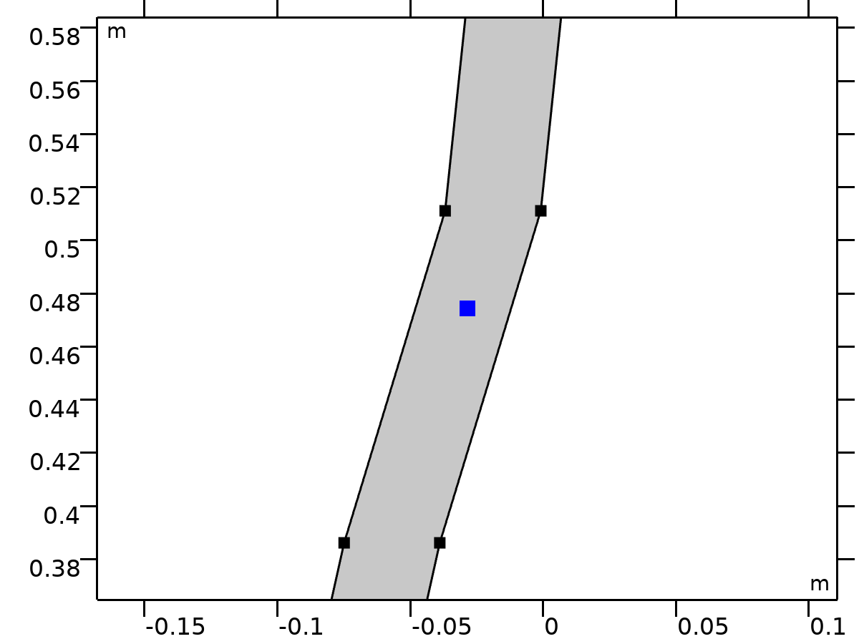

Center of Mass: Point 2

Selection

|  |  |
| --- | --- |
| Geometric entity level | Point |
| Selection | Geometry geom1: Dimension 0: Point 46 |

###### Variables

| **Name** | **Expression** | **Unit** | **Description** | **Selection** | **Details** |
| --- | --- | --- | --- | --- | --- |
| mbd.rd2.mmi1.xmx | mbd.rd2.mmi1.cmp1.int(X)/mbd.rd2.mmi1.cmp1.int(1) | m | Global coordinates of center of mass, x-component | Global | + operation |
| mbd.rd2.mmi1.xmy | mbd.rd2.mmi1.cmp1.int(Y)/mbd.rd2.mmi1.cmp1.int(1) | m | Global coordinates of center of mass, y-component | Global | + operation |
| mbd.rd2.mmi1.xmz | mbd.rd2.mmi1.cmp1.int(0)/mbd.rd2.mmi1.cmp1.int(1) | m | Global coordinates of center of mass, z-component | Global | + operation |

### Torso

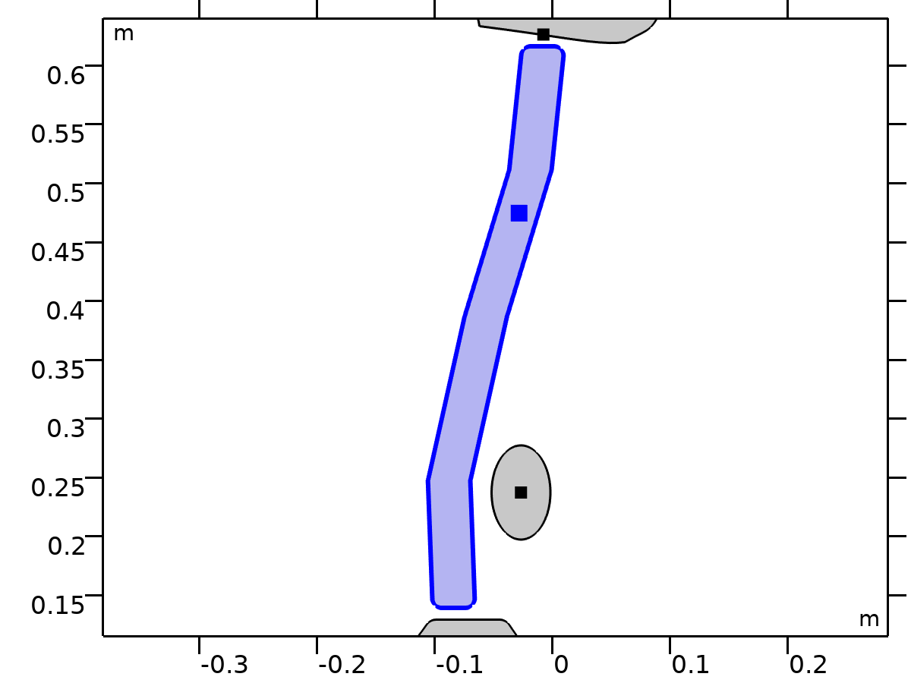

Torso

Selection

|  |  |
| --- | --- |
| Geometric entity level | Domain |
| Selection | Geometry geom1: Dimension 2: Domain 3 |

Equations





















#### Density

Settings

| **Description** | **Value** | **Unit** |
| --- | --- | --- |
| Density | User defined |  |
| Density | 0 | kg/m³ |

#### Center of Rotation

Settings

| **Description** | **Value** |
| --- | --- |
| Center of rotation | Center of mass |
| Offset | Off |

#### Initial Values

Settings

| **Description** | **Value** |
| --- | --- |
| Initial values | From physics interface node |
| Consistent initialization | Default |

#### Variables

| **Name** | **Expression** | **Unit** | **Description** | **Selection** | **Details** |
| --- | --- | --- | --- | --- | --- |
| u | mbd.rd3.Udx | m | Displacement field, X-component | Domain 3 |  |
| v | mbd.rd3.Udy | m | Displacement field, Y-component | Domain 3 |  |
| w | mbd.rd3.Udz | m | Displacement field, Z-component | Domain 3 |  |
| mbd.Wk_tot | 0.25*(mbd.rd3.m*(realdot(mbd.rd3.u*mbd.iomega,mbd.rd3.u*mbd.iomega)+realdot(mbd.rd3.v*mbd.iomega,mbd.rd3.v*mbd.iomega)+realdot(mbd.rd3.w*mbd.iomega,mbd.rd3.w*mbd.iomega))+realdot(mbd.rd3.Iz*mbd.rd3.thx*mbd.iomega,mbd.rd3.thx*mbd.iomega)+realdot(mbd.rd3.Iz*mbd.rd3.thy*mbd.iomega,mbd.rd3.thy*mbd.iomega)+realdot(mbd.rd3.Iz*mbd.rd3.thz*mbd.iomega,mbd.rd3.thz*mbd.iomega)) | J | Total kinetic energy | Global | + operation |
| mbd.RFtotalx | reacf(mbd.rd3.U) | N | Total reaction force, x-component | Global | + operation |
| mbd.RFtotaly | reacf(mbd.rd3.V) | N | Total reaction force, y-component | Global | + operation |
| mbd.RFtotalz | 0 | N | Total reaction force, z-component | Global | + operation |
| mbd.RMtotalx | -reacf(mbd.rd3.V)*mbd.rd3.RMmaz | N·m | Total reaction moment, x-component | Global | + operation |
| mbd.RMtotaly | reacf(mbd.rd3.U)*mbd.rd3.RMmaz | N·m | Total reaction moment, y-component | Global | + operation |
| mbd.RMtotalz | reacf(mbd.rd3.V)*mbd.rd3.RMmax-reacf(mbd.rd3.U)*mbd.rd3.RMmay+reacf(mbd.rd3.Phi) | N·m | Total reaction moment, z-component | Global | + operation |
| mbd.disp | sqrteps(real(u)^2+real(v)^2) | m | Displacement magnitude | Domain 3 |  |
| mbd.disp_rms | sqrt(0.5*(realdot(u,u)+realdot(v,v))) | m | Displacement, RMS | Domain 3 |  |
| mbd.gradUxX | -1+mbd.FdxX | 1 | Displacement gradient, xX-component | Domain 3 |  |
| mbd.gradUyX | mbd.FdyX | 1 | Displacement gradient, yX-component | Domain 3 |  |
| mbd.gradUzX | mbd.FdzX | 1 | Displacement gradient, zX-component | Domain 3 |  |
| mbd.gradUxY | mbd.FdxY | 1 | Displacement gradient, xY-component | Domain 3 |  |
| mbd.gradUyY | -1+mbd.FdyY | 1 | Displacement gradient, yY-component | Domain 3 |  |
| mbd.gradUzY | mbd.FdzY | 1 | Displacement gradient, zY-component | Domain 3 |  |
| mbd.gradUxZ | mbd.FdxZ | 1 | Displacement gradient, xZ-component | Domain 3 |  |
| mbd.gradUyZ | mbd.FdyZ | 1 | Displacement gradient, yZ-component | Domain 3 |  |
| mbd.gradUzZ | -1+mbd.FdzZ | 1 | Displacement gradient, zZ-component | Domain 3 |  |
| mbd.FdxX | mbd.rd3.rotxx | 1 | Deformation gradient, xX-component | Domain 3 |  |
| mbd.FdyX | mbd.rd3.rotyx | 1 | Deformation gradient, yX-component | Domain 3 |  |
| mbd.FdzX | mbd.rd3.rotzx | 1 | Deformation gradient, zX-component | Domain 3 |  |
| mbd.FdxY | mbd.rd3.rotxy | 1 | Deformation gradient, xY-component | Domain 3 |  |
| mbd.FdyY | mbd.rd3.rotyy | 1 | Deformation gradient, yY-component | Domain 3 |  |
| mbd.FdzY | mbd.rd3.rotzy | 1 | Deformation gradient, zY-component | Domain 3 |  |
| mbd.FdxZ | mbd.rd3.rotxz | 1 | Deformation gradient, xZ-component | Domain 3 |  |
| mbd.FdyZ | mbd.rd3.rotyz | 1 | Deformation gradient, yZ-component | Domain 3 |  |
| mbd.FdzZ | mbd.rd3.rotzz | 1 | Deformation gradient, zZ-component | Domain 3 |  |
| mbd.FdiXx | (mbd.FdyY*mbd.FdzZ-mbd.FdyZ*mbd.FdzY)/mbd.J | 1 | Deformation gradient inverse, Xx-component | Domain 3 |  |
| mbd.FdiYx | (mbd.FdyZ*mbd.FdzX-mbd.FdyX*mbd.FdzZ)/mbd.J | 1 | Deformation gradient inverse, Yx-component | Domain 3 |  |
| mbd.FdiZx | (mbd.FdyX*mbd.FdzY-mbd.FdyY*mbd.FdzX)/mbd.J | 1 | Deformation gradient inverse, Zx-component | Domain 3 |  |
| mbd.FdiXy | (mbd.FdxZ*mbd.FdzY-mbd.FdxY*mbd.FdzZ)/mbd.J | 1 | Deformation gradient inverse, Xy-component | Domain 3 |  |
| mbd.FdiYy | (mbd.FdxX*mbd.FdzZ-mbd.FdxZ*mbd.FdzX)/mbd.J | 1 | Deformation gradient inverse, Yy-component | Domain 3 |  |
| mbd.FdiZy | (mbd.FdxY*mbd.FdzX-mbd.FdxX*mbd.FdzY)/mbd.J | 1 | Deformation gradient inverse, Zy-component | Domain 3 |  |
| mbd.FdiXz | (mbd.FdxY*mbd.FdyZ-mbd.FdxZ*mbd.FdyY)/mbd.J | 1 | Deformation gradient inverse, Xz-component | Domain 3 |  |
| mbd.FdiYz | (mbd.FdxZ*mbd.FdyX-mbd.FdxX*mbd.FdyZ)/mbd.J | 1 | Deformation gradient inverse, Yz-component | Domain 3 |  |
| mbd.FdiZz | (mbd.FdxX*mbd.FdyY-mbd.FdxY*mbd.FdyX)/mbd.J | 1 | Deformation gradient inverse, Zz-component | Domain 3 |  |
| mbd.J | 1 | 1 | Volume ratio | Domain 3 |  |
| mbd.Ws | 0 | J/m³ | Elastic strain energy density | Domain 3 | + operation |
| mbd.Ws_tot | 0 | J | Total elastic strain energy | Global | + operation |
| mbd.Wk | 0.25*mbd.rho*(realdot(u*mbd.iomega,u*mbd.iomega)+realdot(v*mbd.iomega,v*mbd.iomega)) | J/m³ | Kinetic energy density | Domain 3 | + operation |
| mbd.Eequ | Inf | Pa | Equivalent Young's modulus | Domain 3 |  |
| mbd.nuequ | 0 | 1 | Equivalent Poisson's ratio | Domain 3 |  |
| mbd.Eequtot | mbd.Eequ | Pa | Total equivalent Young's modulus | Domain 3 | + operation |
| mbd.rho | 0 | kg/m³ | Density | Domain 3 | * operation |
| mbd.u_ttX | material.dt(material.dt(mbd.rd3.Udx)) | m/s² | Acceleration, X-component | Domain 3 |  |
| mbd.u_ttY | material.dt(material.dt(mbd.rd3.Udy)) | m/s² | Acceleration, Y-component | Domain 3 |  |
| mbd.u_ttZ | material.dt(material.dt(mbd.rd3.Udz)) | m/s² | Acceleration, Z-component | Domain 3 |  |
| mbd.u_tX | material.dt(mbd.rd3.Udx) | m/s | Velocity, X-component | Domain 3 |  |
| mbd.u_tY | material.dt(mbd.rd3.Udy) | m/s | Velocity, Y-component | Domain 3 |  |
| mbd.u_tZ | material.dt(mbd.rd3.Udz) | m/s | Velocity, Z-component | Domain 3 |  |
| mbd.vel_rms | sqrt(0.5*(realdot(mbd.u_tX,mbd.u_tX)+realdot(mbd.u_tY,mbd.u_tY)+realdot(mbd.u_tZ,mbd.u_tZ))) | m/s | Velocity magnitude, RMS | Domain 3 |  |
| mbd.acc_rms | sqrt(0.5*(realdot(mbd.u_ttX,mbd.u_ttX)+realdot(mbd.u_ttY,mbd.u_ttY)+realdot(mbd.u_ttZ,mbd.u_ttZ))) | m/s² | Acceleration magnitude, RMS | Domain 3 |  |
| mbd.afX | 0 | m/s² | Frame acceleration, X-component | Domain 3 | + operation |
| mbd.afY | 0 | m/s² | Frame acceleration, Y-component | Domain 3 | + operation |
| mbd.afZ | 0 | m/s² | Frame acceleration, Z-component | Domain 3 | + operation |
| mbd.accX | mbd.u_ttX | m/s² | Effective acceleration, X-component | Domain 3 | + operation |
| mbd.accY | mbd.u_ttY | m/s² | Effective acceleration, Y-component | Domain 3 | + operation |
| mbd.accZ | mbd.u_ttZ | m/s² | Effective acceleration, Z-component | Domain 3 | + operation |
| mbd.vel | sqrteps(real(mbd.u_tX)^2+real(mbd.u_tY)^2+real(mbd.u_tZ)^2) | m/s | Velocity magnitude | Domain 3 |  |
| mbd.acc | sqrteps(real(mbd.accX)^2+real(mbd.accY)^2+real(mbd.accZ)^2) | m/s² | Effective acceleration magnitude | Domain 3 |  |
| mbd.u_tt | sqrteps(real(mbd.u_ttX)^2+real(mbd.u_ttY)^2+real(mbd.u_ttZ)^2) | m/s² | Acceleration magnitude | Domain 3 |  |
| mbd.phase | if(isdefined(phase),phase,0) | 1 | Phase | Global |  |
| mbd.rd3.xcx | mbd.rd3.xmx | m | Center of rotation, x-component | Global | + operation |
| mbd.rd3.xcy | mbd.rd3.xmy | m | Center of rotation, y-component | Global | + operation |
| mbd.rd3.xcz | mbd.rd3.xmz | m | Center of rotation, z-component | Global | + operation |
| mbd.rd3.phi | mbd.rd3.Phi | rad | Rigid body rotation | Global |  |
| mbd.rd3.rotxx | 1 | 1 | Rotation matrix, xx-component | Global |  |
| mbd.rd3.rotyx | mbd.rd3.phi*exp(-(j*mbd.phase)) | 1 | Rotation matrix, yx-component | Global |  |
| mbd.rd3.rotzx | 0 | 1 | Rotation matrix, zx-component | Global |  |
| mbd.rd3.rotxy | -mbd.rd3.phi*exp(-(j*mbd.phase)) | 1 | Rotation matrix, xy-component | Global |  |
| mbd.rd3.rotyy | 1 | 1 | Rotation matrix, yy-component | Global |  |
| mbd.rd3.rotzy | 0 | 1 | Rotation matrix, zy-component | Global |  |
| mbd.rd3.rotxz | 0 | 1 | Rotation matrix, xz-component | Global |  |
| mbd.rd3.rotyz | 0 | 1 | Rotation matrix, yz-component | Global |  |
| mbd.rd3.rotzz | 1 | 1 | Rotation matrix, zz-component | Global |  |
| mbd.rd3.RMmax | mbd.rd3.xcx-mbd.refpntx | m | Moment arm, x-component | Global |  |
| mbd.rd3.RMmay | mbd.rd3.xcy-mbd.refpnty | m | Moment arm, y-component | Global |  |
| mbd.rd3.RMmaz | 0 | m | Moment arm, z-component | Global |  |
| mbd.rd3.u | mbd.rd3.U | m | Rigid body displacement, x-component | Global |  |
| mbd.rd3.v | mbd.rd3.V | m | Rigid body displacement, y-component | Global |  |
| mbd.rd3.w | 0 | m | Rigid body displacement, z-component | Global |  |
| mbd.rd3.xmx | mbd.rd3.int((mbd.rho+eps)*mbd.d*X)/mbd.rd3.int((mbd.rho+eps)*mbd.d) | m | Center of mass, x-component | Global |  |
| mbd.rd3.xmy | mbd.rd3.int((mbd.rho+eps)*mbd.d*Y)/mbd.rd3.int((mbd.rho+eps)*mbd.d) | m | Center of mass, y-component | Global |  |
| mbd.rd3.xmz | 0 | m | Center of mass, z-component | Global |  |
| mbd.rd3.Iz | mbd.rd3.int(((X-mbd.rd3.xmx)^2+(Y-mbd.rd3.xmy)^2+mbd.rd3.xmz^2)*mbd.rho*mbd.d) | kg·m² | Moment of inertia | Global |  |
| mbd.rd3.um | mbd.rd3.u | m | Rigid body displacement, x-component | Global |  |
| mbd.rd3.vm | mbd.rd3.v | m | Rigid body displacement, y-component | Global |  |
| mbd.rd3.wm | 0 | m | Rigid body displacement, z-component | Global |  |
| mbd.rd3.m | mbd.rd3.int(mbd.rho*mbd.d) | kg | Mass | Global |  |
| mbd.rd3.Udx | (mbd.rd3.rotxx*(X-mbd.rd3.xcx)+mbd.rd3.rotxy*(Y-mbd.rd3.xcy)-mbd.rd3.rotxz*mbd.rd3.xcz-X+mbd.rd3.xcx)*exp(j*mbd.phase)+mbd.rd3.u | m | Domain displacement, x-component | Domain 3 | + operation |
| mbd.rd3.Udy | (mbd.rd3.rotyx*(X-mbd.rd3.xcx)+mbd.rd3.rotyy*(Y-mbd.rd3.xcy)-mbd.rd3.rotyz*mbd.rd3.xcz-Y+mbd.rd3.xcy)*exp(j*mbd.phase)+mbd.rd3.v | m | Domain displacement, y-component | Domain 3 | + operation |
| mbd.rd3.Udz | (mbd.rd3.rotzx*(X-mbd.rd3.xcx)+mbd.rd3.rotzy*(Y-mbd.rd3.xcy)-mbd.rd3.rotzz*mbd.rd3.xcz+mbd.rd3.xcz)*exp(j*mbd.phase)+mbd.rd3.w | m | Domain displacement, z-component | Domain 3 | + operation |
| mbd.rd3.thx | 0 | rad | Rigid body rotation, x-component | Global |  |
| mbd.rd3.thy | 0 | rad | Rigid body rotation, y-component | Global |  |
| mbd.rd3.thz | mbd.rd3.phi | rad | Rigid body rotation, z-component | Global |  |
| mbd.rd3.u_tx | mbd.iomega*mbd.rd3.u | m/s | Rigid body velocity, x-component | Global |  |
| mbd.rd3.u_ty | mbd.iomega*mbd.rd3.v | m/s | Rigid body velocity, y-component | Global |  |
| mbd.rd3.u_tz | mbd.iomega*mbd.rd3.w | m/s | Rigid body velocity, z-component | Global |  |
| mbd.rd3.u_ttx | mbd.iomega*mbd.rd3.u_tx | m/s² | Rigid body acceleration, x-component | Global |  |
| mbd.rd3.u_tty | mbd.iomega*mbd.rd3.u_ty | m/s² | Rigid body acceleration, y-component | Global |  |
| mbd.rd3.u_ttz | mbd.iomega*mbd.rd3.u_tz | m/s² | Rigid body acceleration, z-component | Global |  |
| mbd.rd3.um_ttx | mbd.iomega^2*mbd.rd3.um | m/s² | Rigid body acceleration, x-component | Global |  |
| mbd.rd3.um_tty | mbd.iomega^2*mbd.rd3.vm | m/s² | Rigid body acceleration, y-component | Global |  |
| mbd.rd3.um_ttz | mbd.iomega^2*mbd.rd3.wm | m/s² | Rigid body acceleration, z-component | Global |  |
| mbd.rd3.th_tx | mbd.iomega*mbd.rd3.thx | rad/s | Rigid body angular velocity, x-component | Global |  |
| mbd.rd3.th_ty | mbd.iomega*mbd.rd3.thy | rad/s | Rigid body angular velocity, y-component | Global |  |
| mbd.rd3.th_tz | mbd.iomega*mbd.rd3.thz | rad/s | Rigid body angular velocity, z-component | Global |  |
| mbd.rd3.th_ttx | mbd.iomega*mbd.rd3.th_tx | rad/s² | Rigid body angular acceleration, x-component | Global |  |
| mbd.rd3.th_tty | mbd.iomega*mbd.rd3.th_ty | rad/s² | Rigid body angular acceleration, y-component | Global |  |
| mbd.rd3.th_ttz | mbd.iomega*mbd.rd3.th_tz | rad/s² | Rigid body angular acceleration, z-component | Global |  |
| mbd.rd3.FIx | -mbd.rd3.m*mbd.rd3.um_ttx | N | Inertial force, x-component | Global |  |
| mbd.rd3.FIy | -mbd.rd3.m*mbd.rd3.um_tty | N | Inertial force, y-component | Global |  |
| mbd.rd3.FIz | 0 | N | Inertial force, z-component | Global |  |
| mbd.rd3.MIz | -mbd.rd3.Iz*mbd.iomega^2*mbd.rd3.phi | N·m | Inertial moment | Global |  |
| mbd.rd3.i_rot | 1 | 1 | Free rotation indicator | Global | * operation |

#### Shape functions

| **Name** | **Shape function** | **Unit** | **Description** | **Shape frame** | **Selection** |
| --- | --- | --- | --- | --- | --- |
| mbd.rd3.U | ODE | m | Rigid body displacement, x-component |  | Global |
| mbd.rd3.V | ODE | m | Rigid body displacement, y-component |  | Global |
| mbd.rd3.Phi | ODE | rad | Rigid body rotation |  | Global |

#### Weak Expressions

| **Weak expression** | **Integration order** | **Integration frame** | **Selection** |
| --- | --- | --- | --- |
| mbd.rd3.FIx*test(mbd.rd3.um)+mbd.rd3.FIy*test(mbd.rd3.vm)+mbd.rd3.FIz*test(mbd.rd3.wm) | 2 |  | Global |
| mbd.rd3.MIz*test(mbd.rd3.phi) | 2 |  | Global |

#### Constraints

| **Constraint** | **Constraint force** | **Shape function** | **Selection** | **Details** |
| --- | --- | --- | --- | --- |
| up(u)-down(u) | test(up(u)-down(u)) | Lagrange (Linear) | No boundaries | Elemental |
| up(v)-down(v) | test(up(v)-down(v)) | Lagrange (Linear) | No boundaries | Elemental |
| 0 | 0 |  | No boundaries | Elemental |

#### Mass and Moment of Inertia 3

Selection

|  |  |
| --- | --- |
| Geometric entity level | Entire model |

Equations









##### Center of Mass

Settings

| **Description** | **Value** |
| --- | --- |
| Center of mass | Centroid of selected entities |
| Entity level | Point |
| Offset | Off |

##### Mass and Moment of Inertia

Settings

| **Description** | **Value** | **Unit** |
| --- | --- | --- |
| Mass | m_torso | kg |
| Moment of inertia | I_torso | kg·m² |

##### Frame Acceleration Forces

Settings

| **Description** | **Value** |
| --- | --- |
| Exclude contribution | Off |

##### Variables

| **Name** | **Expression** | **Unit** | **Description** | **Selection** | **Details** |
| --- | --- | --- | --- | --- | --- |
| mbd.Wk_tot | 0.25*(mbd.rd3.mmi1.mt*(realdot((mbd.rd3.u+mbd.rd3.mmi1.dMrotx-mbd.rd3.mmi1.dMx)*mbd.iomega,(mbd.rd3.u+mbd.rd3.mmi1.dMrotx-mbd.rd3.mmi1.dMx)*mbd.iomega)+realdot((mbd.rd3.v+mbd.rd3.mmi1.dMroty-mbd.rd3.mmi1.dMy)*mbd.iomega,(mbd.rd3.v+mbd.rd3.mmi1.dMroty-mbd.rd3.mmi1.dMy)*mbd.iomega)+realdot((mbd.rd3.w+mbd.rd3.mmi1.dMrotz-mbd.rd3.mmi1.dMz)*mbd.iomega,(mbd.rd3.w+mbd.rd3.mmi1.dMrotz-mbd.rd3.mmi1.dMz)*mbd.iomega))+mbd.rd3.mmi1.Iz*realdot(mbd.rd3.phi*mbd.iomega,mbd.rd3.phi*mbd.iomega)) | J | Total kinetic energy | Global | + operation |
| mbd.rd3.mmi1.mt | m_torso | kg | Mass | Global |  |
| mbd.rd3.mmi1.Iz | I_torso | kg·m² | Moment of inertia | Global |  |
| mbd.rd3.mmi1.xmsx | mbd.rd3.xcx+mbd.rd3.u+mbd.rd3.rotxx*(mbd.rd3.mmi1.xmx-mbd.rd3.xcx)+mbd.rd3.rotxy*(mbd.rd3.mmi1.xmy-mbd.rd3.xcy)+mbd.rd3.rotxz*(mbd.rd3.mmi1.xmz-mbd.rd3.xcz) | m | Global coordinates of center of mass, x-component | Global |  |
| mbd.rd3.mmi1.xmsy | mbd.rd3.xcy+mbd.rd3.v+mbd.rd3.rotyx*(mbd.rd3.mmi1.xmx-mbd.rd3.xcx)+mbd.rd3.rotyy*(mbd.rd3.mmi1.xmy-mbd.rd3.xcy)+mbd.rd3.rotyz*(mbd.rd3.mmi1.xmz-mbd.rd3.xcz) | m | Global coordinates of center of mass, y-component | Global |  |
| mbd.rd3.mmi1.xmsz | mbd.rd3.xcz+mbd.rd3.w+mbd.rd3.rotzx*(mbd.rd3.mmi1.xmx-mbd.rd3.xcx)+mbd.rd3.rotzy*(mbd.rd3.mmi1.xmy-mbd.rd3.xcy)+mbd.rd3.rotzz*(mbd.rd3.mmi1.xmz-mbd.rd3.xcz) | m | Global coordinates of center of mass, z-component | Global |  |
| mbd.rd3.mmi1.umx | mbd.rd3.u+mbd.rd3.rotxx*(mbd.rd3.mmi1.xmx-mbd.rd3.xcx)+mbd.rd3.rotxy*(mbd.rd3.mmi1.xmy-mbd.rd3.xcy)+mbd.rd3.rotxz*(mbd.rd3.mmi1.xmz-mbd.rd3.xcz)-mbd.rd3.mmi1.xmx+mbd.rd3.xcx | m | Displacement at center of mass, x-component | Global |  |
| mbd.rd3.mmi1.umy | mbd.rd3.v+mbd.rd3.rotyx*(mbd.rd3.mmi1.xmx-mbd.rd3.xcx)+mbd.rd3.rotyy*(mbd.rd3.mmi1.xmy-mbd.rd3.xcy)+mbd.rd3.rotyz*(mbd.rd3.mmi1.xmz-mbd.rd3.xcz)-mbd.rd3.mmi1.xmy+mbd.rd3.xcy | m | Displacement at center of mass, y-component | Global |  |
| mbd.rd3.mmi1.umz | mbd.rd3.w+mbd.rd3.rotzx*(mbd.rd3.mmi1.xmx-mbd.rd3.xcx)+mbd.rd3.rotzy*(mbd.rd3.mmi1.xmy-mbd.rd3.xcy)+mbd.rd3.rotzz*(mbd.rd3.mmi1.xmz-mbd.rd3.xcz)-mbd.rd3.mmi1.xmz+mbd.rd3.xcz | m | Displacement at center of mass, z-component | Global |  |
| mbd.rd3.mmi1.FIx | -mbd.rd3.mmi1.mt*mbd.iomega^2*(mbd.rd3.u+mbd.rd3.mmi1.dMrotx-mbd.rd3.mmi1.dMx) | N | Inertial force, x-component | Global |  |
| mbd.rd3.mmi1.FIy | -mbd.rd3.mmi1.mt*mbd.iomega^2*(mbd.rd3.v+mbd.rd3.mmi1.dMroty-mbd.rd3.mmi1.dMy) | N | Inertial force, y-component | Global |  |
| mbd.rd3.mmi1.FIz | -mbd.rd3.mmi1.mt*mbd.iomega^2*(mbd.rd3.w+mbd.rd3.mmi1.dMrotz-mbd.rd3.mmi1.dMz) | N | Inertial force, z-component | Global |  |
| mbd.rd3.mmi1.MIz | -mbd.rd3.mmi1.Iz*mbd.iomega^2*mbd.rd3.phi | N·m | Inertial moment | Global |  |
| mbd.rd3.mmi1.dMx | mbd.rd3.mmi1.xmx-mbd.rd3.xcx | m | Mass offset from CoR, Original, x-component | Global |  |
| mbd.rd3.mmi1.dMy | mbd.rd3.mmi1.xmy-mbd.rd3.xcy | m | Mass offset from CoR, Original, y-component | Global |  |
| mbd.rd3.mmi1.dMz | mbd.rd3.mmi1.xmz-mbd.rd3.xcz | m | Mass offset from CoR, Original, z-component | Global |  |
| mbd.rd3.mmi1.dMrotx | mbd.rd3.rotxx*mbd.rd3.mmi1.dMx+mbd.rd3.rotxy*mbd.rd3.mmi1.dMy+mbd.rd3.rotxz*mbd.rd3.mmi1.dMz | m | Mass offset from CoR, Rotated, x-component | Global |  |
| mbd.rd3.mmi1.dMroty | mbd.rd3.rotyx*mbd.rd3.mmi1.dMx+mbd.rd3.rotyy*mbd.rd3.mmi1.dMy+mbd.rd3.rotyz*mbd.rd3.mmi1.dMz | m | Mass offset from CoR, Rotated, y-component | Global |  |
| mbd.rd3.mmi1.dMrotz | mbd.rd3.rotzx*mbd.rd3.mmi1.dMx+mbd.rd3.rotzy*mbd.rd3.mmi1.dMy+mbd.rd3.rotzz*mbd.rd3.mmi1.dMz | m | Mass offset from CoR, Rotated, z-component | Global |  |
| mbd.rd3.mmi1.Fx | mbd.rd3.mmi1.FIx | N | Applied force, x-component | Global |  |
| mbd.rd3.mmi1.Fy | mbd.rd3.mmi1.FIy | N | Applied force, y-component | Global |  |
| mbd.rd3.mmi1.Fz | mbd.rd3.mmi1.FIz | N | Applied force, z-component | Global |  |
| mbd.rd3.mmi1.F_Mag | sqrt(real(mbd.rd3.mmi1.Fx)^2+real(mbd.rd3.mmi1.Fy)^2+real(mbd.rd3.mmi1.Fz)^2) | N | Load magnitude | Global |  |
| mbd.rd3.mmi1.Mx | 0 | N·m | Applied moment, x-component | Global |  |
| mbd.rd3.mmi1.My | 0 | N·m | Applied moment, y-component | Global |  |
| mbd.rd3.mmi1.Mz | mbd.rd3.mmi1.MIz | N·m | Applied moment, z-component | Global |  |
| mbd.rd3.mmi1.M_Mag | sqrt(real(mbd.rd3.mmi1.Mx)^2+real(mbd.rd3.mmi1.My)^2+real(mbd.rd3.mmi1.Mz)^2) | N·m | Moment magnitude | Global |  |
| mbd.rd3.mmi1.loadposx | mbd.rd3.mmi1.xmx | m | Load position, x-component | Global |  |
| mbd.rd3.mmi1.loadposy | mbd.rd3.mmi1.xmy | m | Load position, y-component | Global |  |
| mbd.rd3.mmi1.loadposz | mbd.rd3.mmi1.xmz | m | Load position, z-component | Global |  |
| mbd.rd3.mmi1.momposx | mbd.rd3.mmi1.xmx | m | Moment position, x-component | Global |  |
| mbd.rd3.mmi1.momposy | mbd.rd3.mmi1.xmy | m | Moment position, y-component | Global |  |
| mbd.rd3.mmi1.momposz | mbd.rd3.mmi1.xmz | m | Moment position, z-component | Global |  |

##### Weak Expressions

| **Weak expression** | **Integration order** | **Integration frame** | **Selection** |
| --- | --- | --- | --- |
| mbd.rd3.mmi1.FIx*test(mbd.rd3.u+mbd.rd3.mmi1.dMrotx)+mbd.rd3.mmi1.FIy*test(mbd.rd3.v+mbd.rd3.mmi1.dMroty)+mbd.rd3.mmi1.FIz*test(mbd.rd3.w+mbd.rd3.mmi1.dMrotz) | 2 |  | Global |
| mbd.rd3.mmi1.MIz*test(mbd.rd3.phi) | 2 |  | Global |

##### Center of Mass: Point 3



Center of Mass: Point 3

Selection

|  |  |
| --- | --- |
| Geometric entity level | Point |
| Selection | Geometry geom1: Dimension 0: Point 46 |

###### Variables

| **Name** | **Expression** | **Unit** | **Description** | **Selection** | **Details** |
| --- | --- | --- | --- | --- | --- |
| mbd.rd3.mmi1.xmx | mbd.rd3.mmi1.cmp1.int(X)/mbd.rd3.mmi1.cmp1.int(1) | m | Global coordinates of center of mass, x-component | Global | + operation |
| mbd.rd3.mmi1.xmy | mbd.rd3.mmi1.cmp1.int(Y)/mbd.rd3.mmi1.cmp1.int(1) | m | Global coordinates of center of mass, y-component | Global | + operation |
| mbd.rd3.mmi1.xmz | mbd.rd3.mmi1.cmp1.int(0)/mbd.rd3.mmi1.cmp1.int(1) | m | Global coordinates of center of mass, z-component | Global | + operation |

### Viscera

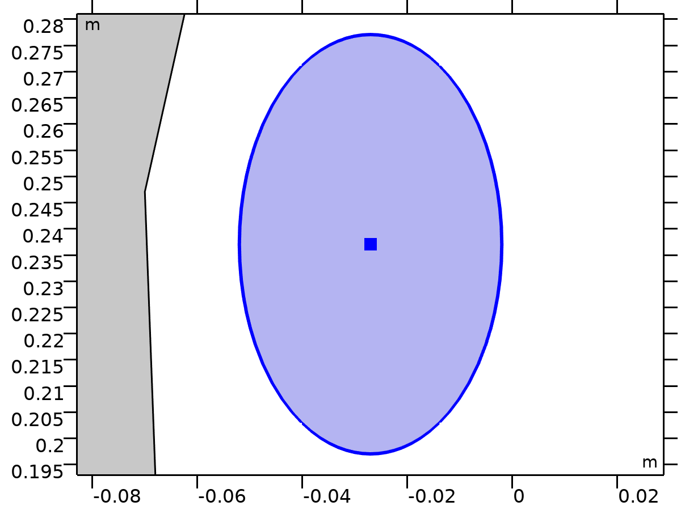

Viscera

Selection

|  |  |
| --- | --- |
| Geometric entity level | Domain |
| Selection | Geometry geom1: Dimension 2: Domain 4 |

Equations





















#### Density

Settings

| **Description** | **Value** | **Unit** |
| --- | --- | --- |
| Density | User defined |  |
| Density | 0 | kg/m³ |

#### Center of Rotation

Settings

| **Description** | **Value** |
| --- | --- |
| Center of rotation | Center of mass |
| Offset | Off |

#### Initial Values

Settings

| **Description** | **Value** |
| --- | --- |
| Initial values | From physics interface node |
| Consistent initialization | Default |

#### Variables

| **Name** | **Expression** | **Unit** | **Description** | **Selection** | **Details** |
| --- | --- | --- | --- | --- | --- |
| u | mbd.rd4.Udx | m | Displacement field, X-component | Domain 4 |  |
| v | mbd.rd4.Udy | m | Displacement field, Y-component | Domain 4 |  |
| w | mbd.rd4.Udz | m | Displacement field, Z-component | Domain 4 |  |
| mbd.Wk_tot | 0.25*(mbd.rd4.m*(realdot(mbd.rd4.u*mbd.iomega,mbd.rd4.u*mbd.iomega)+realdot(mbd.rd4.v*mbd.iomega,mbd.rd4.v*mbd.iomega)+realdot(mbd.rd4.w*mbd.iomega,mbd.rd4.w*mbd.iomega))+realdot(mbd.rd4.Iz*mbd.rd4.thx*mbd.iomega,mbd.rd4.thx*mbd.iomega)+realdot(mbd.rd4.Iz*mbd.rd4.thy*mbd.iomega,mbd.rd4.thy*mbd.iomega)+realdot(mbd.rd4.Iz*mbd.rd4.thz*mbd.iomega,mbd.rd4.thz*mbd.iomega)) | J | Total kinetic energy | Global | + operation |
| mbd.RFtotalx | reacf(mbd.rd4.U) | N | Total reaction force, x-component | Global | + operation |
| mbd.RFtotaly | reacf(mbd.rd4.V) | N | Total reaction force, y-component | Global | + operation |
| mbd.RFtotalz | 0 | N | Total reaction force, z-component | Global | + operation |
| mbd.RMtotalx | -reacf(mbd.rd4.V)*mbd.rd4.RMmaz | N·m | Total reaction moment, x-component | Global | + operation |
| mbd.RMtotaly | reacf(mbd.rd4.U)*mbd.rd4.RMmaz | N·m | Total reaction moment, y-component | Global | + operation |
| mbd.RMtotalz | reacf(mbd.rd4.V)*mbd.rd4.RMmax-reacf(mbd.rd4.U)*mbd.rd4.RMmay+reacf(mbd.rd4.Phi) | N·m | Total reaction moment, z-component | Global | + operation |
| mbd.disp | sqrteps(real(u)^2+real(v)^2) | m | Displacement magnitude | Domain 4 |  |
| mbd.disp_rms | sqrt(0.5*(realdot(u,u)+realdot(v,v))) | m | Displacement, RMS | Domain 4 |  |
| mbd.gradUxX | -1+mbd.FdxX | 1 | Displacement gradient, xX-component | Domain 4 |  |
| mbd.gradUyX | mbd.FdyX | 1 | Displacement gradient, yX-component | Domain 4 |  |
| mbd.gradUzX | mbd.FdzX | 1 | Displacement gradient, zX-component | Domain 4 |  |
| mbd.gradUxY | mbd.FdxY | 1 | Displacement gradient, xY-component | Domain 4 |  |
| mbd.gradUyY | -1+mbd.FdyY | 1 | Displacement gradient, yY-component | Domain 4 |  |
| mbd.gradUzY | mbd.FdzY | 1 | Displacement gradient, zY-component | Domain 4 |  |
| mbd.gradUxZ | mbd.FdxZ | 1 | Displacement gradient, xZ-component | Domain 4 |  |
| mbd.gradUyZ | mbd.FdyZ | 1 | Displacement gradient, yZ-component | Domain 4 |  |
| mbd.gradUzZ | -1+mbd.FdzZ | 1 | Displacement gradient, zZ-component | Domain 4 |  |
| mbd.FdxX | mbd.rd4.rotxx | 1 | Deformation gradient, xX-component | Domain 4 |  |
| mbd.FdyX | mbd.rd4.rotyx | 1 | Deformation gradient, yX-component | Domain 4 |  |
| mbd.FdzX | mbd.rd4.rotzx | 1 | Deformation gradient, zX-component | Domain 4 |  |
| mbd.FdxY | mbd.rd4.rotxy | 1 | Deformation gradient, xY-component | Domain 4 |  |
| mbd.FdyY | mbd.rd4.rotyy | 1 | Deformation gradient, yY-component | Domain 4 |  |
| mbd.FdzY | mbd.rd4.rotzy | 1 | Deformation gradient, zY-component | Domain 4 |  |
| mbd.FdxZ | mbd.rd4.rotxz | 1 | Deformation gradient, xZ-component | Domain 4 |  |
| mbd.FdyZ | mbd.rd4.rotyz | 1 | Deformation gradient, yZ-component | Domain 4 |  |
| mbd.FdzZ | mbd.rd4.rotzz | 1 | Deformation gradient, zZ-component | Domain 4 |  |
| mbd.FdiXx | (mbd.FdyY*mbd.FdzZ-mbd.FdyZ*mbd.FdzY)/mbd.J | 1 | Deformation gradient inverse, Xx-component | Domain 4 |  |
| mbd.FdiYx | (mbd.FdyZ*mbd.FdzX-mbd.FdyX*mbd.FdzZ)/mbd.J | 1 | Deformation gradient inverse, Yx-component | Domain 4 |  |
| mbd.FdiZx | (mbd.FdyX*mbd.FdzY-mbd.FdyY*mbd.FdzX)/mbd.J | 1 | Deformation gradient inverse, Zx-component | Domain 4 |  |
| mbd.FdiXy | (mbd.FdxZ*mbd.FdzY-mbd.FdxY*mbd.FdzZ)/mbd.J | 1 | Deformation gradient inverse, Xy-component | Domain 4 |  |
| mbd.FdiYy | (mbd.FdxX*mbd.FdzZ-mbd.FdxZ*mbd.FdzX)/mbd.J | 1 | Deformation gradient inverse, Yy-component | Domain 4 |  |
| mbd.FdiZy | (mbd.FdxY*mbd.FdzX-mbd.FdxX*mbd.FdzY)/mbd.J | 1 | Deformation gradient inverse, Zy-component | Domain 4 |  |
| mbd.FdiXz | (mbd.FdxY*mbd.FdyZ-mbd.FdxZ*mbd.FdyY)/mbd.J | 1 | Deformation gradient inverse, Xz-component | Domain 4 |  |
| mbd.FdiYz | (mbd.FdxZ*mbd.FdyX-mbd.FdxX*mbd.FdyZ)/mbd.J | 1 | Deformation gradient inverse, Yz-component | Domain 4 |  |
| mbd.FdiZz | (mbd.FdxX*mbd.FdyY-mbd.FdxY*mbd.FdyX)/mbd.J | 1 | Deformation gradient inverse, Zz-component | Domain 4 |  |
| mbd.J | 1 | 1 | Volume ratio | Domain 4 |  |
| mbd.Ws | 0 | J/m³ | Elastic strain energy density | Domain 4 | + operation |
| mbd.Ws_tot | 0 | J | Total elastic strain energy | Global | + operation |
| mbd.Wk | 0.25*mbd.rho*(realdot(u*mbd.iomega,u*mbd.iomega)+realdot(v*mbd.iomega,v*mbd.iomega)) | J/m³ | Kinetic energy density | Domain 4 | + operation |
| mbd.Eequ | Inf | Pa | Equivalent Young's modulus | Domain 4 |  |
| mbd.nuequ | 0 | 1 | Equivalent Poisson's ratio | Domain 4 |  |
| mbd.Eequtot | mbd.Eequ | Pa | Total equivalent Young's modulus | Domain 4 | + operation |
| mbd.rho | 0 | kg/m³ | Density | Domain 4 | * operation |
| mbd.u_ttX | material.dt(material.dt(mbd.rd4.Udx)) | m/s² | Acceleration, X-component | Domain 4 |  |
| mbd.u_ttY | material.dt(material.dt(mbd.rd4.Udy)) | m/s² | Acceleration, Y-component | Domain 4 |  |
| mbd.u_ttZ | material.dt(material.dt(mbd.rd4.Udz)) | m/s² | Acceleration, Z-component | Domain 4 |  |
| mbd.u_tX | material.dt(mbd.rd4.Udx) | m/s | Velocity, X-component | Domain 4 |  |
| mbd.u_tY | material.dt(mbd.rd4.Udy) | m/s | Velocity, Y-component | Domain 4 |  |
| mbd.u_tZ | material.dt(mbd.rd4.Udz) | m/s | Velocity, Z-component | Domain 4 |  |
| mbd.vel_rms | sqrt(0.5*(realdot(mbd.u_tX,mbd.u_tX)+realdot(mbd.u_tY,mbd.u_tY)+realdot(mbd.u_tZ,mbd.u_tZ))) | m/s | Velocity magnitude, RMS | Domain 4 |  |
| mbd.acc_rms | sqrt(0.5*(realdot(mbd.u_ttX,mbd.u_ttX)+realdot(mbd.u_ttY,mbd.u_ttY)+realdot(mbd.u_ttZ,mbd.u_ttZ))) | m/s² | Acceleration magnitude, RMS | Domain 4 |  |
| mbd.afX | 0 | m/s² | Frame acceleration, X-component | Domain 4 | + operation |
| mbd.afY | 0 | m/s² | Frame acceleration, Y-component | Domain 4 | + operation |
| mbd.afZ | 0 | m/s² | Frame acceleration, Z-component | Domain 4 | + operation |
| mbd.accX | mbd.u_ttX | m/s² | Effective acceleration, X-component | Domain 4 | + operation |
| mbd.accY | mbd.u_ttY | m/s² | Effective acceleration, Y-component | Domain 4 | + operation |
| mbd.accZ | mbd.u_ttZ | m/s² | Effective acceleration, Z-component | Domain 4 | + operation |
| mbd.vel | sqrteps(real(mbd.u_tX)^2+real(mbd.u_tY)^2+real(mbd.u_tZ)^2) | m/s | Velocity magnitude | Domain 4 |  |
| mbd.acc | sqrteps(real(mbd.accX)^2+real(mbd.accY)^2+real(mbd.accZ)^2) | m/s² | Effective acceleration magnitude | Domain 4 |  |
| mbd.u_tt | sqrteps(real(mbd.u_ttX)^2+real(mbd.u_ttY)^2+real(mbd.u_ttZ)^2) | m/s² | Acceleration magnitude | Domain 4 |  |
| mbd.phase | if(isdefined(phase),phase,0) | 1 | Phase | Global |  |
| mbd.rd4.xcx | mbd.rd4.xmx | m | Center of rotation, x-component | Global | + operation |
| mbd.rd4.xcy | mbd.rd4.xmy | m | Center of rotation, y-component | Global | + operation |
| mbd.rd4.xcz | mbd.rd4.xmz | m | Center of rotation, z-component | Global | + operation |
| mbd.rd4.phi | mbd.rd4.Phi | rad | Rigid body rotation | Global |  |
| mbd.rd4.rotxx | 1 | 1 | Rotation matrix, xx-component | Global |  |
| mbd.rd4.rotyx | mbd.rd4.phi*exp(-(j*mbd.phase)) | 1 | Rotation matrix, yx-component | Global |  |
| mbd.rd4.rotzx | 0 | 1 | Rotation matrix, zx-component | Global |  |
| mbd.rd4.rotxy | -mbd.rd4.phi*exp(-(j*mbd.phase)) | 1 | Rotation matrix, xy-component | Global |  |
| mbd.rd4.rotyy | 1 | 1 | Rotation matrix, yy-component | Global |  |
| mbd.rd4.rotzy | 0 | 1 | Rotation matrix, zy-component | Global |  |
| mbd.rd4.rotxz | 0 | 1 | Rotation matrix, xz-component | Global |  |
| mbd.rd4.rotyz | 0 | 1 | Rotation matrix, yz-component | Global |  |
| mbd.rd4.rotzz | 1 | 1 | Rotation matrix, zz-component | Global |  |
| mbd.rd4.RMmax | mbd.rd4.xcx-mbd.refpntx | m | Moment arm, x-component | Global |  |
| mbd.rd4.RMmay | mbd.rd4.xcy-mbd.refpnty | m | Moment arm, y-component | Global |  |
| mbd.rd4.RMmaz | 0 | m | Moment arm, z-component | Global |  |
| mbd.rd4.u | mbd.rd4.U | m | Rigid body displacement, x-component | Global |  |
| mbd.rd4.v | mbd.rd4.V | m | Rigid body displacement, y-component | Global |  |
| mbd.rd4.w | 0 | m | Rigid body displacement, z-component | Global |  |
| mbd.rd4.xmx | mbd.rd4.int((mbd.rho+eps)*mbd.d*X)/mbd.rd4.int((mbd.rho+eps)*mbd.d) | m | Center of mass, x-component | Global |  |
| mbd.rd4.xmy | mbd.rd4.int((mbd.rho+eps)*mbd.d*Y)/mbd.rd4.int((mbd.rho+eps)*mbd.d) | m | Center of mass, y-component | Global |  |
| mbd.rd4.xmz | 0 | m | Center of mass, z-component | Global |  |
| mbd.rd4.Iz | mbd.rd4.int(((X-mbd.rd4.xmx)^2+(Y-mbd.rd4.xmy)^2+mbd.rd4.xmz^2)*mbd.rho*mbd.d) | kg·m² | Moment of inertia | Global |  |
| mbd.rd4.um | mbd.rd4.u | m | Rigid body displacement, x-component | Global |  |
| mbd.rd4.vm | mbd.rd4.v | m | Rigid body displacement, y-component | Global |  |
| mbd.rd4.wm | 0 | m | Rigid body displacement, z-component | Global |  |
| mbd.rd4.m | mbd.rd4.int(mbd.rho*mbd.d) | kg | Mass | Global |  |
| mbd.rd4.Udx | (mbd.rd4.rotxx*(X-mbd.rd4.xcx)+mbd.rd4.rotxy*(Y-mbd.rd4.xcy)-mbd.rd4.rotxz*mbd.rd4.xcz-X+mbd.rd4.xcx)*exp(j*mbd.phase)+mbd.rd4.u | m | Domain displacement, x-component | Domain 4 | + operation |
| mbd.rd4.Udy | (mbd.rd4.rotyx*(X-mbd.rd4.xcx)+mbd.rd4.rotyy*(Y-mbd.rd4.xcy)-mbd.rd4.rotyz*mbd.rd4.xcz-Y+mbd.rd4.xcy)*exp(j*mbd.phase)+mbd.rd4.v | m | Domain displacement, y-component | Domain 4 | + operation |
| mbd.rd4.Udz | (mbd.rd4.rotzx*(X-mbd.rd4.xcx)+mbd.rd4.rotzy*(Y-mbd.rd4.xcy)-mbd.rd4.rotzz*mbd.rd4.xcz+mbd.rd4.xcz)*exp(j*mbd.phase)+mbd.rd4.w | m | Domain displacement, z-component | Domain 4 | + operation |
| mbd.rd4.thx | 0 | rad | Rigid body rotation, x-component | Global |  |
| mbd.rd4.thy | 0 | rad | Rigid body rotation, y-component | Global |  |
| mbd.rd4.thz | mbd.rd4.phi | rad | Rigid body rotation, z-component | Global |  |
| mbd.rd4.u_tx | mbd.iomega*mbd.rd4.u | m/s | Rigid body velocity, x-component | Global |  |
| mbd.rd4.u_ty | mbd.iomega*mbd.rd4.v | m/s | Rigid body velocity, y-component | Global |  |
| mbd.rd4.u_tz | mbd.iomega*mbd.rd4.w | m/s | Rigid body velocity, z-component | Global |  |
| mbd.rd4.u_ttx | mbd.iomega*mbd.rd4.u_tx | m/s² | Rigid body acceleration, x-component | Global |  |
| mbd.rd4.u_tty | mbd.iomega*mbd.rd4.u_ty | m/s² | Rigid body acceleration, y-component | Global |  |
| mbd.rd4.u_ttz | mbd.iomega*mbd.rd4.u_tz | m/s² | Rigid body acceleration, z-component | Global |  |
| mbd.rd4.um_ttx | mbd.iomega^2*mbd.rd4.um | m/s² | Rigid body acceleration, x-component | Global |  |
| mbd.rd4.um_tty | mbd.iomega^2*mbd.rd4.vm | m/s² | Rigid body acceleration, y-component | Global |  |
| mbd.rd4.um_ttz | mbd.iomega^2*mbd.rd4.wm | m/s² | Rigid body acceleration, z-component | Global |  |
| mbd.rd4.th_tx | mbd.iomega*mbd.rd4.thx | rad/s | Rigid body angular velocity, x-component | Global |  |
| mbd.rd4.th_ty | mbd.iomega*mbd.rd4.thy | rad/s | Rigid body angular velocity, y-component | Global |  |
| mbd.rd4.th_tz | mbd.iomega*mbd.rd4.thz | rad/s | Rigid body angular velocity, z-component | Global |  |
| mbd.rd4.th_ttx | mbd.iomega*mbd.rd4.th_tx | rad/s² | Rigid body angular acceleration, x-component | Global |  |
| mbd.rd4.th_tty | mbd.iomega*mbd.rd4.th_ty | rad/s² | Rigid body angular acceleration, y-component | Global |  |
| mbd.rd4.th_ttz | mbd.iomega*mbd.rd4.th_tz | rad/s² | Rigid body angular acceleration, z-component | Global |  |
| mbd.rd4.FIx | -mbd.rd4.m*mbd.rd4.um_ttx | N | Inertial force, x-component | Global |  |
| mbd.rd4.FIy | -mbd.rd4.m*mbd.rd4.um_tty | N | Inertial force, y-component | Global |  |
| mbd.rd4.FIz | 0 | N | Inertial force, z-component | Global |  |
| mbd.rd4.MIz | -mbd.rd4.Iz*mbd.iomega^2*mbd.rd4.phi | N·m | Inertial moment | Global |  |
| mbd.rd4.i_rot | 1 | 1 | Free rotation indicator | Global | * operation |

#### Shape functions

| **Name** | **Shape function** | **Unit** | **Description** | **Shape frame** | **Selection** |
| --- | --- | --- | --- | --- | --- |
| mbd.rd4.U | ODE | m | Rigid body displacement, x-component |  | Global |
| mbd.rd4.V | ODE | m | Rigid body displacement, y-component |  | Global |
| mbd.rd4.Phi | ODE | rad | Rigid body rotation |  | Global |

#### Weak Expressions

| **Weak expression** | **Integration order** | **Integration frame** | **Selection** |
| --- | --- | --- | --- |
| mbd.rd4.FIx*test(mbd.rd4.um)+mbd.rd4.FIy*test(mbd.rd4.vm)+mbd.rd4.FIz*test(mbd.rd4.wm) | 2 |  | Global |
| mbd.rd4.MIz*test(mbd.rd4.phi) | 2 |  | Global |

#### Constraints

| **Constraint** | **Constraint force** | **Shape function** | **Selection** | **Details** |
| --- | --- | --- | --- | --- |
| up(u)-down(u) | test(up(u)-down(u)) | Lagrange (Linear) | No boundaries | Elemental |
| up(v)-down(v) | test(up(v)-down(v)) | Lagrange (Linear) | No boundaries | Elemental |
| 0 | 0 |  | No boundaries | Elemental |

#### Mass and Moment of Inertia 4

Selection

|  |  |
| --- | --- |
| Geometric entity level | Entire model |

Equations









##### Center of Mass

Settings

| **Description** | **Value** |
| --- | --- |
| Center of mass | Centroid of selected entities |
| Entity level | Point |
| Offset | Off |

##### Mass and Moment of Inertia

Settings

| **Description** | **Value** | **Unit** |
| --- | --- | --- |
| Mass | m_viscera | kg |
| Moment of inertia | 0 | kg·m² |

##### Frame Acceleration Forces

Settings

| **Description** | **Value** |
| --- | --- |
| Exclude contribution | Off |

##### Variables

| **Name** | **Expression** | **Unit** | **Description** | **Selection** | **Details** |
| --- | --- | --- | --- | --- | --- |
| mbd.Wk_tot | 0.25*(mbd.rd4.mmi1.mt*(realdot((mbd.rd4.u+mbd.rd4.mmi1.dMrotx-mbd.rd4.mmi1.dMx)*mbd.iomega,(mbd.rd4.u+mbd.rd4.mmi1.dMrotx-mbd.rd4.mmi1.dMx)*mbd.iomega)+realdot((mbd.rd4.v+mbd.rd4.mmi1.dMroty-mbd.rd4.mmi1.dMy)*mbd.iomega,(mbd.rd4.v+mbd.rd4.mmi1.dMroty-mbd.rd4.mmi1.dMy)*mbd.iomega)+realdot((mbd.rd4.w+mbd.rd4.mmi1.dMrotz-mbd.rd4.mmi1.dMz)*mbd.iomega,(mbd.rd4.w+mbd.rd4.mmi1.dMrotz-mbd.rd4.mmi1.dMz)*mbd.iomega))+mbd.rd4.mmi1.Iz*realdot(mbd.rd4.phi*mbd.iomega,mbd.rd4.phi*mbd.iomega)) | J | Total kinetic energy | Global | + operation |
| mbd.rd4.mmi1.mt | m_viscera | kg | Mass | Global |  |
| mbd.rd4.mmi1.Iz | 0 | kg·m² | Moment of inertia | Global |  |
| mbd.rd4.mmi1.xmsx | mbd.rd4.xcx+mbd.rd4.u+mbd.rd4.rotxx*(mbd.rd4.mmi1.xmx-mbd.rd4.xcx)+mbd.rd4.rotxy*(mbd.rd4.mmi1.xmy-mbd.rd4.xcy)+mbd.rd4.rotxz*(mbd.rd4.mmi1.xmz-mbd.rd4.xcz) | m | Global coordinates of center of mass, x-component | Global |  |
| mbd.rd4.mmi1.xmsy | mbd.rd4.xcy+mbd.rd4.v+mbd.rd4.rotyx*(mbd.rd4.mmi1.xmx-mbd.rd4.xcx)+mbd.rd4.rotyy*(mbd.rd4.mmi1.xmy-mbd.rd4.xcy)+mbd.rd4.rotyz*(mbd.rd4.mmi1.xmz-mbd.rd4.xcz) | m | Global coordinates of center of mass, y-component | Global |  |
| mbd.rd4.mmi1.xmsz | mbd.rd4.xcz+mbd.rd4.w+mbd.rd4.rotzx*(mbd.rd4.mmi1.xmx-mbd.rd4.xcx)+mbd.rd4.rotzy*(mbd.rd4.mmi1.xmy-mbd.rd4.xcy)+mbd.rd4.rotzz*(mbd.rd4.mmi1.xmz-mbd.rd4.xcz) | m | Global coordinates of center of mass, z-component | Global |  |
| mbd.rd4.mmi1.umx | mbd.rd4.u+mbd.rd4.rotxx*(mbd.rd4.mmi1.xmx-mbd.rd4.xcx)+mbd.rd4.rotxy*(mbd.rd4.mmi1.xmy-mbd.rd4.xcy)+mbd.rd4.rotxz*(mbd.rd4.mmi1.xmz-mbd.rd4.xcz)-mbd.rd4.mmi1.xmx+mbd.rd4.xcx | m | Displacement at center of mass, x-component | Global |  |
| mbd.rd4.mmi1.umy | mbd.rd4.v+mbd.rd4.rotyx*(mbd.rd4.mmi1.xmx-mbd.rd4.xcx)+mbd.rd4.rotyy*(mbd.rd4.mmi1.xmy-mbd.rd4.xcy)+mbd.rd4.rotyz*(mbd.rd4.mmi1.xmz-mbd.rd4.xcz)-mbd.rd4.mmi1.xmy+mbd.rd4.xcy | m | Displacement at center of mass, y-component | Global |  |
| mbd.rd4.mmi1.umz | mbd.rd4.w+mbd.rd4.rotzx*(mbd.rd4.mmi1.xmx-mbd.rd4.xcx)+mbd.rd4.rotzy*(mbd.rd4.mmi1.xmy-mbd.rd4.xcy)+mbd.rd4.rotzz*(mbd.rd4.mmi1.xmz-mbd.rd4.xcz)-mbd.rd4.mmi1.xmz+mbd.rd4.xcz | m | Displacement at center of mass, z-component | Global |  |
| mbd.rd4.mmi1.FIx | -mbd.rd4.mmi1.mt*mbd.iomega^2*(mbd.rd4.u+mbd.rd4.mmi1.dMrotx-mbd.rd4.mmi1.dMx) | N | Inertial force, x-component | Global |  |
| mbd.rd4.mmi1.FIy | -mbd.rd4.mmi1.mt*mbd.iomega^2*(mbd.rd4.v+mbd.rd4.mmi1.dMroty-mbd.rd4.mmi1.dMy) | N | Inertial force, y-component | Global |  |
| mbd.rd4.mmi1.FIz | -mbd.rd4.mmi1.mt*mbd.iomega^2*(mbd.rd4.w+mbd.rd4.mmi1.dMrotz-mbd.rd4.mmi1.dMz) | N | Inertial force, z-component | Global |  |
| mbd.rd4.mmi1.MIz | -mbd.rd4.mmi1.Iz*mbd.iomega^2*mbd.rd4.phi | N·m | Inertial moment | Global |  |
| mbd.rd4.mmi1.dMx | mbd.rd4.mmi1.xmx-mbd.rd4.xcx | m | Mass offset from CoR, Original, x-component | Global |  |
| mbd.rd4.mmi1.dMy | mbd.rd4.mmi1.xmy-mbd.rd4.xcy | m | Mass offset from CoR, Original, y-component | Global |  |
| mbd.rd4.mmi1.dMz | mbd.rd4.mmi1.xmz-mbd.rd4.xcz | m | Mass offset from CoR, Original, z-component | Global |  |
| mbd.rd4.mmi1.dMrotx | mbd.rd4.rotxx*mbd.rd4.mmi1.dMx+mbd.rd4.rotxy*mbd.rd4.mmi1.dMy+mbd.rd4.rotxz*mbd.rd4.mmi1.dMz | m | Mass offset from CoR, Rotated, x-component | Global |  |
| mbd.rd4.mmi1.dMroty | mbd.rd4.rotyx*mbd.rd4.mmi1.dMx+mbd.rd4.rotyy*mbd.rd4.mmi1.dMy+mbd.rd4.rotyz*mbd.rd4.mmi1.dMz | m | Mass offset from CoR, Rotated, y-component | Global |  |
| mbd.rd4.mmi1.dMrotz | mbd.rd4.rotzx*mbd.rd4.mmi1.dMx+mbd.rd4.rotzy*mbd.rd4.mmi1.dMy+mbd.rd4.rotzz*mbd.rd4.mmi1.dMz | m | Mass offset from CoR, Rotated, z-component | Global |  |
| mbd.rd4.mmi1.Fx | mbd.rd4.mmi1.FIx | N | Applied force, x-component | Global |  |
| mbd.rd4.mmi1.Fy | mbd.rd4.mmi1.FIy | N | Applied force, y-component | Global |  |
| mbd.rd4.mmi1.Fz | mbd.rd4.mmi1.FIz | N | Applied force, z-component | Global |  |
| mbd.rd4.mmi1.F_Mag | sqrt(real(mbd.rd4.mmi1.Fx)^2+real(mbd.rd4.mmi1.Fy)^2+real(mbd.rd4.mmi1.Fz)^2) | N | Load magnitude | Global |  |
| mbd.rd4.mmi1.Mx | 0 | N·m | Applied moment, x-component | Global |  |
| mbd.rd4.mmi1.My | 0 | N·m | Applied moment, y-component | Global |  |
| mbd.rd4.mmi1.Mz | mbd.rd4.mmi1.MIz | N·m | Applied moment, z-component | Global |  |
| mbd.rd4.mmi1.M_Mag | sqrt(real(mbd.rd4.mmi1.Mx)^2+real(mbd.rd4.mmi1.My)^2+real(mbd.rd4.mmi1.Mz)^2) | N·m | Moment magnitude | Global |  |
| mbd.rd4.mmi1.loadposx | mbd.rd4.mmi1.xmx | m | Load position, x-component | Global |  |
| mbd.rd4.mmi1.loadposy | mbd.rd4.mmi1.xmy | m | Load position, y-component | Global |  |
| mbd.rd4.mmi1.loadposz | mbd.rd4.mmi1.xmz | m | Load position, z-component | Global |  |
| mbd.rd4.mmi1.momposx | mbd.rd4.mmi1.xmx | m | Moment position, x-component | Global |  |
| mbd.rd4.mmi1.momposy | mbd.rd4.mmi1.xmy | m | Moment position, y-component | Global |  |
| mbd.rd4.mmi1.momposz | mbd.rd4.mmi1.xmz | m | Moment position, z-component | Global |  |

##### Weak Expressions

| **Weak expression** | **Integration order** | **Integration frame** | **Selection** |
| --- | --- | --- | --- |
| mbd.rd4.mmi1.FIx*test(mbd.rd4.u+mbd.rd4.mmi1.dMrotx)+mbd.rd4.mmi1.FIy*test(mbd.rd4.v+mbd.rd4.mmi1.dMroty)+mbd.rd4.mmi1.FIz*test(mbd.rd4.w+mbd.rd4.mmi1.dMrotz) | 2 |  | Global |
| mbd.rd4.mmi1.MIz*test(mbd.rd4.phi) | 2 |  | Global |

##### Center of Mass: Point 4

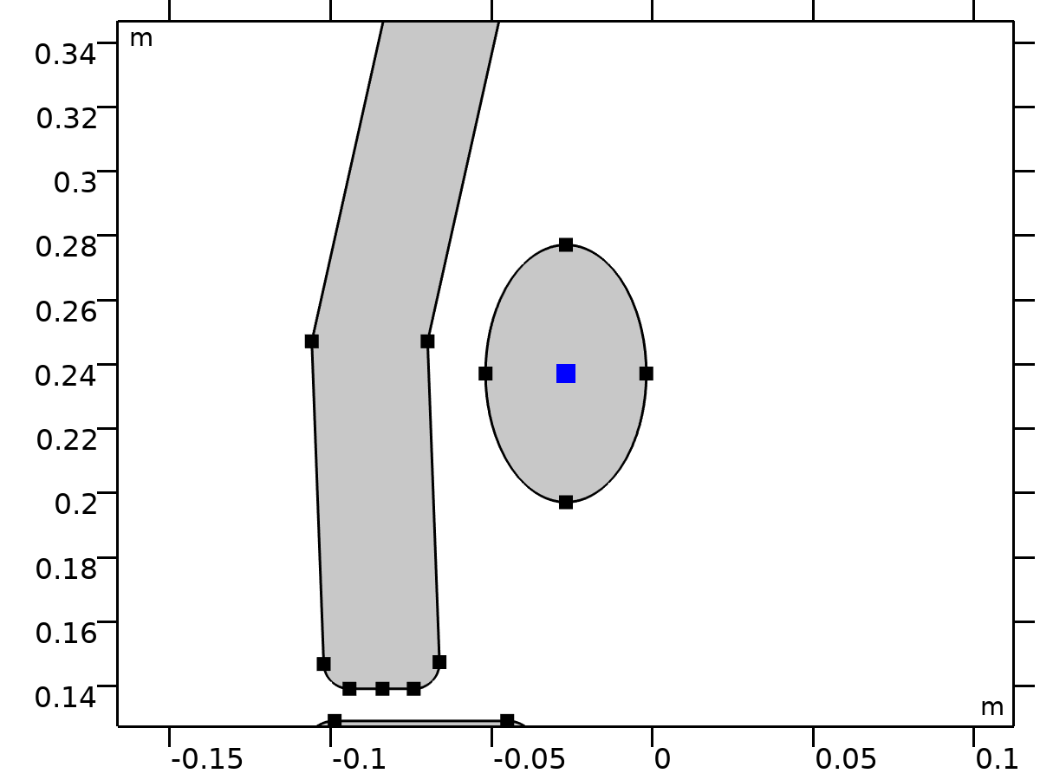

Center of Mass: Point 4

Selection

|  |  |
| --- | --- |
| Geometric entity level | Point |
| Selection | Geometry geom1: Dimension 0: Point 55 |

###### Variables

| **Name** | **Expression** | **Unit** | **Description** | **Selection** | **Details** |
| --- | --- | --- | --- | --- | --- |
| mbd.rd4.mmi1.xmx | mbd.rd4.mmi1.cmp1.int(X)/mbd.rd4.mmi1.cmp1.int(1) | m | Global coordinates of center of mass, x-component | Global | + operation |
| mbd.rd4.mmi1.xmy | mbd.rd4.mmi1.cmp1.int(Y)/mbd.rd4.mmi1.cmp1.int(1) | m | Global coordinates of center of mass, y-component | Global | + operation |
| mbd.rd4.mmi1.xmz | mbd.rd4.mmi1.cmp1.int(0)/mbd.rd4.mmi1.cmp1.int(1) | m | Global coordinates of center of mass, z-component | Global | + operation |

#### Prescribed Displacement/Rotation 1

Selection

|  |  |
| --- | --- |
| Geometric entity level | Entire model |

Equations



##### Center of Rotation

Settings

| **Description** | **Value** |
| --- | --- |
| Center of rotation | From parent |
| Offset | Off |

##### Prescribed Displacement at Center of Rotation

Settings

| **Description** | **Value** |
| --- | --- |
| Prescribed in x direction | Off |
| Prescribed in y direction | Off |
| Prescribed in z direction | Off |

##### Prescribed Rotation

Settings

| **Description** | **Value** |
| --- | --- |
| By | Constrained rotation |

##### Reaction Force Settings

Settings

| **Description** | **Value** |
| --- | --- |
| Evaluate reaction forces | Off |
| Apply reaction only on rigid body variables | Off |

##### Coordinate System Selection

Settings

| **Description** | **Value** |
| --- | --- |
| Coordinate system | Global coordinate system |

##### Variables

| **Name** | **Expression** | **Unit** | **Description** | **Selection** | **Details** |
| --- | --- | --- | --- | --- | --- |
| mbd.rd4.pdr1.xcx | mbd.rd4.xcx | m | Global coordinates of center of rotation, x-component | Global | + operation |
| mbd.rd4.pdr1.xcy | mbd.rd4.xcy | m | Global coordinates of center of rotation, y-component | Global | + operation |
| mbd.rd4.pdr1.xcz | mbd.rd4.xcz | m | Global coordinates of center of rotation, z-component | Global | + operation |
| mbd.rd4.pdr1.u | mbd.rd4.rotxx*(mbd.rd4.pdr1.xcx-mbd.rd4.xcx)+mbd.rd4.rotxy*(mbd.rd4.pdr1.xcy-mbd.rd4.xcy)+mbd.rd4.rotxz*(mbd.rd4.pdr1.xcz-mbd.rd4.xcz)-mbd.rd4.pdr1.xcx+mbd.rd4.xcx+mbd.rd4.u | m | Rigid body displacement, x-component | Global |  |
| mbd.rd4.pdr1.v | mbd.rd4.rotyx*(mbd.rd4.pdr1.xcx-mbd.rd4.xcx)+mbd.rd4.rotyy*(mbd.rd4.pdr1.xcy-mbd.rd4.xcy)+mbd.rd4.rotyz*(mbd.rd4.pdr1.xcz-mbd.rd4.xcz)-mbd.rd4.pdr1.xcy+mbd.rd4.xcy+mbd.rd4.v | m | Rigid body displacement, y-component | Global |  |
| mbd.rd4.pdr1.w | mbd.rd4.rotzx*(mbd.rd4.pdr1.xcx-mbd.rd4.xcx)+mbd.rd4.rotzy*(mbd.rd4.pdr1.xcy-mbd.rd4.xcy)+mbd.rd4.rotzz*(mbd.rd4.pdr1.xcz-mbd.rd4.xcz)-mbd.rd4.pdr1.xcz+mbd.rd4.xcz+mbd.rd4.w | m | Rigid body displacement, z-component | Global |  |
| mbd.rd4.pdr1.ul | mbd.rd4.pdr1.u | m | Rigid body displacement, x-component | Global |  |
| mbd.rd4.pdr1.vl | mbd.rd4.pdr1.v | m | Rigid body displacement, y-component | Global |  |
| mbd.rd4.pdr1.wl | mbd.rd4.pdr1.w | m | Rigid body displacement, z-component | Global |  |

##### Constraints

| **Constraint** | **Constraint force** | **Shape function** | **Selection** | **Details** |
| --- | --- | --- | --- | --- |
| -mbd.rd4.phi | test(-mbd.rd4.phi) |  | Global | Elemental |

### Thigh

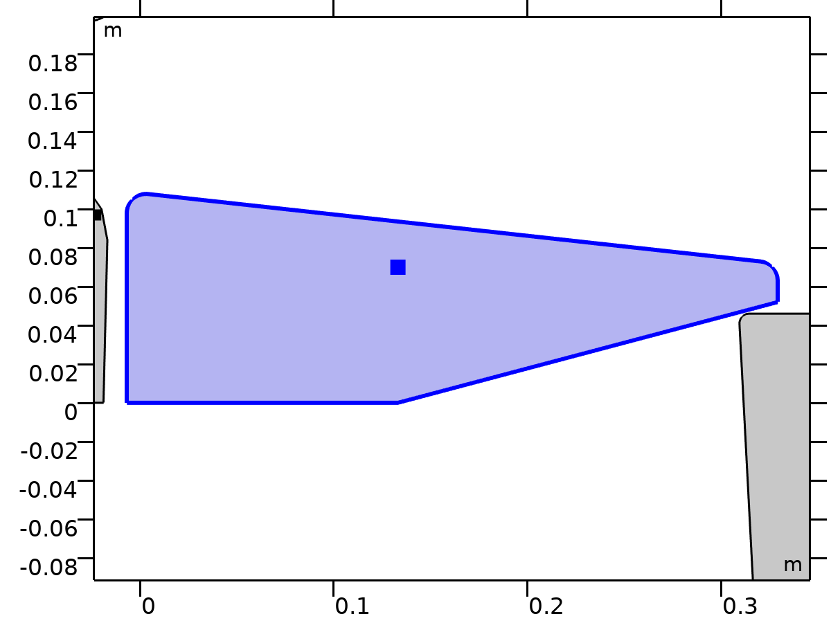

Thigh

Selection

|  |  |
| --- | --- |
| Geometric entity level | Domain |
| Selection | Geometry geom1: Dimension 2: Domain 5 |

Equations





















#### Density

Settings

| **Description** | **Value** | **Unit** |
| --- | --- | --- |
| Density | User defined |  |
| Density | 0 | kg/m³ |

#### Center of Rotation

Settings

| **Description** | **Value** |
| --- | --- |
| Center of rotation | Center of mass |
| Offset | Off |

#### Initial Values

Settings

| **Description** | **Value** |
| --- | --- |
| Initial values | From physics interface node |
| Consistent initialization | Default |

#### Variables

| **Name** | **Expression** | **Unit** | **Description** | **Selection** | **Details** |
| --- | --- | --- | --- | --- | --- |
| u | mbd.rd5.Udx | m | Displacement field, X-component | Domain 5 |  |
| v | mbd.rd5.Udy | m | Displacement field, Y-component | Domain 5 |  |
| w | mbd.rd5.Udz | m | Displacement field, Z-component | Domain 5 |  |
| mbd.Wk_tot | 0.25*(mbd.rd5.m*(realdot(mbd.rd5.u*mbd.iomega,mbd.rd5.u*mbd.iomega)+realdot(mbd.rd5.v*mbd.iomega,mbd.rd5.v*mbd.iomega)+realdot(mbd.rd5.w*mbd.iomega,mbd.rd5.w*mbd.iomega))+realdot(mbd.rd5.Iz*mbd.rd5.thx*mbd.iomega,mbd.rd5.thx*mbd.iomega)+realdot(mbd.rd5.Iz*mbd.rd5.thy*mbd.iomega,mbd.rd5.thy*mbd.iomega)+realdot(mbd.rd5.Iz*mbd.rd5.thz*mbd.iomega,mbd.rd5.thz*mbd.iomega)) | J | Total kinetic energy | Global | + operation |
| mbd.RFtotalx | reacf(mbd.rd5.U) | N | Total reaction force, x-component | Global | + operation |
| mbd.RFtotaly | reacf(mbd.rd5.V) | N | Total reaction force, y-component | Global | + operation |
| mbd.RFtotalz | 0 | N | Total reaction force, z-component | Global | + operation |
| mbd.RMtotalx | -reacf(mbd.rd5.V)*mbd.rd5.RMmaz | N·m | Total reaction moment, x-component | Global | + operation |
| mbd.RMtotaly | reacf(mbd.rd5.U)*mbd.rd5.RMmaz | N·m | Total reaction moment, y-component | Global | + operation |
| mbd.RMtotalz | reacf(mbd.rd5.V)*mbd.rd5.RMmax-reacf(mbd.rd5.U)*mbd.rd5.RMmay+reacf(mbd.rd5.Phi) | N·m | Total reaction moment, z-component | Global | + operation |
| mbd.disp | sqrteps(real(u)^2+real(v)^2) | m | Displacement magnitude | Domain 5 |  |
| mbd.disp_rms | sqrt(0.5*(realdot(u,u)+realdot(v,v))) | m | Displacement, RMS | Domain 5 |  |
| mbd.gradUxX | -1+mbd.FdxX | 1 | Displacement gradient, xX-component | Domain 5 |  |
| mbd.gradUyX | mbd.FdyX | 1 | Displacement gradient, yX-component | Domain 5 |  |
| mbd.gradUzX | mbd.FdzX | 1 | Displacement gradient, zX-component | Domain 5 |  |
| mbd.gradUxY | mbd.FdxY | 1 | Displacement gradient, xY-component | Domain 5 |  |
| mbd.gradUyY | -1+mbd.FdyY | 1 | Displacement gradient, yY-component | Domain 5 |  |
| mbd.gradUzY | mbd.FdzY | 1 | Displacement gradient, zY-component | Domain 5 |  |
| mbd.gradUxZ | mbd.FdxZ | 1 | Displacement gradient, xZ-component | Domain 5 |  |
| mbd.gradUyZ | mbd.FdyZ | 1 | Displacement gradient, yZ-component | Domain 5 |  |
| mbd.gradUzZ | -1+mbd.FdzZ | 1 | Displacement gradient, zZ-component | Domain 5 |  |
| mbd.FdxX | mbd.rd5.rotxx | 1 | Deformation gradient, xX-component | Domain 5 |  |
| mbd.FdyX | mbd.rd5.rotyx | 1 | Deformation gradient, yX-component | Domain 5 |  |
| mbd.FdzX | mbd.rd5.rotzx | 1 | Deformation gradient, zX-component | Domain 5 |  |
| mbd.FdxY | mbd.rd5.rotxy | 1 | Deformation gradient, xY-component | Domain 5 |  |
| mbd.FdyY | mbd.rd5.rotyy | 1 | Deformation gradient, yY-component | Domain 5 |  |
| mbd.FdzY | mbd.rd5.rotzy | 1 | Deformation gradient, zY-component | Domain 5 |  |
| mbd.FdxZ | mbd.rd5.rotxz | 1 | Deformation gradient, xZ-component | Domain 5 |  |
| mbd.FdyZ | mbd.rd5.rotyz | 1 | Deformation gradient, yZ-component | Domain 5 |  |
| mbd.FdzZ | mbd.rd5.rotzz | 1 | Deformation gradient, zZ-component | Domain 5 |  |
| mbd.FdiXx | (mbd.FdyY*mbd.FdzZ-mbd.FdyZ*mbd.FdzY)/mbd.J | 1 | Deformation gradient inverse, Xx-component | Domain 5 |  |
| mbd.FdiYx | (mbd.FdyZ*mbd.FdzX-mbd.FdyX*mbd.FdzZ)/mbd.J | 1 | Deformation gradient inverse, Yx-component | Domain 5 |  |
| mbd.FdiZx | (mbd.FdyX*mbd.FdzY-mbd.FdyY*mbd.FdzX)/mbd.J | 1 | Deformation gradient inverse, Zx-component | Domain 5 |  |
| mbd.FdiXy | (mbd.FdxZ*mbd.FdzY-mbd.FdxY*mbd.FdzZ)/mbd.J | 1 | Deformation gradient inverse, Xy-component | Domain 5 |  |
| mbd.FdiYy | (mbd.FdxX*mbd.FdzZ-mbd.FdxZ*mbd.FdzX)/mbd.J | 1 | Deformation gradient inverse, Yy-component | Domain 5 |  |
| mbd.FdiZy | (mbd.FdxY*mbd.FdzX-mbd.FdxX*mbd.FdzY)/mbd.J | 1 | Deformation gradient inverse, Zy-component | Domain 5 |  |
| mbd.FdiXz | (mbd.FdxY*mbd.FdyZ-mbd.FdxZ*mbd.FdyY)/mbd.J | 1 | Deformation gradient inverse, Xz-component | Domain 5 |  |
| mbd.FdiYz | (mbd.FdxZ*mbd.FdyX-mbd.FdxX*mbd.FdyZ)/mbd.J | 1 | Deformation gradient inverse, Yz-component | Domain 5 |  |
| mbd.FdiZz | (mbd.FdxX*mbd.FdyY-mbd.FdxY*mbd.FdyX)/mbd.J | 1 | Deformation gradient inverse, Zz-component | Domain 5 |  |
| mbd.J | 1 | 1 | Volume ratio | Domain 5 |  |
| mbd.Ws | 0 | J/m³ | Elastic strain energy density | Domain 5 | + operation |
| mbd.Ws_tot | 0 | J | Total elastic strain energy | Global | + operation |
| mbd.Wk | 0.25*mbd.rho*(realdot(u*mbd.iomega,u*mbd.iomega)+realdot(v*mbd.iomega,v*mbd.iomega)) | J/m³ | Kinetic energy density | Domain 5 | + operation |
| mbd.Eequ | Inf | Pa | Equivalent Young's modulus | Domain 5 |  |
| mbd.nuequ | 0 | 1 | Equivalent Poisson's ratio | Domain 5 |  |
| mbd.Eequtot | mbd.Eequ | Pa | Total equivalent Young's modulus | Domain 5 | + operation |
| mbd.rho | 0 | kg/m³ | Density | Domain 5 | * operation |
| mbd.u_ttX | material.dt(material.dt(mbd.rd5.Udx)) | m/s² | Acceleration, X-component | Domain 5 |  |
| mbd.u_ttY | material.dt(material.dt(mbd.rd5.Udy)) | m/s² | Acceleration, Y-component | Domain 5 |  |
| mbd.u_ttZ | material.dt(material.dt(mbd.rd5.Udz)) | m/s² | Acceleration, Z-component | Domain 5 |  |
| mbd.u_tX | material.dt(mbd.rd5.Udx) | m/s | Velocity, X-component | Domain 5 |  |
| mbd.u_tY | material.dt(mbd.rd5.Udy) | m/s | Velocity, Y-component | Domain 5 |  |
| mbd.u_tZ | material.dt(mbd.rd5.Udz) | m/s | Velocity, Z-component | Domain 5 |  |
| mbd.vel_rms | sqrt(0.5*(realdot(mbd.u_tX,mbd.u_tX)+realdot(mbd.u_tY,mbd.u_tY)+realdot(mbd.u_tZ,mbd.u_tZ))) | m/s | Velocity magnitude, RMS | Domain 5 |  |
| mbd.acc_rms | sqrt(0.5*(realdot(mbd.u_ttX,mbd.u_ttX)+realdot(mbd.u_ttY,mbd.u_ttY)+realdot(mbd.u_ttZ,mbd.u_ttZ))) | m/s² | Acceleration magnitude, RMS | Domain 5 |  |
| mbd.afX | 0 | m/s² | Frame acceleration, X-component | Domain 5 | + operation |
| mbd.afY | 0 | m/s² | Frame acceleration, Y-component | Domain 5 | + operation |
| mbd.afZ | 0 | m/s² | Frame acceleration, Z-component | Domain 5 | + operation |
| mbd.accX | mbd.u_ttX | m/s² | Effective acceleration, X-component | Domain 5 | + operation |
| mbd.accY | mbd.u_ttY | m/s² | Effective acceleration, Y-component | Domain 5 | + operation |
| mbd.accZ | mbd.u_ttZ | m/s² | Effective acceleration, Z-component | Domain 5 | + operation |
| mbd.vel | sqrteps(real(mbd.u_tX)^2+real(mbd.u_tY)^2+real(mbd.u_tZ)^2) | m/s | Velocity magnitude | Domain 5 |  |
| mbd.acc | sqrteps(real(mbd.accX)^2+real(mbd.accY)^2+real(mbd.accZ)^2) | m/s² | Effective acceleration magnitude | Domain 5 |  |
| mbd.u_tt | sqrteps(real(mbd.u_ttX)^2+real(mbd.u_ttY)^2+real(mbd.u_ttZ)^2) | m/s² | Acceleration magnitude | Domain 5 |  |
| mbd.phase | if(isdefined(phase),phase,0) | 1 | Phase | Global |  |
| mbd.rd5.xcx | mbd.rd5.xmx | m | Center of rotation, x-component | Global | + operation |
| mbd.rd5.xcy | mbd.rd5.xmy | m | Center of rotation, y-component | Global | + operation |
| mbd.rd5.xcz | mbd.rd5.xmz | m | Center of rotation, z-component | Global | + operation |
| mbd.rd5.phi | mbd.rd5.Phi | rad | Rigid body rotation | Global |  |
| mbd.rd5.rotxx | 1 | 1 | Rotation matrix, xx-component | Global |  |
| mbd.rd5.rotyx | mbd.rd5.phi*exp(-(j*mbd.phase)) | 1 | Rotation matrix, yx-component | Global |  |
| mbd.rd5.rotzx | 0 | 1 | Rotation matrix, zx-component | Global |  |
| mbd.rd5.rotxy | -mbd.rd5.phi*exp(-(j*mbd.phase)) | 1 | Rotation matrix, xy-component | Global |  |
| mbd.rd5.rotyy | 1 | 1 | Rotation matrix, yy-component | Global |  |
| mbd.rd5.rotzy | 0 | 1 | Rotation matrix, zy-component | Global |  |
| mbd.rd5.rotxz | 0 | 1 | Rotation matrix, xz-component | Global |  |
| mbd.rd5.rotyz | 0 | 1 | Rotation matrix, yz-component | Global |  |
| mbd.rd5.rotzz | 1 | 1 | Rotation matrix, zz-component | Global |  |
| mbd.rd5.RMmax | mbd.rd5.xcx-mbd.refpntx | m | Moment arm, x-component | Global |  |
| mbd.rd5.RMmay | mbd.rd5.xcy-mbd.refpnty | m | Moment arm, y-component | Global |  |
| mbd.rd5.RMmaz | 0 | m | Moment arm, z-component | Global |  |
| mbd.rd5.u | mbd.rd5.U | m | Rigid body displacement, x-component | Global |  |
| mbd.rd5.v | mbd.rd5.V | m | Rigid body displacement, y-component | Global |  |
| mbd.rd5.w | 0 | m | Rigid body displacement, z-component | Global |  |
| mbd.rd5.xmx | mbd.rd5.int((mbd.rho+eps)*mbd.d*X)/mbd.rd5.int((mbd.rho+eps)*mbd.d) | m | Center of mass, x-component | Global |  |
| mbd.rd5.xmy | mbd.rd5.int((mbd.rho+eps)*mbd.d*Y)/mbd.rd5.int((mbd.rho+eps)*mbd.d) | m | Center of mass, y-component | Global |  |
| mbd.rd5.xmz | 0 | m | Center of mass, z-component | Global |  |
| mbd.rd5.Iz | mbd.rd5.int(((X-mbd.rd5.xmx)^2+(Y-mbd.rd5.xmy)^2+mbd.rd5.xmz^2)*mbd.rho*mbd.d) | kg·m² | Moment of inertia | Global |  |
| mbd.rd5.um | mbd.rd5.u | m | Rigid body displacement, x-component | Global |  |
| mbd.rd5.vm | mbd.rd5.v | m | Rigid body displacement, y-component | Global |  |
| mbd.rd5.wm | 0 | m | Rigid body displacement, z-component | Global |  |
| mbd.rd5.m | mbd.rd5.int(mbd.rho*mbd.d) | kg | Mass | Global |  |
| mbd.rd5.Udx | (mbd.rd5.rotxx*(X-mbd.rd5.xcx)+mbd.rd5.rotxy*(Y-mbd.rd5.xcy)-mbd.rd5.rotxz*mbd.rd5.xcz-X+mbd.rd5.xcx)*exp(j*mbd.phase)+mbd.rd5.u | m | Domain displacement, x-component | Domain 5 | + operation |
| mbd.rd5.Udy | (mbd.rd5.rotyx*(X-mbd.rd5.xcx)+mbd.rd5.rotyy*(Y-mbd.rd5.xcy)-mbd.rd5.rotyz*mbd.rd5.xcz-Y+mbd.rd5.xcy)*exp(j*mbd.phase)+mbd.rd5.v | m | Domain displacement, y-component | Domain 5 | + operation |
| mbd.rd5.Udz | (mbd.rd5.rotzx*(X-mbd.rd5.xcx)+mbd.rd5.rotzy*(Y-mbd.rd5.xcy)-mbd.rd5.rotzz*mbd.rd5.xcz+mbd.rd5.xcz)*exp(j*mbd.phase)+mbd.rd5.w | m | Domain displacement, z-component | Domain 5 | + operation |
| mbd.rd5.thx | 0 | rad | Rigid body rotation, x-component | Global |  |
| mbd.rd5.thy | 0 | rad | Rigid body rotation, y-component | Global |  |
| mbd.rd5.thz | mbd.rd5.phi | rad | Rigid body rotation, z-component | Global |  |
| mbd.rd5.u_tx | mbd.iomega*mbd.rd5.u | m/s | Rigid body velocity, x-component | Global |  |
| mbd.rd5.u_ty | mbd.iomega*mbd.rd5.v | m/s | Rigid body velocity, y-component | Global |  |
| mbd.rd5.u_tz | mbd.iomega*mbd.rd5.w | m/s | Rigid body velocity, z-component | Global |  |
| mbd.rd5.u_ttx | mbd.iomega*mbd.rd5.u_tx | m/s² | Rigid body acceleration, x-component | Global |  |
| mbd.rd5.u_tty | mbd.iomega*mbd.rd5.u_ty | m/s² | Rigid body acceleration, y-component | Global |  |
| mbd.rd5.u_ttz | mbd.iomega*mbd.rd5.u_tz | m/s² | Rigid body acceleration, z-component | Global |  |
| mbd.rd5.um_ttx | mbd.iomega^2*mbd.rd5.um | m/s² | Rigid body acceleration, x-component | Global |  |
| mbd.rd5.um_tty | mbd.iomega^2*mbd.rd5.vm | m/s² | Rigid body acceleration, y-component | Global |  |
| mbd.rd5.um_ttz | mbd.iomega^2*mbd.rd5.wm | m/s² | Rigid body acceleration, z-component | Global |  |
| mbd.rd5.th_tx | mbd.iomega*mbd.rd5.thx | rad/s | Rigid body angular velocity, x-component | Global |  |
| mbd.rd5.th_ty | mbd.iomega*mbd.rd5.thy | rad/s | Rigid body angular velocity, y-component | Global |  |
| mbd.rd5.th_tz | mbd.iomega*mbd.rd5.thz | rad/s | Rigid body angular velocity, z-component | Global |  |
| mbd.rd5.th_ttx | mbd.iomega*mbd.rd5.th_tx | rad/s² | Rigid body angular acceleration, x-component | Global |  |
| mbd.rd5.th_tty | mbd.iomega*mbd.rd5.th_ty | rad/s² | Rigid body angular acceleration, y-component | Global |  |
| mbd.rd5.th_ttz | mbd.iomega*mbd.rd5.th_tz | rad/s² | Rigid body angular acceleration, z-component | Global |  |
| mbd.rd5.FIx | -mbd.rd5.m*mbd.rd5.um_ttx | N | Inertial force, x-component | Global |  |
| mbd.rd5.FIy | -mbd.rd5.m*mbd.rd5.um_tty | N | Inertial force, y-component | Global |  |
| mbd.rd5.FIz | 0 | N | Inertial force, z-component | Global |  |
| mbd.rd5.MIz | -mbd.rd5.Iz*mbd.iomega^2*mbd.rd5.phi | N·m | Inertial moment | Global |  |
| mbd.rd5.i_rot | 1 | 1 | Free rotation indicator | Global | * operation |

#### Shape functions

| **Name** | **Shape function** | **Unit** | **Description** | **Shape frame** | **Selection** |
| --- | --- | --- | --- | --- | --- |
| mbd.rd5.U | ODE | m | Rigid body displacement, x-component |  | Global |
| mbd.rd5.V | ODE | m | Rigid body displacement, y-component |  | Global |
| mbd.rd5.Phi | ODE | rad | Rigid body rotation |  | Global |

#### Weak Expressions

| **Weak expression** | **Integration order** | **Integration frame** | **Selection** |
| --- | --- | --- | --- |
| mbd.rd5.FIx*test(mbd.rd5.um)+mbd.rd5.FIy*test(mbd.rd5.vm)+mbd.rd5.FIz*test(mbd.rd5.wm) | 2 |  | Global |
| mbd.rd5.MIz*test(mbd.rd5.phi) | 2 |  | Global |

#### Constraints

| **Constraint** | **Constraint force** | **Shape function** | **Selection** | **Details** |
| --- | --- | --- | --- | --- |
| up(u)-down(u) | test(up(u)-down(u)) | Lagrange (Linear) | No boundaries | Elemental |
| up(v)-down(v) | test(up(v)-down(v)) | Lagrange (Linear) | No boundaries | Elemental |
| 0 | 0 |  | No boundaries | Elemental |

#### Mass and Moment of Inertia 5

Selection

|  |  |
| --- | --- |
| Geometric entity level | Entire model |

Equations









##### Center of Mass

Settings

| **Description** | **Value** |
| --- | --- |
| Center of mass | Centroid of selected entities |
| Entity level | Point |
| Offset | Off |

##### Mass and Moment of Inertia

Settings

| **Description** | **Value** | **Unit** |
| --- | --- | --- |
| Mass | m_thigh | kg |
| Moment of inertia | I_thigh | kg·m² |

##### Frame Acceleration Forces

Settings

| **Description** | **Value** |
| --- | --- |
| Exclude contribution | Off |

##### Variables

| **Name** | **Expression** | **Unit** | **Description** | **Selection** | **Details** |
| --- | --- | --- | --- | --- | --- |
| mbd.Wk_tot | 0.25*(mbd.rd5.mmi1.mt*(realdot((mbd.rd5.u+mbd.rd5.mmi1.dMrotx-mbd.rd5.mmi1.dMx)*mbd.iomega,(mbd.rd5.u+mbd.rd5.mmi1.dMrotx-mbd.rd5.mmi1.dMx)*mbd.iomega)+realdot((mbd.rd5.v+mbd.rd5.mmi1.dMroty-mbd.rd5.mmi1.dMy)*mbd.iomega,(mbd.rd5.v+mbd.rd5.mmi1.dMroty-mbd.rd5.mmi1.dMy)*mbd.iomega)+realdot((mbd.rd5.w+mbd.rd5.mmi1.dMrotz-mbd.rd5.mmi1.dMz)*mbd.iomega,(mbd.rd5.w+mbd.rd5.mmi1.dMrotz-mbd.rd5.mmi1.dMz)*mbd.iomega))+mbd.rd5.mmi1.Iz*realdot(mbd.rd5.phi*mbd.iomega,mbd.rd5.phi*mbd.iomega)) | J | Total kinetic energy | Global | + operation |
| mbd.rd5.mmi1.mt | m_thigh | kg | Mass | Global |  |
| mbd.rd5.mmi1.Iz | I_thigh | kg·m² | Moment of inertia | Global |  |
| mbd.rd5.mmi1.xmsx | mbd.rd5.xcx+mbd.rd5.u+mbd.rd5.rotxx*(mbd.rd5.mmi1.xmx-mbd.rd5.xcx)+mbd.rd5.rotxy*(mbd.rd5.mmi1.xmy-mbd.rd5.xcy)+mbd.rd5.rotxz*(mbd.rd5.mmi1.xmz-mbd.rd5.xcz) | m | Global coordinates of center of mass, x-component | Global |  |
| mbd.rd5.mmi1.xmsy | mbd.rd5.xcy+mbd.rd5.v+mbd.rd5.rotyx*(mbd.rd5.mmi1.xmx-mbd.rd5.xcx)+mbd.rd5.rotyy*(mbd.rd5.mmi1.xmy-mbd.rd5.xcy)+mbd.rd5.rotyz*(mbd.rd5.mmi1.xmz-mbd.rd5.xcz) | m | Global coordinates of center of mass, y-component | Global |  |
| mbd.rd5.mmi1.xmsz | mbd.rd5.xcz+mbd.rd5.w+mbd.rd5.rotzx*(mbd.rd5.mmi1.xmx-mbd.rd5.xcx)+mbd.rd5.rotzy*(mbd.rd5.mmi1.xmy-mbd.rd5.xcy)+mbd.rd5.rotzz*(mbd.rd5.mmi1.xmz-mbd.rd5.xcz) | m | Global coordinates of center of mass, z-component | Global |  |
| mbd.rd5.mmi1.umx | mbd.rd5.u+mbd.rd5.rotxx*(mbd.rd5.mmi1.xmx-mbd.rd5.xcx)+mbd.rd5.rotxy*(mbd.rd5.mmi1.xmy-mbd.rd5.xcy)+mbd.rd5.rotxz*(mbd.rd5.mmi1.xmz-mbd.rd5.xcz)-mbd.rd5.mmi1.xmx+mbd.rd5.xcx | m | Displacement at center of mass, x-component | Global |  |
| mbd.rd5.mmi1.umy | mbd.rd5.v+mbd.rd5.rotyx*(mbd.rd5.mmi1.xmx-mbd.rd5.xcx)+mbd.rd5.rotyy*(mbd.rd5.mmi1.xmy-mbd.rd5.xcy)+mbd.rd5.rotyz*(mbd.rd5.mmi1.xmz-mbd.rd5.xcz)-mbd.rd5.mmi1.xmy+mbd.rd5.xcy | m | Displacement at center of mass, y-component | Global |  |
| mbd.rd5.mmi1.umz | mbd.rd5.w+mbd.rd5.rotzx*(mbd.rd5.mmi1.xmx-mbd.rd5.xcx)+mbd.rd5.rotzy*(mbd.rd5.mmi1.xmy-mbd.rd5.xcy)+mbd.rd5.rotzz*(mbd.rd5.mmi1.xmz-mbd.rd5.xcz)-mbd.rd5.mmi1.xmz+mbd.rd5.xcz | m | Displacement at center of mass, z-component | Global |  |
| mbd.rd5.mmi1.FIx | -mbd.rd5.mmi1.mt*mbd.iomega^2*(mbd.rd5.u+mbd.rd5.mmi1.dMrotx-mbd.rd5.mmi1.dMx) | N | Inertial force, x-component | Global |  |
| mbd.rd5.mmi1.FIy | -mbd.rd5.mmi1.mt*mbd.iomega^2*(mbd.rd5.v+mbd.rd5.mmi1.dMroty-mbd.rd5.mmi1.dMy) | N | Inertial force, y-component | Global |  |
| mbd.rd5.mmi1.FIz | -mbd.rd5.mmi1.mt*mbd.iomega^2*(mbd.rd5.w+mbd.rd5.mmi1.dMrotz-mbd.rd5.mmi1.dMz) | N | Inertial force, z-component | Global |  |
| mbd.rd5.mmi1.MIz | -mbd.rd5.mmi1.Iz*mbd.iomega^2*mbd.rd5.phi | N·m | Inertial moment | Global |  |
| mbd.rd5.mmi1.dMx | mbd.rd5.mmi1.xmx-mbd.rd5.xcx | m | Mass offset from CoR, Original, x-component | Global |  |
| mbd.rd5.mmi1.dMy | mbd.rd5.mmi1.xmy-mbd.rd5.xcy | m | Mass offset from CoR, Original, y-component | Global |  |
| mbd.rd5.mmi1.dMz | mbd.rd5.mmi1.xmz-mbd.rd5.xcz | m | Mass offset from CoR, Original, z-component | Global |  |
| mbd.rd5.mmi1.dMrotx | mbd.rd5.rotxx*mbd.rd5.mmi1.dMx+mbd.rd5.rotxy*mbd.rd5.mmi1.dMy+mbd.rd5.rotxz*mbd.rd5.mmi1.dMz | m | Mass offset from CoR, Rotated, x-component | Global |  |
| mbd.rd5.mmi1.dMroty | mbd.rd5.rotyx*mbd.rd5.mmi1.dMx+mbd.rd5.rotyy*mbd.rd5.mmi1.dMy+mbd.rd5.rotyz*mbd.rd5.mmi1.dMz | m | Mass offset from CoR, Rotated, y-component | Global |  |
| mbd.rd5.mmi1.dMrotz | mbd.rd5.rotzx*mbd.rd5.mmi1.dMx+mbd.rd5.rotzy*mbd.rd5.mmi1.dMy+mbd.rd5.rotzz*mbd.rd5.mmi1.dMz | m | Mass offset from CoR, Rotated, z-component | Global |  |
| mbd.rd5.mmi1.Fx | mbd.rd5.mmi1.FIx | N | Applied force, x-component | Global |  |
| mbd.rd5.mmi1.Fy | mbd.rd5.mmi1.FIy | N | Applied force, y-component | Global |  |
| mbd.rd5.mmi1.Fz | mbd.rd5.mmi1.FIz | N | Applied force, z-component | Global |  |
| mbd.rd5.mmi1.F_Mag | sqrt(real(mbd.rd5.mmi1.Fx)^2+real(mbd.rd5.mmi1.Fy)^2+real(mbd.rd5.mmi1.Fz)^2) | N | Load magnitude | Global |  |
| mbd.rd5.mmi1.Mx | 0 | N·m | Applied moment, x-component | Global |  |
| mbd.rd5.mmi1.My | 0 | N·m | Applied moment, y-component | Global |  |
| mbd.rd5.mmi1.Mz | mbd.rd5.mmi1.MIz | N·m | Applied moment, z-component | Global |  |
| mbd.rd5.mmi1.M_Mag | sqrt(real(mbd.rd5.mmi1.Mx)^2+real(mbd.rd5.mmi1.My)^2+real(mbd.rd5.mmi1.Mz)^2) | N·m | Moment magnitude | Global |  |
| mbd.rd5.mmi1.loadposx | mbd.rd5.mmi1.xmx | m | Load position, x-component | Global |  |
| mbd.rd5.mmi1.loadposy | mbd.rd5.mmi1.xmy | m | Load position, y-component | Global |  |
| mbd.rd5.mmi1.loadposz | mbd.rd5.mmi1.xmz | m | Load position, z-component | Global |  |
| mbd.rd5.mmi1.momposx | mbd.rd5.mmi1.xmx | m | Moment position, x-component | Global |  |
| mbd.rd5.mmi1.momposy | mbd.rd5.mmi1.xmy | m | Moment position, y-component | Global |  |
| mbd.rd5.mmi1.momposz | mbd.rd5.mmi1.xmz | m | Moment position, z-component | Global |  |

##### Weak Expressions

| **Weak expression** | **Integration order** | **Integration frame** | **Selection** |
| --- | --- | --- | --- |
| mbd.rd5.mmi1.FIx*test(mbd.rd5.u+mbd.rd5.mmi1.dMrotx)+mbd.rd5.mmi1.FIy*test(mbd.rd5.v+mbd.rd5.mmi1.dMroty)+mbd.rd5.mmi1.FIz*test(mbd.rd5.w+mbd.rd5.mmi1.dMrotz) | 2 |  | Global |
| mbd.rd5.mmi1.MIz*test(mbd.rd5.phi) | 2 |  | Global |

##### Center of Mass: Point 5

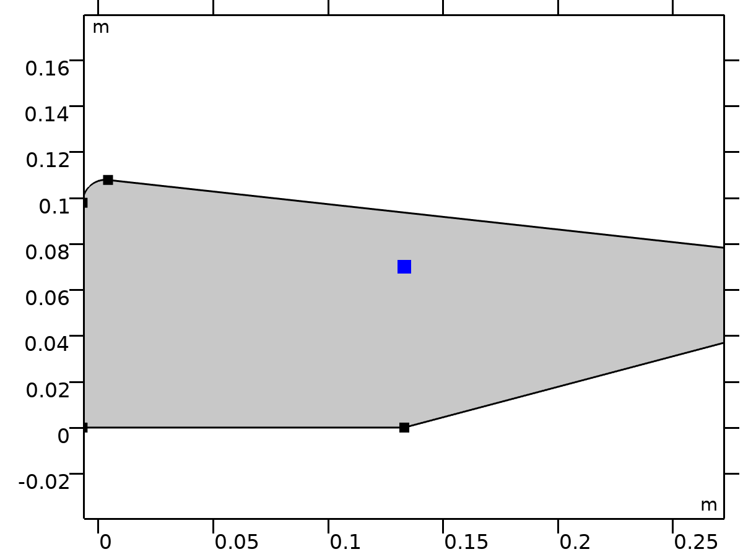

Center of Mass: Point 5

Selection

|  |  |
| --- | --- |
| Geometric entity level | Point |
| Selection | Geometry geom1: Dimension 0: Point 62 |

###### Variables

| **Name** | **Expression** | **Unit** | **Description** | **Selection** | **Details** |
| --- | --- | --- | --- | --- | --- |
| mbd.rd5.mmi1.xmx | mbd.rd5.mmi1.cmp1.int(X)/mbd.rd5.mmi1.cmp1.int(1) | m | Global coordinates of center of mass, x-component | Global | + operation |
| mbd.rd5.mmi1.xmy | mbd.rd5.mmi1.cmp1.int(Y)/mbd.rd5.mmi1.cmp1.int(1) | m | Global coordinates of center of mass, y-component | Global | + operation |
| mbd.rd5.mmi1.xmz | mbd.rd5.mmi1.cmp1.int(0)/mbd.rd5.mmi1.cmp1.int(1) | m | Global coordinates of center of mass, z-component | Global | + operation |

### Leg

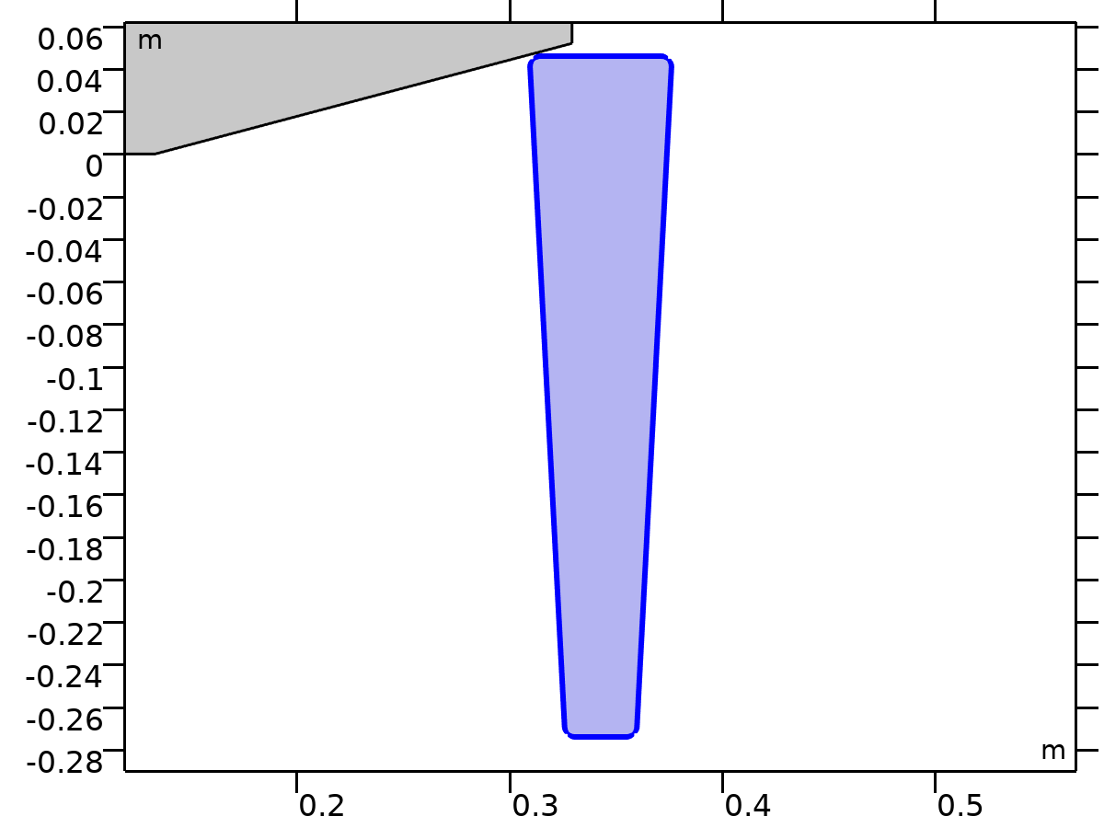

Leg

Selection

|  |  |
| --- | --- |
| Geometric entity level | Domain |
| Selection | Geometry geom1: Dimension 2: Domain 6 |

Equations





















#### Density

Settings

| **Description** | **Value** | **Unit** |
| --- | --- | --- |
| Density | User defined |  |
| Density | 0 | kg/m³ |

#### Center of Rotation

Settings

| **Description** | **Value** |
| --- | --- |
| Center of rotation | Center of mass |
| Offset | Off |

#### Initial Values

Settings

| **Description** | **Value** |
| --- | --- |
| Initial values | From physics interface node |
| Consistent initialization | Default |

#### Variables

| **Name** | **Expression** | **Unit** | **Description** | **Selection** | **Details** |
| --- | --- | --- | --- | --- | --- |
| u | mbd.rd6.Udx | m | Displacement field, X-component | Domain 6 |  |
| v | mbd.rd6.Udy | m | Displacement field, Y-component | Domain 6 |  |
| w | mbd.rd6.Udz | m | Displacement field, Z-component | Domain 6 |  |
| mbd.Wk_tot | 0.25*(mbd.rd6.m*(realdot(mbd.rd6.u*mbd.iomega,mbd.rd6.u*mbd.iomega)+realdot(mbd.rd6.v*mbd.iomega,mbd.rd6.v*mbd.iomega)+realdot(mbd.rd6.w*mbd.iomega,mbd.rd6.w*mbd.iomega))+realdot(mbd.rd6.Iz*mbd.rd6.thx*mbd.iomega,mbd.rd6.thx*mbd.iomega)+realdot(mbd.rd6.Iz*mbd.rd6.thy*mbd.iomega,mbd.rd6.thy*mbd.iomega)+realdot(mbd.rd6.Iz*mbd.rd6.thz*mbd.iomega,mbd.rd6.thz*mbd.iomega)) | J | Total kinetic energy | Global | + operation |
| mbd.RFtotalx | reacf(mbd.rd6.U) | N | Total reaction force, x-component | Global | + operation |
| mbd.RFtotaly | reacf(mbd.rd6.V) | N | Total reaction force, y-component | Global | + operation |
| mbd.RFtotalz | 0 | N | Total reaction force, z-component | Global | + operation |
| mbd.RMtotalx | -reacf(mbd.rd6.V)*mbd.rd6.RMmaz | N·m | Total reaction moment, x-component | Global | + operation |
| mbd.RMtotaly | reacf(mbd.rd6.U)*mbd.rd6.RMmaz | N·m | Total reaction moment, y-component | Global | + operation |
| mbd.RMtotalz | reacf(mbd.rd6.V)*mbd.rd6.RMmax-reacf(mbd.rd6.U)*mbd.rd6.RMmay+reacf(mbd.rd6.Phi) | N·m | Total reaction moment, z-component | Global | + operation |
| mbd.disp | sqrteps(real(u)^2+real(v)^2) | m | Displacement magnitude | Domain 6 |  |
| mbd.disp_rms | sqrt(0.5*(realdot(u,u)+realdot(v,v))) | m | Displacement, RMS | Domain 6 |  |
| mbd.gradUxX | -1+mbd.FdxX | 1 | Displacement gradient, xX-component | Domain 6 |  |
| mbd.gradUyX | mbd.FdyX | 1 | Displacement gradient, yX-component | Domain 6 |  |
| mbd.gradUzX | mbd.FdzX | 1 | Displacement gradient, zX-component | Domain 6 |  |
| mbd.gradUxY | mbd.FdxY | 1 | Displacement gradient, xY-component | Domain 6 |  |
| mbd.gradUyY | -1+mbd.FdyY | 1 | Displacement gradient, yY-component | Domain 6 |  |
| mbd.gradUzY | mbd.FdzY | 1 | Displacement gradient, zY-component | Domain 6 |  |
| mbd.gradUxZ | mbd.FdxZ | 1 | Displacement gradient, xZ-component | Domain 6 |  |
| mbd.gradUyZ | mbd.FdyZ | 1 | Displacement gradient, yZ-component | Domain 6 |  |
| mbd.gradUzZ | -1+mbd.FdzZ | 1 | Displacement gradient, zZ-component | Domain 6 |  |
| mbd.FdxX | mbd.rd6.rotxx | 1 | Deformation gradient, xX-component | Domain 6 |  |
| mbd.FdyX | mbd.rd6.rotyx | 1 | Deformation gradient, yX-component | Domain 6 |  |
| mbd.FdzX | mbd.rd6.rotzx | 1 | Deformation gradient, zX-component | Domain 6 |  |
| mbd.FdxY | mbd.rd6.rotxy | 1 | Deformation gradient, xY-component | Domain 6 |  |
| mbd.FdyY | mbd.rd6.rotyy | 1 | Deformation gradient, yY-component | Domain 6 |  |
| mbd.FdzY | mbd.rd6.rotzy | 1 | Deformation gradient, zY-component | Domain 6 |  |
| mbd.FdxZ | mbd.rd6.rotxz | 1 | Deformation gradient, xZ-component | Domain 6 |  |
| mbd.FdyZ | mbd.rd6.rotyz | 1 | Deformation gradient, yZ-component | Domain 6 |  |
| mbd.FdzZ | mbd.rd6.rotzz | 1 | Deformation gradient, zZ-component | Domain 6 |  |
| mbd.FdiXx | (mbd.FdyY*mbd.FdzZ-mbd.FdyZ*mbd.FdzY)/mbd.J | 1 | Deformation gradient inverse, Xx-component | Domain 6 |  |
| mbd.FdiYx | (mbd.FdyZ*mbd.FdzX-mbd.FdyX*mbd.FdzZ)/mbd.J | 1 | Deformation gradient inverse, Yx-component | Domain 6 |  |
| mbd.FdiZx | (mbd.FdyX*mbd.FdzY-mbd.FdyY*mbd.FdzX)/mbd.J | 1 | Deformation gradient inverse, Zx-component | Domain 6 |  |
| mbd.FdiXy | (mbd.FdxZ*mbd.FdzY-mbd.FdxY*mbd.FdzZ)/mbd.J | 1 | Deformation gradient inverse, Xy-component | Domain 6 |  |
| mbd.FdiYy | (mbd.FdxX*mbd.FdzZ-mbd.FdxZ*mbd.FdzX)/mbd.J | 1 | Deformation gradient inverse, Yy-component | Domain 6 |  |
| mbd.FdiZy | (mbd.FdxY*mbd.FdzX-mbd.FdxX*mbd.FdzY)/mbd.J | 1 | Deformation gradient inverse, Zy-component | Domain 6 |  |
| mbd.FdiXz | (mbd.FdxY*mbd.FdyZ-mbd.FdxZ*mbd.FdyY)/mbd.J | 1 | Deformation gradient inverse, Xz-component | Domain 6 |  |
| mbd.FdiYz | (mbd.FdxZ*mbd.FdyX-mbd.FdxX*mbd.FdyZ)/mbd.J | 1 | Deformation gradient inverse, Yz-component | Domain 6 |  |
| mbd.FdiZz | (mbd.FdxX*mbd.FdyY-mbd.FdxY*mbd.FdyX)/mbd.J | 1 | Deformation gradient inverse, Zz-component | Domain 6 |  |
| mbd.J | 1 | 1 | Volume ratio | Domain 6 |  |
| mbd.Ws | 0 | J/m³ | Elastic strain energy density | Domain 6 | + operation |
| mbd.Ws_tot | 0 | J | Total elastic strain energy | Global | + operation |
| mbd.Wk | 0.25*mbd.rho*(realdot(u*mbd.iomega,u*mbd.iomega)+realdot(v*mbd.iomega,v*mbd.iomega)) | J/m³ | Kinetic energy density | Domain 6 | + operation |
| mbd.Eequ | Inf | Pa | Equivalent Young's modulus | Domain 6 |  |
| mbd.nuequ | 0 | 1 | Equivalent Poisson's ratio | Domain 6 |  |
| mbd.Eequtot | mbd.Eequ | Pa | Total equivalent Young's modulus | Domain 6 | + operation |
| mbd.rho | 0 | kg/m³ | Density | Domain 6 | * operation |
| mbd.u_ttX | material.dt(material.dt(mbd.rd6.Udx)) | m/s² | Acceleration, X-component | Domain 6 |  |
| mbd.u_ttY | material.dt(material.dt(mbd.rd6.Udy)) | m/s² | Acceleration, Y-component | Domain 6 |  |
| mbd.u_ttZ | material.dt(material.dt(mbd.rd6.Udz)) | m/s² | Acceleration, Z-component | Domain 6 |  |
| mbd.u_tX | material.dt(mbd.rd6.Udx) | m/s | Velocity, X-component | Domain 6 |  |
| mbd.u_tY | material.dt(mbd.rd6.Udy) | m/s | Velocity, Y-component | Domain 6 |  |
| mbd.u_tZ | material.dt(mbd.rd6.Udz) | m/s | Velocity, Z-component | Domain 6 |  |
| mbd.vel_rms | sqrt(0.5*(realdot(mbd.u_tX,mbd.u_tX)+realdot(mbd.u_tY,mbd.u_tY)+realdot(mbd.u_tZ,mbd.u_tZ))) | m/s | Velocity magnitude, RMS | Domain 6 |  |
| mbd.acc_rms | sqrt(0.5*(realdot(mbd.u_ttX,mbd.u_ttX)+realdot(mbd.u_ttY,mbd.u_ttY)+realdot(mbd.u_ttZ,mbd.u_ttZ))) | m/s² | Acceleration magnitude, RMS | Domain 6 |  |
| mbd.afX | 0 | m/s² | Frame acceleration, X-component | Domain 6 | + operation |
| mbd.afY | 0 | m/s² | Frame acceleration, Y-component | Domain 6 | + operation |
| mbd.afZ | 0 | m/s² | Frame acceleration, Z-component | Domain 6 | + operation |
| mbd.accX | mbd.u_ttX | m/s² | Effective acceleration, X-component | Domain 6 | + operation |
| mbd.accY | mbd.u_ttY | m/s² | Effective acceleration, Y-component | Domain 6 | + operation |
| mbd.accZ | mbd.u_ttZ | m/s² | Effective acceleration, Z-component | Domain 6 | + operation |
| mbd.vel | sqrteps(real(mbd.u_tX)^2+real(mbd.u_tY)^2+real(mbd.u_tZ)^2) | m/s | Velocity magnitude | Domain 6 |  |
| mbd.acc | sqrteps(real(mbd.accX)^2+real(mbd.accY)^2+real(mbd.accZ)^2) | m/s² | Effective acceleration magnitude | Domain 6 |  |
| mbd.u_tt | sqrteps(real(mbd.u_ttX)^2+real(mbd.u_ttY)^2+real(mbd.u_ttZ)^2) | m/s² | Acceleration magnitude | Domain 6 |  |
| mbd.phase | if(isdefined(phase),phase,0) | 1 | Phase | Global |  |
| mbd.rd6.xcx | mbd.rd6.xmx | m | Center of rotation, x-component | Global | + operation |
| mbd.rd6.xcy | mbd.rd6.xmy | m | Center of rotation, y-component | Global | + operation |
| mbd.rd6.xcz | mbd.rd6.xmz | m | Center of rotation, z-component | Global | + operation |
| mbd.rd6.phi | mbd.rd6.Phi | rad | Rigid body rotation | Global |  |
| mbd.rd6.rotxx | 1 | 1 | Rotation matrix, xx-component | Global |  |
| mbd.rd6.rotyx | mbd.rd6.phi*exp(-(j*mbd.phase)) | 1 | Rotation matrix, yx-component | Global |  |
| mbd.rd6.rotzx | 0 | 1 | Rotation matrix, zx-component | Global |  |
| mbd.rd6.rotxy | -mbd.rd6.phi*exp(-(j*mbd.phase)) | 1 | Rotation matrix, xy-component | Global |  |
| mbd.rd6.rotyy | 1 | 1 | Rotation matrix, yy-component | Global |  |
| mbd.rd6.rotzy | 0 | 1 | Rotation matrix, zy-component | Global |  |
| mbd.rd6.rotxz | 0 | 1 | Rotation matrix, xz-component | Global |  |
| mbd.rd6.rotyz | 0 | 1 | Rotation matrix, yz-component | Global |  |
| mbd.rd6.rotzz | 1 | 1 | Rotation matrix, zz-component | Global |  |
| mbd.rd6.RMmax | mbd.rd6.xcx-mbd.refpntx | m | Moment arm, x-component | Global |  |
| mbd.rd6.RMmay | mbd.rd6.xcy-mbd.refpnty | m | Moment arm, y-component | Global |  |
| mbd.rd6.RMmaz | 0 | m | Moment arm, z-component | Global |  |
| mbd.rd6.u | mbd.rd6.U | m | Rigid body displacement, x-component | Global |  |
| mbd.rd6.v | mbd.rd6.V | m | Rigid body displacement, y-component | Global |  |
| mbd.rd6.w | 0 | m | Rigid body displacement, z-component | Global |  |
| mbd.rd6.xmx | mbd.rd6.int((mbd.rho+eps)*mbd.d*X)/mbd.rd6.int((mbd.rho+eps)*mbd.d) | m | Center of mass, x-component | Global |  |
| mbd.rd6.xmy | mbd.rd6.int((mbd.rho+eps)*mbd.d*Y)/mbd.rd6.int((mbd.rho+eps)*mbd.d) | m | Center of mass, y-component | Global |  |
| mbd.rd6.xmz | 0 | m | Center of mass, z-component | Global |  |
| mbd.rd6.Iz | mbd.rd6.int(((X-mbd.rd6.xmx)^2+(Y-mbd.rd6.xmy)^2+mbd.rd6.xmz^2)*mbd.rho*mbd.d) | kg·m² | Moment of inertia | Global |  |
| mbd.rd6.um | mbd.rd6.u | m | Rigid body displacement, x-component | Global |  |
| mbd.rd6.vm | mbd.rd6.v | m | Rigid body displacement, y-component | Global |  |
| mbd.rd6.wm | 0 | m | Rigid body displacement, z-component | Global |  |
| mbd.rd6.m | mbd.rd6.int(mbd.rho*mbd.d) | kg | Mass | Global |  |
| mbd.rd6.Udx | (mbd.rd6.rotxx*(X-mbd.rd6.xcx)+mbd.rd6.rotxy*(Y-mbd.rd6.xcy)-mbd.rd6.rotxz*mbd.rd6.xcz-X+mbd.rd6.xcx)*exp(j*mbd.phase)+mbd.rd6.u | m | Domain displacement, x-component | Domain 6 | + operation |
| mbd.rd6.Udy | (mbd.rd6.rotyx*(X-mbd.rd6.xcx)+mbd.rd6.rotyy*(Y-mbd.rd6.xcy)-mbd.rd6.rotyz*mbd.rd6.xcz-Y+mbd.rd6.xcy)*exp(j*mbd.phase)+mbd.rd6.v | m | Domain displacement, y-component | Domain 6 | + operation |
| mbd.rd6.Udz | (mbd.rd6.rotzx*(X-mbd.rd6.xcx)+mbd.rd6.rotzy*(Y-mbd.rd6.xcy)-mbd.rd6.rotzz*mbd.rd6.xcz+mbd.rd6.xcz)*exp(j*mbd.phase)+mbd.rd6.w | m | Domain displacement, z-component | Domain 6 | + operation |
| mbd.rd6.thx | 0 | rad | Rigid body rotation, x-component | Global |  |
| mbd.rd6.thy | 0 | rad | Rigid body rotation, y-component | Global |  |
| mbd.rd6.thz | mbd.rd6.phi | rad | Rigid body rotation, z-component | Global |  |
| mbd.rd6.u_tx | mbd.iomega*mbd.rd6.u | m/s | Rigid body velocity, x-component | Global |  |
| mbd.rd6.u_ty | mbd.iomega*mbd.rd6.v | m/s | Rigid body velocity, y-component | Global |  |
| mbd.rd6.u_tz | mbd.iomega*mbd.rd6.w | m/s | Rigid body velocity, z-component | Global |  |
| mbd.rd6.u_ttx | mbd.iomega*mbd.rd6.u_tx | m/s² | Rigid body acceleration, x-component | Global |  |
| mbd.rd6.u_tty | mbd.iomega*mbd.rd6.u_ty | m/s² | Rigid body acceleration, y-component | Global |  |
| mbd.rd6.u_ttz | mbd.iomega*mbd.rd6.u_tz | m/s² | Rigid body acceleration, z-component | Global |  |
| mbd.rd6.um_ttx | mbd.iomega^2*mbd.rd6.um | m/s² | Rigid body acceleration, x-component | Global |  |
| mbd.rd6.um_tty | mbd.iomega^2*mbd.rd6.vm | m/s² | Rigid body acceleration, y-component | Global |  |
| mbd.rd6.um_ttz | mbd.iomega^2*mbd.rd6.wm | m/s² | Rigid body acceleration, z-component | Global |  |
| mbd.rd6.th_tx | mbd.iomega*mbd.rd6.thx | rad/s | Rigid body angular velocity, x-component | Global |  |
| mbd.rd6.th_ty | mbd.iomega*mbd.rd6.thy | rad/s | Rigid body angular velocity, y-component | Global |  |
| mbd.rd6.th_tz | mbd.iomega*mbd.rd6.thz | rad/s | Rigid body angular velocity, z-component | Global |  |
| mbd.rd6.th_ttx | mbd.iomega*mbd.rd6.th_tx | rad/s² | Rigid body angular acceleration, x-component | Global |  |
| mbd.rd6.th_tty | mbd.iomega*mbd.rd6.th_ty | rad/s² | Rigid body angular acceleration, y-component | Global |  |
| mbd.rd6.th_ttz | mbd.iomega*mbd.rd6.th_tz | rad/s² | Rigid body angular acceleration, z-component | Global |  |
| mbd.rd6.FIx | -mbd.rd6.m*mbd.rd6.um_ttx | N | Inertial force, x-component | Global |  |
| mbd.rd6.FIy | -mbd.rd6.m*mbd.rd6.um_tty | N | Inertial force, y-component | Global |  |
| mbd.rd6.FIz | 0 | N | Inertial force, z-component | Global |  |
| mbd.rd6.MIz | -mbd.rd6.Iz*mbd.iomega^2*mbd.rd6.phi | N·m | Inertial moment | Global |  |
| mbd.rd6.i_rot | 1 | 1 | Free rotation indicator | Global | * operation |

#### Shape functions

| **Name** | **Shape function** | **Unit** | **Description** | **Shape frame** | **Selection** |
| --- | --- | --- | --- | --- | --- |
| mbd.rd6.U | ODE | m | Rigid body displacement, x-component |  | Global |
| mbd.rd6.V | ODE | m | Rigid body displacement, y-component |  | Global |
| mbd.rd6.Phi | ODE | rad | Rigid body rotation |  | Global |

#### Weak Expressions

| **Weak expression** | **Integration order** | **Integration frame** | **Selection** |
| --- | --- | --- | --- |
| mbd.rd6.FIx*test(mbd.rd6.um)+mbd.rd6.FIy*test(mbd.rd6.vm)+mbd.rd6.FIz*test(mbd.rd6.wm) | 2 |  | Global |
| mbd.rd6.MIz*test(mbd.rd6.phi) | 2 |  | Global |

#### Constraints

| **Constraint** | **Constraint force** | **Shape function** | **Selection** | **Details** |
| --- | --- | --- | --- | --- |
| up(u)-down(u) | test(up(u)-down(u)) | Lagrange (Linear) | No boundaries | Elemental |
| up(v)-down(v) | test(up(v)-down(v)) | Lagrange (Linear) | No boundaries | Elemental |
| 0 | 0 |  | No boundaries | Elemental |

#### Mass and Moment of Inertia 1

Selection

|  |  |
| --- | --- |
| Geometric entity level | Entire model |

Equations







##### Center of Mass

Settings

| **Description** | **Value** |
| --- | --- |
| Center of mass | Center of rotation |
| Offset | Off |

##### Mass and Moment of Inertia

Settings

| **Description** | **Value** | **Unit** |
| --- | --- | --- |
| Mass | 0 | kg |
| Moment of inertia | 0 | kg·m² |

##### Frame Acceleration Forces

Settings

| **Description** | **Value** |
| --- | --- |
| Exclude contribution | Off |

##### Variables

| **Name** | **Expression** | **Unit** | **Description** | **Selection** | **Details** |
| --- | --- | --- | --- | --- | --- |
| mbd.Wk_tot | 0.25*(mbd.rd6.mmi1.mt*(realdot((mbd.rd6.u+mbd.rd6.mmi1.dMrotx-mbd.rd6.mmi1.dMx)*mbd.iomega,(mbd.rd6.u+mbd.rd6.mmi1.dMrotx-mbd.rd6.mmi1.dMx)*mbd.iomega)+realdot((mbd.rd6.v+mbd.rd6.mmi1.dMroty-mbd.rd6.mmi1.dMy)*mbd.iomega,(mbd.rd6.v+mbd.rd6.mmi1.dMroty-mbd.rd6.mmi1.dMy)*mbd.iomega)+realdot((mbd.rd6.w+mbd.rd6.mmi1.dMrotz-mbd.rd6.mmi1.dMz)*mbd.iomega,(mbd.rd6.w+mbd.rd6.mmi1.dMrotz-mbd.rd6.mmi1.dMz)*mbd.iomega))+mbd.rd6.mmi1.Iz*realdot(mbd.rd6.phi*mbd.iomega,mbd.rd6.phi*mbd.iomega)) | J | Total kinetic energy | Global | + operation |
| mbd.rd6.mmi1.mt | 0 | kg | Mass | Global |  |
| mbd.rd6.mmi1.Iz | 0 | kg·m² | Moment of inertia | Global |  |
| mbd.rd6.mmi1.xmsx | mbd.rd6.xcx+mbd.rd6.u+mbd.rd6.rotxx*(mbd.rd6.mmi1.xmx-mbd.rd6.xcx)+mbd.rd6.rotxy*(mbd.rd6.mmi1.xmy-mbd.rd6.xcy)+mbd.rd6.rotxz*(mbd.rd6.mmi1.xmz-mbd.rd6.xcz) | m | Global coordinates of center of mass, x-component | Global |  |
| mbd.rd6.mmi1.xmsy | mbd.rd6.xcy+mbd.rd6.v+mbd.rd6.rotyx*(mbd.rd6.mmi1.xmx-mbd.rd6.xcx)+mbd.rd6.rotyy*(mbd.rd6.mmi1.xmy-mbd.rd6.xcy)+mbd.rd6.rotyz*(mbd.rd6.mmi1.xmz-mbd.rd6.xcz) | m | Global coordinates of center of mass, y-component | Global |  |
| mbd.rd6.mmi1.xmsz | mbd.rd6.xcz+mbd.rd6.w+mbd.rd6.rotzx*(mbd.rd6.mmi1.xmx-mbd.rd6.xcx)+mbd.rd6.rotzy*(mbd.rd6.mmi1.xmy-mbd.rd6.xcy)+mbd.rd6.rotzz*(mbd.rd6.mmi1.xmz-mbd.rd6.xcz) | m | Global coordinates of center of mass, z-component | Global |  |
| mbd.rd6.mmi1.umx | mbd.rd6.u+mbd.rd6.rotxx*(mbd.rd6.mmi1.xmx-mbd.rd6.xcx)+mbd.rd6.rotxy*(mbd.rd6.mmi1.xmy-mbd.rd6.xcy)+mbd.rd6.rotxz*(mbd.rd6.mmi1.xmz-mbd.rd6.xcz)-mbd.rd6.mmi1.xmx+mbd.rd6.xcx | m | Displacement at center of mass, x-component | Global |  |
| mbd.rd6.mmi1.umy | mbd.rd6.v+mbd.rd6.rotyx*(mbd.rd6.mmi1.xmx-mbd.rd6.xcx)+mbd.rd6.rotyy*(mbd.rd6.mmi1.xmy-mbd.rd6.xcy)+mbd.rd6.rotyz*(mbd.rd6.mmi1.xmz-mbd.rd6.xcz)-mbd.rd6.mmi1.xmy+mbd.rd6.xcy | m | Displacement at center of mass, y-component | Global |  |
| mbd.rd6.mmi1.umz | mbd.rd6.w+mbd.rd6.rotzx*(mbd.rd6.mmi1.xmx-mbd.rd6.xcx)+mbd.rd6.rotzy*(mbd.rd6.mmi1.xmy-mbd.rd6.xcy)+mbd.rd6.rotzz*(mbd.rd6.mmi1.xmz-mbd.rd6.xcz)-mbd.rd6.mmi1.xmz+mbd.rd6.xcz | m | Displacement at center of mass, z-component | Global |  |
| mbd.rd6.mmi1.xmx | mbd.rd6.xcx | m | Global coordinates of center of mass, x-component | Global |  |
| mbd.rd6.mmi1.xmy | mbd.rd6.xcy | m | Global coordinates of center of mass, y-component | Global |  |
| mbd.rd6.mmi1.xmz | mbd.rd6.xcz | m | Global coordinates of center of mass, z-component | Global |  |
| mbd.rd6.mmi1.FIx | -mbd.rd6.mmi1.mt*mbd.iomega^2*(mbd.rd6.u+mbd.rd6.mmi1.dMrotx-mbd.rd6.mmi1.dMx) | N | Inertial force, x-component | Global |  |
| mbd.rd6.mmi1.FIy | -mbd.rd6.mmi1.mt*mbd.iomega^2*(mbd.rd6.v+mbd.rd6.mmi1.dMroty-mbd.rd6.mmi1.dMy) | N | Inertial force, y-component | Global |  |
| mbd.rd6.mmi1.FIz | -mbd.rd6.mmi1.mt*mbd.iomega^2*(mbd.rd6.w+mbd.rd6.mmi1.dMrotz-mbd.rd6.mmi1.dMz) | N | Inertial force, z-component | Global |  |
| mbd.rd6.mmi1.MIz | -mbd.rd6.mmi1.Iz*mbd.iomega^2*mbd.rd6.phi | N·m | Inertial moment | Global |  |
| mbd.rd6.mmi1.dMx | mbd.rd6.mmi1.xmx-mbd.rd6.xcx | m | Mass offset from CoR, Original, x-component | Global |  |
| mbd.rd6.mmi1.dMy | mbd.rd6.mmi1.xmy-mbd.rd6.xcy | m | Mass offset from CoR, Original, y-component | Global |  |
| mbd.rd6.mmi1.dMz | mbd.rd6.mmi1.xmz-mbd.rd6.xcz | m | Mass offset from CoR, Original, z-component | Global |  |
| mbd.rd6.mmi1.dMrotx | mbd.rd6.rotxx*mbd.rd6.mmi1.dMx+mbd.rd6.rotxy*mbd.rd6.mmi1.dMy+mbd.rd6.rotxz*mbd.rd6.mmi1.dMz | m | Mass offset from CoR, Rotated, x-component | Global |  |
| mbd.rd6.mmi1.dMroty | mbd.rd6.rotyx*mbd.rd6.mmi1.dMx+mbd.rd6.rotyy*mbd.rd6.mmi1.dMy+mbd.rd6.rotyz*mbd.rd6.mmi1.dMz | m | Mass offset from CoR, Rotated, y-component | Global |  |
| mbd.rd6.mmi1.dMrotz | mbd.rd6.rotzx*mbd.rd6.mmi1.dMx+mbd.rd6.rotzy*mbd.rd6.mmi1.dMy+mbd.rd6.rotzz*mbd.rd6.mmi1.dMz | m | Mass offset from CoR, Rotated, z-component | Global |  |
| mbd.rd6.mmi1.Fx | mbd.rd6.mmi1.FIx | N | Applied force, x-component | Global |  |
| mbd.rd6.mmi1.Fy | mbd.rd6.mmi1.FIy | N | Applied force, y-component | Global |  |
| mbd.rd6.mmi1.Fz | mbd.rd6.mmi1.FIz | N | Applied force, z-component | Global |  |
| mbd.rd6.mmi1.F_Mag | sqrt(real(mbd.rd6.mmi1.Fx)^2+real(mbd.rd6.mmi1.Fy)^2+real(mbd.rd6.mmi1.Fz)^2) | N | Load magnitude | Global |  |
| mbd.rd6.mmi1.Mx | 0 | N·m | Applied moment, x-component | Global |  |
| mbd.rd6.mmi1.My | 0 | N·m | Applied moment, y-component | Global |  |
| mbd.rd6.mmi1.Mz | mbd.rd6.mmi1.MIz | N·m | Applied moment, z-component | Global |  |
| mbd.rd6.mmi1.M_Mag | sqrt(real(mbd.rd6.mmi1.Mx)^2+real(mbd.rd6.mmi1.My)^2+real(mbd.rd6.mmi1.Mz)^2) | N·m | Moment magnitude | Global |  |
| mbd.rd6.mmi1.loadposx | mbd.rd6.mmi1.xmx | m | Load position, x-component | Global |  |
| mbd.rd6.mmi1.loadposy | mbd.rd6.mmi1.xmy | m | Load position, y-component | Global |  |
| mbd.rd6.mmi1.loadposz | mbd.rd6.mmi1.xmz | m | Load position, z-component | Global |  |
| mbd.rd6.mmi1.momposx | mbd.rd6.mmi1.xmx | m | Moment position, x-component | Global |  |
| mbd.rd6.mmi1.momposy | mbd.rd6.mmi1.xmy | m | Moment position, y-component | Global |  |
| mbd.rd6.mmi1.momposz | mbd.rd6.mmi1.xmz | m | Moment position, z-component | Global |  |

##### Weak Expressions

| **Weak expression** | **Integration order** | **Integration frame** | **Selection** |
| --- | --- | --- | --- |
| mbd.rd6.mmi1.FIx*test(mbd.rd6.u+mbd.rd6.mmi1.dMrotx)+mbd.rd6.mmi1.FIy*test(mbd.rd6.v+mbd.rd6.mmi1.dMroty)+mbd.rd6.mmi1.FIz*test(mbd.rd6.w+mbd.rd6.mmi1.dMrotz) | 2 |  | Global |
| mbd.rd6.mmi1.MIz*test(mbd.rd6.phi) | 2 |  | Global |

### Seat

Selection

|  |  |
| --- | --- |
| Geometric entity level | Entire model |

Equations

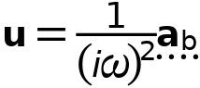

#### Base Motion

Settings

| **Description** | **Value** | **Unit** |
| --- | --- | --- |
| Base motion type | Acceleration |  |
| Base acceleration, x-component | 0 | m/s² |
| Base acceleration, y-component | vtt_in | m/s² |
| Base acceleration, z-component | 0 | m/s² |

#### Initial Base Displacement

Settings

| **Description** | **Value** | **Unit** |
| --- | --- | --- |
| Initial base displacement, x-component | 0 | m |
| Initial base displacement, y-component | 0 | m |
| Initial base displacement, z-component | 0 | m |

#### Initial Base Velocity

Settings

| **Description** | **Value** | **Unit** |
| --- | --- | --- |
| Initial base velocity, x-component | 0 | m/s |
| Initial base velocity, y-component | 0 | m/s |
| Initial base velocity, z-component | 0 | m/s |

#### Coordinate System Selection

Settings

| **Description** | **Value** |
| --- | --- |
| Coordinate system | Global coordinate system |

#### Variables

| **Name** | **Expression** | **Unit** | **Description** | **Selection** |
| --- | --- | --- | --- | --- |
| mbd.bsm1.abx | 0 | m/s² | Base acceleration, x-component | Global |
| mbd.bsm1.aby | vtt_in | m/s² | Base acceleration, y-component | Global |
| mbd.bsm1.abz | 0 | m/s² | Base acceleration, z-component | Global |
| mbd.bsm1.ub0x | 0 | m | Initial base displacement, x-component | Global |
| mbd.bsm1.ub0y | 0 | m | Initial base displacement, y-component | Global |
| mbd.bsm1.ub0z | 0 | m | Initial base displacement, z-component | Global |
| mbd.bsm1.vb0x | 0 | m/s | Initial base velocity, x-component | Global |
| mbd.bsm1.vb0y | 0 | m/s | Initial base velocity, y-component | Global |
| mbd.bsm1.vb0z | 0 | m/s | Initial base velocity, z-component | Global |
| mbd.bsm1.u | mbd.bsm1.abx/mbd.iomega^2 | m | Base displacement, x-component | Global |
| mbd.bsm1.v | mbd.bsm1.aby/mbd.iomega^2 | m | Base displacement, y-component | Global |
| mbd.bsm1.w | mbd.bsm1.abz/mbd.iomega^2 | m | Base displacement, z-component | Global |

### Head-Torso



Head-Torso



Head-Torso

Selection

|  |  |
| --- | --- |
| Geometric entity level | Entire model |

Equations









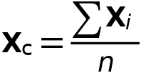

#### Attachment Selection

Settings

| **Description** | **Value** |
| --- | --- |
| Source | Head |
| Destination | Torso |
| Use selection filter | Off |

#### Center of Joint

Settings

| **Description** | **Value** |
| --- | --- |
| Center of joint | Centroid of selected entities |
| Entity level | Point |
| Offset | Off |

#### Axis of Joint

Settings

| **Description** | **Value** |
| --- | --- |
| Axis of joint | Specify direction |
| Axis of joint, x-component | 1 |
| Axis of joint, y-component | 0 |
| Axis of joint, z-component | 0 |

#### Joint Elasticity

Settings

| **Description** | **Value** |
| --- | --- |
| Joint elasticity | Elastic joint |

#### Joint Forces and Moments

Settings

| **Description** | **Value** |
| --- | --- |
| Joint forces and moments | Do not compute |

#### Coordinate System Selection

Settings

| **Description** | **Value** |
| --- | --- |
| Coordinate system | Global coordinate system |

#### Variables

| **Name** | **Expression** | **Unit** | **Description** | **Selection** |
| --- | --- | --- | --- | --- |
| mbd.fxj1.e10x | 1 | 1 | Initial joint axis, x-component | Global |
| mbd.fxj1.e10y | 0 | 1 | Initial joint axis, y-component | Global |
| mbd.fxj1.e10z | 0 | 1 | Initial joint axis, z-component | Global |
| mbd.fxj1.e20x | (mbd.fxj1.e10z*mbd.fxj1.e30y-mbd.fxj1.e10y*mbd.fxj1.e30z)/sqrt((mbd.fxj1.e10z*mbd.fxj1.e30y-mbd.fxj1.e10y*mbd.fxj1.e30z)^2+(-mbd.fxj1.e10z*mbd.fxj1.e30x+mbd.fxj1.e10x*mbd.fxj1.e30z)^2+(mbd.fxj1.e10y*mbd.fxj1.e30x-mbd.fxj1.e10x*mbd.fxj1.e30y)^2) | 1 | Initial second axis, x-component | Global |
| mbd.fxj1.e20y | (-mbd.fxj1.e10z*mbd.fxj1.e30x+mbd.fxj1.e10x*mbd.fxj1.e30z)/sqrt((mbd.fxj1.e10z*mbd.fxj1.e30y-mbd.fxj1.e10y*mbd.fxj1.e30z)^2+(-mbd.fxj1.e10z*mbd.fxj1.e30x+mbd.fxj1.e10x*mbd.fxj1.e30z)^2+(mbd.fxj1.e10y*mbd.fxj1.e30x-mbd.fxj1.e10x*mbd.fxj1.e30y)^2) | 1 | Initial second axis, y-component | Global |
| mbd.fxj1.e20z | (mbd.fxj1.e10y*mbd.fxj1.e30x-mbd.fxj1.e10x*mbd.fxj1.e30y)/sqrt((mbd.fxj1.e10z*mbd.fxj1.e30y-mbd.fxj1.e10y*mbd.fxj1.e30z)^2+(-mbd.fxj1.e10z*mbd.fxj1.e30x+mbd.fxj1.e10x*mbd.fxj1.e30z)^2+(mbd.fxj1.e10y*mbd.fxj1.e30x-mbd.fxj1.e10x*mbd.fxj1.e30y)^2) | 1 | Initial second axis, z-component | Global |
| mbd.fxj1.e30x | 0 | 1 | Initial third axis, x-component | Global |
| mbd.fxj1.e30y | 0 | 1 | Initial third axis, y-component | Global |
| mbd.fxj1.e30z | 1 | 1 | Initial third axis, z-component | Global |
| mbd.fxj1.e1x | mbd.rd2.rotxx*mbd.fxj1.e10x+mbd.rd2.rotxy*mbd.fxj1.e10y+mbd.rd2.rotxz*mbd.fxj1.e10z | 1 | Joint axis, x-component | Global |
| mbd.fxj1.e1y | mbd.rd2.rotyx*mbd.fxj1.e10x+mbd.rd2.rotyy*mbd.fxj1.e10y+mbd.rd2.rotyz*mbd.fxj1.e10z | 1 | Joint axis, y-component | Global |
| mbd.fxj1.e1z | mbd.rd2.rotzx*mbd.fxj1.e10x+mbd.rd2.rotzy*mbd.fxj1.e10y+mbd.rd2.rotzz*mbd.fxj1.e10z | 1 | Joint axis, z-component | Global |
| mbd.fxj1.e2x | mbd.rd2.rotxx*mbd.fxj1.e20x+mbd.rd2.rotxy*mbd.fxj1.e20y+mbd.rd2.rotxz*mbd.fxj1.e20z | 1 | Second axis, x-component | Global |
| mbd.fxj1.e2y | mbd.rd2.rotyx*mbd.fxj1.e20x+mbd.rd2.rotyy*mbd.fxj1.e20y+mbd.rd2.rotyz*mbd.fxj1.e20z | 1 | Second axis, y-component | Global |
| mbd.fxj1.e2z | mbd.rd2.rotzx*mbd.fxj1.e20x+mbd.rd2.rotzy*mbd.fxj1.e20y+mbd.rd2.rotzz*mbd.fxj1.e20z | 1 | Second axis, z-component | Global |
| mbd.fxj1.e3x | mbd.rd2.rotxx*mbd.fxj1.e30x+mbd.rd2.rotxy*mbd.fxj1.e30y+mbd.rd2.rotxz*mbd.fxj1.e30z | 1 | Third axis, x-component | Global |
| mbd.fxj1.e3y | mbd.rd2.rotyx*mbd.fxj1.e30x+mbd.rd2.rotyy*mbd.fxj1.e30y+mbd.rd2.rotyz*mbd.fxj1.e30z | 1 | Third axis, y-component | Global |
| mbd.fxj1.e3z | mbd.rd2.rotzx*mbd.fxj1.e30x+mbd.rd2.rotzy*mbd.fxj1.e30y+mbd.rd2.rotzz*mbd.fxj1.e30z | 1 | Third axis, z-component | Global |
| mbd.fxj1.uc_src | mbd.rd2.rotxx*(mbd.fxj1.xcx-mbd.rd2.xcx)+mbd.rd2.rotxy*(mbd.fxj1.xcy-mbd.rd2.xcy)+mbd.rd2.rotxz*(mbd.fxj1.xcz-mbd.rd2.xcz)-mbd.fxj1.xcx+mbd.rd2.xcx+mbd.rd2.u+mbd.fxj1.u_el | m | Source displacement at center of joint, x-component | Global |
| mbd.fxj1.vc_src | mbd.rd2.rotyx*(mbd.fxj1.xcx-mbd.rd2.xcx)+mbd.rd2.rotyy*(mbd.fxj1.xcy-mbd.rd2.xcy)+mbd.rd2.rotyz*(mbd.fxj1.xcz-mbd.rd2.xcz)-mbd.fxj1.xcy+mbd.rd2.xcy+mbd.rd2.v+mbd.fxj1.v_el | m | Source displacement at center of joint, y-component | Global |
| mbd.fxj1.wc_src | mbd.rd2.rotzx*(mbd.fxj1.xcx-mbd.rd2.xcx)+mbd.rd2.rotzy*(mbd.fxj1.xcy-mbd.rd2.xcy)+mbd.rd2.rotzz*(mbd.fxj1.xcz-mbd.rd2.xcz)-mbd.fxj1.xcz+mbd.rd2.xcz+mbd.fxj1.w_el | m | Source displacement at center of joint, z-component | Global |
| mbd.fxj1.uc_dest | mbd.rd3.rotxx*(mbd.fxj1.xcx-mbd.rd3.xcx)+mbd.rd3.rotxy*(mbd.fxj1.xcy-mbd.rd3.xcy)+mbd.rd3.rotxz*(mbd.fxj1.xcz-mbd.rd3.xcz)-mbd.fxj1.xcx+mbd.rd3.xcx+mbd.rd3.u | m | Destination displacement at center of joint, x-component | Global |
| mbd.fxj1.vc_dest | mbd.rd3.rotyx*(mbd.fxj1.xcx-mbd.rd3.xcx)+mbd.rd3.rotyy*(mbd.fxj1.xcy-mbd.rd3.xcy)+mbd.rd3.rotyz*(mbd.fxj1.xcz-mbd.rd3.xcz)-mbd.fxj1.xcy+mbd.rd3.xcy+mbd.rd3.v | m | Destination displacement at center of joint, y-component | Global |
| mbd.fxj1.wc_dest | mbd.rd3.rotzx*(mbd.fxj1.xcx-mbd.rd3.xcx)+mbd.rd3.rotzy*(mbd.fxj1.xcy-mbd.rd3.xcy)+mbd.rd3.rotzz*(mbd.fxj1.xcz-mbd.rd3.xcz)-mbd.fxj1.xcz+mbd.rd3.xcz | m | Destination displacement at center of joint, z-component | Global |
| mbd.fxj1.phi_src | mbd.rd2.phi+mbd.fxj1.th_el | rad | Source rotation | Global |
| mbd.fxj1.phi_dest | mbd.rd3.phi | rad | Destination rotation | Global |

#### Constraints

| **Constraint** | **Constraint force** | **Shape function** | **Selection** | **Details** |
| --- | --- | --- | --- | --- |
| mbd.fxj1.uc_src-mbd.fxj1.uc_dest | test(mbd.fxj1.uc_src-mbd.fxj1.uc_dest) |  | Global | Elemental |
| mbd.fxj1.vc_src-mbd.fxj1.vc_dest | test(mbd.fxj1.vc_src-mbd.fxj1.vc_dest) |  | Global | Elemental |
| mbd.fxj1.phi_src-mbd.fxj1.phi_dest | test(mbd.fxj1.phi_src-mbd.fxj1.phi_dest) |  | Global | Elemental |

#### Center of Joint: Point 1

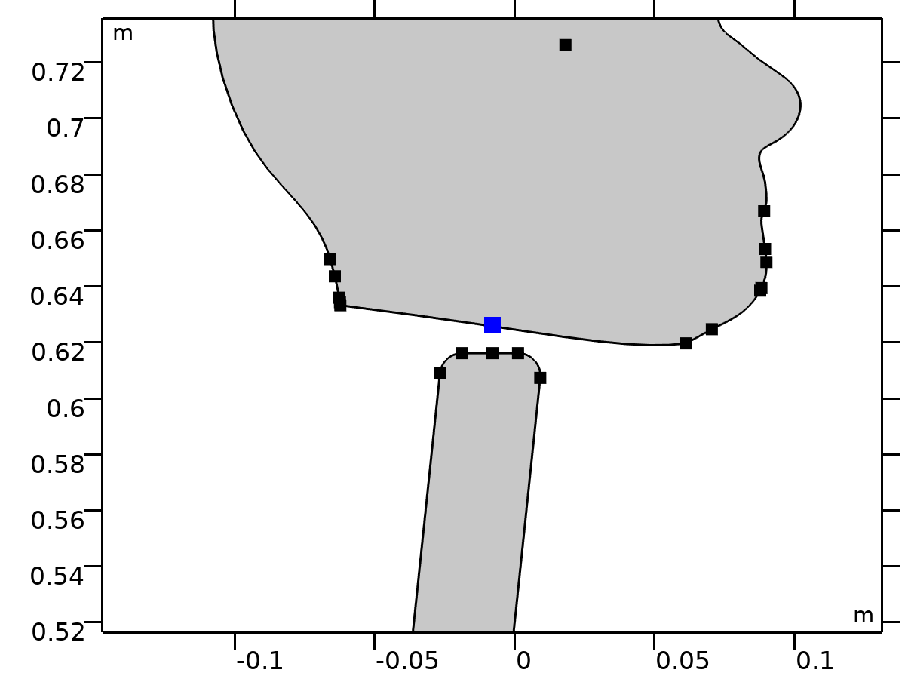

Center of Joint: Point 1

Selection

|  |  |
| --- | --- |
| Geometric entity level | Point |
| Selection | Geometry geom1: Dimension 0: Point 24 |

##### Variables

| **Name** | **Expression** | **Unit** | **Description** | **Selection** | **Details** |
| --- | --- | --- | --- | --- | --- |
| mbd.fxj1.xcx | mbd.fxj1.cjp1.int(X)/mbd.fxj1.cjp1.int(1) | m | Center of joint, x-component | Global | + operation |
| mbd.fxj1.xcy | mbd.fxj1.cjp1.int(Y)/mbd.fxj1.cjp1.int(1) | m | Center of joint, y-component | Global | + operation |
| mbd.fxj1.xcz | mbd.fxj1.cjp1.int(0)/mbd.fxj1.cjp1.int(1) | m | Center of joint, z-component | Global | + operation |

#### Joint Elasticity 1

Selection

|  |  |
| --- | --- |
| Geometric entity level | Entire model |

Equations











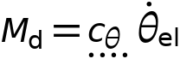

##### Elastic Degrees of Freedom

Settings

| **Description** | **Value** |
| --- | --- |
| First axis | On |
| Second axis | On |
| Third axis | On |

##### Spring

Settings

| **Description** | **Value** | **Unit** |
| --- | --- | --- |
| Translational-rotational coupling | Off |  |
| Spring constant, xx-component | {k1, k1, 0} | N/m |
| Spring constant | kr1 | N·m/rad |

##### Viscous Damping

Settings

| **Description** | **Value** | **Unit** |
| --- | --- | --- |
| Translational-rotational coupling | Off |  |
| Damping coefficient, xx-component | {if(i_c==1, c1, 0), if(i_c==1, c1, 0), 0} | N·s/m |
| Damping coefficient | if(i_c==1, cr1, 0) | N·m·s/rad |

##### Coordinate System Selection

Settings

| **Description** | **Value** |
| --- | --- |
| Coordinate system | Joint coordinate system |

##### Variables

| **Name** | **Expression** | **Unit** | **Description** | **Selection** | **Details** |
| --- | --- | --- | --- | --- | --- |
| mbd.Ws_tot | mbd.fxj1.Ws_el | J | Total elastic strain energy | Global | + operation |
| mbd.fxj1.u_el | mbd.fxj1.u1*mbd.fxj1.e1x+mbd.fxj1.u2*mbd.fxj1.e2x | m | Relative displacement (elastic), x-component | Global | + operation |
| mbd.fxj1.v_el | mbd.fxj1.u1*mbd.fxj1.e1y+mbd.fxj1.u2*mbd.fxj1.e2y | m | Relative displacement (elastic), y-component | Global | + operation |
| mbd.fxj1.w_el | mbd.fxj1.u1*mbd.fxj1.e1z+mbd.fxj1.u2*mbd.fxj1.e2z | m | Relative displacement (elastic), z-component | Global | + operation |
| mbd.fxj1.th_el | mbd.fxj1.th | rad | Relative rotation (elastic) | Global | + operation |
| mbd.fxj1.je1.k_u11 | k1 | N/m | Spring constant, xx-component | Global |  |
| mbd.fxj1.je1.k_u21 | 0 | N/m | Spring constant, yx-component | Global |  |
| mbd.fxj1.je1.k_u31 | 0 | N/m | Spring constant, zx-component | Global |  |
| mbd.fxj1.je1.k_u12 | 0 | N/m | Spring constant, xy-component | Global |  |
| mbd.fxj1.je1.k_u22 | k1 | N/m | Spring constant, yy-component | Global |  |
| mbd.fxj1.je1.k_u32 | 0 | N/m | Spring constant, zy-component | Global |  |
| mbd.fxj1.je1.k_u13 | 0 | N/m | Spring constant, xz-component | Global |  |
| mbd.fxj1.je1.k_u23 | 0 | N/m | Spring constant, yz-component | Global |  |
| mbd.fxj1.je1.k_u33 | 0 | N/m | Spring constant, zz-component | Global |  |
| mbd.fxj1.je1.k_th | kr1 | N·m/rad | Spring constant | Global |  |
| mbd.fxj1.je1.c_u11 | if(i_c==1,c1,0) | N·s/m | Damping coefficient, xx-component | Global |  |
| mbd.fxj1.je1.c_u21 | 0 | N·s/m | Damping coefficient, yx-component | Global |  |
| mbd.fxj1.je1.c_u31 | 0 | N·s/m | Damping coefficient, zx-component | Global |  |
| mbd.fxj1.je1.c_u12 | 0 | N·s/m | Damping coefficient, xy-component | Global |  |
| mbd.fxj1.je1.c_u22 | if(i_c==1,c1,0) | N·s/m | Damping coefficient, yy-component | Global |  |
| mbd.fxj1.je1.c_u32 | 0 | N·s/m | Damping coefficient, zy-component | Global |  |
| mbd.fxj1.je1.c_u13 | 0 | N·s/m | Damping coefficient, xz-component | Global |  |
| mbd.fxj1.je1.c_u23 | 0 | N·s/m | Damping coefficient, yz-component | Global |  |
| mbd.fxj1.je1.c_u33 | 0 | N·s/m | Damping coefficient, zz-component | Global |  |
| mbd.fxj1.je1.c_th | if(i_c==1,cr1,0) | N·m·s/rad | Damping coefficient | Global |  |
| mbd.fxj1.u1 | mbd.fxj1.U1 | m | Relative displacement along joint axis | Global |  |
| mbd.fxj1.u2 | mbd.fxj1.U2 | m | Relative displacement along second axis | Global |  |
| mbd.fxj1.th | mbd.fxj1.Th | rad | Relative rotation | Global |  |
| mbd.fxj1.kl_u11 | mbd.fxj1.je1.k_u11 | N/m | Spring constant, joint coordinate system, 11-component | Global |  |
| mbd.fxj1.kl_u21 | mbd.fxj1.je1.k_u21 | N/m | Spring constant, joint coordinate system, 21-component | Global |  |
| mbd.fxj1.kl_u31 | mbd.fxj1.je1.k_u31 | N/m | Spring constant, joint coordinate system, 31-component | Global |  |
| mbd.fxj1.kl_u12 | mbd.fxj1.je1.k_u12 | N/m | Spring constant, joint coordinate system, 12-component | Global |  |
| mbd.fxj1.kl_u22 | mbd.fxj1.je1.k_u22 | N/m | Spring constant, joint coordinate system, 22-component | Global |  |
| mbd.fxj1.kl_u32 | mbd.fxj1.je1.k_u32 | N/m | Spring constant, joint coordinate system, 32-component | Global |  |
| mbd.fxj1.kl_u13 | mbd.fxj1.je1.k_u13 | N/m | Spring constant, joint coordinate system, 13-component | Global |  |
| mbd.fxj1.kl_u23 | mbd.fxj1.je1.k_u23 | N/m | Spring constant, joint coordinate system, 23-component | Global |  |
| mbd.fxj1.kl_u33 | mbd.fxj1.je1.k_u33 | N/m | Spring constant, joint coordinate system, 33-component | Global |  |
| mbd.fxj1.cl_u11 | mbd.fxj1.je1.c_u11 | N·s/m | Damping coefficient, joint coordinate system, 11-component | Global |  |
| mbd.fxj1.cl_u21 | mbd.fxj1.je1.c_u21 | N·s/m | Damping coefficient, joint coordinate system, 21-component | Global |  |
| mbd.fxj1.cl_u31 | mbd.fxj1.je1.c_u31 | N·s/m | Damping coefficient, joint coordinate system, 31-component | Global |  |
| mbd.fxj1.cl_u12 | mbd.fxj1.je1.c_u12 | N·s/m | Damping coefficient, joint coordinate system, 12-component | Global |  |
| mbd.fxj1.cl_u22 | mbd.fxj1.je1.c_u22 | N·s/m | Damping coefficient, joint coordinate system, 22-component | Global |  |
| mbd.fxj1.cl_u32 | mbd.fxj1.je1.c_u32 | N·s/m | Damping coefficient, joint coordinate system, 32-component | Global |  |
| mbd.fxj1.cl_u13 | mbd.fxj1.je1.c_u13 | N·s/m | Damping coefficient, joint coordinate system, 13-component | Global |  |
| mbd.fxj1.cl_u23 | mbd.fxj1.je1.c_u23 | N·s/m | Damping coefficient, joint coordinate system, 23-component | Global |  |
| mbd.fxj1.cl_u33 | mbd.fxj1.je1.c_u33 | N·s/m | Damping coefficient, joint coordinate system, 33-component | Global |  |
| mbd.fxj1.ul_el | mbd.fxj1.u1 | m | Relative displacement (elastic), joint coordinate system, 1-component | Global | + operation |
| mbd.fxj1.vl_el | mbd.fxj1.u2 | m | Relative displacement (elastic), joint coordinate system, 2-component | Global | + operation |
| mbd.fxj1.wl_el | 0 | m | Relative displacement (elastic), joint coordinate system, 3-component | Global | + operation |
| mbd.fxj1.Fs_el1 | mbd.fxj1.kl_u11*mbd.fxj1.ul_el+mbd.fxj1.kl_u12*mbd.fxj1.vl_el+mbd.fxj1.kl_u13*mbd.fxj1.wl_el | N | Spring force, joint coordinate system, 1-component | Global | + operation |
| mbd.fxj1.Fs_el2 | mbd.fxj1.kl_u21*mbd.fxj1.ul_el+mbd.fxj1.kl_u22*mbd.fxj1.vl_el+mbd.fxj1.kl_u23*mbd.fxj1.wl_el | N | Spring force, joint coordinate system, 2-component | Global | + operation |
| mbd.fxj1.Fs_el3 | mbd.fxj1.kl_u31*mbd.fxj1.ul_el+mbd.fxj1.kl_u32*mbd.fxj1.vl_el+mbd.fxj1.kl_u33*mbd.fxj1.wl_el | N | Spring force, joint coordinate system, 3-component | Global | + operation |
| mbd.fxj1.Ms_el | mbd.fxj1.je1.k_th*mbd.fxj1.th_el | N·m | Spring moment, joint coordinate system | Global | + operation |
| mbd.fxj1.Fd_el1 | (mbd.fxj1.cl_u11*mbd.fxj1.ul_el+mbd.fxj1.cl_u12*mbd.fxj1.vl_el+mbd.fxj1.cl_u13*mbd.fxj1.wl_el)*mbd.iomega | N | Damping force, joint coordinate system, 1-component | Global | + operation |
| mbd.fxj1.Fd_el2 | (mbd.fxj1.cl_u21*mbd.fxj1.ul_el+mbd.fxj1.cl_u22*mbd.fxj1.vl_el+mbd.fxj1.cl_u23*mbd.fxj1.wl_el)*mbd.iomega | N | Damping force, joint coordinate system, 2-component | Global | + operation |
| mbd.fxj1.Fd_el3 | (mbd.fxj1.cl_u31*mbd.fxj1.ul_el+mbd.fxj1.cl_u32*mbd.fxj1.vl_el+mbd.fxj1.cl_u33*mbd.fxj1.wl_el)*mbd.iomega | N | Damping force, joint coordinate system, 3-component | Global | + operation |
| mbd.fxj1.Md_el | mbd.fxj1.je1.c_th*mbd.fxj1.th_el*mbd.iomega | N·m | Damping moment, joint coordinate system | Global | + operation |
| mbd.fxj1.Fl_el1 | -mbd.fxj1.Fd_el1-mbd.fxj1.Fs_el1 | N | Joint force (elastic), local coordinate system, 1-component | Global | + operation |
| mbd.fxj1.Fl_el2 | -mbd.fxj1.Fd_el2-mbd.fxj1.Fs_el2 | N | Joint force (elastic), local coordinate system, 2-component | Global | + operation |
| mbd.fxj1.Fl_el3 | -mbd.fxj1.Fd_el3-mbd.fxj1.Fs_el3 | N | Joint force (elastic), local coordinate system, 3-component | Global | + operation |
| mbd.fxj1.Ml_el1 | 0 | N·m | Joint moment (elastic), local coordinate system, 1-component | Global | + operation |
| mbd.fxj1.Ml_el2 | 0 | N·m | Joint moment (elastic), local coordinate system, 2-component | Global | + operation |
| mbd.fxj1.Ml_el3 | -mbd.fxj1.Md_el-mbd.fxj1.Ms_el | N·m | Joint moment (elastic), local coordinate system, 3-component | Global | + operation |
| mbd.fxj1.F_elx | mbd.fxj1.e1x*mbd.fxj1.Fl_el1+mbd.fxj1.e2x*mbd.fxj1.Fl_el2+mbd.fxj1.e3x*mbd.fxj1.Fl_el3 | N | Joint force (elastic), x-component | Global |  |
| mbd.fxj1.F_ely | mbd.fxj1.e1y*mbd.fxj1.Fl_el1+mbd.fxj1.e2y*mbd.fxj1.Fl_el2+mbd.fxj1.e3y*mbd.fxj1.Fl_el3 | N | Joint force (elastic), y-component | Global |  |
| mbd.fxj1.F_elz | mbd.fxj1.e1z*mbd.fxj1.Fl_el1+mbd.fxj1.e2z*mbd.fxj1.Fl_el2+mbd.fxj1.e3z*mbd.fxj1.Fl_el3 | N | Joint force (elastic), z-component | Global |  |
| mbd.fxj1.M_elx | mbd.fxj1.e1x*mbd.fxj1.Ml_el1+mbd.fxj1.e2x*mbd.fxj1.Ml_el2+mbd.fxj1.e3x*mbd.fxj1.Ml_el3 | N·m | Joint moment (elastic), x-component | Global |  |
| mbd.fxj1.M_ely | mbd.fxj1.e1y*mbd.fxj1.Ml_el1+mbd.fxj1.e2y*mbd.fxj1.Ml_el2+mbd.fxj1.e3y*mbd.fxj1.Ml_el3 | N·m | Joint moment (elastic), y-component | Global |  |
| mbd.fxj1.M_elz | mbd.fxj1.e1z*mbd.fxj1.Ml_el1+mbd.fxj1.e2z*mbd.fxj1.Ml_el2+mbd.fxj1.e3z*mbd.fxj1.Ml_el3 | N·m | Joint moment (elastic), z-component | Global |  |
| mbd.fxj1.Ws_el | 0.25*(realdot(mbd.fxj1.Fs_el1,mbd.fxj1.ul_el)+realdot(mbd.fxj1.Fs_el2,mbd.fxj1.vl_el)+realdot(mbd.fxj1.Fs_el3,mbd.fxj1.wl_el)+realdot(mbd.fxj1.Ms_el,mbd.fxj1.th_el)) | J | Energy stored in spring | Global |  |
| mbd.fxj1.Qd_el | 0.5*mbd.omega^2*(realdot(mbd.fxj1.Fd_el1/mbd.iomega,mbd.fxj1.ul_el)+realdot(mbd.fxj1.Fd_el2/mbd.iomega,mbd.fxj1.vl_el)+realdot(mbd.fxj1.Fd_el3/mbd.iomega,mbd.fxj1.wl_el)+realdot(mbd.fxj1.Md_el/mbd.iomega,mbd.fxj1.th_el)) | W | Energy dissipation rate in damper | Global |  |

##### Shape functions

| **Name** | **Shape function** | **Unit** | **Description** | **Shape frame** | **Selection** |
| --- | --- | --- | --- | --- | --- |
| mbd.fxj1.U1 | ODE | m | Relative displacement along joint axis |  | Global |
| mbd.fxj1.U2 | ODE | m | Relative displacement along second axis |  | Global |
| mbd.fxj1.Th | ODE | rad | Relative rotation |  | Global |

##### Weak Expressions

| **Weak expression** | **Integration order** | **Integration frame** | **Selection** |
| --- | --- | --- | --- |
| mbd.fxj1.Fl_el1*test(mbd.fxj1.ul_el)+mbd.fxj1.Fl_el2*test(mbd.fxj1.vl_el)+mbd.fxj1.Fl_el3*test(mbd.fxj1.wl_el) | 2 |  | Global |
| mbd.fxj1.Ml_el3*test(mbd.fxj1.th_el) | 2 |  | Global |

### Torso-Pelvis



Torso-Pelvis



Torso-Pelvis

Selection

|  |  |
| --- | --- |
| Geometric entity level | Entire model |

Equations











#### Attachment Selection

Settings

| **Description** | **Value** |
| --- | --- |
| Source | Torso |
| Destination | Pelvis |
| Use selection filter | Off |

#### Center of Joint

Settings

| **Description** | **Value** |
| --- | --- |
| Center of joint | Centroid of selected entities |
| Entity level | Point |
| Offset | Off |

#### Axis of Joint

Settings

| **Description** | **Value** |
| --- | --- |
| Axis of joint | Specify direction |
| Axis of joint, x-component | 1 |
| Axis of joint, y-component | 0 |
| Axis of joint, z-component | 0 |

#### Joint Elasticity

Settings

| **Description** | **Value** |
| --- | --- |
| Joint elasticity | Elastic joint |

#### Joint Forces and Moments

Settings

| **Description** | **Value** |
| --- | --- |
| Joint forces and moments | Do not compute |

#### Coordinate System Selection

Settings

| **Description** | **Value** |
| --- | --- |
| Coordinate system | Global coordinate system |

#### Variables

| **Name** | **Expression** | **Unit** | **Description** | **Selection** |
| --- | --- | --- | --- | --- |
| mbd.fxj2.e10x | 1 | 1 | Initial joint axis, x-component | Global |
| mbd.fxj2.e10y | 0 | 1 | Initial joint axis, y-component | Global |
| mbd.fxj2.e10z | 0 | 1 | Initial joint axis, z-component | Global |
| mbd.fxj2.e20x | (mbd.fxj2.e10z*mbd.fxj2.e30y-mbd.fxj2.e10y*mbd.fxj2.e30z)/sqrt((mbd.fxj2.e10z*mbd.fxj2.e30y-mbd.fxj2.e10y*mbd.fxj2.e30z)^2+(-mbd.fxj2.e10z*mbd.fxj2.e30x+mbd.fxj2.e10x*mbd.fxj2.e30z)^2+(mbd.fxj2.e10y*mbd.fxj2.e30x-mbd.fxj2.e10x*mbd.fxj2.e30y)^2) | 1 | Initial second axis, x-component | Global |
| mbd.fxj2.e20y | (-mbd.fxj2.e10z*mbd.fxj2.e30x+mbd.fxj2.e10x*mbd.fxj2.e30z)/sqrt((mbd.fxj2.e10z*mbd.fxj2.e30y-mbd.fxj2.e10y*mbd.fxj2.e30z)^2+(-mbd.fxj2.e10z*mbd.fxj2.e30x+mbd.fxj2.e10x*mbd.fxj2.e30z)^2+(mbd.fxj2.e10y*mbd.fxj2.e30x-mbd.fxj2.e10x*mbd.fxj2.e30y)^2) | 1 | Initial second axis, y-component | Global |
| mbd.fxj2.e20z | (mbd.fxj2.e10y*mbd.fxj2.e30x-mbd.fxj2.e10x*mbd.fxj2.e30y)/sqrt((mbd.fxj2.e10z*mbd.fxj2.e30y-mbd.fxj2.e10y*mbd.fxj2.e30z)^2+(-mbd.fxj2.e10z*mbd.fxj2.e30x+mbd.fxj2.e10x*mbd.fxj2.e30z)^2+(mbd.fxj2.e10y*mbd.fxj2.e30x-mbd.fxj2.e10x*mbd.fxj2.e30y)^2) | 1 | Initial second axis, z-component | Global |
| mbd.fxj2.e30x | 0 | 1 | Initial third axis, x-component | Global |
| mbd.fxj2.e30y | 0 | 1 | Initial third axis, y-component | Global |
| mbd.fxj2.e30z | 1 | 1 | Initial third axis, z-component | Global |
| mbd.fxj2.e1x | mbd.rd3.rotxx*mbd.fxj2.e10x+mbd.rd3.rotxy*mbd.fxj2.e10y+mbd.rd3.rotxz*mbd.fxj2.e10z | 1 | Joint axis, x-component | Global |
| mbd.fxj2.e1y | mbd.rd3.rotyx*mbd.fxj2.e10x+mbd.rd3.rotyy*mbd.fxj2.e10y+mbd.rd3.rotyz*mbd.fxj2.e10z | 1 | Joint axis, y-component | Global |
| mbd.fxj2.e1z | mbd.rd3.rotzx*mbd.fxj2.e10x+mbd.rd3.rotzy*mbd.fxj2.e10y+mbd.rd3.rotzz*mbd.fxj2.e10z | 1 | Joint axis, z-component | Global |
| mbd.fxj2.e2x | mbd.rd3.rotxx*mbd.fxj2.e20x+mbd.rd3.rotxy*mbd.fxj2.e20y+mbd.rd3.rotxz*mbd.fxj2.e20z | 1 | Second axis, x-component | Global |
| mbd.fxj2.e2y | mbd.rd3.rotyx*mbd.fxj2.e20x+mbd.rd3.rotyy*mbd.fxj2.e20y+mbd.rd3.rotyz*mbd.fxj2.e20z | 1 | Second axis, y-component | Global |
| mbd.fxj2.e2z | mbd.rd3.rotzx*mbd.fxj2.e20x+mbd.rd3.rotzy*mbd.fxj2.e20y+mbd.rd3.rotzz*mbd.fxj2.e20z | 1 | Second axis, z-component | Global |
| mbd.fxj2.e3x | mbd.rd3.rotxx*mbd.fxj2.e30x+mbd.rd3.rotxy*mbd.fxj2.e30y+mbd.rd3.rotxz*mbd.fxj2.e30z | 1 | Third axis, x-component | Global |
| mbd.fxj2.e3y | mbd.rd3.rotyx*mbd.fxj2.e30x+mbd.rd3.rotyy*mbd.fxj2.e30y+mbd.rd3.rotyz*mbd.fxj2.e30z | 1 | Third axis, y-component | Global |
| mbd.fxj2.e3z | mbd.rd3.rotzx*mbd.fxj2.e30x+mbd.rd3.rotzy*mbd.fxj2.e30y+mbd.rd3.rotzz*mbd.fxj2.e30z | 1 | Third axis, z-component | Global |
| mbd.fxj2.uc_src | mbd.rd3.rotxx*(mbd.fxj2.xcx-mbd.rd3.xcx)+mbd.rd3.rotxy*(mbd.fxj2.xcy-mbd.rd3.xcy)+mbd.rd3.rotxz*(mbd.fxj2.xcz-mbd.rd3.xcz)-mbd.fxj2.xcx+mbd.rd3.xcx+mbd.rd3.u+mbd.fxj2.u_el | m | Source displacement at center of joint, x-component | Global |
| mbd.fxj2.vc_src | mbd.rd3.rotyx*(mbd.fxj2.xcx-mbd.rd3.xcx)+mbd.rd3.rotyy*(mbd.fxj2.xcy-mbd.rd3.xcy)+mbd.rd3.rotyz*(mbd.fxj2.xcz-mbd.rd3.xcz)-mbd.fxj2.xcy+mbd.rd3.xcy+mbd.rd3.v+mbd.fxj2.v_el | m | Source displacement at center of joint, y-component | Global |
| mbd.fxj2.wc_src | mbd.rd3.rotzx*(mbd.fxj2.xcx-mbd.rd3.xcx)+mbd.rd3.rotzy*(mbd.fxj2.xcy-mbd.rd3.xcy)+mbd.rd3.rotzz*(mbd.fxj2.xcz-mbd.rd3.xcz)-mbd.fxj2.xcz+mbd.rd3.xcz+mbd.fxj2.w_el | m | Source displacement at center of joint, z-component | Global |
| mbd.fxj2.uc_dest | mbd.rd1.rotxx*(mbd.fxj2.xcx-mbd.rd1.xcx)+mbd.rd1.rotxy*(mbd.fxj2.xcy-mbd.rd1.xcy)+mbd.rd1.rotxz*(mbd.fxj2.xcz-mbd.rd1.xcz)-mbd.fxj2.xcx+mbd.rd1.xcx+mbd.rd1.u | m | Destination displacement at center of joint, x-component | Global |
| mbd.fxj2.vc_dest | mbd.rd1.rotyx*(mbd.fxj2.xcx-mbd.rd1.xcx)+mbd.rd1.rotyy*(mbd.fxj2.xcy-mbd.rd1.xcy)+mbd.rd1.rotyz*(mbd.fxj2.xcz-mbd.rd1.xcz)-mbd.fxj2.xcy+mbd.rd1.xcy+mbd.rd1.v | m | Destination displacement at center of joint, y-component | Global |
| mbd.fxj2.wc_dest | mbd.rd1.rotzx*(mbd.fxj2.xcx-mbd.rd1.xcx)+mbd.rd1.rotzy*(mbd.fxj2.xcy-mbd.rd1.xcy)+mbd.rd1.rotzz*(mbd.fxj2.xcz-mbd.rd1.xcz)-mbd.fxj2.xcz+mbd.rd1.xcz | m | Destination displacement at center of joint, z-component | Global |
| mbd.fxj2.phi_src | mbd.rd3.phi+mbd.fxj2.th_el | rad | Source rotation | Global |
| mbd.fxj2.phi_dest | mbd.rd1.phi | rad | Destination rotation | Global |

#### Constraints

| **Constraint** | **Constraint force** | **Shape function** | **Selection** | **Details** |
| --- | --- | --- | --- | --- |
| mbd.fxj2.uc_src-mbd.fxj2.uc_dest | test(mbd.fxj2.uc_src-mbd.fxj2.uc_dest) |  | Global | Elemental |
| mbd.fxj2.vc_src-mbd.fxj2.vc_dest | test(mbd.fxj2.vc_src-mbd.fxj2.vc_dest) |  | Global | Elemental |
| mbd.fxj2.phi_src-mbd.fxj2.phi_dest | test(mbd.fxj2.phi_src-mbd.fxj2.phi_dest) |  | Global | Elemental |

#### Center of Joint: Point 2

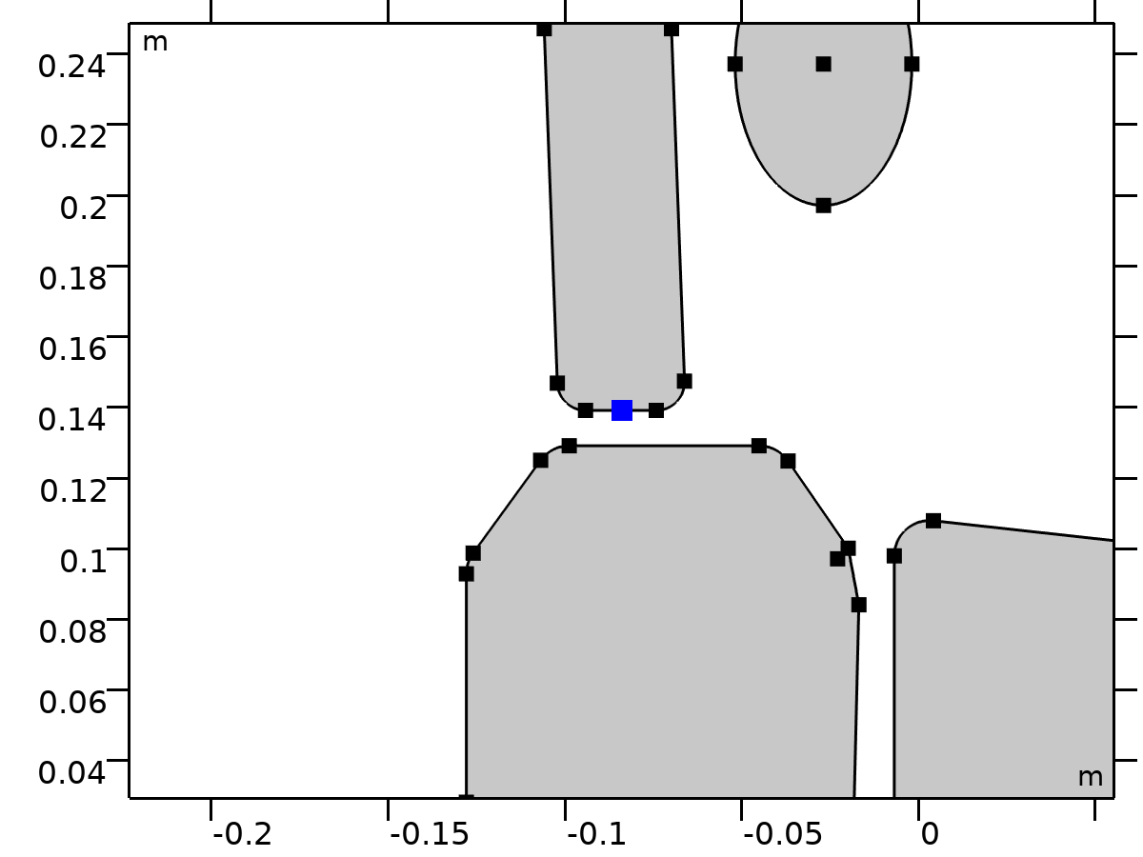

Center of Joint: Point 2

Selection

|  |  |
| --- | --- |
| Geometric entity level | Point |
| Selection | Geometry geom1: Dimension 0: Point 39 |

##### Variables

| **Name** | **Expression** | **Unit** | **Description** | **Selection** | **Details** |
| --- | --- | --- | --- | --- | --- |
| mbd.fxj2.xcx | mbd.fxj2.cjp1.int(X)/mbd.fxj2.cjp1.int(1) | m | Center of joint, x-component | Global | + operation |
| mbd.fxj2.xcy | mbd.fxj2.cjp1.int(Y)/mbd.fxj2.cjp1.int(1) | m | Center of joint, y-component | Global | + operation |
| mbd.fxj2.xcz | mbd.fxj2.cjp1.int(0)/mbd.fxj2.cjp1.int(1) | m | Center of joint, z-component | Global | + operation |

#### Joint Elasticity 2

Selection

|  |  |
| --- | --- |
| Geometric entity level | Entire model |

Equations













##### Elastic Degrees of Freedom

Settings

| **Description** | **Value** |
| --- | --- |
| First axis | On |
| Second axis | On |
| Third axis | On |

##### Spring

Settings

| **Description** | **Value** | **Unit** |
| --- | --- | --- |
| Translational-rotational coupling | Off |  |
| Spring constant, xx-component | {k2, k2, 0} | N/m |
| Spring constant | kr2 | N·m/rad |

##### Viscous Damping

Settings

| **Description** | **Value** | **Unit** |
| --- | --- | --- |
| Translational-rotational coupling | Off |  |
| Damping coefficient, xx-component | if(i_c==1, c2, 0) | N·s/m |
| Damping coefficient | if(i_c==1, cr2, 0) | N·m·s/rad |

##### Coordinate System Selection

Settings

| **Description** | **Value** |
| --- | --- |
| Coordinate system | Joint coordinate system |

##### Variables

| **Name** | **Expression** | **Unit** | **Description** | **Selection** | **Details** |
| --- | --- | --- | --- | --- | --- |
| mbd.Ws_tot | mbd.fxj2.Ws_el | J | Total elastic strain energy | Global | + operation |
| mbd.fxj2.u_el | mbd.fxj2.u1*mbd.fxj2.e1x+mbd.fxj2.u2*mbd.fxj2.e2x | m | Relative displacement (elastic), x-component | Global | + operation |
| mbd.fxj2.v_el | mbd.fxj2.u1*mbd.fxj2.e1y+mbd.fxj2.u2*mbd.fxj2.e2y | m | Relative displacement (elastic), y-component | Global | + operation |
| mbd.fxj2.w_el | mbd.fxj2.u1*mbd.fxj2.e1z+mbd.fxj2.u2*mbd.fxj2.e2z | m | Relative displacement (elastic), z-component | Global | + operation |
| mbd.fxj2.th_el | mbd.fxj2.th | rad | Relative rotation (elastic) | Global | + operation |
| mbd.fxj2.je1.k_u11 | k2 | N/m | Spring constant, xx-component | Global |  |
| mbd.fxj2.je1.k_u21 | 0 | N/m | Spring constant, yx-component | Global |  |
| mbd.fxj2.je1.k_u31 | 0 | N/m | Spring constant, zx-component | Global |  |
| mbd.fxj2.je1.k_u12 | 0 | N/m | Spring constant, xy-component | Global |  |
| mbd.fxj2.je1.k_u22 | k2 | N/m | Spring constant, yy-component | Global |  |
| mbd.fxj2.je1.k_u32 | 0 | N/m | Spring constant, zy-component | Global |  |
| mbd.fxj2.je1.k_u13 | 0 | N/m | Spring constant, xz-component | Global |  |
| mbd.fxj2.je1.k_u23 | 0 | N/m | Spring constant, yz-component | Global |  |
| mbd.fxj2.je1.k_u33 | 0 | N/m | Spring constant, zz-component | Global |  |
| mbd.fxj2.je1.k_th | kr2 | N·m/rad | Spring constant | Global |  |
| mbd.fxj2.je1.c_u11 | if(i_c==1,c2,0) | N·s/m | Damping coefficient, xx-component | Global |  |
| mbd.fxj2.je1.c_u21 | 0 | N·s/m | Damping coefficient, yx-component | Global |  |
| mbd.fxj2.je1.c_u31 | 0 | N·s/m | Damping coefficient, zx-component | Global |  |
| mbd.fxj2.je1.c_u12 | 0 | N·s/m | Damping coefficient, xy-component | Global |  |
| mbd.fxj2.je1.c_u22 | if(i_c==1,c2,0) | N·s/m | Damping coefficient, yy-component | Global |  |
| mbd.fxj2.je1.c_u32 | 0 | N·s/m | Damping coefficient, zy-component | Global |  |
| mbd.fxj2.je1.c_u13 | 0 | N·s/m | Damping coefficient, xz-component | Global |  |
| mbd.fxj2.je1.c_u23 | 0 | N·s/m | Damping coefficient, yz-component | Global |  |
| mbd.fxj2.je1.c_u33 | if(i_c==1,c2,0) | N·s/m | Damping coefficient, zz-component | Global |  |
| mbd.fxj2.je1.c_th | if(i_c==1,cr2,0) | N·m·s/rad | Damping coefficient | Global |  |
| mbd.fxj2.u1 | mbd.fxj2.U1 | m | Relative displacement along joint axis | Global |  |
| mbd.fxj2.u2 | mbd.fxj2.U2 | m | Relative displacement along second axis | Global |  |
| mbd.fxj2.th | mbd.fxj2.Th | rad | Relative rotation | Global |  |
| mbd.fxj2.kl_u11 | mbd.fxj2.je1.k_u11 | N/m | Spring constant, joint coordinate system, 11-component | Global |  |
| mbd.fxj2.kl_u21 | mbd.fxj2.je1.k_u21 | N/m | Spring constant, joint coordinate system, 21-component | Global |  |
| mbd.fxj2.kl_u31 | mbd.fxj2.je1.k_u31 | N/m | Spring constant, joint coordinate system, 31-component | Global |  |
| mbd.fxj2.kl_u12 | mbd.fxj2.je1.k_u12 | N/m | Spring constant, joint coordinate system, 12-component | Global |  |
| mbd.fxj2.kl_u22 | mbd.fxj2.je1.k_u22 | N/m | Spring constant, joint coordinate system, 22-component | Global |  |
| mbd.fxj2.kl_u32 | mbd.fxj2.je1.k_u32 | N/m | Spring constant, joint coordinate system, 32-component | Global |  |
| mbd.fxj2.kl_u13 | mbd.fxj2.je1.k_u13 | N/m | Spring constant, joint coordinate system, 13-component | Global |  |
| mbd.fxj2.kl_u23 | mbd.fxj2.je1.k_u23 | N/m | Spring constant, joint coordinate system, 23-component | Global |  |
| mbd.fxj2.kl_u33 | mbd.fxj2.je1.k_u33 | N/m | Spring constant, joint coordinate system, 33-component | Global |  |
| mbd.fxj2.cl_u11 | mbd.fxj2.je1.c_u11 | N·s/m | Damping coefficient, joint coordinate system, 11-component | Global |  |
| mbd.fxj2.cl_u21 | mbd.fxj2.je1.c_u21 | N·s/m | Damping coefficient, joint coordinate system, 21-component | Global |  |
| mbd.fxj2.cl_u31 | mbd.fxj2.je1.c_u31 | N·s/m | Damping coefficient, joint coordinate system, 31-component | Global |  |
| mbd.fxj2.cl_u12 | mbd.fxj2.je1.c_u12 | N·s/m | Damping coefficient, joint coordinate system, 12-component | Global |  |
| mbd.fxj2.cl_u22 | mbd.fxj2.je1.c_u22 | N·s/m | Damping coefficient, joint coordinate system, 22-component | Global |  |
| mbd.fxj2.cl_u32 | mbd.fxj2.je1.c_u32 | N·s/m | Damping coefficient, joint coordinate system, 32-component | Global |  |
| mbd.fxj2.cl_u13 | mbd.fxj2.je1.c_u13 | N·s/m | Damping coefficient, joint coordinate system, 13-component | Global |  |
| mbd.fxj2.cl_u23 | mbd.fxj2.je1.c_u23 | N·s/m | Damping coefficient, joint coordinate system, 23-component | Global |  |
| mbd.fxj2.cl_u33 | mbd.fxj2.je1.c_u33 | N·s/m | Damping coefficient, joint coordinate system, 33-component | Global |  |
| mbd.fxj2.ul_el | mbd.fxj2.u1 | m | Relative displacement (elastic), joint coordinate system, 1-component | Global | + operation |
| mbd.fxj2.vl_el | mbd.fxj2.u2 | m | Relative displacement (elastic), joint coordinate system, 2-component | Global | + operation |
| mbd.fxj2.wl_el | 0 | m | Relative displacement (elastic), joint coordinate system, 3-component | Global | + operation |
| mbd.fxj2.Fs_el1 | mbd.fxj2.kl_u11*mbd.fxj2.ul_el+mbd.fxj2.kl_u12*mbd.fxj2.vl_el+mbd.fxj2.kl_u13*mbd.fxj2.wl_el | N | Spring force, joint coordinate system, 1-component | Global | + operation |
| mbd.fxj2.Fs_el2 | mbd.fxj2.kl_u21*mbd.fxj2.ul_el+mbd.fxj2.kl_u22*mbd.fxj2.vl_el+mbd.fxj2.kl_u23*mbd.fxj2.wl_el | N | Spring force, joint coordinate system, 2-component | Global | + operation |
| mbd.fxj2.Fs_el3 | mbd.fxj2.kl_u31*mbd.fxj2.ul_el+mbd.fxj2.kl_u32*mbd.fxj2.vl_el+mbd.fxj2.kl_u33*mbd.fxj2.wl_el | N | Spring force, joint coordinate system, 3-component | Global | + operation |
| mbd.fxj2.Ms_el | mbd.fxj2.je1.k_th*mbd.fxj2.th_el | N·m | Spring moment, joint coordinate system | Global | + operation |
| mbd.fxj2.Fd_el1 | (mbd.fxj2.cl_u11*mbd.fxj2.ul_el+mbd.fxj2.cl_u12*mbd.fxj2.vl_el+mbd.fxj2.cl_u13*mbd.fxj2.wl_el)*mbd.iomega | N | Damping force, joint coordinate system, 1-component | Global | + operation |
| mbd.fxj2.Fd_el2 | (mbd.fxj2.cl_u21*mbd.fxj2.ul_el+mbd.fxj2.cl_u22*mbd.fxj2.vl_el+mbd.fxj2.cl_u23*mbd.fxj2.wl_el)*mbd.iomega | N | Damping force, joint coordinate system, 2-component | Global | + operation |
| mbd.fxj2.Fd_el3 | (mbd.fxj2.cl_u31*mbd.fxj2.ul_el+mbd.fxj2.cl_u32*mbd.fxj2.vl_el+mbd.fxj2.cl_u33*mbd.fxj2.wl_el)*mbd.iomega | N | Damping force, joint coordinate system, 3-component | Global | + operation |
| mbd.fxj2.Md_el | mbd.fxj2.je1.c_th*mbd.fxj2.th_el*mbd.iomega | N·m | Damping moment, joint coordinate system | Global | + operation |
| mbd.fxj2.Fl_el1 | -mbd.fxj2.Fd_el1-mbd.fxj2.Fs_el1 | N | Joint force (elastic), local coordinate system, 1-component | Global | + operation |
| mbd.fxj2.Fl_el2 | -mbd.fxj2.Fd_el2-mbd.fxj2.Fs_el2 | N | Joint force (elastic), local coordinate system, 2-component | Global | + operation |
| mbd.fxj2.Fl_el3 | -mbd.fxj2.Fd_el3-mbd.fxj2.Fs_el3 | N | Joint force (elastic), local coordinate system, 3-component | Global | + operation |
| mbd.fxj2.Ml_el1 | 0 | N·m | Joint moment (elastic), local coordinate system, 1-component | Global | + operation |
| mbd.fxj2.Ml_el2 | 0 | N·m | Joint moment (elastic), local coordinate system, 2-component | Global | + operation |
| mbd.fxj2.Ml_el3 | -mbd.fxj2.Md_el-mbd.fxj2.Ms_el | N·m | Joint moment (elastic), local coordinate system, 3-component | Global | + operation |
| mbd.fxj2.F_elx | mbd.fxj2.e1x*mbd.fxj2.Fl_el1+mbd.fxj2.e2x*mbd.fxj2.Fl_el2+mbd.fxj2.e3x*mbd.fxj2.Fl_el3 | N | Joint force (elastic), x-component | Global |  |
| mbd.fxj2.F_ely | mbd.fxj2.e1y*mbd.fxj2.Fl_el1+mbd.fxj2.e2y*mbd.fxj2.Fl_el2+mbd.fxj2.e3y*mbd.fxj2.Fl_el3 | N | Joint force (elastic), y-component | Global |  |
| mbd.fxj2.F_elz | mbd.fxj2.e1z*mbd.fxj2.Fl_el1+mbd.fxj2.e2z*mbd.fxj2.Fl_el2+mbd.fxj2.e3z*mbd.fxj2.Fl_el3 | N | Joint force (elastic), z-component | Global |  |
| mbd.fxj2.M_elx | mbd.fxj2.e1x*mbd.fxj2.Ml_el1+mbd.fxj2.e2x*mbd.fxj2.Ml_el2+mbd.fxj2.e3x*mbd.fxj2.Ml_el3 | N·m | Joint moment (elastic), x-component | Global |  |
| mbd.fxj2.M_ely | mbd.fxj2.e1y*mbd.fxj2.Ml_el1+mbd.fxj2.e2y*mbd.fxj2.Ml_el2+mbd.fxj2.e3y*mbd.fxj2.Ml_el3 | N·m | Joint moment (elastic), y-component | Global |  |
| mbd.fxj2.M_elz | mbd.fxj2.e1z*mbd.fxj2.Ml_el1+mbd.fxj2.e2z*mbd.fxj2.Ml_el2+mbd.fxj2.e3z*mbd.fxj2.Ml_el3 | N·m | Joint moment (elastic), z-component | Global |  |
| mbd.fxj2.Ws_el | 0.25*(realdot(mbd.fxj2.Fs_el1,mbd.fxj2.ul_el)+realdot(mbd.fxj2.Fs_el2,mbd.fxj2.vl_el)+realdot(mbd.fxj2.Fs_el3,mbd.fxj2.wl_el)+realdot(mbd.fxj2.Ms_el,mbd.fxj2.th_el)) | J | Energy stored in spring | Global |  |
| mbd.fxj2.Qd_el | 0.5*mbd.omega^2*(realdot(mbd.fxj2.Fd_el1/mbd.iomega,mbd.fxj2.ul_el)+realdot(mbd.fxj2.Fd_el2/mbd.iomega,mbd.fxj2.vl_el)+realdot(mbd.fxj2.Fd_el3/mbd.iomega,mbd.fxj2.wl_el)+realdot(mbd.fxj2.Md_el/mbd.iomega,mbd.fxj2.th_el)) | W | Energy dissipation rate in damper | Global |  |

##### Shape functions

| **Name** | **Shape function** | **Unit** | **Description** | **Shape frame** | **Selection** |
| --- | --- | --- | --- | --- | --- |
| mbd.fxj2.U1 | ODE | m | Relative displacement along joint axis |  | Global |
| mbd.fxj2.U2 | ODE | m | Relative displacement along second axis |  | Global |
| mbd.fxj2.Th | ODE | rad | Relative rotation |  | Global |

##### Weak Expressions

| **Weak expression** | **Integration order** | **Integration frame** | **Selection** |
| --- | --- | --- | --- |
| mbd.fxj2.Fl_el1*test(mbd.fxj2.ul_el)+mbd.fxj2.Fl_el2*test(mbd.fxj2.vl_el)+mbd.fxj2.Fl_el3*test(mbd.fxj2.wl_el) | 2 |  | Global |
| mbd.fxj2.Ml_el3*test(mbd.fxj2.th_el) | 2 |  | Global |

### Pelvis-Thigh



Pelvis-Thigh



Pelvis-Thigh

Selection

|  |  |
| --- | --- |
| Geometric entity level | Entire model |

Equations











#### Attachment Selection

Settings

| **Description** | **Value** |
| --- | --- |
| Source | Pelvis |
| Destination | Thigh |
| Use selection filter | Off |

#### Center of Joint

Settings

| **Description** | **Value** |
| --- | --- |
| Center of joint | Centroid of selected entities |
| Entity level | Point |
| Offset | Off |

#### Axis of Joint

Settings

| **Description** | **Value** |
| --- | --- |
| Axis of joint | Specify direction |
| Axis of joint, x-component | 1 |
| Axis of joint, y-component | 0 |
| Axis of joint, z-component | 0 |

#### Joint Elasticity

Settings

| **Description** | **Value** |
| --- | --- |
| Joint elasticity | Elastic joint |

#### Joint Forces and Moments

Settings

| **Description** | **Value** |
| --- | --- |
| Joint forces and moments | Do not compute |

#### Coordinate System Selection

Settings

| **Description** | **Value** |
| --- | --- |
| Coordinate system | Global coordinate system |

#### Variables

| **Name** | **Expression** | **Unit** | **Description** | **Selection** |
| --- | --- | --- | --- | --- |
| mbd.fxj3.e10x | 1 | 1 | Initial joint axis, x-component | Global |
| mbd.fxj3.e10y | 0 | 1 | Initial joint axis, y-component | Global |
| mbd.fxj3.e10z | 0 | 1 | Initial joint axis, z-component | Global |
| mbd.fxj3.e20x | (mbd.fxj3.e10z*mbd.fxj3.e30y-mbd.fxj3.e10y*mbd.fxj3.e30z)/sqrt((mbd.fxj3.e10z*mbd.fxj3.e30y-mbd.fxj3.e10y*mbd.fxj3.e30z)^2+(-mbd.fxj3.e10z*mbd.fxj3.e30x+mbd.fxj3.e10x*mbd.fxj3.e30z)^2+(mbd.fxj3.e10y*mbd.fxj3.e30x-mbd.fxj3.e10x*mbd.fxj3.e30y)^2) | 1 | Initial second axis, x-component | Global |
| mbd.fxj3.e20y | (-mbd.fxj3.e10z*mbd.fxj3.e30x+mbd.fxj3.e10x*mbd.fxj3.e30z)/sqrt((mbd.fxj3.e10z*mbd.fxj3.e30y-mbd.fxj3.e10y*mbd.fxj3.e30z)^2+(-mbd.fxj3.e10z*mbd.fxj3.e30x+mbd.fxj3.e10x*mbd.fxj3.e30z)^2+(mbd.fxj3.e10y*mbd.fxj3.e30x-mbd.fxj3.e10x*mbd.fxj3.e30y)^2) | 1 | Initial second axis, y-component | Global |
| mbd.fxj3.e20z | (mbd.fxj3.e10y*mbd.fxj3.e30x-mbd.fxj3.e10x*mbd.fxj3.e30y)/sqrt((mbd.fxj3.e10z*mbd.fxj3.e30y-mbd.fxj3.e10y*mbd.fxj3.e30z)^2+(-mbd.fxj3.e10z*mbd.fxj3.e30x+mbd.fxj3.e10x*mbd.fxj3.e30z)^2+(mbd.fxj3.e10y*mbd.fxj3.e30x-mbd.fxj3.e10x*mbd.fxj3.e30y)^2) | 1 | Initial second axis, z-component | Global |
| mbd.fxj3.e30x | 0 | 1 | Initial third axis, x-component | Global |
| mbd.fxj3.e30y | 0 | 1 | Initial third axis, y-component | Global |
| mbd.fxj3.e30z | 1 | 1 | Initial third axis, z-component | Global |
| mbd.fxj3.e1x | mbd.rd1.rotxx*mbd.fxj3.e10x+mbd.rd1.rotxy*mbd.fxj3.e10y+mbd.rd1.rotxz*mbd.fxj3.e10z | 1 | Joint axis, x-component | Global |
| mbd.fxj3.e1y | mbd.rd1.rotyx*mbd.fxj3.e10x+mbd.rd1.rotyy*mbd.fxj3.e10y+mbd.rd1.rotyz*mbd.fxj3.e10z | 1 | Joint axis, y-component | Global |
| mbd.fxj3.e1z | mbd.rd1.rotzx*mbd.fxj3.e10x+mbd.rd1.rotzy*mbd.fxj3.e10y+mbd.rd1.rotzz*mbd.fxj3.e10z | 1 | Joint axis, z-component | Global |
| mbd.fxj3.e2x | mbd.rd1.rotxx*mbd.fxj3.e20x+mbd.rd1.rotxy*mbd.fxj3.e20y+mbd.rd1.rotxz*mbd.fxj3.e20z | 1 | Second axis, x-component | Global |
| mbd.fxj3.e2y | mbd.rd1.rotyx*mbd.fxj3.e20x+mbd.rd1.rotyy*mbd.fxj3.e20y+mbd.rd1.rotyz*mbd.fxj3.e20z | 1 | Second axis, y-component | Global |
| mbd.fxj3.e2z | mbd.rd1.rotzx*mbd.fxj3.e20x+mbd.rd1.rotzy*mbd.fxj3.e20y+mbd.rd1.rotzz*mbd.fxj3.e20z | 1 | Second axis, z-component | Global |
| mbd.fxj3.e3x | mbd.rd1.rotxx*mbd.fxj3.e30x+mbd.rd1.rotxy*mbd.fxj3.e30y+mbd.rd1.rotxz*mbd.fxj3.e30z | 1 | Third axis, x-component | Global |
| mbd.fxj3.e3y | mbd.rd1.rotyx*mbd.fxj3.e30x+mbd.rd1.rotyy*mbd.fxj3.e30y+mbd.rd1.rotyz*mbd.fxj3.e30z | 1 | Third axis, y-component | Global |
| mbd.fxj3.e3z | mbd.rd1.rotzx*mbd.fxj3.e30x+mbd.rd1.rotzy*mbd.fxj3.e30y+mbd.rd1.rotzz*mbd.fxj3.e30z | 1 | Third axis, z-component | Global |
| mbd.fxj3.uc_src | mbd.rd1.rotxx*(mbd.fxj3.xcx-mbd.rd1.xcx)+mbd.rd1.rotxy*(mbd.fxj3.xcy-mbd.rd1.xcy)+mbd.rd1.rotxz*(mbd.fxj3.xcz-mbd.rd1.xcz)-mbd.fxj3.xcx+mbd.rd1.xcx+mbd.rd1.u+mbd.fxj3.u_el | m | Source displacement at center of joint, x-component | Global |
| mbd.fxj3.vc_src | mbd.rd1.rotyx*(mbd.fxj3.xcx-mbd.rd1.xcx)+mbd.rd1.rotyy*(mbd.fxj3.xcy-mbd.rd1.xcy)+mbd.rd1.rotyz*(mbd.fxj3.xcz-mbd.rd1.xcz)-mbd.fxj3.xcy+mbd.rd1.xcy+mbd.rd1.v+mbd.fxj3.v_el | m | Source displacement at center of joint, y-component | Global |
| mbd.fxj3.wc_src | mbd.rd1.rotzx*(mbd.fxj3.xcx-mbd.rd1.xcx)+mbd.rd1.rotzy*(mbd.fxj3.xcy-mbd.rd1.xcy)+mbd.rd1.rotzz*(mbd.fxj3.xcz-mbd.rd1.xcz)-mbd.fxj3.xcz+mbd.rd1.xcz+mbd.fxj3.w_el | m | Source displacement at center of joint, z-component | Global |
| mbd.fxj3.uc_dest | mbd.rd5.rotxx*(mbd.fxj3.xcx-mbd.rd5.xcx)+mbd.rd5.rotxy*(mbd.fxj3.xcy-mbd.rd5.xcy)+mbd.rd5.rotxz*(mbd.fxj3.xcz-mbd.rd5.xcz)-mbd.fxj3.xcx+mbd.rd5.xcx+mbd.rd5.u | m | Destination displacement at center of joint, x-component | Global |
| mbd.fxj3.vc_dest | mbd.rd5.rotyx*(mbd.fxj3.xcx-mbd.rd5.xcx)+mbd.rd5.rotyy*(mbd.fxj3.xcy-mbd.rd5.xcy)+mbd.rd5.rotyz*(mbd.fxj3.xcz-mbd.rd5.xcz)-mbd.fxj3.xcy+mbd.rd5.xcy+mbd.rd5.v | m | Destination displacement at center of joint, y-component | Global |
| mbd.fxj3.wc_dest | mbd.rd5.rotzx*(mbd.fxj3.xcx-mbd.rd5.xcx)+mbd.rd5.rotzy*(mbd.fxj3.xcy-mbd.rd5.xcy)+mbd.rd5.rotzz*(mbd.fxj3.xcz-mbd.rd5.xcz)-mbd.fxj3.xcz+mbd.rd5.xcz | m | Destination displacement at center of joint, z-component | Global |
| mbd.fxj3.phi_src | mbd.rd1.phi+mbd.fxj3.th_el | rad | Source rotation | Global |
| mbd.fxj3.phi_dest | mbd.rd5.phi | rad | Destination rotation | Global |

#### Constraints

| **Constraint** | **Constraint force** | **Shape function** | **Selection** | **Details** |
| --- | --- | --- | --- | --- |
| mbd.fxj3.uc_src-mbd.fxj3.uc_dest | test(mbd.fxj3.uc_src-mbd.fxj3.uc_dest) |  | Global | Elemental |
| mbd.fxj3.vc_src-mbd.fxj3.vc_dest | test(mbd.fxj3.vc_src-mbd.fxj3.vc_dest) |  | Global | Elemental |
| mbd.fxj3.phi_src-mbd.fxj3.phi_dest | test(mbd.fxj3.phi_src-mbd.fxj3.phi_dest) |  | Global | Elemental |

#### Center of Joint: Point 3

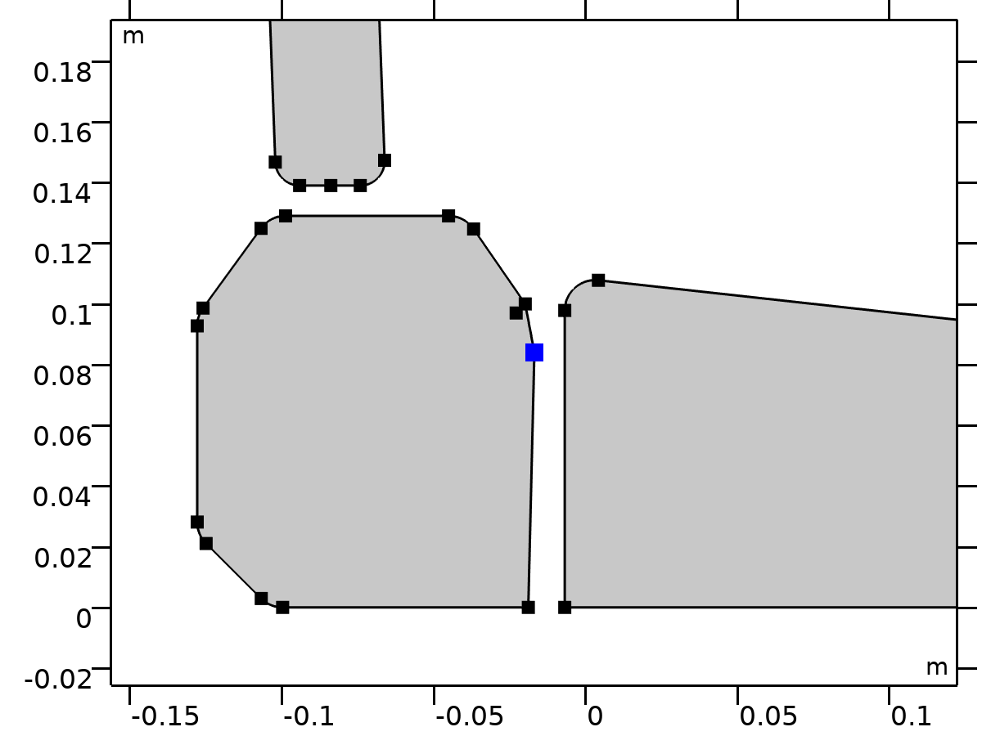

Center of Joint: Point 3

Selection

|  |  |
| --- | --- |
| Geometric entity level | Point |
| Selection | Geometry geom1: Dimension 0: Point 14 |

##### Variables

| **Name** | **Expression** | **Unit** | **Description** | **Selection** | **Details** |
| --- | --- | --- | --- | --- | --- |
| mbd.fxj3.xcx | mbd.fxj3.cjp1.int(X)/mbd.fxj3.cjp1.int(1) | m | Center of joint, x-component | Global | + operation |
| mbd.fxj3.xcy | mbd.fxj3.cjp1.int(Y)/mbd.fxj3.cjp1.int(1) | m | Center of joint, y-component | Global | + operation |
| mbd.fxj3.xcz | mbd.fxj3.cjp1.int(0)/mbd.fxj3.cjp1.int(1) | m | Center of joint, z-component | Global | + operation |

#### Joint Elasticity 3

Selection

|  |  |
| --- | --- |
| Geometric entity level | Entire model |

Equations













##### Elastic Degrees of Freedom

Settings

| **Description** | **Value** |
| --- | --- |
| First axis | On |
| Second axis | On |
| Third axis | On |

##### Spring

Settings

| **Description** | **Value** | **Unit** |
| --- | --- | --- |
| Translational-rotational coupling | Off |  |
| Spring constant, xx-component | {k3, k3, 0} | N/m |
| Spring constant | kr3 | N·m/rad |

##### Viscous Damping

Settings

| **Description** | **Value** | **Unit** |
| --- | --- | --- |
| Translational-rotational coupling | Off |  |
| Damping coefficient, xx-component | {if(i_c==1, c3, 0), if(i_c==1, c3, 0), 0} | N·s/m |
| Damping coefficient | if(i_c==1, cr3, 0) | N·m·s/rad |

##### Coordinate System Selection

Settings

| **Description** | **Value** |
| --- | --- |
| Coordinate system | Joint coordinate system |

##### Variables

| **Name** | **Expression** | **Unit** | **Description** | **Selection** | **Details** |
| --- | --- | --- | --- | --- | --- |
| mbd.Ws_tot | mbd.fxj3.Ws_el | J | Total elastic strain energy | Global | + operation |
| mbd.fxj3.u_el | mbd.fxj3.u1*mbd.fxj3.e1x+mbd.fxj3.u2*mbd.fxj3.e2x | m | Relative displacement (elastic), x-component | Global | + operation |
| mbd.fxj3.v_el | mbd.fxj3.u1*mbd.fxj3.e1y+mbd.fxj3.u2*mbd.fxj3.e2y | m | Relative displacement (elastic), y-component | Global | + operation |
| mbd.fxj3.w_el | mbd.fxj3.u1*mbd.fxj3.e1z+mbd.fxj3.u2*mbd.fxj3.e2z | m | Relative displacement (elastic), z-component | Global | + operation |
| mbd.fxj3.th_el | mbd.fxj3.th | rad | Relative rotation (elastic) | Global | + operation |
| mbd.fxj3.je1.k_u11 | k3 | N/m | Spring constant, xx-component | Global |  |
| mbd.fxj3.je1.k_u21 | 0 | N/m | Spring constant, yx-component | Global |  |
| mbd.fxj3.je1.k_u31 | 0 | N/m | Spring constant, zx-component | Global |  |
| mbd.fxj3.je1.k_u12 | 0 | N/m | Spring constant, xy-component | Global |  |
| mbd.fxj3.je1.k_u22 | k3 | N/m | Spring constant, yy-component | Global |  |
| mbd.fxj3.je1.k_u32 | 0 | N/m | Spring constant, zy-component | Global |  |
| mbd.fxj3.je1.k_u13 | 0 | N/m | Spring constant, xz-component | Global |  |
| mbd.fxj3.je1.k_u23 | 0 | N/m | Spring constant, yz-component | Global |  |
| mbd.fxj3.je1.k_u33 | 0 | N/m | Spring constant, zz-component | Global |  |
| mbd.fxj3.je1.k_th | kr3 | N·m/rad | Spring constant | Global |  |
| mbd.fxj3.je1.c_u11 | if(i_c==1,c3,0) | N·s/m | Damping coefficient, xx-component | Global |  |
| mbd.fxj3.je1.c_u21 | 0 | N·s/m | Damping coefficient, yx-component | Global |  |
| mbd.fxj3.je1.c_u31 | 0 | N·s/m | Damping coefficient, zx-component | Global |  |
| mbd.fxj3.je1.c_u12 | 0 | N·s/m | Damping coefficient, xy-component | Global |  |
| mbd.fxj3.je1.c_u22 | if(i_c==1,c3,0) | N·s/m | Damping coefficient, yy-component | Global |  |
| mbd.fxj3.je1.c_u32 | 0 | N·s/m | Damping coefficient, zy-component | Global |  |
| mbd.fxj3.je1.c_u13 | 0 | N·s/m | Damping coefficient, xz-component | Global |  |
| mbd.fxj3.je1.c_u23 | 0 | N·s/m | Damping coefficient, yz-component | Global |  |
| mbd.fxj3.je1.c_u33 | 0 | N·s/m | Damping coefficient, zz-component | Global |  |
| mbd.fxj3.je1.c_th | if(i_c==1,cr3,0) | N·m·s/rad | Damping coefficient | Global |  |
| mbd.fxj3.u1 | mbd.fxj3.U1 | m | Relative displacement along joint axis | Global |  |
| mbd.fxj3.u2 | mbd.fxj3.U2 | m | Relative displacement along second axis | Global |  |
| mbd.fxj3.th | mbd.fxj3.Th | rad | Relative rotation | Global |  |
| mbd.fxj3.kl_u11 | mbd.fxj3.je1.k_u11 | N/m | Spring constant, joint coordinate system, 11-component | Global |  |
| mbd.fxj3.kl_u21 | mbd.fxj3.je1.k_u21 | N/m | Spring constant, joint coordinate system, 21-component | Global |  |
| mbd.fxj3.kl_u31 | mbd.fxj3.je1.k_u31 | N/m | Spring constant, joint coordinate system, 31-component | Global |  |
| mbd.fxj3.kl_u12 | mbd.fxj3.je1.k_u12 | N/m | Spring constant, joint coordinate system, 12-component | Global |  |
| mbd.fxj3.kl_u22 | mbd.fxj3.je1.k_u22 | N/m | Spring constant, joint coordinate system, 22-component | Global |  |
| mbd.fxj3.kl_u32 | mbd.fxj3.je1.k_u32 | N/m | Spring constant, joint coordinate system, 32-component | Global |  |
| mbd.fxj3.kl_u13 | mbd.fxj3.je1.k_u13 | N/m | Spring constant, joint coordinate system, 13-component | Global |  |
| mbd.fxj3.kl_u23 | mbd.fxj3.je1.k_u23 | N/m | Spring constant, joint coordinate system, 23-component | Global |  |
| mbd.fxj3.kl_u33 | mbd.fxj3.je1.k_u33 | N/m | Spring constant, joint coordinate system, 33-component | Global |  |
| mbd.fxj3.cl_u11 | mbd.fxj3.je1.c_u11 | N·s/m | Damping coefficient, joint coordinate system, 11-component | Global |  |
| mbd.fxj3.cl_u21 | mbd.fxj3.je1.c_u21 | N·s/m | Damping coefficient, joint coordinate system, 21-component | Global |  |
| mbd.fxj3.cl_u31 | mbd.fxj3.je1.c_u31 | N·s/m | Damping coefficient, joint coordinate system, 31-component | Global |  |
| mbd.fxj3.cl_u12 | mbd.fxj3.je1.c_u12 | N·s/m | Damping coefficient, joint coordinate system, 12-component | Global |  |
| mbd.fxj3.cl_u22 | mbd.fxj3.je1.c_u22 | N·s/m | Damping coefficient, joint coordinate system, 22-component | Global |  |
| mbd.fxj3.cl_u32 | mbd.fxj3.je1.c_u32 | N·s/m | Damping coefficient, joint coordinate system, 32-component | Global |  |
| mbd.fxj3.cl_u13 | mbd.fxj3.je1.c_u13 | N·s/m | Damping coefficient, joint coordinate system, 13-component | Global |  |
| mbd.fxj3.cl_u23 | mbd.fxj3.je1.c_u23 | N·s/m | Damping coefficient, joint coordinate system, 23-component | Global |  |
| mbd.fxj3.cl_u33 | mbd.fxj3.je1.c_u33 | N·s/m | Damping coefficient, joint coordinate system, 33-component | Global |  |
| mbd.fxj3.ul_el | mbd.fxj3.u1 | m | Relative displacement (elastic), joint coordinate system, 1-component | Global | + operation |
| mbd.fxj3.vl_el | mbd.fxj3.u2 | m | Relative displacement (elastic), joint coordinate system, 2-component | Global | + operation |
| mbd.fxj3.wl_el | 0 | m | Relative displacement (elastic), joint coordinate system, 3-component | Global | + operation |
| mbd.fxj3.Fs_el1 | mbd.fxj3.kl_u11*mbd.fxj3.ul_el+mbd.fxj3.kl_u12*mbd.fxj3.vl_el+mbd.fxj3.kl_u13*mbd.fxj3.wl_el | N | Spring force, joint coordinate system, 1-component | Global | + operation |
| mbd.fxj3.Fs_el2 | mbd.fxj3.kl_u21*mbd.fxj3.ul_el+mbd.fxj3.kl_u22*mbd.fxj3.vl_el+mbd.fxj3.kl_u23*mbd.fxj3.wl_el | N | Spring force, joint coordinate system, 2-component | Global | + operation |
| mbd.fxj3.Fs_el3 | mbd.fxj3.kl_u31*mbd.fxj3.ul_el+mbd.fxj3.kl_u32*mbd.fxj3.vl_el+mbd.fxj3.kl_u33*mbd.fxj3.wl_el | N | Spring force, joint coordinate system, 3-component | Global | + operation |
| mbd.fxj3.Ms_el | mbd.fxj3.je1.k_th*mbd.fxj3.th_el | N·m | Spring moment, joint coordinate system | Global | + operation |
| mbd.fxj3.Fd_el1 | (mbd.fxj3.cl_u11*mbd.fxj3.ul_el+mbd.fxj3.cl_u12*mbd.fxj3.vl_el+mbd.fxj3.cl_u13*mbd.fxj3.wl_el)*mbd.iomega | N | Damping force, joint coordinate system, 1-component | Global | + operation |
| mbd.fxj3.Fd_el2 | (mbd.fxj3.cl_u21*mbd.fxj3.ul_el+mbd.fxj3.cl_u22*mbd.fxj3.vl_el+mbd.fxj3.cl_u23*mbd.fxj3.wl_el)*mbd.iomega | N | Damping force, joint coordinate system, 2-component | Global | + operation |
| mbd.fxj3.Fd_el3 | (mbd.fxj3.cl_u31*mbd.fxj3.ul_el+mbd.fxj3.cl_u32*mbd.fxj3.vl_el+mbd.fxj3.cl_u33*mbd.fxj3.wl_el)*mbd.iomega | N | Damping force, joint coordinate system, 3-component | Global | + operation |
| mbd.fxj3.Md_el | mbd.fxj3.je1.c_th*mbd.fxj3.th_el*mbd.iomega | N·m | Damping moment, joint coordinate system | Global | + operation |
| mbd.fxj3.Fl_el1 | -mbd.fxj3.Fd_el1-mbd.fxj3.Fs_el1 | N | Joint force (elastic), local coordinate system, 1-component | Global | + operation |
| mbd.fxj3.Fl_el2 | -mbd.fxj3.Fd_el2-mbd.fxj3.Fs_el2 | N | Joint force (elastic), local coordinate system, 2-component | Global | + operation |
| mbd.fxj3.Fl_el3 | -mbd.fxj3.Fd_el3-mbd.fxj3.Fs_el3 | N | Joint force (elastic), local coordinate system, 3-component | Global | + operation |
| mbd.fxj3.Ml_el1 | 0 | N·m | Joint moment (elastic), local coordinate system, 1-component | Global | + operation |
| mbd.fxj3.Ml_el2 | 0 | N·m | Joint moment (elastic), local coordinate system, 2-component | Global | + operation |
| mbd.fxj3.Ml_el3 | -mbd.fxj3.Md_el-mbd.fxj3.Ms_el | N·m | Joint moment (elastic), local coordinate system, 3-component | Global | + operation |
| mbd.fxj3.F_elx | mbd.fxj3.e1x*mbd.fxj3.Fl_el1+mbd.fxj3.e2x*mbd.fxj3.Fl_el2+mbd.fxj3.e3x*mbd.fxj3.Fl_el3 | N | Joint force (elastic), x-component | Global |  |
| mbd.fxj3.F_ely | mbd.fxj3.e1y*mbd.fxj3.Fl_el1+mbd.fxj3.e2y*mbd.fxj3.Fl_el2+mbd.fxj3.e3y*mbd.fxj3.Fl_el3 | N | Joint force (elastic), y-component | Global |  |
| mbd.fxj3.F_elz | mbd.fxj3.e1z*mbd.fxj3.Fl_el1+mbd.fxj3.e2z*mbd.fxj3.Fl_el2+mbd.fxj3.e3z*mbd.fxj3.Fl_el3 | N | Joint force (elastic), z-component | Global |  |
| mbd.fxj3.M_elx | mbd.fxj3.e1x*mbd.fxj3.Ml_el1+mbd.fxj3.e2x*mbd.fxj3.Ml_el2+mbd.fxj3.e3x*mbd.fxj3.Ml_el3 | N·m | Joint moment (elastic), x-component | Global |  |
| mbd.fxj3.M_ely | mbd.fxj3.e1y*mbd.fxj3.Ml_el1+mbd.fxj3.e2y*mbd.fxj3.Ml_el2+mbd.fxj3.e3y*mbd.fxj3.Ml_el3 | N·m | Joint moment (elastic), y-component | Global |  |
| mbd.fxj3.M_elz | mbd.fxj3.e1z*mbd.fxj3.Ml_el1+mbd.fxj3.e2z*mbd.fxj3.Ml_el2+mbd.fxj3.e3z*mbd.fxj3.Ml_el3 | N·m | Joint moment (elastic), z-component | Global |  |
| mbd.fxj3.Ws_el | 0.25*(realdot(mbd.fxj3.Fs_el1,mbd.fxj3.ul_el)+realdot(mbd.fxj3.Fs_el2,mbd.fxj3.vl_el)+realdot(mbd.fxj3.Fs_el3,mbd.fxj3.wl_el)+realdot(mbd.fxj3.Ms_el,mbd.fxj3.th_el)) | J | Energy stored in spring | Global |  |
| mbd.fxj3.Qd_el | 0.5*mbd.omega^2*(realdot(mbd.fxj3.Fd_el1/mbd.iomega,mbd.fxj3.ul_el)+realdot(mbd.fxj3.Fd_el2/mbd.iomega,mbd.fxj3.vl_el)+realdot(mbd.fxj3.Fd_el3/mbd.iomega,mbd.fxj3.wl_el)+realdot(mbd.fxj3.Md_el/mbd.iomega,mbd.fxj3.th_el)) | W | Energy dissipation rate in damper | Global |  |

##### Shape functions

| **Name** | **Shape function** | **Unit** | **Description** | **Shape frame** | **Selection** |
| --- | --- | --- | --- | --- | --- |
| mbd.fxj3.U1 | ODE | m | Relative displacement along joint axis |  | Global |
| mbd.fxj3.U2 | ODE | m | Relative displacement along second axis |  | Global |
| mbd.fxj3.Th | ODE | rad | Relative rotation |  | Global |

##### Weak Expressions

| **Weak expression** | **Integration order** | **Integration frame** | **Selection** |
| --- | --- | --- | --- |
| mbd.fxj3.Fl_el1*test(mbd.fxj3.ul_el)+mbd.fxj3.Fl_el2*test(mbd.fxj3.vl_el)+mbd.fxj3.Fl_el3*test(mbd.fxj3.wl_el) | 2 |  | Global |
| mbd.fxj3.Ml_el3*test(mbd.fxj3.th_el) | 2 |  | Global |

### Thigh-Leg



Thigh-Leg



Thigh-Leg

Selection

|  |  |
| --- | --- |
| Geometric entity level | Entire model |

Equations











#### Attachment Selection

Settings

| **Description** | **Value** |
| --- | --- |
| Source | Thigh |
| Destination | Leg |
| Use selection filter | Off |

#### Center of Joint

Settings

| **Description** | **Value** |
| --- | --- |
| Center of joint | Centroid of selected entities |
| Entity level | Point |
| Offset | Off |

#### Axis of Joint

Settings

| **Description** | **Value** |
| --- | --- |
| Axis of joint | Specify direction |
| Axis of joint, x-component | 1 |
| Axis of joint, y-component | 0 |
| Axis of joint, z-component | 0 |

#### Joint Elasticity

Settings

| **Description** | **Value** |
| --- | --- |
| Joint elasticity | Elastic joint |

#### Joint Forces and Moments

Settings

| **Description** | **Value** |
| --- | --- |
| Joint forces and moments | Do not compute |

#### Coordinate System Selection

Settings

| **Description** | **Value** |
| --- | --- |
| Coordinate system | Global coordinate system |

#### Variables

| **Name** | **Expression** | **Unit** | **Description** | **Selection** |
| --- | --- | --- | --- | --- |
| mbd.fxj4.e10x | 1 | 1 | Initial joint axis, x-component | Global |
| mbd.fxj4.e10y | 0 | 1 | Initial joint axis, y-component | Global |
| mbd.fxj4.e10z | 0 | 1 | Initial joint axis, z-component | Global |
| mbd.fxj4.e20x | (mbd.fxj4.e10z*mbd.fxj4.e30y-mbd.fxj4.e10y*mbd.fxj4.e30z)/sqrt((mbd.fxj4.e10z*mbd.fxj4.e30y-mbd.fxj4.e10y*mbd.fxj4.e30z)^2+(-mbd.fxj4.e10z*mbd.fxj4.e30x+mbd.fxj4.e10x*mbd.fxj4.e30z)^2+(mbd.fxj4.e10y*mbd.fxj4.e30x-mbd.fxj4.e10x*mbd.fxj4.e30y)^2) | 1 | Initial second axis, x-component | Global |
| mbd.fxj4.e20y | (-mbd.fxj4.e10z*mbd.fxj4.e30x+mbd.fxj4.e10x*mbd.fxj4.e30z)/sqrt((mbd.fxj4.e10z*mbd.fxj4.e30y-mbd.fxj4.e10y*mbd.fxj4.e30z)^2+(-mbd.fxj4.e10z*mbd.fxj4.e30x+mbd.fxj4.e10x*mbd.fxj4.e30z)^2+(mbd.fxj4.e10y*mbd.fxj4.e30x-mbd.fxj4.e10x*mbd.fxj4.e30y)^2) | 1 | Initial second axis, y-component | Global |
| mbd.fxj4.e20z | (mbd.fxj4.e10y*mbd.fxj4.e30x-mbd.fxj4.e10x*mbd.fxj4.e30y)/sqrt((mbd.fxj4.e10z*mbd.fxj4.e30y-mbd.fxj4.e10y*mbd.fxj4.e30z)^2+(-mbd.fxj4.e10z*mbd.fxj4.e30x+mbd.fxj4.e10x*mbd.fxj4.e30z)^2+(mbd.fxj4.e10y*mbd.fxj4.e30x-mbd.fxj4.e10x*mbd.fxj4.e30y)^2) | 1 | Initial second axis, z-component | Global |
| mbd.fxj4.e30x | 0 | 1 | Initial third axis, x-component | Global |
| mbd.fxj4.e30y | 0 | 1 | Initial third axis, y-component | Global |
| mbd.fxj4.e30z | 1 | 1 | Initial third axis, z-component | Global |
| mbd.fxj4.e1x | mbd.rd5.rotxx*mbd.fxj4.e10x+mbd.rd5.rotxy*mbd.fxj4.e10y+mbd.rd5.rotxz*mbd.fxj4.e10z | 1 | Joint axis, x-component | Global |
| mbd.fxj4.e1y | mbd.rd5.rotyx*mbd.fxj4.e10x+mbd.rd5.rotyy*mbd.fxj4.e10y+mbd.rd5.rotyz*mbd.fxj4.e10z | 1 | Joint axis, y-component | Global |
| mbd.fxj4.e1z | mbd.rd5.rotzx*mbd.fxj4.e10x+mbd.rd5.rotzy*mbd.fxj4.e10y+mbd.rd5.rotzz*mbd.fxj4.e10z | 1 | Joint axis, z-component | Global |
| mbd.fxj4.e2x | mbd.rd5.rotxx*mbd.fxj4.e20x+mbd.rd5.rotxy*mbd.fxj4.e20y+mbd.rd5.rotxz*mbd.fxj4.e20z | 1 | Second axis, x-component | Global |
| mbd.fxj4.e2y | mbd.rd5.rotyx*mbd.fxj4.e20x+mbd.rd5.rotyy*mbd.fxj4.e20y+mbd.rd5.rotyz*mbd.fxj4.e20z | 1 | Second axis, y-component | Global |
| mbd.fxj4.e2z | mbd.rd5.rotzx*mbd.fxj4.e20x+mbd.rd5.rotzy*mbd.fxj4.e20y+mbd.rd5.rotzz*mbd.fxj4.e20z | 1 | Second axis, z-component | Global |
| mbd.fxj4.e3x | mbd.rd5.rotxx*mbd.fxj4.e30x+mbd.rd5.rotxy*mbd.fxj4.e30y+mbd.rd5.rotxz*mbd.fxj4.e30z | 1 | Third axis, x-component | Global |
| mbd.fxj4.e3y | mbd.rd5.rotyx*mbd.fxj4.e30x+mbd.rd5.rotyy*mbd.fxj4.e30y+mbd.rd5.rotyz*mbd.fxj4.e30z | 1 | Third axis, y-component | Global |
| mbd.fxj4.e3z | mbd.rd5.rotzx*mbd.fxj4.e30x+mbd.rd5.rotzy*mbd.fxj4.e30y+mbd.rd5.rotzz*mbd.fxj4.e30z | 1 | Third axis, z-component | Global |
| mbd.fxj4.uc_src | mbd.rd5.rotxx*(mbd.fxj4.xcx-mbd.rd5.xcx)+mbd.rd5.rotxy*(mbd.fxj4.xcy-mbd.rd5.xcy)+mbd.rd5.rotxz*(mbd.fxj4.xcz-mbd.rd5.xcz)-mbd.fxj4.xcx+mbd.rd5.xcx+mbd.rd5.u+mbd.fxj4.u_el | m | Source displacement at center of joint, x-component | Global |
| mbd.fxj4.vc_src | mbd.rd5.rotyx*(mbd.fxj4.xcx-mbd.rd5.xcx)+mbd.rd5.rotyy*(mbd.fxj4.xcy-mbd.rd5.xcy)+mbd.rd5.rotyz*(mbd.fxj4.xcz-mbd.rd5.xcz)-mbd.fxj4.xcy+mbd.rd5.xcy+mbd.rd5.v+mbd.fxj4.v_el | m | Source displacement at center of joint, y-component | Global |
| mbd.fxj4.wc_src | mbd.rd5.rotzx*(mbd.fxj4.xcx-mbd.rd5.xcx)+mbd.rd5.rotzy*(mbd.fxj4.xcy-mbd.rd5.xcy)+mbd.rd5.rotzz*(mbd.fxj4.xcz-mbd.rd5.xcz)-mbd.fxj4.xcz+mbd.rd5.xcz+mbd.fxj4.w_el | m | Source displacement at center of joint, z-component | Global |
| mbd.fxj4.uc_dest | mbd.rd6.rotxx*(mbd.fxj4.xcx-mbd.rd6.xcx)+mbd.rd6.rotxy*(mbd.fxj4.xcy-mbd.rd6.xcy)+mbd.rd6.rotxz*(mbd.fxj4.xcz-mbd.rd6.xcz)-mbd.fxj4.xcx+mbd.rd6.xcx+mbd.rd6.u | m | Destination displacement at center of joint, x-component | Global |
| mbd.fxj4.vc_dest | mbd.rd6.rotyx*(mbd.fxj4.xcx-mbd.rd6.xcx)+mbd.rd6.rotyy*(mbd.fxj4.xcy-mbd.rd6.xcy)+mbd.rd6.rotyz*(mbd.fxj4.xcz-mbd.rd6.xcz)-mbd.fxj4.xcy+mbd.rd6.xcy+mbd.rd6.v | m | Destination displacement at center of joint, y-component | Global |
| mbd.fxj4.wc_dest | mbd.rd6.rotzx*(mbd.fxj4.xcx-mbd.rd6.xcx)+mbd.rd6.rotzy*(mbd.fxj4.xcy-mbd.rd6.xcy)+mbd.rd6.rotzz*(mbd.fxj4.xcz-mbd.rd6.xcz)-mbd.fxj4.xcz+mbd.rd6.xcz | m | Destination displacement at center of joint, z-component | Global |
| mbd.fxj4.phi_src | mbd.rd5.phi+mbd.fxj4.th_el | rad | Source rotation | Global |
| mbd.fxj4.phi_dest | mbd.rd6.phi | rad | Destination rotation | Global |

#### Constraints

| **Constraint** | **Constraint force** | **Shape function** | **Selection** | **Details** |
| --- | --- | --- | --- | --- |
| mbd.fxj4.uc_src-mbd.fxj4.uc_dest | test(mbd.fxj4.uc_src-mbd.fxj4.uc_dest) |  | Global | Elemental |
| mbd.fxj4.vc_src-mbd.fxj4.vc_dest | test(mbd.fxj4.vc_src-mbd.fxj4.vc_dest) |  | Global | Elemental |
| mbd.fxj4.phi_src-mbd.fxj4.phi_dest | test(mbd.fxj4.phi_src-mbd.fxj4.phi_dest) |  | Global | Elemental |

#### Center of Joint: Point 4

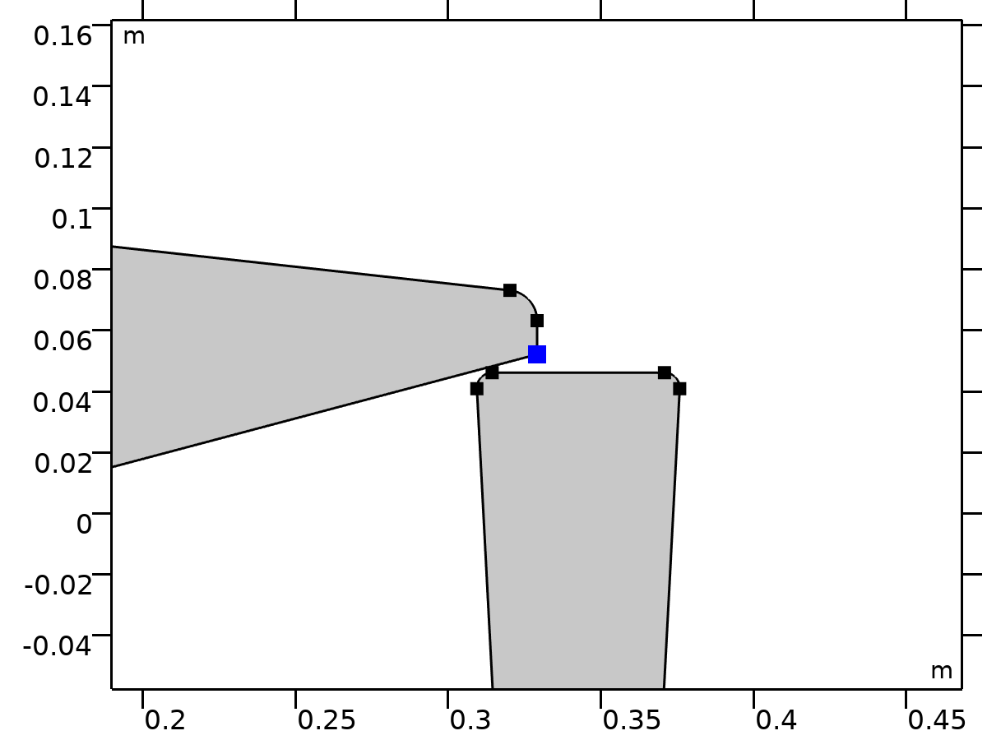

Center of Joint: Point 4

Selection

|  |  |
| --- | --- |
| Geometric entity level | Point |
| Selection | Geometry geom1: Dimension 0: Point 64 |

##### Variables

| **Name** | **Expression** | **Unit** | **Description** | **Selection** | **Details** |
| --- | --- | --- | --- | --- | --- |
| mbd.fxj4.xcx | mbd.fxj4.cjp1.int(X)/mbd.fxj4.cjp1.int(1) | m | Center of joint, x-component | Global | + operation |
| mbd.fxj4.xcy | mbd.fxj4.cjp1.int(Y)/mbd.fxj4.cjp1.int(1) | m | Center of joint, y-component | Global | + operation |
| mbd.fxj4.xcz | mbd.fxj4.cjp1.int(0)/mbd.fxj4.cjp1.int(1) | m | Center of joint, z-component | Global | + operation |

#### Joint Elasticity 4

Selection

|  |  |
| --- | --- |
| Geometric entity level | Entire model |

Equations













##### Elastic Degrees of Freedom

Settings

| **Description** | **Value** |
| --- | --- |
| First axis | On |
| Second axis | On |
| Third axis | On |

##### Spring

Settings

| **Description** | **Value** | **Unit** |
| --- | --- | --- |
| Translational-rotational coupling | Off |  |
| Spring constant, xx-component | {k4, k4, 0} | N/m |
| Spring constant | kr4 | N·m/rad |

##### Viscous Damping

Settings

| **Description** | **Value** | **Unit** |
| --- | --- | --- |
| Translational-rotational coupling | Off |  |
| Damping coefficient, xx-component | if(i_c==1, c4, 0) | N·s/m |
| Damping coefficient | if(i_c==1, cr4, 0) | N·m·s/rad |

##### Coordinate System Selection

Settings

| **Description** | **Value** |
| --- | --- |
| Coordinate system | Joint coordinate system |

##### Variables

| **Name** | **Expression** | **Unit** | **Description** | **Selection** | **Details** |
| --- | --- | --- | --- | --- | --- |
| mbd.Ws_tot | mbd.fxj4.Ws_el | J | Total elastic strain energy | Global | + operation |
| mbd.fxj4.u_el | mbd.fxj4.u1*mbd.fxj4.e1x+mbd.fxj4.u2*mbd.fxj4.e2x | m | Relative displacement (elastic), x-component | Global | + operation |
| mbd.fxj4.v_el | mbd.fxj4.u1*mbd.fxj4.e1y+mbd.fxj4.u2*mbd.fxj4.e2y | m | Relative displacement (elastic), y-component | Global | + operation |
| mbd.fxj4.w_el | mbd.fxj4.u1*mbd.fxj4.e1z+mbd.fxj4.u2*mbd.fxj4.e2z | m | Relative displacement (elastic), z-component | Global | + operation |
| mbd.fxj4.th_el | mbd.fxj4.th | rad | Relative rotation (elastic) | Global | + operation |
| mbd.fxj4.je1.k_u11 | k4 | N/m | Spring constant, xx-component | Global |  |
| mbd.fxj4.je1.k_u21 | 0 | N/m | Spring constant, yx-component | Global |  |
| mbd.fxj4.je1.k_u31 | 0 | N/m | Spring constant, zx-component | Global |  |
| mbd.fxj4.je1.k_u12 | 0 | N/m | Spring constant, xy-component | Global |  |
| mbd.fxj4.je1.k_u22 | k4 | N/m | Spring constant, yy-component | Global |  |
| mbd.fxj4.je1.k_u32 | 0 | N/m | Spring constant, zy-component | Global |  |
| mbd.fxj4.je1.k_u13 | 0 | N/m | Spring constant, xz-component | Global |  |
| mbd.fxj4.je1.k_u23 | 0 | N/m | Spring constant, yz-component | Global |  |
| mbd.fxj4.je1.k_u33 | 0 | N/m | Spring constant, zz-component | Global |  |
| mbd.fxj4.je1.k_th | kr4 | N·m/rad | Spring constant | Global |  |
| mbd.fxj4.je1.c_u11 | if(i_c==1,c4,0) | N·s/m | Damping coefficient, xx-component | Global |  |
| mbd.fxj4.je1.c_u21 | 0 | N·s/m | Damping coefficient, yx-component | Global |  |
| mbd.fxj4.je1.c_u31 | 0 | N·s/m | Damping coefficient, zx-component | Global |  |
| mbd.fxj4.je1.c_u12 | 0 | N·s/m | Damping coefficient, xy-component | Global |  |
| mbd.fxj4.je1.c_u22 | if(i_c==1,c4,0) | N·s/m | Damping coefficient, yy-component | Global |  |
| mbd.fxj4.je1.c_u32 | 0 | N·s/m | Damping coefficient, zy-component | Global |  |
| mbd.fxj4.je1.c_u13 | 0 | N·s/m | Damping coefficient, xz-component | Global |  |
| mbd.fxj4.je1.c_u23 | 0 | N·s/m | Damping coefficient, yz-component | Global |  |
| mbd.fxj4.je1.c_u33 | if(i_c==1,c4,0) | N·s/m | Damping coefficient, zz-component | Global |  |
| mbd.fxj4.je1.c_th | if(i_c==1,cr4,0) | N·m·s/rad | Damping coefficient | Global |  |
| mbd.fxj4.u1 | mbd.fxj4.U1 | m | Relative displacement along joint axis | Global |  |
| mbd.fxj4.u2 | mbd.fxj4.U2 | m | Relative displacement along second axis | Global |  |
| mbd.fxj4.th | mbd.fxj4.Th | rad | Relative rotation | Global |  |
| mbd.fxj4.kl_u11 | mbd.fxj4.je1.k_u11 | N/m | Spring constant, joint coordinate system, 11-component | Global |  |
| mbd.fxj4.kl_u21 | mbd.fxj4.je1.k_u21 | N/m | Spring constant, joint coordinate system, 21-component | Global |  |
| mbd.fxj4.kl_u31 | mbd.fxj4.je1.k_u31 | N/m | Spring constant, joint coordinate system, 31-component | Global |  |
| mbd.fxj4.kl_u12 | mbd.fxj4.je1.k_u12 | N/m | Spring constant, joint coordinate system, 12-component | Global |  |
| mbd.fxj4.kl_u22 | mbd.fxj4.je1.k_u22 | N/m | Spring constant, joint coordinate system, 22-component | Global |  |
| mbd.fxj4.kl_u32 | mbd.fxj4.je1.k_u32 | N/m | Spring constant, joint coordinate system, 32-component | Global |  |
| mbd.fxj4.kl_u13 | mbd.fxj4.je1.k_u13 | N/m | Spring constant, joint coordinate system, 13-component | Global |  |
| mbd.fxj4.kl_u23 | mbd.fxj4.je1.k_u23 | N/m | Spring constant, joint coordinate system, 23-component | Global |  |
| mbd.fxj4.kl_u33 | mbd.fxj4.je1.k_u33 | N/m | Spring constant, joint coordinate system, 33-component | Global |  |
| mbd.fxj4.cl_u11 | mbd.fxj4.je1.c_u11 | N·s/m | Damping coefficient, joint coordinate system, 11-component | Global |  |
| mbd.fxj4.cl_u21 | mbd.fxj4.je1.c_u21 | N·s/m | Damping coefficient, joint coordinate system, 21-component | Global |  |
| mbd.fxj4.cl_u31 | mbd.fxj4.je1.c_u31 | N·s/m | Damping coefficient, joint coordinate system, 31-component | Global |  |
| mbd.fxj4.cl_u12 | mbd.fxj4.je1.c_u12 | N·s/m | Damping coefficient, joint coordinate system, 12-component | Global |  |
| mbd.fxj4.cl_u22 | mbd.fxj4.je1.c_u22 | N·s/m | Damping coefficient, joint coordinate system, 22-component | Global |  |
| mbd.fxj4.cl_u32 | mbd.fxj4.je1.c_u32 | N·s/m | Damping coefficient, joint coordinate system, 32-component | Global |  |
| mbd.fxj4.cl_u13 | mbd.fxj4.je1.c_u13 | N·s/m | Damping coefficient, joint coordinate system, 13-component | Global |  |
| mbd.fxj4.cl_u23 | mbd.fxj4.je1.c_u23 | N·s/m | Damping coefficient, joint coordinate system, 23-component | Global |  |
| mbd.fxj4.cl_u33 | mbd.fxj4.je1.c_u33 | N·s/m | Damping coefficient, joint coordinate system, 33-component | Global |  |
| mbd.fxj4.ul_el | mbd.fxj4.u1 | m | Relative displacement (elastic), joint coordinate system, 1-component | Global | + operation |
| mbd.fxj4.vl_el | mbd.fxj4.u2 | m | Relative displacement (elastic), joint coordinate system, 2-component | Global | + operation |
| mbd.fxj4.wl_el | 0 | m | Relative displacement (elastic), joint coordinate system, 3-component | Global | + operation |
| mbd.fxj4.Fs_el1 | mbd.fxj4.kl_u11*mbd.fxj4.ul_el+mbd.fxj4.kl_u12*mbd.fxj4.vl_el+mbd.fxj4.kl_u13*mbd.fxj4.wl_el | N | Spring force, joint coordinate system, 1-component | Global | + operation |
| mbd.fxj4.Fs_el2 | mbd.fxj4.kl_u21*mbd.fxj4.ul_el+mbd.fxj4.kl_u22*mbd.fxj4.vl_el+mbd.fxj4.kl_u23*mbd.fxj4.wl_el | N | Spring force, joint coordinate system, 2-component | Global | + operation |
| mbd.fxj4.Fs_el3 | mbd.fxj4.kl_u31*mbd.fxj4.ul_el+mbd.fxj4.kl_u32*mbd.fxj4.vl_el+mbd.fxj4.kl_u33*mbd.fxj4.wl_el | N | Spring force, joint coordinate system, 3-component | Global | + operation |
| mbd.fxj4.Ms_el | mbd.fxj4.je1.k_th*mbd.fxj4.th_el | N·m | Spring moment, joint coordinate system | Global | + operation |
| mbd.fxj4.Fd_el1 | (mbd.fxj4.cl_u11*mbd.fxj4.ul_el+mbd.fxj4.cl_u12*mbd.fxj4.vl_el+mbd.fxj4.cl_u13*mbd.fxj4.wl_el)*mbd.iomega | N | Damping force, joint coordinate system, 1-component | Global | + operation |
| mbd.fxj4.Fd_el2 | (mbd.fxj4.cl_u21*mbd.fxj4.ul_el+mbd.fxj4.cl_u22*mbd.fxj4.vl_el+mbd.fxj4.cl_u23*mbd.fxj4.wl_el)*mbd.iomega | N | Damping force, joint coordinate system, 2-component | Global | + operation |
| mbd.fxj4.Fd_el3 | (mbd.fxj4.cl_u31*mbd.fxj4.ul_el+mbd.fxj4.cl_u32*mbd.fxj4.vl_el+mbd.fxj4.cl_u33*mbd.fxj4.wl_el)*mbd.iomega | N | Damping force, joint coordinate system, 3-component | Global | + operation |
| mbd.fxj4.Md_el | mbd.fxj4.je1.c_th*mbd.fxj4.th_el*mbd.iomega | N·m | Damping moment, joint coordinate system | Global | + operation |
| mbd.fxj4.Fl_el1 | -mbd.fxj4.Fd_el1-mbd.fxj4.Fs_el1 | N | Joint force (elastic), local coordinate system, 1-component | Global | + operation |
| mbd.fxj4.Fl_el2 | -mbd.fxj4.Fd_el2-mbd.fxj4.Fs_el2 | N | Joint force (elastic), local coordinate system, 2-component | Global | + operation |
| mbd.fxj4.Fl_el3 | -mbd.fxj4.Fd_el3-mbd.fxj4.Fs_el3 | N | Joint force (elastic), local coordinate system, 3-component | Global | + operation |
| mbd.fxj4.Ml_el1 | 0 | N·m | Joint moment (elastic), local coordinate system, 1-component | Global | + operation |
| mbd.fxj4.Ml_el2 | 0 | N·m | Joint moment (elastic), local coordinate system, 2-component | Global | + operation |
| mbd.fxj4.Ml_el3 | -mbd.fxj4.Md_el-mbd.fxj4.Ms_el | N·m | Joint moment (elastic), local coordinate system, 3-component | Global | + operation |
| mbd.fxj4.F_elx | mbd.fxj4.e1x*mbd.fxj4.Fl_el1+mbd.fxj4.e2x*mbd.fxj4.Fl_el2+mbd.fxj4.e3x*mbd.fxj4.Fl_el3 | N | Joint force (elastic), x-component | Global |  |
| mbd.fxj4.F_ely | mbd.fxj4.e1y*mbd.fxj4.Fl_el1+mbd.fxj4.e2y*mbd.fxj4.Fl_el2+mbd.fxj4.e3y*mbd.fxj4.Fl_el3 | N | Joint force (elastic), y-component | Global |  |
| mbd.fxj4.F_elz | mbd.fxj4.e1z*mbd.fxj4.Fl_el1+mbd.fxj4.e2z*mbd.fxj4.Fl_el2+mbd.fxj4.e3z*mbd.fxj4.Fl_el3 | N | Joint force (elastic), z-component | Global |  |
| mbd.fxj4.M_elx | mbd.fxj4.e1x*mbd.fxj4.Ml_el1+mbd.fxj4.e2x*mbd.fxj4.Ml_el2+mbd.fxj4.e3x*mbd.fxj4.Ml_el3 | N·m | Joint moment (elastic), x-component | Global |  |
| mbd.fxj4.M_ely | mbd.fxj4.e1y*mbd.fxj4.Ml_el1+mbd.fxj4.e2y*mbd.fxj4.Ml_el2+mbd.fxj4.e3y*mbd.fxj4.Ml_el3 | N·m | Joint moment (elastic), y-component | Global |  |
| mbd.fxj4.M_elz | mbd.fxj4.e1z*mbd.fxj4.Ml_el1+mbd.fxj4.e2z*mbd.fxj4.Ml_el2+mbd.fxj4.e3z*mbd.fxj4.Ml_el3 | N·m | Joint moment (elastic), z-component | Global |  |
| mbd.fxj4.Ws_el | 0.25*(realdot(mbd.fxj4.Fs_el1,mbd.fxj4.ul_el)+realdot(mbd.fxj4.Fs_el2,mbd.fxj4.vl_el)+realdot(mbd.fxj4.Fs_el3,mbd.fxj4.wl_el)+realdot(mbd.fxj4.Ms_el,mbd.fxj4.th_el)) | J | Energy stored in spring | Global |  |
| mbd.fxj4.Qd_el | 0.5*mbd.omega^2*(realdot(mbd.fxj4.Fd_el1/mbd.iomega,mbd.fxj4.ul_el)+realdot(mbd.fxj4.Fd_el2/mbd.iomega,mbd.fxj4.vl_el)+realdot(mbd.fxj4.Fd_el3/mbd.iomega,mbd.fxj4.wl_el)+realdot(mbd.fxj4.Md_el/mbd.iomega,mbd.fxj4.th_el)) | W | Energy dissipation rate in damper | Global |  |

##### Shape functions

| **Name** | **Shape function** | **Unit** | **Description** | **Shape frame** | **Selection** |
| --- | --- | --- | --- | --- | --- |
| mbd.fxj4.U1 | ODE | m | Relative displacement along joint axis |  | Global |
| mbd.fxj4.U2 | ODE | m | Relative displacement along second axis |  | Global |
| mbd.fxj4.Th | ODE | rad | Relative rotation |  | Global |

##### Weak Expressions

| **Weak expression** | **Integration order** | **Integration frame** | **Selection** |
| --- | --- | --- | --- |
| mbd.fxj4.Fl_el1*test(mbd.fxj4.ul_el)+mbd.fxj4.Fl_el2*test(mbd.fxj4.vl_el)+mbd.fxj4.Fl_el3*test(mbd.fxj4.wl_el) | 2 |  | Global |
| mbd.fxj4.Ml_el3*test(mbd.fxj4.th_el) | 2 |  | Global |

### Viscera-Torso



Viscera-Torso



Viscera-Torso

Selection

|  |  |
| --- | --- |
| Geometric entity level | Entire model |

Equations











#### Attachment Selection

Settings

| **Description** | **Value** |
| --- | --- |
| Source | Viscera |
| Destination | Torso |
| Use selection filter | Off |

#### Center of Joint

Settings

| **Description** | **Value** |
| --- | --- |
| Center of joint | Centroid of selected entities |
| Entity level | Point |
| Offset | Off |

#### Axis of Joint

Settings

| **Description** | **Value** |
| --- | --- |
| Axis of joint | Specify direction |
| Axis of joint, x-component | 1 |
| Axis of joint, y-component | 0 |
| Axis of joint, z-component | 0 |

#### Joint Elasticity

Settings

| **Description** | **Value** |
| --- | --- |
| Joint elasticity | Elastic joint |

#### Joint Forces and Moments

Settings

| **Description** | **Value** |
| --- | --- |
| Joint forces and moments | Do not compute |

#### Coordinate System Selection

Settings

| **Description** | **Value** |
| --- | --- |
| Coordinate system | Global coordinate system |

#### Variables

| **Name** | **Expression** | **Unit** | **Description** | **Selection** |
| --- | --- | --- | --- | --- |
| mbd.fxj5.e10x | 1 | 1 | Initial joint axis, x-component | Global |
| mbd.fxj5.e10y | 0 | 1 | Initial joint axis, y-component | Global |
| mbd.fxj5.e10z | 0 | 1 | Initial joint axis, z-component | Global |
| mbd.fxj5.e20x | (mbd.fxj5.e10z*mbd.fxj5.e30y-mbd.fxj5.e10y*mbd.fxj5.e30z)/sqrt((mbd.fxj5.e10z*mbd.fxj5.e30y-mbd.fxj5.e10y*mbd.fxj5.e30z)^2+(-mbd.fxj5.e10z*mbd.fxj5.e30x+mbd.fxj5.e10x*mbd.fxj5.e30z)^2+(mbd.fxj5.e10y*mbd.fxj5.e30x-mbd.fxj5.e10x*mbd.fxj5.e30y)^2) | 1 | Initial second axis, x-component | Global |
| mbd.fxj5.e20y | (-mbd.fxj5.e10z*mbd.fxj5.e30x+mbd.fxj5.e10x*mbd.fxj5.e30z)/sqrt((mbd.fxj5.e10z*mbd.fxj5.e30y-mbd.fxj5.e10y*mbd.fxj5.e30z)^2+(-mbd.fxj5.e10z*mbd.fxj5.e30x+mbd.fxj5.e10x*mbd.fxj5.e30z)^2+(mbd.fxj5.e10y*mbd.fxj5.e30x-mbd.fxj5.e10x*mbd.fxj5.e30y)^2) | 1 | Initial second axis, y-component | Global |
| mbd.fxj5.e20z | (mbd.fxj5.e10y*mbd.fxj5.e30x-mbd.fxj5.e10x*mbd.fxj5.e30y)/sqrt((mbd.fxj5.e10z*mbd.fxj5.e30y-mbd.fxj5.e10y*mbd.fxj5.e30z)^2+(-mbd.fxj5.e10z*mbd.fxj5.e30x+mbd.fxj5.e10x*mbd.fxj5.e30z)^2+(mbd.fxj5.e10y*mbd.fxj5.e30x-mbd.fxj5.e10x*mbd.fxj5.e30y)^2) | 1 | Initial second axis, z-component | Global |
| mbd.fxj5.e30x | 0 | 1 | Initial third axis, x-component | Global |
| mbd.fxj5.e30y | 0 | 1 | Initial third axis, y-component | Global |
| mbd.fxj5.e30z | 1 | 1 | Initial third axis, z-component | Global |
| mbd.fxj5.e1x | mbd.rd4.rotxx*mbd.fxj5.e10x+mbd.rd4.rotxy*mbd.fxj5.e10y+mbd.rd4.rotxz*mbd.fxj5.e10z | 1 | Joint axis, x-component | Global |
| mbd.fxj5.e1y | mbd.rd4.rotyx*mbd.fxj5.e10x+mbd.rd4.rotyy*mbd.fxj5.e10y+mbd.rd4.rotyz*mbd.fxj5.e10z | 1 | Joint axis, y-component | Global |
| mbd.fxj5.e1z | mbd.rd4.rotzx*mbd.fxj5.e10x+mbd.rd4.rotzy*mbd.fxj5.e10y+mbd.rd4.rotzz*mbd.fxj5.e10z | 1 | Joint axis, z-component | Global |
| mbd.fxj5.e2x | mbd.rd4.rotxx*mbd.fxj5.e20x+mbd.rd4.rotxy*mbd.fxj5.e20y+mbd.rd4.rotxz*mbd.fxj5.e20z | 1 | Second axis, x-component | Global |
| mbd.fxj5.e2y | mbd.rd4.rotyx*mbd.fxj5.e20x+mbd.rd4.rotyy*mbd.fxj5.e20y+mbd.rd4.rotyz*mbd.fxj5.e20z | 1 | Second axis, y-component | Global |
| mbd.fxj5.e2z | mbd.rd4.rotzx*mbd.fxj5.e20x+mbd.rd4.rotzy*mbd.fxj5.e20y+mbd.rd4.rotzz*mbd.fxj5.e20z | 1 | Second axis, z-component | Global |
| mbd.fxj5.e3x | mbd.rd4.rotxx*mbd.fxj5.e30x+mbd.rd4.rotxy*mbd.fxj5.e30y+mbd.rd4.rotxz*mbd.fxj5.e30z | 1 | Third axis, x-component | Global |
| mbd.fxj5.e3y | mbd.rd4.rotyx*mbd.fxj5.e30x+mbd.rd4.rotyy*mbd.fxj5.e30y+mbd.rd4.rotyz*mbd.fxj5.e30z | 1 | Third axis, y-component | Global |
| mbd.fxj5.e3z | mbd.rd4.rotzx*mbd.fxj5.e30x+mbd.rd4.rotzy*mbd.fxj5.e30y+mbd.rd4.rotzz*mbd.fxj5.e30z | 1 | Third axis, z-component | Global |
| mbd.fxj5.uc_src | mbd.rd4.rotxx*(mbd.fxj5.xcx-mbd.rd4.xcx)+mbd.rd4.rotxy*(mbd.fxj5.xcy-mbd.rd4.xcy)+mbd.rd4.rotxz*(mbd.fxj5.xcz-mbd.rd4.xcz)-mbd.fxj5.xcx+mbd.rd4.xcx+mbd.rd4.u+mbd.fxj5.u_el | m | Source displacement at center of joint, x-component | Global |
| mbd.fxj5.vc_src | mbd.rd4.rotyx*(mbd.fxj5.xcx-mbd.rd4.xcx)+mbd.rd4.rotyy*(mbd.fxj5.xcy-mbd.rd4.xcy)+mbd.rd4.rotyz*(mbd.fxj5.xcz-mbd.rd4.xcz)-mbd.fxj5.xcy+mbd.rd4.xcy+mbd.rd4.v+mbd.fxj5.v_el | m | Source displacement at center of joint, y-component | Global |
| mbd.fxj5.wc_src | mbd.rd4.rotzx*(mbd.fxj5.xcx-mbd.rd4.xcx)+mbd.rd4.rotzy*(mbd.fxj5.xcy-mbd.rd4.xcy)+mbd.rd4.rotzz*(mbd.fxj5.xcz-mbd.rd4.xcz)-mbd.fxj5.xcz+mbd.rd4.xcz+mbd.fxj5.w_el | m | Source displacement at center of joint, z-component | Global |
| mbd.fxj5.uc_dest | mbd.rd3.rotxx*(mbd.fxj5.xcx-mbd.rd3.xcx)+mbd.rd3.rotxy*(mbd.fxj5.xcy-mbd.rd3.xcy)+mbd.rd3.rotxz*(mbd.fxj5.xcz-mbd.rd3.xcz)-mbd.fxj5.xcx+mbd.rd3.xcx+mbd.rd3.u | m | Destination displacement at center of joint, x-component | Global |
| mbd.fxj5.vc_dest | mbd.rd3.rotyx*(mbd.fxj5.xcx-mbd.rd3.xcx)+mbd.rd3.rotyy*(mbd.fxj5.xcy-mbd.rd3.xcy)+mbd.rd3.rotyz*(mbd.fxj5.xcz-mbd.rd3.xcz)-mbd.fxj5.xcy+mbd.rd3.xcy+mbd.rd3.v | m | Destination displacement at center of joint, y-component | Global |
| mbd.fxj5.wc_dest | mbd.rd3.rotzx*(mbd.fxj5.xcx-mbd.rd3.xcx)+mbd.rd3.rotzy*(mbd.fxj5.xcy-mbd.rd3.xcy)+mbd.rd3.rotzz*(mbd.fxj5.xcz-mbd.rd3.xcz)-mbd.fxj5.xcz+mbd.rd3.xcz | m | Destination displacement at center of joint, z-component | Global |
| mbd.fxj5.phi_src | mbd.rd4.phi+mbd.fxj5.th_el | rad | Source rotation | Global |
| mbd.fxj5.phi_dest | mbd.rd3.phi | rad | Destination rotation | Global |

#### Constraints

| **Constraint** | **Constraint force** | **Shape function** | **Selection** | **Details** |
| --- | --- | --- | --- | --- |
| mbd.fxj5.uc_src-mbd.fxj5.uc_dest | test(mbd.fxj5.uc_src-mbd.fxj5.uc_dest) |  | Global | Elemental |
| mbd.fxj5.vc_src-mbd.fxj5.vc_dest | test(mbd.fxj5.vc_src-mbd.fxj5.vc_dest) |  | Global | Elemental |
| mbd.fxj5.phi_src-mbd.fxj5.phi_dest | test(mbd.fxj5.phi_src-mbd.fxj5.phi_dest) |  | Global | Elemental |

#### Center of Joint: Point 5



Center of Joint: Point 5

Selection

|  |  |
| --- | --- |
| Geometric entity level | Point |
| Selection | Geometry geom1: Dimension 0: Point 55 |

##### Variables

| **Name** | **Expression** | **Unit** | **Description** | **Selection** | **Details** |
| --- | --- | --- | --- | --- | --- |
| mbd.fxj5.xcx | mbd.fxj5.cjp1.int(X)/mbd.fxj5.cjp1.int(1) | m | Center of joint, x-component | Global | + operation |
| mbd.fxj5.xcy | mbd.fxj5.cjp1.int(Y)/mbd.fxj5.cjp1.int(1) | m | Center of joint, y-component | Global | + operation |
| mbd.fxj5.xcz | mbd.fxj5.cjp1.int(0)/mbd.fxj5.cjp1.int(1) | m | Center of joint, z-component | Global | + operation |

#### Joint Elasticity 5

Selection

|  |  |
| --- | --- |
| Geometric entity level | Entire model |

Equations













##### Elastic Degrees of Freedom

Settings

| **Description** | **Value** |
| --- | --- |
| First axis | On |
| Second axis | On |
| Third axis | On |

##### Spring

Settings

| **Description** | **Value** | **Unit** |
| --- | --- | --- |
| Translational-rotational coupling | Off |  |
| Spring constant, xx-component | {kh5, 0, 0} | N/m |
| Spring constant | 0 | N·m/rad |

##### Viscous Damping

Settings

| **Description** | **Value** | **Unit** |
| --- | --- | --- |
| Translational-rotational coupling | Off |  |
| Damping coefficient, xx-component | {if(i_c==1, ch5, 0), 0, 0} | N·s/m |
| Damping coefficient | 0 | N·m·s/rad |

##### Coordinate System Selection

Settings

| **Description** | **Value** |
| --- | --- |
| Coordinate system | Joint coordinate system |

##### Variables

| **Name** | **Expression** | **Unit** | **Description** | **Selection** | **Details** |
| --- | --- | --- | --- | --- | --- |
| mbd.Ws_tot | mbd.fxj5.Ws_el | J | Total elastic strain energy | Global | + operation |
| mbd.fxj5.u_el | mbd.fxj5.u1*mbd.fxj5.e1x+mbd.fxj5.u2*mbd.fxj5.e2x | m | Relative displacement (elastic), x-component | Global | + operation |
| mbd.fxj5.v_el | mbd.fxj5.u1*mbd.fxj5.e1y+mbd.fxj5.u2*mbd.fxj5.e2y | m | Relative displacement (elastic), y-component | Global | + operation |
| mbd.fxj5.w_el | mbd.fxj5.u1*mbd.fxj5.e1z+mbd.fxj5.u2*mbd.fxj5.e2z | m | Relative displacement (elastic), z-component | Global | + operation |
| mbd.fxj5.th_el | mbd.fxj5.th | rad | Relative rotation (elastic) | Global | + operation |
| mbd.fxj5.je1.k_u11 | kh5 | N/m | Spring constant, xx-component | Global |  |
| mbd.fxj5.je1.k_u21 | 0 | N/m | Spring constant, yx-component | Global |  |
| mbd.fxj5.je1.k_u31 | 0 | N/m | Spring constant, zx-component | Global |  |
| mbd.fxj5.je1.k_u12 | 0 | N/m | Spring constant, xy-component | Global |  |
| mbd.fxj5.je1.k_u22 | 0 | N/m | Spring constant, yy-component | Global |  |
| mbd.fxj5.je1.k_u32 | 0 | N/m | Spring constant, zy-component | Global |  |
| mbd.fxj5.je1.k_u13 | 0 | N/m | Spring constant, xz-component | Global |  |
| mbd.fxj5.je1.k_u23 | 0 | N/m | Spring constant, yz-component | Global |  |
| mbd.fxj5.je1.k_u33 | 0 | N/m | Spring constant, zz-component | Global |  |
| mbd.fxj5.je1.k_th | 0 | N·m/rad | Spring constant | Global |  |
| mbd.fxj5.je1.c_u11 | if(i_c==1,ch5,0) | N·s/m | Damping coefficient, xx-component | Global |  |
| mbd.fxj5.je1.c_u21 | 0 | N·s/m | Damping coefficient, yx-component | Global |  |
| mbd.fxj5.je1.c_u31 | 0 | N·s/m | Damping coefficient, zx-component | Global |  |
| mbd.fxj5.je1.c_u12 | 0 | N·s/m | Damping coefficient, xy-component | Global |  |
| mbd.fxj5.je1.c_u22 | 0 | N·s/m | Damping coefficient, yy-component | Global |  |
| mbd.fxj5.je1.c_u32 | 0 | N·s/m | Damping coefficient, zy-component | Global |  |
| mbd.fxj5.je1.c_u13 | 0 | N·s/m | Damping coefficient, xz-component | Global |  |
| mbd.fxj5.je1.c_u23 | 0 | N·s/m | Damping coefficient, yz-component | Global |  |
| mbd.fxj5.je1.c_u33 | 0 | N·s/m | Damping coefficient, zz-component | Global |  |
| mbd.fxj5.je1.c_th | 0 | N·m·s/rad | Damping coefficient | Global |  |
| mbd.fxj5.u1 | mbd.fxj5.U1 | m | Relative displacement along joint axis | Global |  |
| mbd.fxj5.u2 | mbd.fxj5.U2 | m | Relative displacement along second axis | Global |  |
| mbd.fxj5.th | mbd.fxj5.Th | rad | Relative rotation | Global |  |
| mbd.fxj5.kl_u11 | mbd.fxj5.je1.k_u11 | N/m | Spring constant, joint coordinate system, 11-component | Global |  |
| mbd.fxj5.kl_u21 | mbd.fxj5.je1.k_u21 | N/m | Spring constant, joint coordinate system, 21-component | Global |  |
| mbd.fxj5.kl_u31 | mbd.fxj5.je1.k_u31 | N/m | Spring constant, joint coordinate system, 31-component | Global |  |
| mbd.fxj5.kl_u12 | mbd.fxj5.je1.k_u12 | N/m | Spring constant, joint coordinate system, 12-component | Global |  |
| mbd.fxj5.kl_u22 | mbd.fxj5.je1.k_u22 | N/m | Spring constant, joint coordinate system, 22-component | Global |  |
| mbd.fxj5.kl_u32 | mbd.fxj5.je1.k_u32 | N/m | Spring constant, joint coordinate system, 32-component | Global |  |
| mbd.fxj5.kl_u13 | mbd.fxj5.je1.k_u13 | N/m | Spring constant, joint coordinate system, 13-component | Global |  |
| mbd.fxj5.kl_u23 | mbd.fxj5.je1.k_u23 | N/m | Spring constant, joint coordinate system, 23-component | Global |  |
| mbd.fxj5.kl_u33 | mbd.fxj5.je1.k_u33 | N/m | Spring constant, joint coordinate system, 33-component | Global |  |
| mbd.fxj5.cl_u11 | mbd.fxj5.je1.c_u11 | N·s/m | Damping coefficient, joint coordinate system, 11-component | Global |  |
| mbd.fxj5.cl_u21 | mbd.fxj5.je1.c_u21 | N·s/m | Damping coefficient, joint coordinate system, 21-component | Global |  |
| mbd.fxj5.cl_u31 | mbd.fxj5.je1.c_u31 | N·s/m | Damping coefficient, joint coordinate system, 31-component | Global |  |
| mbd.fxj5.cl_u12 | mbd.fxj5.je1.c_u12 | N·s/m | Damping coefficient, joint coordinate system, 12-component | Global |  |
| mbd.fxj5.cl_u22 | mbd.fxj5.je1.c_u22 | N·s/m | Damping coefficient, joint coordinate system, 22-component | Global |  |
| mbd.fxj5.cl_u32 | mbd.fxj5.je1.c_u32 | N·s/m | Damping coefficient, joint coordinate system, 32-component | Global |  |
| mbd.fxj5.cl_u13 | mbd.fxj5.je1.c_u13 | N·s/m | Damping coefficient, joint coordinate system, 13-component | Global |  |
| mbd.fxj5.cl_u23 | mbd.fxj5.je1.c_u23 | N·s/m | Damping coefficient, joint coordinate system, 23-component | Global |  |
| mbd.fxj5.cl_u33 | mbd.fxj5.je1.c_u33 | N·s/m | Damping coefficient, joint coordinate system, 33-component | Global |  |
| mbd.fxj5.ul_el | mbd.fxj5.u1 | m | Relative displacement (elastic), joint coordinate system, 1-component | Global | + operation |
| mbd.fxj5.vl_el | mbd.fxj5.u2 | m | Relative displacement (elastic), joint coordinate system, 2-component | Global | + operation |
| mbd.fxj5.wl_el | 0 | m | Relative displacement (elastic), joint coordinate system, 3-component | Global | + operation |
| mbd.fxj5.Fs_el1 | mbd.fxj5.kl_u11*mbd.fxj5.ul_el+mbd.fxj5.kl_u12*mbd.fxj5.vl_el+mbd.fxj5.kl_u13*mbd.fxj5.wl_el | N | Spring force, joint coordinate system, 1-component | Global | + operation |
| mbd.fxj5.Fs_el2 | mbd.fxj5.kl_u21*mbd.fxj5.ul_el+mbd.fxj5.kl_u22*mbd.fxj5.vl_el+mbd.fxj5.kl_u23*mbd.fxj5.wl_el | N | Spring force, joint coordinate system, 2-component | Global | + operation |
| mbd.fxj5.Fs_el3 | mbd.fxj5.kl_u31*mbd.fxj5.ul_el+mbd.fxj5.kl_u32*mbd.fxj5.vl_el+mbd.fxj5.kl_u33*mbd.fxj5.wl_el | N | Spring force, joint coordinate system, 3-component | Global | + operation |
| mbd.fxj5.Ms_el | mbd.fxj5.je1.k_th*mbd.fxj5.th_el | N·m | Spring moment, joint coordinate system | Global | + operation |
| mbd.fxj5.Fd_el1 | (mbd.fxj5.cl_u11*mbd.fxj5.ul_el+mbd.fxj5.cl_u12*mbd.fxj5.vl_el+mbd.fxj5.cl_u13*mbd.fxj5.wl_el)*mbd.iomega | N | Damping force, joint coordinate system, 1-component | Global | + operation |
| mbd.fxj5.Fd_el2 | (mbd.fxj5.cl_u21*mbd.fxj5.ul_el+mbd.fxj5.cl_u22*mbd.fxj5.vl_el+mbd.fxj5.cl_u23*mbd.fxj5.wl_el)*mbd.iomega | N | Damping force, joint coordinate system, 2-component | Global | + operation |
| mbd.fxj5.Fd_el3 | (mbd.fxj5.cl_u31*mbd.fxj5.ul_el+mbd.fxj5.cl_u32*mbd.fxj5.vl_el+mbd.fxj5.cl_u33*mbd.fxj5.wl_el)*mbd.iomega | N | Damping force, joint coordinate system, 3-component | Global | + operation |
| mbd.fxj5.Md_el | mbd.fxj5.je1.c_th*mbd.fxj5.th_el*mbd.iomega | N·m | Damping moment, joint coordinate system | Global | + operation |
| mbd.fxj5.Fl_el1 | -mbd.fxj5.Fd_el1-mbd.fxj5.Fs_el1 | N | Joint force (elastic), local coordinate system, 1-component | Global | + operation |
| mbd.fxj5.Fl_el2 | -mbd.fxj5.Fd_el2-mbd.fxj5.Fs_el2 | N | Joint force (elastic), local coordinate system, 2-component | Global | + operation |
| mbd.fxj5.Fl_el3 | -mbd.fxj5.Fd_el3-mbd.fxj5.Fs_el3 | N | Joint force (elastic), local coordinate system, 3-component | Global | + operation |
| mbd.fxj5.Ml_el1 | 0 | N·m | Joint moment (elastic), local coordinate system, 1-component | Global | + operation |
| mbd.fxj5.Ml_el2 | 0 | N·m | Joint moment (elastic), local coordinate system, 2-component | Global | + operation |
| mbd.fxj5.Ml_el3 | -mbd.fxj5.Md_el-mbd.fxj5.Ms_el | N·m | Joint moment (elastic), local coordinate system, 3-component | Global | + operation |
| mbd.fxj5.F_elx | mbd.fxj5.e1x*mbd.fxj5.Fl_el1+mbd.fxj5.e2x*mbd.fxj5.Fl_el2+mbd.fxj5.e3x*mbd.fxj5.Fl_el3 | N | Joint force (elastic), x-component | Global |  |
| mbd.fxj5.F_ely | mbd.fxj5.e1y*mbd.fxj5.Fl_el1+mbd.fxj5.e2y*mbd.fxj5.Fl_el2+mbd.fxj5.e3y*mbd.fxj5.Fl_el3 | N | Joint force (elastic), y-component | Global |  |
| mbd.fxj5.F_elz | mbd.fxj5.e1z*mbd.fxj5.Fl_el1+mbd.fxj5.e2z*mbd.fxj5.Fl_el2+mbd.fxj5.e3z*mbd.fxj5.Fl_el3 | N | Joint force (elastic), z-component | Global |  |
| mbd.fxj5.M_elx | mbd.fxj5.e1x*mbd.fxj5.Ml_el1+mbd.fxj5.e2x*mbd.fxj5.Ml_el2+mbd.fxj5.e3x*mbd.fxj5.Ml_el3 | N·m | Joint moment (elastic), x-component | Global |  |
| mbd.fxj5.M_ely | mbd.fxj5.e1y*mbd.fxj5.Ml_el1+mbd.fxj5.e2y*mbd.fxj5.Ml_el2+mbd.fxj5.e3y*mbd.fxj5.Ml_el3 | N·m | Joint moment (elastic), y-component | Global |  |
| mbd.fxj5.M_elz | mbd.fxj5.e1z*mbd.fxj5.Ml_el1+mbd.fxj5.e2z*mbd.fxj5.Ml_el2+mbd.fxj5.e3z*mbd.fxj5.Ml_el3 | N·m | Joint moment (elastic), z-component | Global |  |
| mbd.fxj5.Ws_el | 0.25*(realdot(mbd.fxj5.Fs_el1,mbd.fxj5.ul_el)+realdot(mbd.fxj5.Fs_el2,mbd.fxj5.vl_el)+realdot(mbd.fxj5.Fs_el3,mbd.fxj5.wl_el)+realdot(mbd.fxj5.Ms_el,mbd.fxj5.th_el)) | J | Energy stored in spring | Global |  |
| mbd.fxj5.Qd_el | 0.5*mbd.omega^2*(realdot(mbd.fxj5.Fd_el1/mbd.iomega,mbd.fxj5.ul_el)+realdot(mbd.fxj5.Fd_el2/mbd.iomega,mbd.fxj5.vl_el)+realdot(mbd.fxj5.Fd_el3/mbd.iomega,mbd.fxj5.wl_el)+realdot(mbd.fxj5.Md_el/mbd.iomega,mbd.fxj5.th_el)) | W | Energy dissipation rate in damper | Global |  |

##### Shape functions

| **Name** | **Shape function** | **Unit** | **Description** | **Shape frame** | **Selection** |
| --- | --- | --- | --- | --- | --- |
| mbd.fxj5.U1 | ODE | m | Relative displacement along joint axis |  | Global |
| mbd.fxj5.U2 | ODE | m | Relative displacement along second axis |  | Global |
| mbd.fxj5.Th | ODE | rad | Relative rotation |  | Global |

##### Weak Expressions

| **Weak expression** | **Integration order** | **Integration frame** | **Selection** |
| --- | --- | --- | --- |
| mbd.fxj5.Fl_el1*test(mbd.fxj5.ul_el)+mbd.fxj5.Fl_el2*test(mbd.fxj5.vl_el)+mbd.fxj5.Fl_el3*test(mbd.fxj5.wl_el) | 2 |  | Global |
| mbd.fxj5.Ml_el3*test(mbd.fxj5.th_el) | 2 |  | Global |

### Viscera-Pelvis



Viscera-Pelvis



Viscera-Pelvis

Selection

|  |  |
| --- | --- |
| Geometric entity level | Entire model |

Equations











#### Attachment Selection

Settings

| **Description** | **Value** |
| --- | --- |
| Source | Viscera |
| Destination | Pelvis |
| Use selection filter | Off |

#### Center of Joint

Settings

| **Description** | **Value** |
| --- | --- |
| Center of joint | Centroid of selected entities |
| Entity level | Point |
| Offset | Off |

#### Axis of Joint

Settings

| **Description** | **Value** |
| --- | --- |
| Axis of joint | Specify direction |
| Axis of joint, x-component | 1 |
| Axis of joint, y-component | 0 |
| Axis of joint, z-component | 0 |

#### Joint Elasticity

Settings

| **Description** | **Value** |
| --- | --- |
| Joint elasticity | Elastic joint |

#### Joint Forces and Moments

Settings

| **Description** | **Value** |
| --- | --- |
| Joint forces and moments | Do not compute |

#### Coordinate System Selection

Settings

| **Description** | **Value** |
| --- | --- |
| Coordinate system | Global coordinate system |

#### Variables

| **Name** | **Expression** | **Unit** | **Description** | **Selection** |
| --- | --- | --- | --- | --- |
| mbd.fxj6.e10x | 1 | 1 | Initial joint axis, x-component | Global |
| mbd.fxj6.e10y | 0 | 1 | Initial joint axis, y-component | Global |
| mbd.fxj6.e10z | 0 | 1 | Initial joint axis, z-component | Global |
| mbd.fxj6.e20x | (mbd.fxj6.e10z*mbd.fxj6.e30y-mbd.fxj6.e10y*mbd.fxj6.e30z)/sqrt((mbd.fxj6.e10z*mbd.fxj6.e30y-mbd.fxj6.e10y*mbd.fxj6.e30z)^2+(-mbd.fxj6.e10z*mbd.fxj6.e30x+mbd.fxj6.e10x*mbd.fxj6.e30z)^2+(mbd.fxj6.e10y*mbd.fxj6.e30x-mbd.fxj6.e10x*mbd.fxj6.e30y)^2) | 1 | Initial second axis, x-component | Global |
| mbd.fxj6.e20y | (-mbd.fxj6.e10z*mbd.fxj6.e30x+mbd.fxj6.e10x*mbd.fxj6.e30z)/sqrt((mbd.fxj6.e10z*mbd.fxj6.e30y-mbd.fxj6.e10y*mbd.fxj6.e30z)^2+(-mbd.fxj6.e10z*mbd.fxj6.e30x+mbd.fxj6.e10x*mbd.fxj6.e30z)^2+(mbd.fxj6.e10y*mbd.fxj6.e30x-mbd.fxj6.e10x*mbd.fxj6.e30y)^2) | 1 | Initial second axis, y-component | Global |
| mbd.fxj6.e20z | (mbd.fxj6.e10y*mbd.fxj6.e30x-mbd.fxj6.e10x*mbd.fxj6.e30y)/sqrt((mbd.fxj6.e10z*mbd.fxj6.e30y-mbd.fxj6.e10y*mbd.fxj6.e30z)^2+(-mbd.fxj6.e10z*mbd.fxj6.e30x+mbd.fxj6.e10x*mbd.fxj6.e30z)^2+(mbd.fxj6.e10y*mbd.fxj6.e30x-mbd.fxj6.e10x*mbd.fxj6.e30y)^2) | 1 | Initial second axis, z-component | Global |
| mbd.fxj6.e30x | 0 | 1 | Initial third axis, x-component | Global |
| mbd.fxj6.e30y | 0 | 1 | Initial third axis, y-component | Global |
| mbd.fxj6.e30z | 1 | 1 | Initial third axis, z-component | Global |
| mbd.fxj6.e1x | mbd.rd4.rotxx*mbd.fxj6.e10x+mbd.rd4.rotxy*mbd.fxj6.e10y+mbd.rd4.rotxz*mbd.fxj6.e10z | 1 | Joint axis, x-component | Global |
| mbd.fxj6.e1y | mbd.rd4.rotyx*mbd.fxj6.e10x+mbd.rd4.rotyy*mbd.fxj6.e10y+mbd.rd4.rotyz*mbd.fxj6.e10z | 1 | Joint axis, y-component | Global |
| mbd.fxj6.e1z | mbd.rd4.rotzx*mbd.fxj6.e10x+mbd.rd4.rotzy*mbd.fxj6.e10y+mbd.rd4.rotzz*mbd.fxj6.e10z | 1 | Joint axis, z-component | Global |
| mbd.fxj6.e2x | mbd.rd4.rotxx*mbd.fxj6.e20x+mbd.rd4.rotxy*mbd.fxj6.e20y+mbd.rd4.rotxz*mbd.fxj6.e20z | 1 | Second axis, x-component | Global |
| mbd.fxj6.e2y | mbd.rd4.rotyx*mbd.fxj6.e20x+mbd.rd4.rotyy*mbd.fxj6.e20y+mbd.rd4.rotyz*mbd.fxj6.e20z | 1 | Second axis, y-component | Global |
| mbd.fxj6.e2z | mbd.rd4.rotzx*mbd.fxj6.e20x+mbd.rd4.rotzy*mbd.fxj6.e20y+mbd.rd4.rotzz*mbd.fxj6.e20z | 1 | Second axis, z-component | Global |
| mbd.fxj6.e3x | mbd.rd4.rotxx*mbd.fxj6.e30x+mbd.rd4.rotxy*mbd.fxj6.e30y+mbd.rd4.rotxz*mbd.fxj6.e30z | 1 | Third axis, x-component | Global |
| mbd.fxj6.e3y | mbd.rd4.rotyx*mbd.fxj6.e30x+mbd.rd4.rotyy*mbd.fxj6.e30y+mbd.rd4.rotyz*mbd.fxj6.e30z | 1 | Third axis, y-component | Global |
| mbd.fxj6.e3z | mbd.rd4.rotzx*mbd.fxj6.e30x+mbd.rd4.rotzy*mbd.fxj6.e30y+mbd.rd4.rotzz*mbd.fxj6.e30z | 1 | Third axis, z-component | Global |
| mbd.fxj6.uc_src | mbd.rd4.rotxx*(mbd.fxj6.xcx-mbd.rd4.xcx)+mbd.rd4.rotxy*(mbd.fxj6.xcy-mbd.rd4.xcy)+mbd.rd4.rotxz*(mbd.fxj6.xcz-mbd.rd4.xcz)-mbd.fxj6.xcx+mbd.rd4.xcx+mbd.rd4.u+mbd.fxj6.u_el | m | Source displacement at center of joint, x-component | Global |
| mbd.fxj6.vc_src | mbd.rd4.rotyx*(mbd.fxj6.xcx-mbd.rd4.xcx)+mbd.rd4.rotyy*(mbd.fxj6.xcy-mbd.rd4.xcy)+mbd.rd4.rotyz*(mbd.fxj6.xcz-mbd.rd4.xcz)-mbd.fxj6.xcy+mbd.rd4.xcy+mbd.rd4.v+mbd.fxj6.v_el | m | Source displacement at center of joint, y-component | Global |
| mbd.fxj6.wc_src | mbd.rd4.rotzx*(mbd.fxj6.xcx-mbd.rd4.xcx)+mbd.rd4.rotzy*(mbd.fxj6.xcy-mbd.rd4.xcy)+mbd.rd4.rotzz*(mbd.fxj6.xcz-mbd.rd4.xcz)-mbd.fxj6.xcz+mbd.rd4.xcz+mbd.fxj6.w_el | m | Source displacement at center of joint, z-component | Global |
| mbd.fxj6.uc_dest | mbd.rd1.rotxx*(mbd.fxj6.xcx-mbd.rd1.xcx)+mbd.rd1.rotxy*(mbd.fxj6.xcy-mbd.rd1.xcy)+mbd.rd1.rotxz*(mbd.fxj6.xcz-mbd.rd1.xcz)-mbd.fxj6.xcx+mbd.rd1.xcx+mbd.rd1.u | m | Destination displacement at center of joint, x-component | Global |
| mbd.fxj6.vc_dest | mbd.rd1.rotyx*(mbd.fxj6.xcx-mbd.rd1.xcx)+mbd.rd1.rotyy*(mbd.fxj6.xcy-mbd.rd1.xcy)+mbd.rd1.rotyz*(mbd.fxj6.xcz-mbd.rd1.xcz)-mbd.fxj6.xcy+mbd.rd1.xcy+mbd.rd1.v | m | Destination displacement at center of joint, y-component | Global |
| mbd.fxj6.wc_dest | mbd.rd1.rotzx*(mbd.fxj6.xcx-mbd.rd1.xcx)+mbd.rd1.rotzy*(mbd.fxj6.xcy-mbd.rd1.xcy)+mbd.rd1.rotzz*(mbd.fxj6.xcz-mbd.rd1.xcz)-mbd.fxj6.xcz+mbd.rd1.xcz | m | Destination displacement at center of joint, z-component | Global |
| mbd.fxj6.phi_src | mbd.rd4.phi+mbd.fxj6.th_el | rad | Source rotation | Global |
| mbd.fxj6.phi_dest | mbd.rd1.phi | rad | Destination rotation | Global |

#### Constraints

| **Constraint** | **Constraint force** | **Shape function** | **Selection** | **Details** |
| --- | --- | --- | --- | --- |
| mbd.fxj6.uc_src-mbd.fxj6.uc_dest | test(mbd.fxj6.uc_src-mbd.fxj6.uc_dest) |  | Global | Elemental |
| mbd.fxj6.vc_src-mbd.fxj6.vc_dest | test(mbd.fxj6.vc_src-mbd.fxj6.vc_dest) |  | Global | Elemental |
| mbd.fxj6.phi_src-mbd.fxj6.phi_dest | test(mbd.fxj6.phi_src-mbd.fxj6.phi_dest) |  | Global | Elemental |

#### Center of Joint: Point 6



Center of Joint: Point 6

Selection

|  |  |
| --- | --- |
| Geometric entity level | Point |
| Selection | Geometry geom1: Dimension 0: Point 55 |

##### Variables

| **Name** | **Expression** | **Unit** | **Description** | **Selection** | **Details** |
| --- | --- | --- | --- | --- | --- |
| mbd.fxj6.xcx | mbd.fxj6.cjp1.int(X)/mbd.fxj6.cjp1.int(1) | m | Center of joint, x-component | Global | + operation |
| mbd.fxj6.xcy | mbd.fxj6.cjp1.int(Y)/mbd.fxj6.cjp1.int(1) | m | Center of joint, y-component | Global | + operation |
| mbd.fxj6.xcz | mbd.fxj6.cjp1.int(0)/mbd.fxj6.cjp1.int(1) | m | Center of joint, z-component | Global | + operation |

#### Joint Elasticity 6

Selection

|  |  |
| --- | --- |
| Geometric entity level | Entire model |

Equations













##### Elastic Degrees of Freedom

Settings

| **Description** | **Value** |
| --- | --- |
| First axis | On |
| Second axis | On |
| Third axis | On |

##### Spring

Settings

| **Description** | **Value** | **Unit** |
| --- | --- | --- |
| Translational-rotational coupling | Off |  |
| Spring constant, xx-component | {0, kv6, 0} | N/m |
| Spring constant | 0 | N·m/rad |

##### Viscous Damping

Settings

| **Description** | **Value** | **Unit** |
| --- | --- | --- |
| Translational-rotational coupling | Off |  |
| Damping coefficient, xx-component | {0, if(i_c==1, cv6, 0), 0} | N·s/m |
| Damping coefficient | 0 | N·m·s/rad |

##### Coordinate System Selection

Settings

| **Description** | **Value** |
| --- | --- |
| Coordinate system | Joint coordinate system |

##### Variables

| **Name** | **Expression** | **Unit** | **Description** | **Selection** | **Details** |
| --- | --- | --- | --- | --- | --- |
| mbd.Ws_tot | mbd.fxj6.Ws_el | J | Total elastic strain energy | Global | + operation |
| mbd.fxj6.u_el | mbd.fxj6.u1*mbd.fxj6.e1x+mbd.fxj6.u2*mbd.fxj6.e2x | m | Relative displacement (elastic), x-component | Global | + operation |
| mbd.fxj6.v_el | mbd.fxj6.u1*mbd.fxj6.e1y+mbd.fxj6.u2*mbd.fxj6.e2y | m | Relative displacement (elastic), y-component | Global | + operation |
| mbd.fxj6.w_el | mbd.fxj6.u1*mbd.fxj6.e1z+mbd.fxj6.u2*mbd.fxj6.e2z | m | Relative displacement (elastic), z-component | Global | + operation |
| mbd.fxj6.th_el | mbd.fxj6.th | rad | Relative rotation (elastic) | Global | + operation |
| mbd.fxj6.je1.k_u11 | 0 | N/m | Spring constant, xx-component | Global |  |
| mbd.fxj6.je1.k_u21 | 0 | N/m | Spring constant, yx-component | Global |  |
| mbd.fxj6.je1.k_u31 | 0 | N/m | Spring constant, zx-component | Global |  |
| mbd.fxj6.je1.k_u12 | 0 | N/m | Spring constant, xy-component | Global |  |
| mbd.fxj6.je1.k_u22 | kv6 | N/m | Spring constant, yy-component | Global |  |
| mbd.fxj6.je1.k_u32 | 0 | N/m | Spring constant, zy-component | Global |  |
| mbd.fxj6.je1.k_u13 | 0 | N/m | Spring constant, xz-component | Global |  |
| mbd.fxj6.je1.k_u23 | 0 | N/m | Spring constant, yz-component | Global |  |
| mbd.fxj6.je1.k_u33 | 0 | N/m | Spring constant, zz-component | Global |  |
| mbd.fxj6.je1.k_th | 0 | N·m/rad | Spring constant | Global |  |
| mbd.fxj6.je1.c_u11 | 0 | N·s/m | Damping coefficient, xx-component | Global |  |
| mbd.fxj6.je1.c_u21 | 0 | N·s/m | Damping coefficient, yx-component | Global |  |
| mbd.fxj6.je1.c_u31 | 0 | N·s/m | Damping coefficient, zx-component | Global |  |
| mbd.fxj6.je1.c_u12 | 0 | N·s/m | Damping coefficient, xy-component | Global |  |
| mbd.fxj6.je1.c_u22 | if(i_c==1,cv6,0) | N·s/m | Damping coefficient, yy-component | Global |  |
| mbd.fxj6.je1.c_u32 | 0 | N·s/m | Damping coefficient, zy-component | Global |  |
| mbd.fxj6.je1.c_u13 | 0 | N·s/m | Damping coefficient, xz-component | Global |  |
| mbd.fxj6.je1.c_u23 | 0 | N·s/m | Damping coefficient, yz-component | Global |  |
| mbd.fxj6.je1.c_u33 | 0 | N·s/m | Damping coefficient, zz-component | Global |  |
| mbd.fxj6.je1.c_th | 0 | N·m·s/rad | Damping coefficient | Global |  |
| mbd.fxj6.u1 | mbd.fxj6.U1 | m | Relative displacement along joint axis | Global |  |
| mbd.fxj6.u2 | mbd.fxj6.U2 | m | Relative displacement along second axis | Global |  |
| mbd.fxj6.th | mbd.fxj6.Th | rad | Relative rotation | Global |  |
| mbd.fxj6.kl_u11 | mbd.fxj6.je1.k_u11 | N/m | Spring constant, joint coordinate system, 11-component | Global |  |
| mbd.fxj6.kl_u21 | mbd.fxj6.je1.k_u21 | N/m | Spring constant, joint coordinate system, 21-component | Global |  |
| mbd.fxj6.kl_u31 | mbd.fxj6.je1.k_u31 | N/m | Spring constant, joint coordinate system, 31-component | Global |  |
| mbd.fxj6.kl_u12 | mbd.fxj6.je1.k_u12 | N/m | Spring constant, joint coordinate system, 12-component | Global |  |
| mbd.fxj6.kl_u22 | mbd.fxj6.je1.k_u22 | N/m | Spring constant, joint coordinate system, 22-component | Global |  |
| mbd.fxj6.kl_u32 | mbd.fxj6.je1.k_u32 | N/m | Spring constant, joint coordinate system, 32-component | Global |  |
| mbd.fxj6.kl_u13 | mbd.fxj6.je1.k_u13 | N/m | Spring constant, joint coordinate system, 13-component | Global |  |
| mbd.fxj6.kl_u23 | mbd.fxj6.je1.k_u23 | N/m | Spring constant, joint coordinate system, 23-component | Global |  |
| mbd.fxj6.kl_u33 | mbd.fxj6.je1.k_u33 | N/m | Spring constant, joint coordinate system, 33-component | Global |  |
| mbd.fxj6.cl_u11 | mbd.fxj6.je1.c_u11 | N·s/m | Damping coefficient, joint coordinate system, 11-component | Global |  |
| mbd.fxj6.cl_u21 | mbd.fxj6.je1.c_u21 | N·s/m | Damping coefficient, joint coordinate system, 21-component | Global |  |
| mbd.fxj6.cl_u31 | mbd.fxj6.je1.c_u31 | N·s/m | Damping coefficient, joint coordinate system, 31-component | Global |  |
| mbd.fxj6.cl_u12 | mbd.fxj6.je1.c_u12 | N·s/m | Damping coefficient, joint coordinate system, 12-component | Global |  |
| mbd.fxj6.cl_u22 | mbd.fxj6.je1.c_u22 | N·s/m | Damping coefficient, joint coordinate system, 22-component | Global |  |
| mbd.fxj6.cl_u32 | mbd.fxj6.je1.c_u32 | N·s/m | Damping coefficient, joint coordinate system, 32-component | Global |  |
| mbd.fxj6.cl_u13 | mbd.fxj6.je1.c_u13 | N·s/m | Damping coefficient, joint coordinate system, 13-component | Global |  |
| mbd.fxj6.cl_u23 | mbd.fxj6.je1.c_u23 | N·s/m | Damping coefficient, joint coordinate system, 23-component | Global |  |
| mbd.fxj6.cl_u33 | mbd.fxj6.je1.c_u33 | N·s/m | Damping coefficient, joint coordinate system, 33-component | Global |  |
| mbd.fxj6.ul_el | mbd.fxj6.u1 | m | Relative displacement (elastic), joint coordinate system, 1-component | Global | + operation |
| mbd.fxj6.vl_el | mbd.fxj6.u2 | m | Relative displacement (elastic), joint coordinate system, 2-component | Global | + operation |
| mbd.fxj6.wl_el | 0 | m | Relative displacement (elastic), joint coordinate system, 3-component | Global | + operation |
| mbd.fxj6.Fs_el1 | mbd.fxj6.kl_u11*mbd.fxj6.ul_el+mbd.fxj6.kl_u12*mbd.fxj6.vl_el+mbd.fxj6.kl_u13*mbd.fxj6.wl_el | N | Spring force, joint coordinate system, 1-component | Global | + operation |
| mbd.fxj6.Fs_el2 | mbd.fxj6.kl_u21*mbd.fxj6.ul_el+mbd.fxj6.kl_u22*mbd.fxj6.vl_el+mbd.fxj6.kl_u23*mbd.fxj6.wl_el | N | Spring force, joint coordinate system, 2-component | Global | + operation |
| mbd.fxj6.Fs_el3 | mbd.fxj6.kl_u31*mbd.fxj6.ul_el+mbd.fxj6.kl_u32*mbd.fxj6.vl_el+mbd.fxj6.kl_u33*mbd.fxj6.wl_el | N | Spring force, joint coordinate system, 3-component | Global | + operation |
| mbd.fxj6.Ms_el | mbd.fxj6.je1.k_th*mbd.fxj6.th_el | N·m | Spring moment, joint coordinate system | Global | + operation |
| mbd.fxj6.Fd_el1 | (mbd.fxj6.cl_u11*mbd.fxj6.ul_el+mbd.fxj6.cl_u12*mbd.fxj6.vl_el+mbd.fxj6.cl_u13*mbd.fxj6.wl_el)*mbd.iomega | N | Damping force, joint coordinate system, 1-component | Global | + operation |
| mbd.fxj6.Fd_el2 | (mbd.fxj6.cl_u21*mbd.fxj6.ul_el+mbd.fxj6.cl_u22*mbd.fxj6.vl_el+mbd.fxj6.cl_u23*mbd.fxj6.wl_el)*mbd.iomega | N | Damping force, joint coordinate system, 2-component | Global | + operation |
| mbd.fxj6.Fd_el3 | (mbd.fxj6.cl_u31*mbd.fxj6.ul_el+mbd.fxj6.cl_u32*mbd.fxj6.vl_el+mbd.fxj6.cl_u33*mbd.fxj6.wl_el)*mbd.iomega | N | Damping force, joint coordinate system, 3-component | Global | + operation |
| mbd.fxj6.Md_el | mbd.fxj6.je1.c_th*mbd.fxj6.th_el*mbd.iomega | N·m | Damping moment, joint coordinate system | Global | + operation |
| mbd.fxj6.Fl_el1 | -mbd.fxj6.Fd_el1-mbd.fxj6.Fs_el1 | N | Joint force (elastic), local coordinate system, 1-component | Global | + operation |
| mbd.fxj6.Fl_el2 | -mbd.fxj6.Fd_el2-mbd.fxj6.Fs_el2 | N | Joint force (elastic), local coordinate system, 2-component | Global | + operation |
| mbd.fxj6.Fl_el3 | -mbd.fxj6.Fd_el3-mbd.fxj6.Fs_el3 | N | Joint force (elastic), local coordinate system, 3-component | Global | + operation |
| mbd.fxj6.Ml_el1 | 0 | N·m | Joint moment (elastic), local coordinate system, 1-component | Global | + operation |
| mbd.fxj6.Ml_el2 | 0 | N·m | Joint moment (elastic), local coordinate system, 2-component | Global | + operation |
| mbd.fxj6.Ml_el3 | -mbd.fxj6.Md_el-mbd.fxj6.Ms_el | N·m | Joint moment (elastic), local coordinate system, 3-component | Global | + operation |
| mbd.fxj6.F_elx | mbd.fxj6.e1x*mbd.fxj6.Fl_el1+mbd.fxj6.e2x*mbd.fxj6.Fl_el2+mbd.fxj6.e3x*mbd.fxj6.Fl_el3 | N | Joint force (elastic), x-component | Global |  |
| mbd.fxj6.F_ely | mbd.fxj6.e1y*mbd.fxj6.Fl_el1+mbd.fxj6.e2y*mbd.fxj6.Fl_el2+mbd.fxj6.e3y*mbd.fxj6.Fl_el3 | N | Joint force (elastic), y-component | Global |  |
| mbd.fxj6.F_elz | mbd.fxj6.e1z*mbd.fxj6.Fl_el1+mbd.fxj6.e2z*mbd.fxj6.Fl_el2+mbd.fxj6.e3z*mbd.fxj6.Fl_el3 | N | Joint force (elastic), z-component | Global |  |
| mbd.fxj6.M_elx | mbd.fxj6.e1x*mbd.fxj6.Ml_el1+mbd.fxj6.e2x*mbd.fxj6.Ml_el2+mbd.fxj6.e3x*mbd.fxj6.Ml_el3 | N·m | Joint moment (elastic), x-component | Global |  |
| mbd.fxj6.M_ely | mbd.fxj6.e1y*mbd.fxj6.Ml_el1+mbd.fxj6.e2y*mbd.fxj6.Ml_el2+mbd.fxj6.e3y*mbd.fxj6.Ml_el3 | N·m | Joint moment (elastic), y-component | Global |  |
| mbd.fxj6.M_elz | mbd.fxj6.e1z*mbd.fxj6.Ml_el1+mbd.fxj6.e2z*mbd.fxj6.Ml_el2+mbd.fxj6.e3z*mbd.fxj6.Ml_el3 | N·m | Joint moment (elastic), z-component | Global |  |
| mbd.fxj6.Ws_el | 0.25*(realdot(mbd.fxj6.Fs_el1,mbd.fxj6.ul_el)+realdot(mbd.fxj6.Fs_el2,mbd.fxj6.vl_el)+realdot(mbd.fxj6.Fs_el3,mbd.fxj6.wl_el)+realdot(mbd.fxj6.Ms_el,mbd.fxj6.th_el)) | J | Energy stored in spring | Global |  |
| mbd.fxj6.Qd_el | 0.5*mbd.omega^2*(realdot(mbd.fxj6.Fd_el1/mbd.iomega,mbd.fxj6.ul_el)+realdot(mbd.fxj6.Fd_el2/mbd.iomega,mbd.fxj6.vl_el)+realdot(mbd.fxj6.Fd_el3/mbd.iomega,mbd.fxj6.wl_el)+realdot(mbd.fxj6.Md_el/mbd.iomega,mbd.fxj6.th_el)) | W | Energy dissipation rate in damper | Global |  |

##### Shape functions

| **Name** | **Shape function** | **Unit** | **Description** | **Shape frame** | **Selection** |
| --- | --- | --- | --- | --- | --- |
| mbd.fxj6.U1 | ODE | m | Relative displacement along joint axis |  | Global |
| mbd.fxj6.U2 | ODE | m | Relative displacement along second axis |  | Global |
| mbd.fxj6.Th | ODE | rad | Relative rotation |  | Global |

##### Weak Expressions

| **Weak expression** | **Integration order** | **Integration frame** | **Selection** |
| --- | --- | --- | --- |
| mbd.fxj6.Fl_el1*test(mbd.fxj6.ul_el)+mbd.fxj6.Fl_el2*test(mbd.fxj6.vl_el)+mbd.fxj6.Fl_el3*test(mbd.fxj6.wl_el) | 2 |  | Global |
| mbd.fxj6.Ml_el3*test(mbd.fxj6.th_el) | 2 |  | Global |

### Seat-Pelvis



Seat-Pelvis

Selection

|  |  |
| --- | --- |
| Geometric entity level | Entire model |

Equations











#### Attachment Selection

Settings

| **Description** | **Value** |
| --- | --- |
| Source | Seat |
| Destination | Pelvis |
| Use selection filter | Off |

#### Center of Joint

Settings

| **Description** | **Value** |
| --- | --- |
| Center of joint | Centroid of selected entities |
| Entity level | Point |
| Offset | Off |

#### Axis of Joint

Settings

| **Description** | **Value** |
| --- | --- |
| Axis of joint | Specify direction |
| Axis of joint, x-component | 1 |
| Axis of joint, y-component | 0 |
| Axis of joint, z-component | 0 |

#### Joint Elasticity

Settings

| **Description** | **Value** |
| --- | --- |
| Joint elasticity | Elastic joint |

#### Joint Forces and Moments

Settings

| **Description** | **Value** |
| --- | --- |
| Joint forces and moments | Computed using weak constraints |

#### Coordinate System Selection

Settings

| **Description** | **Value** |
| --- | --- |
| Coordinate system | Global coordinate system |

#### Variables

| **Name** | **Expression** | **Unit** | **Description** | **Selection** | **Details** |
| --- | --- | --- | --- | --- | --- |
| mbd.fxj7.e10x | 1 | 1 | Initial joint axis, x-component | Global |  |
| mbd.fxj7.e10y | 0 | 1 | Initial joint axis, y-component | Global |  |
| mbd.fxj7.e10z | 0 | 1 | Initial joint axis, z-component | Global |  |
| mbd.fxj7.e20x | (mbd.fxj7.e10z*mbd.fxj7.e30y-mbd.fxj7.e10y*mbd.fxj7.e30z)/sqrt((mbd.fxj7.e10z*mbd.fxj7.e30y-mbd.fxj7.e10y*mbd.fxj7.e30z)^2+(-mbd.fxj7.e10z*mbd.fxj7.e30x+mbd.fxj7.e10x*mbd.fxj7.e30z)^2+(mbd.fxj7.e10y*mbd.fxj7.e30x-mbd.fxj7.e10x*mbd.fxj7.e30y)^2) | 1 | Initial second axis, x-component | Global |  |
| mbd.fxj7.e20y | (-mbd.fxj7.e10z*mbd.fxj7.e30x+mbd.fxj7.e10x*mbd.fxj7.e30z)/sqrt((mbd.fxj7.e10z*mbd.fxj7.e30y-mbd.fxj7.e10y*mbd.fxj7.e30z)^2+(-mbd.fxj7.e10z*mbd.fxj7.e30x+mbd.fxj7.e10x*mbd.fxj7.e30z)^2+(mbd.fxj7.e10y*mbd.fxj7.e30x-mbd.fxj7.e10x*mbd.fxj7.e30y)^2) | 1 | Initial second axis, y-component | Global |  |
| mbd.fxj7.e20z | (mbd.fxj7.e10y*mbd.fxj7.e30x-mbd.fxj7.e10x*mbd.fxj7.e30y)/sqrt((mbd.fxj7.e10z*mbd.fxj7.e30y-mbd.fxj7.e10y*mbd.fxj7.e30z)^2+(-mbd.fxj7.e10z*mbd.fxj7.e30x+mbd.fxj7.e10x*mbd.fxj7.e30z)^2+(mbd.fxj7.e10y*mbd.fxj7.e30x-mbd.fxj7.e10x*mbd.fxj7.e30y)^2) | 1 | Initial second axis, z-component | Global |  |
| mbd.fxj7.e30x | 0 | 1 | Initial third axis, x-component | Global |  |
| mbd.fxj7.e30y | 0 | 1 | Initial third axis, y-component | Global |  |
| mbd.fxj7.e30z | 1 | 1 | Initial third axis, z-component | Global |  |
| mbd.fxj7.e1x | mbd.fxj7.rot_srcxx*mbd.fxj7.e10x+mbd.fxj7.rot_srcxy*mbd.fxj7.e10y+mbd.fxj7.rot_srcxz*mbd.fxj7.e10z | 1 | Joint axis, x-component | Global |  |
| mbd.fxj7.e1y | mbd.fxj7.rot_srcyx*mbd.fxj7.e10x+mbd.fxj7.rot_srcyy*mbd.fxj7.e10y+mbd.fxj7.rot_srcyz*mbd.fxj7.e10z | 1 | Joint axis, y-component | Global |  |
| mbd.fxj7.e1z | mbd.fxj7.rot_srczx*mbd.fxj7.e10x+mbd.fxj7.rot_srczy*mbd.fxj7.e10y+mbd.fxj7.rot_srczz*mbd.fxj7.e10z | 1 | Joint axis, z-component | Global |  |
| mbd.fxj7.e2x | mbd.fxj7.rot_srcxx*mbd.fxj7.e20x+mbd.fxj7.rot_srcxy*mbd.fxj7.e20y+mbd.fxj7.rot_srcxz*mbd.fxj7.e20z | 1 | Second axis, x-component | Global |  |
| mbd.fxj7.e2y | mbd.fxj7.rot_srcyx*mbd.fxj7.e20x+mbd.fxj7.rot_srcyy*mbd.fxj7.e20y+mbd.fxj7.rot_srcyz*mbd.fxj7.e20z | 1 | Second axis, y-component | Global |  |
| mbd.fxj7.e2z | mbd.fxj7.rot_srczx*mbd.fxj7.e20x+mbd.fxj7.rot_srczy*mbd.fxj7.e20y+mbd.fxj7.rot_srczz*mbd.fxj7.e20z | 1 | Second axis, z-component | Global |  |
| mbd.fxj7.e3x | mbd.fxj7.rot_srcxx*mbd.fxj7.e30x+mbd.fxj7.rot_srcxy*mbd.fxj7.e30y+mbd.fxj7.rot_srcxz*mbd.fxj7.e30z | 1 | Third axis, x-component | Global |  |
| mbd.fxj7.e3y | mbd.fxj7.rot_srcyx*mbd.fxj7.e30x+mbd.fxj7.rot_srcyy*mbd.fxj7.e30y+mbd.fxj7.rot_srcyz*mbd.fxj7.e30z | 1 | Third axis, y-component | Global |  |
| mbd.fxj7.e3z | mbd.fxj7.rot_srczx*mbd.fxj7.e30x+mbd.fxj7.rot_srczy*mbd.fxj7.e30y+mbd.fxj7.rot_srczz*mbd.fxj7.e30z | 1 | Third axis, z-component | Global |  |
| mbd.fxj7.uc_src | mbd.bsm1.u+mbd.fxj7.u_el | m | Source displacement at center of joint, x-component | Global |  |
| mbd.fxj7.vc_src | mbd.bsm1.v+mbd.fxj7.v_el | m | Source displacement at center of joint, y-component | Global |  |
| mbd.fxj7.wc_src | mbd.fxj7.w_el | m | Source displacement at center of joint, z-component | Global |  |
| mbd.fxj7.uc_dest | mbd.rd1.rotxx*(mbd.fxj7.xcx-mbd.rd1.xcx)+mbd.rd1.rotxy*(mbd.fxj7.xcy-mbd.rd1.xcy)+mbd.rd1.rotxz*(mbd.fxj7.xcz-mbd.rd1.xcz)-mbd.fxj7.xcx+mbd.rd1.xcx+mbd.rd1.u | m | Destination displacement at center of joint, x-component | Global |  |
| mbd.fxj7.vc_dest | mbd.rd1.rotyx*(mbd.fxj7.xcx-mbd.rd1.xcx)+mbd.rd1.rotyy*(mbd.fxj7.xcy-mbd.rd1.xcy)+mbd.rd1.rotyz*(mbd.fxj7.xcz-mbd.rd1.xcz)-mbd.fxj7.xcy+mbd.rd1.xcy+mbd.rd1.v | m | Destination displacement at center of joint, y-component | Global |  |
| mbd.fxj7.wc_dest | mbd.rd1.rotzx*(mbd.fxj7.xcx-mbd.rd1.xcx)+mbd.rd1.rotzy*(mbd.fxj7.xcy-mbd.rd1.xcy)+mbd.rd1.rotzz*(mbd.fxj7.xcz-mbd.rd1.xcz)-mbd.fxj7.xcz+mbd.rd1.xcz | m | Destination displacement at center of joint, z-component | Global |  |
| mbd.fxj7.phi_src | mbd.fxj7.th_el | rad | Source rotation | Global |  |
| mbd.fxj7.phi_dest | mbd.rd1.phi | rad | Destination rotation | Global |  |
| mbd.fxj7.rot_srcxx | 1 | 1 | Source rotation matrix, xx-component | Global |  |
| mbd.fxj7.rot_srcyx | 0 | 1 | Source rotation matrix, yx-component | Global |  |
| mbd.fxj7.rot_srczx | 0 | 1 | Source rotation matrix, zx-component | Global |  |
| mbd.fxj7.rot_srcxy | 0 | 1 | Source rotation matrix, xy-component | Global |  |
| mbd.fxj7.rot_srcyy | 1 | 1 | Source rotation matrix, yy-component | Global |  |
| mbd.fxj7.rot_srczy | 0 | 1 | Source rotation matrix, zy-component | Global |  |
| mbd.fxj7.rot_srcxz | 0 | 1 | Source rotation matrix, xz-component | Global |  |
| mbd.fxj7.rot_srcyz | 0 | 1 | Source rotation matrix, yz-component | Global |  |
| mbd.fxj7.rot_srczz | 1 | 1 | Source rotation matrix, zz-component | Global |  |
| mbd.fxj7.Fx | mbd.fxj7.RFx | N | Joint force, x-component | Global | + operation |
| mbd.fxj7.Fy | mbd.fxj7.RFy | N | Joint force, y-component | Global | + operation |
| mbd.fxj7.Fz | 0 | N | Joint force, z-component | Global | + operation |
| mbd.fxj7.rx | mbd.fxj7.uc_dest-mbd.fxj7.uc_src+mbd.fxj7.u_el | m | Joint moment arm, x-component | Global |  |
| mbd.fxj7.ry | mbd.fxj7.vc_dest-mbd.fxj7.vc_src+mbd.fxj7.v_el | m | Joint moment arm, y-component | Global |  |
| mbd.fxj7.rz | mbd.fxj7.wc_dest-mbd.fxj7.wc_src+mbd.fxj7.w_el | m | Joint moment arm, z-component | Global |  |
| mbd.fxj7.Mx | -mbd.fxj7.RFy*mbd.fxj7.rz | N·m | Joint moment, x-component | Global | + operation |
| mbd.fxj7.My | mbd.fxj7.RFx*mbd.fxj7.rz | N·m | Joint moment, y-component | Global | + operation |
| mbd.fxj7.Mz | mbd.fxj7.Rphi+mbd.fxj7.RFy*mbd.fxj7.rx-mbd.fxj7.RFx*mbd.fxj7.ry | N·m | Joint moment, z-component | Global | + operation |
| mbd.fxj7.Fl1 | mbd.fxj7.Fx*mbd.fxj7.e1x+mbd.fxj7.Fy*mbd.fxj7.e1y+mbd.fxj7.Fz*mbd.fxj7.e1z | N | Joint force, local coordinate system, 1 component | Global |  |
| mbd.fxj7.Fl2 | mbd.fxj7.Fx*mbd.fxj7.e2x+mbd.fxj7.Fy*mbd.fxj7.e2y+mbd.fxj7.Fz*mbd.fxj7.e2z | N | Joint force, local coordinate system, 2 component | Global |  |
| mbd.fxj7.Fl3 | mbd.fxj7.Fx*mbd.fxj7.e3x+mbd.fxj7.Fy*mbd.fxj7.e3y+mbd.fxj7.Fz*mbd.fxj7.e3z | N | Joint force, local coordinate system, 3 component | Global |  |
| mbd.fxj7.Ml1 | mbd.fxj7.Mx*mbd.fxj7.e1x+mbd.fxj7.My*mbd.fxj7.e1y+mbd.fxj7.Mz*mbd.fxj7.e1z | N·m | Joint moment, local coordinate system, 1 component | Global |  |
| mbd.fxj7.Ml2 | mbd.fxj7.Mx*mbd.fxj7.e2x+mbd.fxj7.My*mbd.fxj7.e2y+mbd.fxj7.Mz*mbd.fxj7.e2z | N·m | Joint moment, local coordinate system, 2 component | Global |  |
| mbd.fxj7.Ml3 | mbd.fxj7.Mx*mbd.fxj7.e3x+mbd.fxj7.My*mbd.fxj7.e3y+mbd.fxj7.Mz*mbd.fxj7.e3z | N·m | Joint moment, local coordinate system, 3 component | Global |  |

#### Shape functions

| **Name** | **Shape function** | **Unit** | **Description** | **Shape frame** | **Selection** |
| --- | --- | --- | --- | --- | --- |
| mbd.fxj7.RFx | ODE | N | Reaction force, x-component |  | Global |
| mbd.fxj7.RFy | ODE | N | Reaction force, y-component |  | Global |
| mbd.fxj7.Rphi | ODE | N·m | Reaction moment |  | Global |

#### Weak Expressions

| **Weak expression** | **Integration order** | **Integration frame** | **Selection** |
| --- | --- | --- | --- |
| (mbd.fxj7.uc_src-mbd.fxj7.uc_dest)*test(-mbd.fxj7.RFx)-test(mbd.fxj7.u_el-mbd.fxj7.uc_dest)*mbd.fxj7.RFx | 2 |  | Global |
| (mbd.fxj7.vc_src-mbd.fxj7.vc_dest)*test(-mbd.fxj7.RFy)-test(mbd.fxj7.v_el-mbd.fxj7.vc_dest)*mbd.fxj7.RFy | 2 |  | Global |
| (mbd.fxj7.phi_src-mbd.fxj7.phi_dest)*test(-mbd.fxj7.Rphi)-test(mbd.fxj7.phi_src-mbd.fxj7.phi_dest)*mbd.fxj7.Rphi | 2 |  | Global |

#### Center of Joint: Point 7

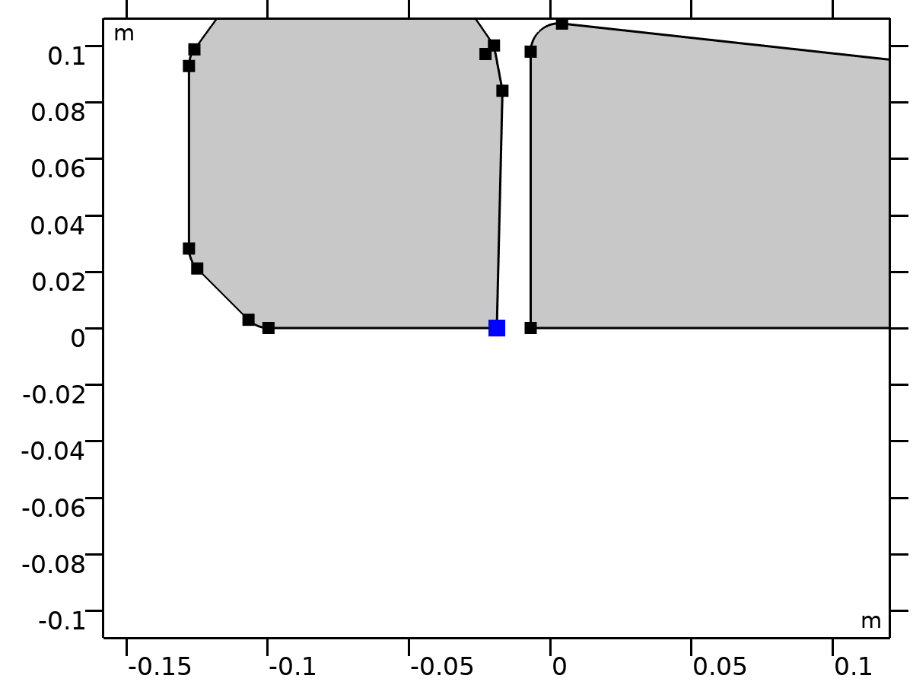

Center of Joint: Point 7

Selection

|  |  |
| --- | --- |
| Geometric entity level | Point |
| Selection | Geometry geom1: Dimension 0: Point 13 |

##### Variables

| **Name** | **Expression** | **Unit** | **Description** | **Selection** | **Details** |
| --- | --- | --- | --- | --- | --- |
| mbd.fxj7.xcx | mbd.fxj7.cjp1.int(X)/mbd.fxj7.cjp1.int(1) | m | Center of joint, x-component | Global | + operation |
| mbd.fxj7.xcy | mbd.fxj7.cjp1.int(Y)/mbd.fxj7.cjp1.int(1) | m | Center of joint, y-component | Global | + operation |
| mbd.fxj7.xcz | mbd.fxj7.cjp1.int(0)/mbd.fxj7.cjp1.int(1) | m | Center of joint, z-component | Global | + operation |

#### Joint Elasticity 7

Selection

|  |  |
| --- | --- |
| Geometric entity level | Entire model |

Equations













##### Elastic Degrees of Freedom

Settings

| **Description** | **Value** |
| --- | --- |
| First axis | On |
| Second axis | On |
| Third axis | On |

##### Spring

Settings

| **Description** | **Value** | **Unit** |
| --- | --- | --- |
| Translational-rotational coupling | Off |  |
| Spring constant, xx-component | {kh7, kv7, 0} | N/m |
| Spring constant | 0 | N·m/rad |

##### Viscous Damping

Settings

| **Description** | **Value** | **Unit** |
| --- | --- | --- |
| Translational-rotational coupling | Off |  |
| Damping coefficient, xx-component | {if(i_c==1, ch7, 0), if(i_c==1, cv7, 0), 0} | N·s/m |
| Damping coefficient | 0 | N·m·s/rad |

##### Coordinate System Selection

Settings

| **Description** | **Value** |
| --- | --- |
| Coordinate system | Joint coordinate system |

##### Variables

| **Name** | **Expression** | **Unit** | **Description** | **Selection** | **Details** |
| --- | --- | --- | --- | --- | --- |
| mbd.Ws_tot | mbd.fxj7.Ws_el | J | Total elastic strain energy | Global | + operation |
| mbd.fxj7.u_el | mbd.fxj7.u1*mbd.fxj7.e1x+mbd.fxj7.u2*mbd.fxj7.e2x | m | Relative displacement (elastic), x-component | Global | + operation |
| mbd.fxj7.v_el | mbd.fxj7.u1*mbd.fxj7.e1y+mbd.fxj7.u2*mbd.fxj7.e2y | m | Relative displacement (elastic), y-component | Global | + operation |
| mbd.fxj7.w_el | mbd.fxj7.u1*mbd.fxj7.e1z+mbd.fxj7.u2*mbd.fxj7.e2z | m | Relative displacement (elastic), z-component | Global | + operation |
| mbd.fxj7.th_el | mbd.fxj7.th | rad | Relative rotation (elastic) | Global | + operation |
| mbd.fxj7.je1.k_u11 | kh7 | N/m | Spring constant, xx-component | Global |  |
| mbd.fxj7.je1.k_u21 | 0 | N/m | Spring constant, yx-component | Global |  |
| mbd.fxj7.je1.k_u31 | 0 | N/m | Spring constant, zx-component | Global |  |
| mbd.fxj7.je1.k_u12 | 0 | N/m | Spring constant, xy-component | Global |  |
| mbd.fxj7.je1.k_u22 | kv7 | N/m | Spring constant, yy-component | Global |  |
| mbd.fxj7.je1.k_u32 | 0 | N/m | Spring constant, zy-component | Global |  |
| mbd.fxj7.je1.k_u13 | 0 | N/m | Spring constant, xz-component | Global |  |
| mbd.fxj7.je1.k_u23 | 0 | N/m | Spring constant, yz-component | Global |  |
| mbd.fxj7.je1.k_u33 | 0 | N/m | Spring constant, zz-component | Global |  |
| mbd.fxj7.je1.k_th | 0 | N·m/rad | Spring constant | Global |  |
| mbd.fxj7.je1.c_u11 | if(i_c==1,ch7,0) | N·s/m | Damping coefficient, xx-component | Global |  |
| mbd.fxj7.je1.c_u21 | 0 | N·s/m | Damping coefficient, yx-component | Global |  |
| mbd.fxj7.je1.c_u31 | 0 | N·s/m | Damping coefficient, zx-component | Global |  |
| mbd.fxj7.je1.c_u12 | 0 | N·s/m | Damping coefficient, xy-component | Global |  |
| mbd.fxj7.je1.c_u22 | if(i_c==1,cv7,0) | N·s/m | Damping coefficient, yy-component | Global |  |
| mbd.fxj7.je1.c_u32 | 0 | N·s/m | Damping coefficient, zy-component | Global |  |
| mbd.fxj7.je1.c_u13 | 0 | N·s/m | Damping coefficient, xz-component | Global |  |
| mbd.fxj7.je1.c_u23 | 0 | N·s/m | Damping coefficient, yz-component | Global |  |
| mbd.fxj7.je1.c_u33 | 0 | N·s/m | Damping coefficient, zz-component | Global |  |
| mbd.fxj7.je1.c_th | 0 | N·m·s/rad | Damping coefficient | Global |  |
| mbd.fxj7.u1 | mbd.fxj7.U1 | m | Relative displacement along joint axis | Global |  |
| mbd.fxj7.u2 | mbd.fxj7.U2 | m | Relative displacement along second axis | Global |  |
| mbd.fxj7.th | mbd.fxj7.Th | rad | Relative rotation | Global |  |
| mbd.fxj7.kl_u11 | mbd.fxj7.je1.k_u11 | N/m | Spring constant, joint coordinate system, 11-component | Global |  |
| mbd.fxj7.kl_u21 | mbd.fxj7.je1.k_u21 | N/m | Spring constant, joint coordinate system, 21-component | Global |  |
| mbd.fxj7.kl_u31 | mbd.fxj7.je1.k_u31 | N/m | Spring constant, joint coordinate system, 31-component | Global |  |
| mbd.fxj7.kl_u12 | mbd.fxj7.je1.k_u12 | N/m | Spring constant, joint coordinate system, 12-component | Global |  |
| mbd.fxj7.kl_u22 | mbd.fxj7.je1.k_u22 | N/m | Spring constant, joint coordinate system, 22-component | Global |  |
| mbd.fxj7.kl_u32 | mbd.fxj7.je1.k_u32 | N/m | Spring constant, joint coordinate system, 32-component | Global |  |
| mbd.fxj7.kl_u13 | mbd.fxj7.je1.k_u13 | N/m | Spring constant, joint coordinate system, 13-component | Global |  |
| mbd.fxj7.kl_u23 | mbd.fxj7.je1.k_u23 | N/m | Spring constant, joint coordinate system, 23-component | Global |  |
| mbd.fxj7.kl_u33 | mbd.fxj7.je1.k_u33 | N/m | Spring constant, joint coordinate system, 33-component | Global |  |
| mbd.fxj7.cl_u11 | mbd.fxj7.je1.c_u11 | N·s/m | Damping coefficient, joint coordinate system, 11-component | Global |  |
| mbd.fxj7.cl_u21 | mbd.fxj7.je1.c_u21 | N·s/m | Damping coefficient, joint coordinate system, 21-component | Global |  |
| mbd.fxj7.cl_u31 | mbd.fxj7.je1.c_u31 | N·s/m | Damping coefficient, joint coordinate system, 31-component | Global |  |
| mbd.fxj7.cl_u12 | mbd.fxj7.je1.c_u12 | N·s/m | Damping coefficient, joint coordinate system, 12-component | Global |  |
| mbd.fxj7.cl_u22 | mbd.fxj7.je1.c_u22 | N·s/m | Damping coefficient, joint coordinate system, 22-component | Global |  |
| mbd.fxj7.cl_u32 | mbd.fxj7.je1.c_u32 | N·s/m | Damping coefficient, joint coordinate system, 32-component | Global |  |
| mbd.fxj7.cl_u13 | mbd.fxj7.je1.c_u13 | N·s/m | Damping coefficient, joint coordinate system, 13-component | Global |  |
| mbd.fxj7.cl_u23 | mbd.fxj7.je1.c_u23 | N·s/m | Damping coefficient, joint coordinate system, 23-component | Global |  |
| mbd.fxj7.cl_u33 | mbd.fxj7.je1.c_u33 | N·s/m | Damping coefficient, joint coordinate system, 33-component | Global |  |
| mbd.fxj7.ul_el | mbd.fxj7.u1 | m | Relative displacement (elastic), joint coordinate system, 1-component | Global | + operation |
| mbd.fxj7.vl_el | mbd.fxj7.u2 | m | Relative displacement (elastic), joint coordinate system, 2-component | Global | + operation |
| mbd.fxj7.wl_el | 0 | m | Relative displacement (elastic), joint coordinate system, 3-component | Global | + operation |
| mbd.fxj7.Fs_el1 | mbd.fxj7.kl_u11*mbd.fxj7.ul_el+mbd.fxj7.kl_u12*mbd.fxj7.vl_el+mbd.fxj7.kl_u13*mbd.fxj7.wl_el | N | Spring force, joint coordinate system, 1-component | Global | + operation |
| mbd.fxj7.Fs_el2 | mbd.fxj7.kl_u21*mbd.fxj7.ul_el+mbd.fxj7.kl_u22*mbd.fxj7.vl_el+mbd.fxj7.kl_u23*mbd.fxj7.wl_el | N | Spring force, joint coordinate system, 2-component | Global | + operation |
| mbd.fxj7.Fs_el3 | mbd.fxj7.kl_u31*mbd.fxj7.ul_el+mbd.fxj7.kl_u32*mbd.fxj7.vl_el+mbd.fxj7.kl_u33*mbd.fxj7.wl_el | N | Spring force, joint coordinate system, 3-component | Global | + operation |
| mbd.fxj7.Ms_el | mbd.fxj7.je1.k_th*mbd.fxj7.th_el | N·m | Spring moment, joint coordinate system | Global | + operation |
| mbd.fxj7.Fd_el1 | (mbd.fxj7.cl_u11*mbd.fxj7.ul_el+mbd.fxj7.cl_u12*mbd.fxj7.vl_el+mbd.fxj7.cl_u13*mbd.fxj7.wl_el)*mbd.iomega | N | Damping force, joint coordinate system, 1-component | Global | + operation |
| mbd.fxj7.Fd_el2 | (mbd.fxj7.cl_u21*mbd.fxj7.ul_el+mbd.fxj7.cl_u22*mbd.fxj7.vl_el+mbd.fxj7.cl_u23*mbd.fxj7.wl_el)*mbd.iomega | N | Damping force, joint coordinate system, 2-component | Global | + operation |
| mbd.fxj7.Fd_el3 | (mbd.fxj7.cl_u31*mbd.fxj7.ul_el+mbd.fxj7.cl_u32*mbd.fxj7.vl_el+mbd.fxj7.cl_u33*mbd.fxj7.wl_el)*mbd.iomega | N | Damping force, joint coordinate system, 3-component | Global | + operation |
| mbd.fxj7.Md_el | mbd.fxj7.je1.c_th*mbd.fxj7.th_el*mbd.iomega | N·m | Damping moment, joint coordinate system | Global | + operation |
| mbd.fxj7.Fl_el1 | -mbd.fxj7.Fd_el1-mbd.fxj7.Fs_el1 | N | Joint force (elastic), local coordinate system, 1-component | Global | + operation |
| mbd.fxj7.Fl_el2 | -mbd.fxj7.Fd_el2-mbd.fxj7.Fs_el2 | N | Joint force (elastic), local coordinate system, 2-component | Global | + operation |
| mbd.fxj7.Fl_el3 | -mbd.fxj7.Fd_el3-mbd.fxj7.Fs_el3 | N | Joint force (elastic), local coordinate system, 3-component | Global | + operation |
| mbd.fxj7.Ml_el1 | 0 | N·m | Joint moment (elastic), local coordinate system, 1-component | Global | + operation |
| mbd.fxj7.Ml_el2 | 0 | N·m | Joint moment (elastic), local coordinate system, 2-component | Global | + operation |
| mbd.fxj7.Ml_el3 | -mbd.fxj7.Md_el-mbd.fxj7.Ms_el | N·m | Joint moment (elastic), local coordinate system, 3-component | Global | + operation |
| mbd.fxj7.F_elx | mbd.fxj7.e1x*mbd.fxj7.Fl_el1+mbd.fxj7.e2x*mbd.fxj7.Fl_el2+mbd.fxj7.e3x*mbd.fxj7.Fl_el3 | N | Joint force (elastic), x-component | Global |  |
| mbd.fxj7.F_ely | mbd.fxj7.e1y*mbd.fxj7.Fl_el1+mbd.fxj7.e2y*mbd.fxj7.Fl_el2+mbd.fxj7.e3y*mbd.fxj7.Fl_el3 | N | Joint force (elastic), y-component | Global |  |
| mbd.fxj7.F_elz | mbd.fxj7.e1z*mbd.fxj7.Fl_el1+mbd.fxj7.e2z*mbd.fxj7.Fl_el2+mbd.fxj7.e3z*mbd.fxj7.Fl_el3 | N | Joint force (elastic), z-component | Global |  |
| mbd.fxj7.M_elx | mbd.fxj7.e1x*mbd.fxj7.Ml_el1+mbd.fxj7.e2x*mbd.fxj7.Ml_el2+mbd.fxj7.e3x*mbd.fxj7.Ml_el3 | N·m | Joint moment (elastic), x-component | Global |  |
| mbd.fxj7.M_ely | mbd.fxj7.e1y*mbd.fxj7.Ml_el1+mbd.fxj7.e2y*mbd.fxj7.Ml_el2+mbd.fxj7.e3y*mbd.fxj7.Ml_el3 | N·m | Joint moment (elastic), y-component | Global |  |
| mbd.fxj7.M_elz | mbd.fxj7.e1z*mbd.fxj7.Ml_el1+mbd.fxj7.e2z*mbd.fxj7.Ml_el2+mbd.fxj7.e3z*mbd.fxj7.Ml_el3 | N·m | Joint moment (elastic), z-component | Global |  |
| mbd.fxj7.Ws_el | 0.25*(realdot(mbd.fxj7.Fs_el1,mbd.fxj7.ul_el)+realdot(mbd.fxj7.Fs_el2,mbd.fxj7.vl_el)+realdot(mbd.fxj7.Fs_el3,mbd.fxj7.wl_el)+realdot(mbd.fxj7.Ms_el,mbd.fxj7.th_el)) | J | Energy stored in spring | Global |  |
| mbd.fxj7.Qd_el | 0.5*mbd.omega^2*(realdot(mbd.fxj7.Fd_el1/mbd.iomega,mbd.fxj7.ul_el)+realdot(mbd.fxj7.Fd_el2/mbd.iomega,mbd.fxj7.vl_el)+realdot(mbd.fxj7.Fd_el3/mbd.iomega,mbd.fxj7.wl_el)+realdot(mbd.fxj7.Md_el/mbd.iomega,mbd.fxj7.th_el)) | W | Energy dissipation rate in damper | Global |  |

##### Shape functions

| **Name** | **Shape function** | **Unit** | **Description** | **Shape frame** | **Selection** |
| --- | --- | --- | --- | --- | --- |
| mbd.fxj7.U1 | ODE | m | Relative displacement along joint axis |  | Global |
| mbd.fxj7.U2 | ODE | m | Relative displacement along second axis |  | Global |
| mbd.fxj7.Th | ODE | rad | Relative rotation |  | Global |

##### Weak Expressions

| **Weak expression** | **Integration order** | **Integration frame** | **Selection** |
| --- | --- | --- | --- |
| mbd.fxj7.Fl_el1*test(mbd.fxj7.ul_el)+mbd.fxj7.Fl_el2*test(mbd.fxj7.vl_el)+mbd.fxj7.Fl_el3*test(mbd.fxj7.wl_el) | 2 |  | Global |
| mbd.fxj7.Ml_el3*test(mbd.fxj7.th_el) | 2 |  | Global |

### Seat-Thigh



Seat-Thigh

Selection

|  |  |
| --- | --- |
| Geometric entity level | Entire model |

Equations











#### Attachment Selection

Settings

| **Description** | **Value** |
| --- | --- |
| Source | Seat |
| Destination | Thigh |
| Use selection filter | Off |

#### Center of Joint

Settings

| **Description** | **Value** |
| --- | --- |
| Center of joint | Centroid of selected entities |
| Entity level | Point |
| Offset | Off |

#### Axis of Joint

Settings

| **Description** | **Value** |
| --- | --- |
| Axis of joint | Specify direction |
| Axis of joint, x-component | 1 |
| Axis of joint, y-component | 0 |
| Axis of joint, z-component | 0 |

#### Joint Elasticity

Settings

| **Description** | **Value** |
| --- | --- |
| Joint elasticity | Elastic joint |

#### Joint Forces and Moments

Settings

| **Description** | **Value** |
| --- | --- |
| Joint forces and moments | Computed using weak constraints |

#### Coordinate System Selection

Settings

| **Description** | **Value** |
| --- | --- |
| Coordinate system | Global coordinate system |

#### Variables

| **Name** | **Expression** | **Unit** | **Description** | **Selection** | **Details** |
| --- | --- | --- | --- | --- | --- |
| mbd.fxj8.e10x | 1 | 1 | Initial joint axis, x-component | Global |  |
| mbd.fxj8.e10y | 0 | 1 | Initial joint axis, y-component | Global |  |
| mbd.fxj8.e10z | 0 | 1 | Initial joint axis, z-component | Global |  |
| mbd.fxj8.e20x | (mbd.fxj8.e10z*mbd.fxj8.e30y-mbd.fxj8.e10y*mbd.fxj8.e30z)/sqrt((mbd.fxj8.e10z*mbd.fxj8.e30y-mbd.fxj8.e10y*mbd.fxj8.e30z)^2+(-mbd.fxj8.e10z*mbd.fxj8.e30x+mbd.fxj8.e10x*mbd.fxj8.e30z)^2+(mbd.fxj8.e10y*mbd.fxj8.e30x-mbd.fxj8.e10x*mbd.fxj8.e30y)^2) | 1 | Initial second axis, x-component | Global |  |
| mbd.fxj8.e20y | (-mbd.fxj8.e10z*mbd.fxj8.e30x+mbd.fxj8.e10x*mbd.fxj8.e30z)/sqrt((mbd.fxj8.e10z*mbd.fxj8.e30y-mbd.fxj8.e10y*mbd.fxj8.e30z)^2+(-mbd.fxj8.e10z*mbd.fxj8.e30x+mbd.fxj8.e10x*mbd.fxj8.e30z)^2+(mbd.fxj8.e10y*mbd.fxj8.e30x-mbd.fxj8.e10x*mbd.fxj8.e30y)^2) | 1 | Initial second axis, y-component | Global |  |
| mbd.fxj8.e20z | (mbd.fxj8.e10y*mbd.fxj8.e30x-mbd.fxj8.e10x*mbd.fxj8.e30y)/sqrt((mbd.fxj8.e10z*mbd.fxj8.e30y-mbd.fxj8.e10y*mbd.fxj8.e30z)^2+(-mbd.fxj8.e10z*mbd.fxj8.e30x+mbd.fxj8.e10x*mbd.fxj8.e30z)^2+(mbd.fxj8.e10y*mbd.fxj8.e30x-mbd.fxj8.e10x*mbd.fxj8.e30y)^2) | 1 | Initial second axis, z-component | Global |  |
| mbd.fxj8.e30x | 0 | 1 | Initial third axis, x-component | Global |  |
| mbd.fxj8.e30y | 0 | 1 | Initial third axis, y-component | Global |  |
| mbd.fxj8.e30z | 1 | 1 | Initial third axis, z-component | Global |  |
| mbd.fxj8.e1x | mbd.fxj8.rot_srcxx*mbd.fxj8.e10x+mbd.fxj8.rot_srcxy*mbd.fxj8.e10y+mbd.fxj8.rot_srcxz*mbd.fxj8.e10z | 1 | Joint axis, x-component | Global |  |
| mbd.fxj8.e1y | mbd.fxj8.rot_srcyx*mbd.fxj8.e10x+mbd.fxj8.rot_srcyy*mbd.fxj8.e10y+mbd.fxj8.rot_srcyz*mbd.fxj8.e10z | 1 | Joint axis, y-component | Global |  |
| mbd.fxj8.e1z | mbd.fxj8.rot_srczx*mbd.fxj8.e10x+mbd.fxj8.rot_srczy*mbd.fxj8.e10y+mbd.fxj8.rot_srczz*mbd.fxj8.e10z | 1 | Joint axis, z-component | Global |  |
| mbd.fxj8.e2x | mbd.fxj8.rot_srcxx*mbd.fxj8.e20x+mbd.fxj8.rot_srcxy*mbd.fxj8.e20y+mbd.fxj8.rot_srcxz*mbd.fxj8.e20z | 1 | Second axis, x-component | Global |  |
| mbd.fxj8.e2y | mbd.fxj8.rot_srcyx*mbd.fxj8.e20x+mbd.fxj8.rot_srcyy*mbd.fxj8.e20y+mbd.fxj8.rot_srcyz*mbd.fxj8.e20z | 1 | Second axis, y-component | Global |  |
| mbd.fxj8.e2z | mbd.fxj8.rot_srczx*mbd.fxj8.e20x+mbd.fxj8.rot_srczy*mbd.fxj8.e20y+mbd.fxj8.rot_srczz*mbd.fxj8.e20z | 1 | Second axis, z-component | Global |  |
| mbd.fxj8.e3x | mbd.fxj8.rot_srcxx*mbd.fxj8.e30x+mbd.fxj8.rot_srcxy*mbd.fxj8.e30y+mbd.fxj8.rot_srcxz*mbd.fxj8.e30z | 1 | Third axis, x-component | Global |  |
| mbd.fxj8.e3y | mbd.fxj8.rot_srcyx*mbd.fxj8.e30x+mbd.fxj8.rot_srcyy*mbd.fxj8.e30y+mbd.fxj8.rot_srcyz*mbd.fxj8.e30z | 1 | Third axis, y-component | Global |  |
| mbd.fxj8.e3z | mbd.fxj8.rot_srczx*mbd.fxj8.e30x+mbd.fxj8.rot_srczy*mbd.fxj8.e30y+mbd.fxj8.rot_srczz*mbd.fxj8.e30z | 1 | Third axis, z-component | Global |  |
| mbd.fxj8.uc_src | mbd.bsm1.u+mbd.fxj8.u_el | m | Source displacement at center of joint, x-component | Global |  |
| mbd.fxj8.vc_src | mbd.bsm1.v+mbd.fxj8.v_el | m | Source displacement at center of joint, y-component | Global |  |
| mbd.fxj8.wc_src | mbd.fxj8.w_el | m | Source displacement at center of joint, z-component | Global |  |
| mbd.fxj8.uc_dest | mbd.rd5.rotxx*(mbd.fxj8.xcx-mbd.rd5.xcx)+mbd.rd5.rotxy*(mbd.fxj8.xcy-mbd.rd5.xcy)+mbd.rd5.rotxz*(mbd.fxj8.xcz-mbd.rd5.xcz)-mbd.fxj8.xcx+mbd.rd5.xcx+mbd.rd5.u | m | Destination displacement at center of joint, x-component | Global |  |
| mbd.fxj8.vc_dest | mbd.rd5.rotyx*(mbd.fxj8.xcx-mbd.rd5.xcx)+mbd.rd5.rotyy*(mbd.fxj8.xcy-mbd.rd5.xcy)+mbd.rd5.rotyz*(mbd.fxj8.xcz-mbd.rd5.xcz)-mbd.fxj8.xcy+mbd.rd5.xcy+mbd.rd5.v | m | Destination displacement at center of joint, y-component | Global |  |
| mbd.fxj8.wc_dest | mbd.rd5.rotzx*(mbd.fxj8.xcx-mbd.rd5.xcx)+mbd.rd5.rotzy*(mbd.fxj8.xcy-mbd.rd5.xcy)+mbd.rd5.rotzz*(mbd.fxj8.xcz-mbd.rd5.xcz)-mbd.fxj8.xcz+mbd.rd5.xcz | m | Destination displacement at center of joint, z-component | Global |  |
| mbd.fxj8.phi_src | mbd.fxj8.th_el | rad | Source rotation | Global |  |
| mbd.fxj8.phi_dest | mbd.rd5.phi | rad | Destination rotation | Global |  |
| mbd.fxj8.rot_srcxx | 1 | 1 | Source rotation matrix, xx-component | Global |  |
| mbd.fxj8.rot_srcyx | 0 | 1 | Source rotation matrix, yx-component | Global |  |
| mbd.fxj8.rot_srczx | 0 | 1 | Source rotation matrix, zx-component | Global |  |
| mbd.fxj8.rot_srcxy | 0 | 1 | Source rotation matrix, xy-component | Global |  |
| mbd.fxj8.rot_srcyy | 1 | 1 | Source rotation matrix, yy-component | Global |  |
| mbd.fxj8.rot_srczy | 0 | 1 | Source rotation matrix, zy-component | Global |  |
| mbd.fxj8.rot_srcxz | 0 | 1 | Source rotation matrix, xz-component | Global |  |
| mbd.fxj8.rot_srcyz | 0 | 1 | Source rotation matrix, yz-component | Global |  |
| mbd.fxj8.rot_srczz | 1 | 1 | Source rotation matrix, zz-component | Global |  |
| mbd.fxj8.Fx | mbd.fxj8.RFx | N | Joint force, x-component | Global | + operation |
| mbd.fxj8.Fy | mbd.fxj8.RFy | N | Joint force, y-component | Global | + operation |
| mbd.fxj8.Fz | 0 | N | Joint force, z-component | Global | + operation |
| mbd.fxj8.rx | mbd.fxj8.uc_dest-mbd.fxj8.uc_src+mbd.fxj8.u_el | m | Joint moment arm, x-component | Global |  |
| mbd.fxj8.ry | mbd.fxj8.vc_dest-mbd.fxj8.vc_src+mbd.fxj8.v_el | m | Joint moment arm, y-component | Global |  |
| mbd.fxj8.rz | mbd.fxj8.wc_dest-mbd.fxj8.wc_src+mbd.fxj8.w_el | m | Joint moment arm, z-component | Global |  |
| mbd.fxj8.Mx | -mbd.fxj8.RFy*mbd.fxj8.rz | N·m | Joint moment, x-component | Global | + operation |
| mbd.fxj8.My | mbd.fxj8.RFx*mbd.fxj8.rz | N·m | Joint moment, y-component | Global | + operation |
| mbd.fxj8.Mz | mbd.fxj8.Rphi+mbd.fxj8.RFy*mbd.fxj8.rx-mbd.fxj8.RFx*mbd.fxj8.ry | N·m | Joint moment, z-component | Global | + operation |
| mbd.fxj8.Fl1 | mbd.fxj8.Fx*mbd.fxj8.e1x+mbd.fxj8.Fy*mbd.fxj8.e1y+mbd.fxj8.Fz*mbd.fxj8.e1z | N | Joint force, local coordinate system, 1 component | Global |  |
| mbd.fxj8.Fl2 | mbd.fxj8.Fx*mbd.fxj8.e2x+mbd.fxj8.Fy*mbd.fxj8.e2y+mbd.fxj8.Fz*mbd.fxj8.e2z | N | Joint force, local coordinate system, 2 component | Global |  |
| mbd.fxj8.Fl3 | mbd.fxj8.Fx*mbd.fxj8.e3x+mbd.fxj8.Fy*mbd.fxj8.e3y+mbd.fxj8.Fz*mbd.fxj8.e3z | N | Joint force, local coordinate system, 3 component | Global |  |
| mbd.fxj8.Ml1 | mbd.fxj8.Mx*mbd.fxj8.e1x+mbd.fxj8.My*mbd.fxj8.e1y+mbd.fxj8.Mz*mbd.fxj8.e1z | N·m | Joint moment, local coordinate system, 1 component | Global |  |
| mbd.fxj8.Ml2 | mbd.fxj8.Mx*mbd.fxj8.e2x+mbd.fxj8.My*mbd.fxj8.e2y+mbd.fxj8.Mz*mbd.fxj8.e2z | N·m | Joint moment, local coordinate system, 2 component | Global |  |
| mbd.fxj8.Ml3 | mbd.fxj8.Mx*mbd.fxj8.e3x+mbd.fxj8.My*mbd.fxj8.e3y+mbd.fxj8.Mz*mbd.fxj8.e3z | N·m | Joint moment, local coordinate system, 3 component | Global |  |

#### Shape functions

| **Name** | **Shape function** | **Unit** | **Description** | **Shape frame** | **Selection** |
| --- | --- | --- | --- | --- | --- |
| mbd.fxj8.RFx | ODE | N | Reaction force, x-component |  | Global |
| mbd.fxj8.RFy | ODE | N | Reaction force, y-component |  | Global |
| mbd.fxj8.Rphi | ODE | N·m | Reaction moment |  | Global |

#### Weak Expressions

| **Weak expression** | **Integration order** | **Integration frame** | **Selection** |
| --- | --- | --- | --- |
| (mbd.fxj8.uc_src-mbd.fxj8.uc_dest)*test(-mbd.fxj8.RFx)-test(mbd.fxj8.u_el-mbd.fxj8.uc_dest)*mbd.fxj8.RFx | 2 |  | Global |
| (mbd.fxj8.vc_src-mbd.fxj8.vc_dest)*test(-mbd.fxj8.RFy)-test(mbd.fxj8.v_el-mbd.fxj8.vc_dest)*mbd.fxj8.RFy | 2 |  | Global |
| (mbd.fxj8.phi_src-mbd.fxj8.phi_dest)*test(-mbd.fxj8.Rphi)-test(mbd.fxj8.phi_src-mbd.fxj8.phi_dest)*mbd.fxj8.Rphi | 2 |  | Global |

#### Center of Joint: Point 8

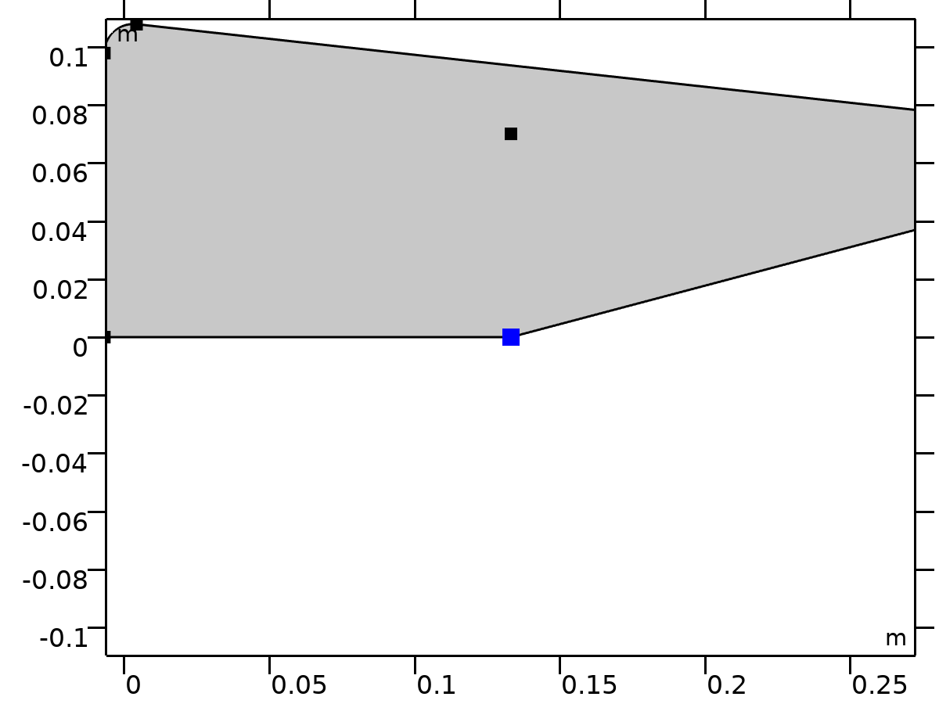

Center of Joint: Point 8

Selection

|  |  |
| --- | --- |
| Geometric entity level | Point |
| Selection | Geometry geom1: Dimension 0: Point 61 |

##### Variables

| **Name** | **Expression** | **Unit** | **Description** | **Selection** | **Details** |
| --- | --- | --- | --- | --- | --- |
| mbd.fxj8.xcx | mbd.fxj8.cjp1.int(X)/mbd.fxj8.cjp1.int(1) | m | Center of joint, x-component | Global | + operation |
| mbd.fxj8.xcy | mbd.fxj8.cjp1.int(Y)/mbd.fxj8.cjp1.int(1) | m | Center of joint, y-component | Global | + operation |
| mbd.fxj8.xcz | mbd.fxj8.cjp1.int(0)/mbd.fxj8.cjp1.int(1) | m | Center of joint, z-component | Global | + operation |

#### Joint Elasticity 8

Selection

|  |  |
| --- | --- |
| Geometric entity level | Entire model |

Equations













##### Elastic Degrees of Freedom

Settings

| **Description** | **Value** |
| --- | --- |
| First axis | On |
| Second axis | On |
| Third axis | On |

##### Spring

Settings

| **Description** | **Value** | **Unit** |
| --- | --- | --- |
| Translational-rotational coupling | Off |  |
| Spring constant, xx-component | {kh8, kv8, 0} | N/m |
| Spring constant | 0 | N·m/rad |

##### Viscous Damping

Settings

| **Description** | **Value** | **Unit** |
| --- | --- | --- |
| Translational-rotational coupling | Off |  |
| Damping coefficient, xx-component | if(i_c==1, cv8, 0) | N·s/m |
| Damping coefficient | 0 | N·m·s/rad |

##### Coordinate System Selection

Settings

| **Description** | **Value** |
| --- | --- |
| Coordinate system | Joint coordinate system |

##### Variables

| **Name** | **Expression** | **Unit** | **Description** | **Selection** | **Details** |
| --- | --- | --- | --- | --- | --- |
| mbd.Ws_tot | mbd.fxj8.Ws_el | J | Total elastic strain energy | Global | + operation |
| mbd.fxj8.u_el | mbd.fxj8.u1*mbd.fxj8.e1x+mbd.fxj8.u2*mbd.fxj8.e2x | m | Relative displacement (elastic), x-component | Global | + operation |
| mbd.fxj8.v_el | mbd.fxj8.u1*mbd.fxj8.e1y+mbd.fxj8.u2*mbd.fxj8.e2y | m | Relative displacement (elastic), y-component | Global | + operation |
| mbd.fxj8.w_el | mbd.fxj8.u1*mbd.fxj8.e1z+mbd.fxj8.u2*mbd.fxj8.e2z | m | Relative displacement (elastic), z-component | Global | + operation |
| mbd.fxj8.th_el | mbd.fxj8.th | rad | Relative rotation (elastic) | Global | + operation |
| mbd.fxj8.je1.k_u11 | kh8 | N/m | Spring constant, xx-component | Global |  |
| mbd.fxj8.je1.k_u21 | 0 | N/m | Spring constant, yx-component | Global |  |
| mbd.fxj8.je1.k_u31 | 0 | N/m | Spring constant, zx-component | Global |  |
| mbd.fxj8.je1.k_u12 | 0 | N/m | Spring constant, xy-component | Global |  |
| mbd.fxj8.je1.k_u22 | kv8 | N/m | Spring constant, yy-component | Global |  |
| mbd.fxj8.je1.k_u32 | 0 | N/m | Spring constant, zy-component | Global |  |
| mbd.fxj8.je1.k_u13 | 0 | N/m | Spring constant, xz-component | Global |  |
| mbd.fxj8.je1.k_u23 | 0 | N/m | Spring constant, yz-component | Global |  |
| mbd.fxj8.je1.k_u33 | 0 | N/m | Spring constant, zz-component | Global |  |
| mbd.fxj8.je1.k_th | 0 | N·m/rad | Spring constant | Global |  |
| mbd.fxj8.je1.c_u11 | if(i_c==1,cv8,0) | N·s/m | Damping coefficient, xx-component | Global |  |
| mbd.fxj8.je1.c_u21 | 0 | N·s/m | Damping coefficient, yx-component | Global |  |
| mbd.fxj8.je1.c_u31 | 0 | N·s/m | Damping coefficient, zx-component | Global |  |
| mbd.fxj8.je1.c_u12 | 0 | N·s/m | Damping coefficient, xy-component | Global |  |
| mbd.fxj8.je1.c_u22 | if(i_c==1,cv8,0) | N·s/m | Damping coefficient, yy-component | Global |  |
| mbd.fxj8.je1.c_u32 | 0 | N·s/m | Damping coefficient, zy-component | Global |  |
| mbd.fxj8.je1.c_u13 | 0 | N·s/m | Damping coefficient, xz-component | Global |  |
| mbd.fxj8.je1.c_u23 | 0 | N·s/m | Damping coefficient, yz-component | Global |  |
| mbd.fxj8.je1.c_u33 | if(i_c==1,cv8,0) | N·s/m | Damping coefficient, zz-component | Global |  |
| mbd.fxj8.je1.c_th | 0 | N·m·s/rad | Damping coefficient | Global |  |
| mbd.fxj8.u1 | mbd.fxj8.U1 | m | Relative displacement along joint axis | Global |  |
| mbd.fxj8.u2 | mbd.fxj8.U2 | m | Relative displacement along second axis | Global |  |
| mbd.fxj8.th | mbd.fxj8.Th | rad | Relative rotation | Global |  |
| mbd.fxj8.kl_u11 | mbd.fxj8.je1.k_u11 | N/m | Spring constant, joint coordinate system, 11-component | Global |  |
| mbd.fxj8.kl_u21 | mbd.fxj8.je1.k_u21 | N/m | Spring constant, joint coordinate system, 21-component | Global |  |
| mbd.fxj8.kl_u31 | mbd.fxj8.je1.k_u31 | N/m | Spring constant, joint coordinate system, 31-component | Global |  |
| mbd.fxj8.kl_u12 | mbd.fxj8.je1.k_u12 | N/m | Spring constant, joint coordinate system, 12-component | Global |  |
| mbd.fxj8.kl_u22 | mbd.fxj8.je1.k_u22 | N/m | Spring constant, joint coordinate system, 22-component | Global |  |
| mbd.fxj8.kl_u32 | mbd.fxj8.je1.k_u32 | N/m | Spring constant, joint coordinate system, 32-component | Global |  |
| mbd.fxj8.kl_u13 | mbd.fxj8.je1.k_u13 | N/m | Spring constant, joint coordinate system, 13-component | Global |  |
| mbd.fxj8.kl_u23 | mbd.fxj8.je1.k_u23 | N/m | Spring constant, joint coordinate system, 23-component | Global |  |
| mbd.fxj8.kl_u33 | mbd.fxj8.je1.k_u33 | N/m | Spring constant, joint coordinate system, 33-component | Global |  |
| mbd.fxj8.cl_u11 | mbd.fxj8.je1.c_u11 | N·s/m | Damping coefficient, joint coordinate system, 11-component | Global |  |
| mbd.fxj8.cl_u21 | mbd.fxj8.je1.c_u21 | N·s/m | Damping coefficient, joint coordinate system, 21-component | Global |  |
| mbd.fxj8.cl_u31 | mbd.fxj8.je1.c_u31 | N·s/m | Damping coefficient, joint coordinate system, 31-component | Global |  |
| mbd.fxj8.cl_u12 | mbd.fxj8.je1.c_u12 | N·s/m | Damping coefficient, joint coordinate system, 12-component | Global |  |
| mbd.fxj8.cl_u22 | mbd.fxj8.je1.c_u22 | N·s/m | Damping coefficient, joint coordinate system, 22-component | Global |  |
| mbd.fxj8.cl_u32 | mbd.fxj8.je1.c_u32 | N·s/m | Damping coefficient, joint coordinate system, 32-component | Global |  |
| mbd.fxj8.cl_u13 | mbd.fxj8.je1.c_u13 | N·s/m | Damping coefficient, joint coordinate system, 13-component | Global |  |
| mbd.fxj8.cl_u23 | mbd.fxj8.je1.c_u23 | N·s/m | Damping coefficient, joint coordinate system, 23-component | Global |  |
| mbd.fxj8.cl_u33 | mbd.fxj8.je1.c_u33 | N·s/m | Damping coefficient, joint coordinate system, 33-component | Global |  |
| mbd.fxj8.ul_el | mbd.fxj8.u1 | m | Relative displacement (elastic), joint coordinate system, 1-component | Global | + operation |
| mbd.fxj8.vl_el | mbd.fxj8.u2 | m | Relative displacement (elastic), joint coordinate system, 2-component | Global | + operation |
| mbd.fxj8.wl_el | 0 | m | Relative displacement (elastic), joint coordinate system, 3-component | Global | + operation |
| mbd.fxj8.Fs_el1 | mbd.fxj8.kl_u11*mbd.fxj8.ul_el+mbd.fxj8.kl_u12*mbd.fxj8.vl_el+mbd.fxj8.kl_u13*mbd.fxj8.wl_el | N | Spring force, joint coordinate system, 1-component | Global | + operation |
| mbd.fxj8.Fs_el2 | mbd.fxj8.kl_u21*mbd.fxj8.ul_el+mbd.fxj8.kl_u22*mbd.fxj8.vl_el+mbd.fxj8.kl_u23*mbd.fxj8.wl_el | N | Spring force, joint coordinate system, 2-component | Global | + operation |
| mbd.fxj8.Fs_el3 | mbd.fxj8.kl_u31*mbd.fxj8.ul_el+mbd.fxj8.kl_u32*mbd.fxj8.vl_el+mbd.fxj8.kl_u33*mbd.fxj8.wl_el | N | Spring force, joint coordinate system, 3-component | Global | + operation |
| mbd.fxj8.Ms_el | mbd.fxj8.je1.k_th*mbd.fxj8.th_el | N·m | Spring moment, joint coordinate system | Global | + operation |
| mbd.fxj8.Fd_el1 | (mbd.fxj8.cl_u11*mbd.fxj8.ul_el+mbd.fxj8.cl_u12*mbd.fxj8.vl_el+mbd.fxj8.cl_u13*mbd.fxj8.wl_el)*mbd.iomega | N | Damping force, joint coordinate system, 1-component | Global | + operation |
| mbd.fxj8.Fd_el2 | (mbd.fxj8.cl_u21*mbd.fxj8.ul_el+mbd.fxj8.cl_u22*mbd.fxj8.vl_el+mbd.fxj8.cl_u23*mbd.fxj8.wl_el)*mbd.iomega | N | Damping force, joint coordinate system, 2-component | Global | + operation |
| mbd.fxj8.Fd_el3 | (mbd.fxj8.cl_u31*mbd.fxj8.ul_el+mbd.fxj8.cl_u32*mbd.fxj8.vl_el+mbd.fxj8.cl_u33*mbd.fxj8.wl_el)*mbd.iomega | N | Damping force, joint coordinate system, 3-component | Global | + operation |
| mbd.fxj8.Md_el | mbd.fxj8.je1.c_th*mbd.fxj8.th_el*mbd.iomega | N·m | Damping moment, joint coordinate system | Global | + operation |
| mbd.fxj8.Fl_el1 | -mbd.fxj8.Fd_el1-mbd.fxj8.Fs_el1 | N | Joint force (elastic), local coordinate system, 1-component | Global | + operation |
| mbd.fxj8.Fl_el2 | -mbd.fxj8.Fd_el2-mbd.fxj8.Fs_el2 | N | Joint force (elastic), local coordinate system, 2-component | Global | + operation |
| mbd.fxj8.Fl_el3 | -mbd.fxj8.Fd_el3-mbd.fxj8.Fs_el3 | N | Joint force (elastic), local coordinate system, 3-component | Global | + operation |
| mbd.fxj8.Ml_el1 | 0 | N·m | Joint moment (elastic), local coordinate system, 1-component | Global | + operation |
| mbd.fxj8.Ml_el2 | 0 | N·m | Joint moment (elastic), local coordinate system, 2-component | Global | + operation |
| mbd.fxj8.Ml_el3 | -mbd.fxj8.Md_el-mbd.fxj8.Ms_el | N·m | Joint moment (elastic), local coordinate system, 3-component | Global | + operation |
| mbd.fxj8.F_elx | mbd.fxj8.e1x*mbd.fxj8.Fl_el1+mbd.fxj8.e2x*mbd.fxj8.Fl_el2+mbd.fxj8.e3x*mbd.fxj8.Fl_el3 | N | Joint force (elastic), x-component | Global |  |
| mbd.fxj8.F_ely | mbd.fxj8.e1y*mbd.fxj8.Fl_el1+mbd.fxj8.e2y*mbd.fxj8.Fl_el2+mbd.fxj8.e3y*mbd.fxj8.Fl_el3 | N | Joint force (elastic), y-component | Global |  |
| mbd.fxj8.F_elz | mbd.fxj8.e1z*mbd.fxj8.Fl_el1+mbd.fxj8.e2z*mbd.fxj8.Fl_el2+mbd.fxj8.e3z*mbd.fxj8.Fl_el3 | N | Joint force (elastic), z-component | Global |  |
| mbd.fxj8.M_elx | mbd.fxj8.e1x*mbd.fxj8.Ml_el1+mbd.fxj8.e2x*mbd.fxj8.Ml_el2+mbd.fxj8.e3x*mbd.fxj8.Ml_el3 | N·m | Joint moment (elastic), x-component | Global |  |
| mbd.fxj8.M_ely | mbd.fxj8.e1y*mbd.fxj8.Ml_el1+mbd.fxj8.e2y*mbd.fxj8.Ml_el2+mbd.fxj8.e3y*mbd.fxj8.Ml_el3 | N·m | Joint moment (elastic), y-component | Global |  |
| mbd.fxj8.M_elz | mbd.fxj8.e1z*mbd.fxj8.Ml_el1+mbd.fxj8.e2z*mbd.fxj8.Ml_el2+mbd.fxj8.e3z*mbd.fxj8.Ml_el3 | N·m | Joint moment (elastic), z-component | Global |  |
| mbd.fxj8.Ws_el | 0.25*(realdot(mbd.fxj8.Fs_el1,mbd.fxj8.ul_el)+realdot(mbd.fxj8.Fs_el2,mbd.fxj8.vl_el)+realdot(mbd.fxj8.Fs_el3,mbd.fxj8.wl_el)+realdot(mbd.fxj8.Ms_el,mbd.fxj8.th_el)) | J | Energy stored in spring | Global |  |
| mbd.fxj8.Qd_el | 0.5*mbd.omega^2*(realdot(mbd.fxj8.Fd_el1/mbd.iomega,mbd.fxj8.ul_el)+realdot(mbd.fxj8.Fd_el2/mbd.iomega,mbd.fxj8.vl_el)+realdot(mbd.fxj8.Fd_el3/mbd.iomega,mbd.fxj8.wl_el)+realdot(mbd.fxj8.Md_el/mbd.iomega,mbd.fxj8.th_el)) | W | Energy dissipation rate in damper | Global |  |

##### Shape functions

| **Name** | **Shape function** | **Unit** | **Description** | **Shape frame** | **Selection** |
| --- | --- | --- | --- | --- | --- |
| mbd.fxj8.U1 | ODE | m | Relative displacement along joint axis |  | Global |
| mbd.fxj8.U2 | ODE | m | Relative displacement along second axis |  | Global |
| mbd.fxj8.Th | ODE | rad | Relative rotation |  | Global |

##### Weak Expressions

| **Weak expression** | **Integration order** | **Integration frame** | **Selection** |
| --- | --- | --- | --- |
| mbd.fxj8.Fl_el1*test(mbd.fxj8.ul_el)+mbd.fxj8.Fl_el2*test(mbd.fxj8.vl_el)+mbd.fxj8.Fl_el3*test(mbd.fxj8.wl_el) | 2 |  | Global |
| mbd.fxj8.Ml_el3*test(mbd.fxj8.th_el) | 2 |  | Global |

### Seat-Leg



Seat-Leg

Selection

|  |  |
| --- | --- |
| Geometric entity level | Entire model |

Equations











#### Attachment Selection

Settings

| **Description** | **Value** |
| --- | --- |
| Source | Seat |
| Destination | Leg |
| Use selection filter | Off |

#### Center of Joint

Settings

| **Description** | **Value** |
| --- | --- |
| Center of joint | Centroid of selected entities |
| Entity level | Point |
| Offset | Off |

#### Axis of Joint

Settings

| **Description** | **Value** |
| --- | --- |
| Axis of joint | Specify direction |
| Axis of joint, x-component | 1 |
| Axis of joint, y-component | 0 |
| Axis of joint, z-component | 0 |

#### Joint Elasticity

Settings

| **Description** | **Value** |
| --- | --- |
| Joint elasticity | Rigid joint |

#### Joint Forces and Moments

Settings

| **Description** | **Value** |
| --- | --- |
| Joint forces and moments | Do not compute |

#### Coordinate System Selection

Settings

| **Description** | **Value** |
| --- | --- |
| Coordinate system | Global coordinate system |

#### Variables

| **Name** | **Expression** | **Unit** | **Description** | **Selection** |
| --- | --- | --- | --- | --- |
| mbd.fxj9.e10x | 1 | 1 | Initial joint axis, x-component | Global |
| mbd.fxj9.e10y | 0 | 1 | Initial joint axis, y-component | Global |
| mbd.fxj9.e10z | 0 | 1 | Initial joint axis, z-component | Global |
| mbd.fxj9.e20x | (mbd.fxj9.e10z*mbd.fxj9.e30y-mbd.fxj9.e10y*mbd.fxj9.e30z)/sqrt((mbd.fxj9.e10z*mbd.fxj9.e30y-mbd.fxj9.e10y*mbd.fxj9.e30z)^2+(-mbd.fxj9.e10z*mbd.fxj9.e30x+mbd.fxj9.e10x*mbd.fxj9.e30z)^2+(mbd.fxj9.e10y*mbd.fxj9.e30x-mbd.fxj9.e10x*mbd.fxj9.e30y)^2) | 1 | Initial second axis, x-component | Global |
| mbd.fxj9.e20y | (-mbd.fxj9.e10z*mbd.fxj9.e30x+mbd.fxj9.e10x*mbd.fxj9.e30z)/sqrt((mbd.fxj9.e10z*mbd.fxj9.e30y-mbd.fxj9.e10y*mbd.fxj9.e30z)^2+(-mbd.fxj9.e10z*mbd.fxj9.e30x+mbd.fxj9.e10x*mbd.fxj9.e30z)^2+(mbd.fxj9.e10y*mbd.fxj9.e30x-mbd.fxj9.e10x*mbd.fxj9.e30y)^2) | 1 | Initial second axis, y-component | Global |
| mbd.fxj9.e20z | (mbd.fxj9.e10y*mbd.fxj9.e30x-mbd.fxj9.e10x*mbd.fxj9.e30y)/sqrt((mbd.fxj9.e10z*mbd.fxj9.e30y-mbd.fxj9.e10y*mbd.fxj9.e30z)^2+(-mbd.fxj9.e10z*mbd.fxj9.e30x+mbd.fxj9.e10x*mbd.fxj9.e30z)^2+(mbd.fxj9.e10y*mbd.fxj9.e30x-mbd.fxj9.e10x*mbd.fxj9.e30y)^2) | 1 | Initial second axis, z-component | Global |
| mbd.fxj9.e30x | 0 | 1 | Initial third axis, x-component | Global |
| mbd.fxj9.e30y | 0 | 1 | Initial third axis, y-component | Global |
| mbd.fxj9.e30z | 1 | 1 | Initial third axis, z-component | Global |
| mbd.fxj9.e1x | mbd.fxj9.rot_srcxx*mbd.fxj9.e10x+mbd.fxj9.rot_srcxy*mbd.fxj9.e10y+mbd.fxj9.rot_srcxz*mbd.fxj9.e10z | 1 | Joint axis, x-component | Global |
| mbd.fxj9.e1y | mbd.fxj9.rot_srcyx*mbd.fxj9.e10x+mbd.fxj9.rot_srcyy*mbd.fxj9.e10y+mbd.fxj9.rot_srcyz*mbd.fxj9.e10z | 1 | Joint axis, y-component | Global |
| mbd.fxj9.e1z | mbd.fxj9.rot_srczx*mbd.fxj9.e10x+mbd.fxj9.rot_srczy*mbd.fxj9.e10y+mbd.fxj9.rot_srczz*mbd.fxj9.e10z | 1 | Joint axis, z-component | Global |
| mbd.fxj9.e2x | mbd.fxj9.rot_srcxx*mbd.fxj9.e20x+mbd.fxj9.rot_srcxy*mbd.fxj9.e20y+mbd.fxj9.rot_srcxz*mbd.fxj9.e20z | 1 | Second axis, x-component | Global |
| mbd.fxj9.e2y | mbd.fxj9.rot_srcyx*mbd.fxj9.e20x+mbd.fxj9.rot_srcyy*mbd.fxj9.e20y+mbd.fxj9.rot_srcyz*mbd.fxj9.e20z | 1 | Second axis, y-component | Global |
| mbd.fxj9.e2z | mbd.fxj9.rot_srczx*mbd.fxj9.e20x+mbd.fxj9.rot_srczy*mbd.fxj9.e20y+mbd.fxj9.rot_srczz*mbd.fxj9.e20z | 1 | Second axis, z-component | Global |
| mbd.fxj9.e3x | mbd.fxj9.rot_srcxx*mbd.fxj9.e30x+mbd.fxj9.rot_srcxy*mbd.fxj9.e30y+mbd.fxj9.rot_srcxz*mbd.fxj9.e30z | 1 | Third axis, x-component | Global |
| mbd.fxj9.e3y | mbd.fxj9.rot_srcyx*mbd.fxj9.e30x+mbd.fxj9.rot_srcyy*mbd.fxj9.e30y+mbd.fxj9.rot_srcyz*mbd.fxj9.e30z | 1 | Third axis, y-component | Global |
| mbd.fxj9.e3z | mbd.fxj9.rot_srczx*mbd.fxj9.e30x+mbd.fxj9.rot_srczy*mbd.fxj9.e30y+mbd.fxj9.rot_srczz*mbd.fxj9.e30z | 1 | Third axis, z-component | Global |
| mbd.fxj9.uc_src | mbd.bsm1.u | m | Source displacement at center of joint, x-component | Global |
| mbd.fxj9.vc_src | mbd.bsm1.v | m | Source displacement at center of joint, y-component | Global |
| mbd.fxj9.wc_src | 0 | m | Source displacement at center of joint, z-component | Global |
| mbd.fxj9.uc_dest | mbd.rd6.rotxx*(mbd.fxj9.xcx-mbd.rd6.xcx)+mbd.rd6.rotxy*(mbd.fxj9.xcy-mbd.rd6.xcy)+mbd.rd6.rotxz*(mbd.fxj9.xcz-mbd.rd6.xcz)-mbd.fxj9.xcx+mbd.rd6.xcx+mbd.rd6.u | m | Destination displacement at center of joint, x-component | Global |
| mbd.fxj9.vc_dest | mbd.rd6.rotyx*(mbd.fxj9.xcx-mbd.rd6.xcx)+mbd.rd6.rotyy*(mbd.fxj9.xcy-mbd.rd6.xcy)+mbd.rd6.rotyz*(mbd.fxj9.xcz-mbd.rd6.xcz)-mbd.fxj9.xcy+mbd.rd6.xcy+mbd.rd6.v | m | Destination displacement at center of joint, y-component | Global |
| mbd.fxj9.wc_dest | mbd.rd6.rotzx*(mbd.fxj9.xcx-mbd.rd6.xcx)+mbd.rd6.rotzy*(mbd.fxj9.xcy-mbd.rd6.xcy)+mbd.rd6.rotzz*(mbd.fxj9.xcz-mbd.rd6.xcz)-mbd.fxj9.xcz+mbd.rd6.xcz | m | Destination displacement at center of joint, z-component | Global |
| mbd.fxj9.phi_src | 0 | rad | Source rotation | Global |
| mbd.fxj9.phi_dest | mbd.rd6.phi | rad | Destination rotation | Global |
| mbd.fxj9.rot_srcxx | 1 | 1 | Source rotation matrix, xx-component | Global |
| mbd.fxj9.rot_srcyx | 0 | 1 | Source rotation matrix, yx-component | Global |
| mbd.fxj9.rot_srczx | 0 | 1 | Source rotation matrix, zx-component | Global |
| mbd.fxj9.rot_srcxy | 0 | 1 | Source rotation matrix, xy-component | Global |
| mbd.fxj9.rot_srcyy | 1 | 1 | Source rotation matrix, yy-component | Global |
| mbd.fxj9.rot_srczy | 0 | 1 | Source rotation matrix, zy-component | Global |
| mbd.fxj9.rot_srcxz | 0 | 1 | Source rotation matrix, xz-component | Global |
| mbd.fxj9.rot_srcyz | 0 | 1 | Source rotation matrix, yz-component | Global |
| mbd.fxj9.rot_srczz | 1 | 1 | Source rotation matrix, zz-component | Global |

#### Constraints

| **Constraint** | **Constraint force** | **Shape function** | **Selection** | **Details** |
| --- | --- | --- | --- | --- |
| mbd.fxj9.uc_src-mbd.fxj9.uc_dest | test(-mbd.fxj9.uc_dest) |  | Global | Elemental |
| mbd.fxj9.vc_src-mbd.fxj9.vc_dest | test(-mbd.fxj9.vc_dest) |  | Global | Elemental |
| mbd.fxj9.phi_src-mbd.fxj9.phi_dest | test(mbd.fxj9.phi_src-mbd.fxj9.phi_dest) |  | Global | Elemental |

#### Center of Joint: Point 9

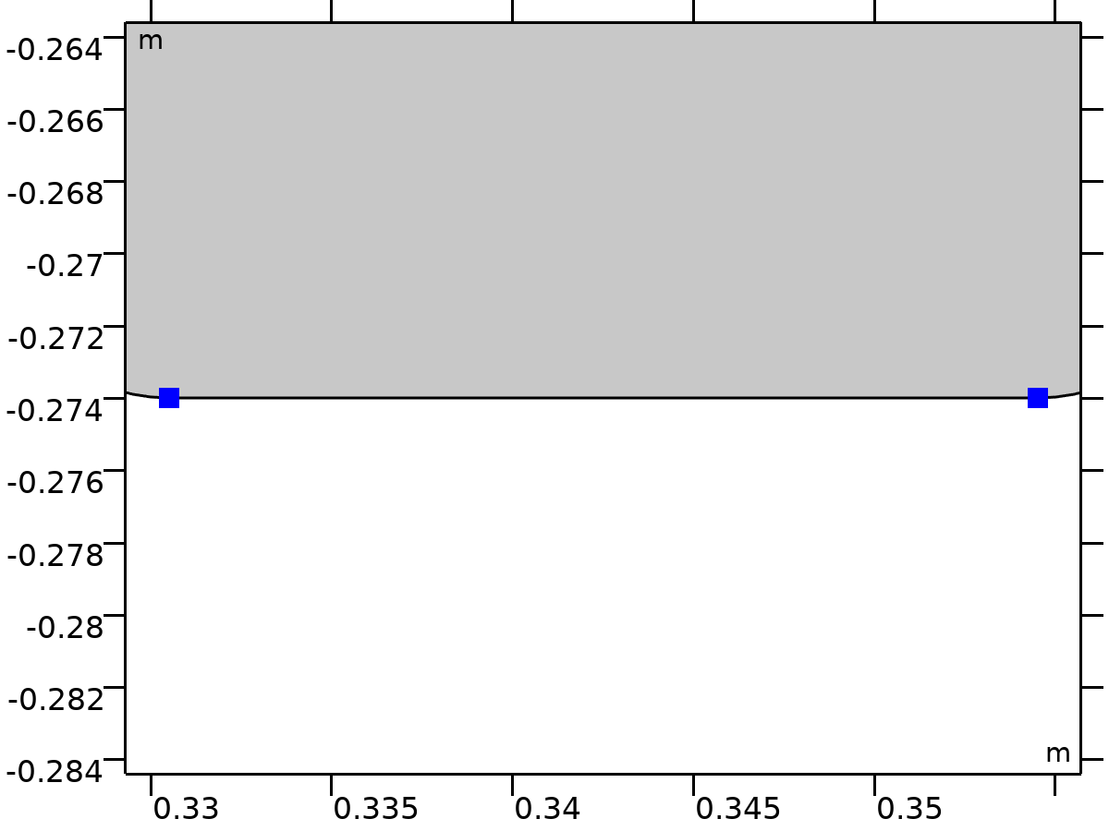

Center of Joint: Point 9

Selection

|  |  |
| --- | --- |
| Geometric entity level | Point |
| Selection | Geometry geom1: Dimension 0: Points 69–70 |

##### Variables

| **Name** | **Expression** | **Unit** | **Description** | **Selection** | **Details** |
| --- | --- | --- | --- | --- | --- |
| mbd.fxj9.xcx | mbd.fxj9.cjp1.int(X)/mbd.fxj9.cjp1.int(1) | m | Center of joint, x-component | Global | + operation |
| mbd.fxj9.xcy | mbd.fxj9.cjp1.int(Y)/mbd.fxj9.cjp1.int(1) | m | Center of joint, y-component | Global | + operation |
| mbd.fxj9.xcz | mbd.fxj9.cjp1.int(0)/mbd.fxj9.cjp1.int(1) | m | Center of joint, z-component | Global | + operation |

## Mesh 1

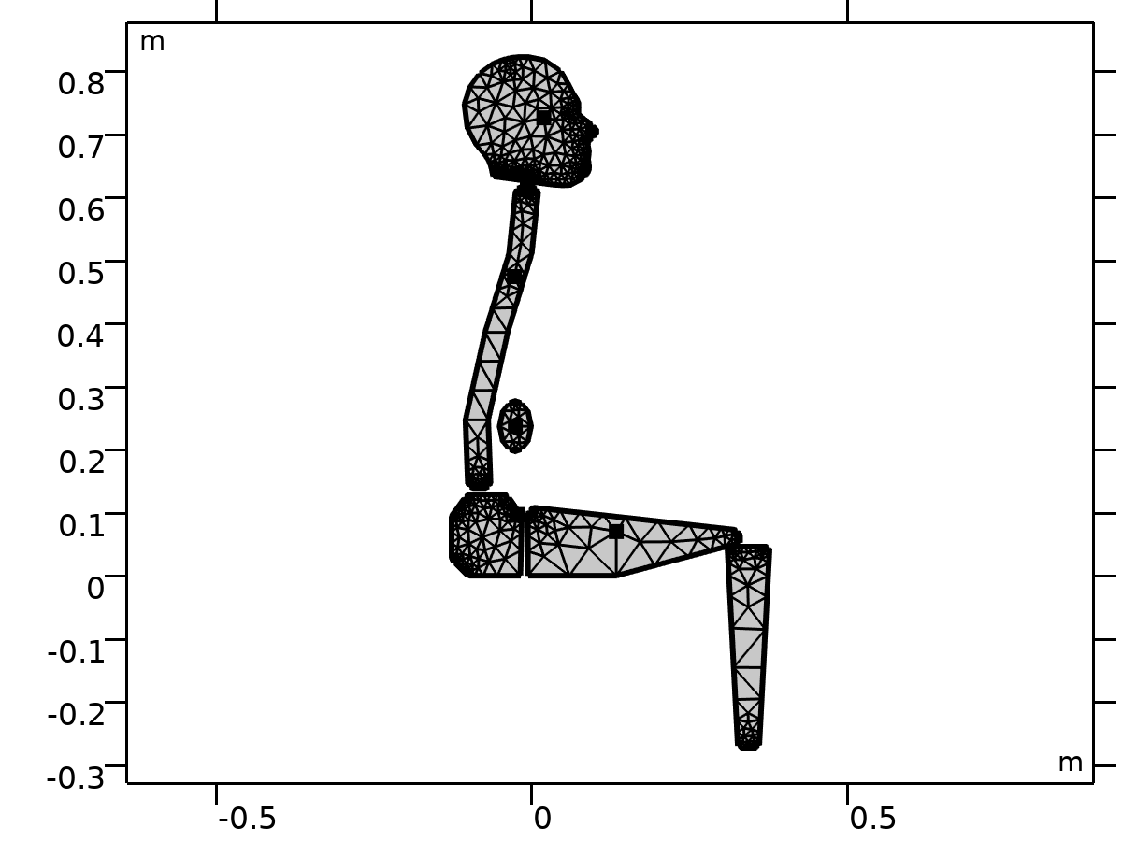

Mesh 1

Mesh statistics

| **Description** | **Value** |
| --- | --- |
| Status | Complete mesh |
| Mesh vertices | 873 |
| Triangles | 1451 |
| Edge elements | 283 |
| Vertex elements | 73 |
| Number of elements | 1451 |
| Minimum element quality | 0.5466 |
| Average element quality | 0.7928 |
| Element area ratio | 5.6069E-5 |
| Mesh area | 0.1061 m² |

### Size (size)

Settings

| **Description** | **Value** |
| --- | --- |
| Maximum element size | 0.143 |
| Minimum element size | 0.00658 |
| Curvature factor | 0.6 |
| Maximum element growth rate | 1.5 |
| Predefined size | Coarser |

### Free Triangular 1 (ftri1)

Selection

|  |  |
| --- | --- |
| Geometric entity level | Domain |
| Selection | Remaining |

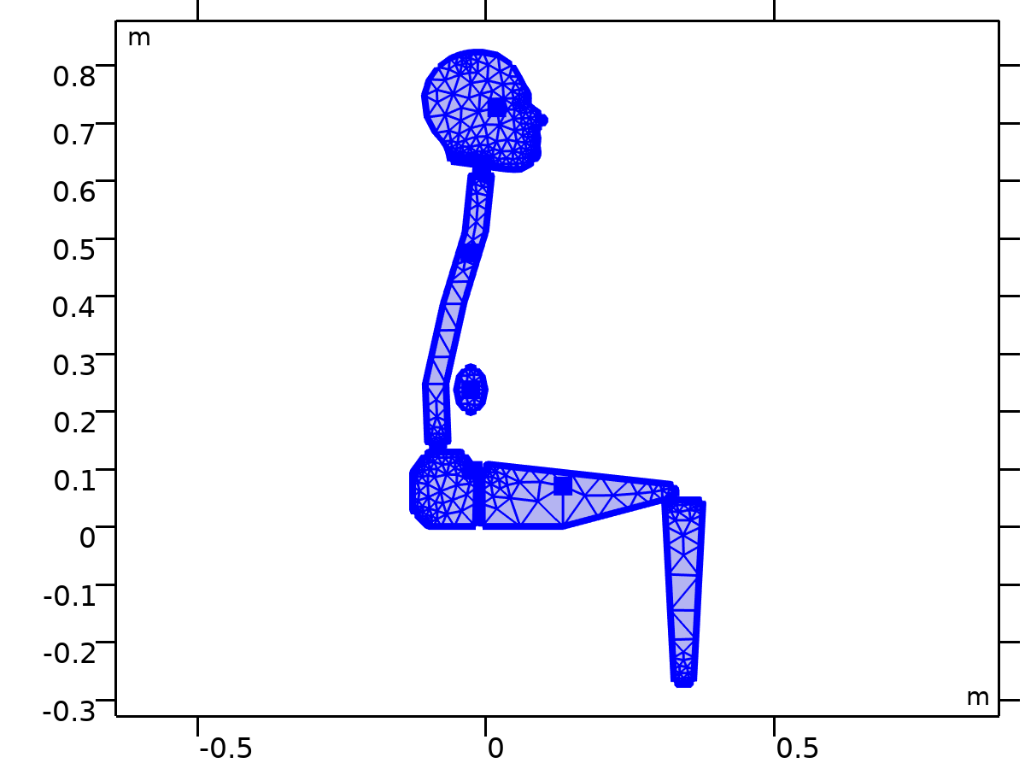

Free Triangular 1

Settings

| **Description** | **Value** |
| --- | --- |
| Number of iterations | 4 |
| Maximum element depth to process | 4 |

Information

| **Description** | **Value** |
| --- | --- |
| Last build time | < 1 second |
| Built with | COMSOL 6.2.0.290 (win64), Dec 16, 2024, 1:31:38 PM |

# Study 1: Eigenfrequency

Computation information

|  |  |
| --- | --- |
| Computation time | 9 s |

## Parametric Sweep

| **Parameter name** | **Parameter value list** |
| --- | --- |
| i_c | 0 1 |

Study settings

| **Description** | **Value** |
| --- | --- |
| Sweep type | Specified combinations |
| Parameter name | i_c |
| Unit |  |

Parameters

| **Parameter name** | **Parameter value list** | **Parameter unit** |
| --- | --- | --- |
| i_c (Damping controller) | 0 1 |  |

## Eigenfrequency

Study settings

| **Description** | **Value** |
| --- | --- |
| Include geometric nonlinearity | Off |

Study settings

| **Description** | **Value** |
| --- | --- |
| Desired number of eigenfrequencies | 12 |
| Desired number of eigenfrequencies | On |
| Search for eigenfrequencies around shift | 0[Hz] |

Physics and variables selection

| **Physics interface** | **Solve for** | **Equation form** |
| --- | --- | --- |
| Multibody Dynamics (mbd) | On | Automatic (Eigenfrequency) |

Store in output

| **Interface** | **Output** | **Selection** |
| --- | --- | --- |
| Multibody Dynamics (mbd) | Physics controlled |  |

Mesh selection

| **Component** | **Mesh** |
| --- | --- |
| Component 1 | Mesh 1 |

## Solver Configurations

### Solution 1

#### Compile Equations: Eigenfrequency (st1)

Study and step

| **Description** | **Value** |
| --- | --- |
| Use study | Study 1: Eigenfrequency |
| Use study step | Eigenfrequency |

Log

<---- Compile Equations: Eigenfrequency in Study 1: Eigenfrequency/Solution 1

      (sol1) -------------------------------------------------------------------

Started at Dec 17, 2024, 11:09:41 PM.

Geometry shape function: Linear Lagrange

Parameter i_c = 1.0 .

Time: 2 s.

Physical memory: 1.25 GB

Virtual memory: 1.65 GB

Ended at Dec 17, 2024, 11:09:43 PM.

----- Compile Equations: Eigenfrequency in Study 1: Eigenfrequency/Solution 1

      (sol1) ------------------------------------------------------------------>

#### Dependent Variables 1 (v1)

General

| **Description** | **Value** |
| --- | --- |
| Defined by study step | Step 1: Eigenfrequency |

Log

<---- Dependent Variables 1 in Study 1: Eigenfrequency/Solution 1 (sol1) -------

Started at Dec 17, 2024, 11:09:43 PM.

Solution time: 0 s.

Physical memory: 1.25 GB

Virtual memory: 1.65 GB

Ended at Dec 17, 2024, 11:09:43 PM.

----- Dependent Variables 1 in Study 1: Eigenfrequency/Solution 1 (sol1) ------>

##### Displacement field (comp1.u) (comp1_u)

General

| **Description** | **Value** |
| --- | --- |
| Field components | {comp1.u, comp1.v} |

Scaling

| **Description** | **Value** |
| --- | --- |
| Method | Manual |
| Scale | 0.012067 |

##### comp1.mbd_rd_disp (comp1_mbd_rd_disp)

General

| **Description** | **Value** |
| --- | --- |
| State components | {comp1.mbd.rd1.U, comp1.mbd.rd1.V, comp1.mbd.rd2.U, comp1.mbd.rd2.V, comp1.mbd.rd3.U, comp1.mbd.rd3.V, comp1.mbd.rd4.U, comp1.mbd.rd4.V, comp1.mbd.rd5.U, comp1.mbd.rd5.V, comp1.mbd.rd6.U, comp1.mbd.rd6.V} |

Scaling

| **Description** | **Value** |
| --- | --- |
| Method | Manual |
| Scale | 0.012067 |

##### comp1.mbd_rd_rot (comp1_mbd_rd_rot)

General

| **Description** | **Value** |
| --- | --- |
| State components | {comp1.mbd.rd1.Phi, comp1.mbd.rd2.Phi, comp1.mbd.rd3.Phi, comp1.mbd.rd4.Phi, comp1.mbd.rd5.Phi, comp1.mbd.rd6.Phi} |

Scaling

| **Description** | **Value** |
| --- | --- |
| Method | Manual |
| Scale | 0.1 |

##### comp1.mbd_jnt_disp (comp1_mbd_jnt_disp)

General

| **Description** | **Value** |
| --- | --- |
| State components | {comp1.mbd.fxj1.U1, comp1.mbd.fxj1.U2, comp1.mbd.fxj2.U1, comp1.mbd.fxj2.U2, comp1.mbd.fxj3.U1, comp1.mbd.fxj3.U2, comp1.mbd.fxj4.U1, comp1.mbd.fxj4.U2, comp1.mbd.fxj5.U1, comp1.mbd.fxj5.U2, comp1.mbd.fxj6.U1, comp1.mbd.fxj6.U2, comp1.mbd.fxj7.U1, comp1.mbd.fxj7.U2, comp1.mbd.fxj8.U1, comp1.mbd.fxj8.U2} |

Scaling

| **Description** | **Value** |
| --- | --- |
| Method | Manual |
| Scale | 0.012067 |

##### comp1.mbd_jnt_rot (comp1_mbd_jnt_rot)

General

| **Description** | **Value** |
| --- | --- |
| State components | {comp1.mbd.fxj1.Th, comp1.mbd.fxj2.Th, comp1.mbd.fxj3.Th, comp1.mbd.fxj4.Th, comp1.mbd.fxj5.Th, comp1.mbd.fxj6.Th, comp1.mbd.fxj7.Th, comp1.mbd.fxj8.Th} |

Scaling

| **Description** | **Value** |
| --- | --- |
| Method | Manual |
| Scale | 0.1 |

##### Reaction force (comp1.mbd.fxj7.RF) (comp1_mbd_fxj7_RF)

General

| **Description** | **Value** |
| --- | --- |
| State components | {comp1.mbd.fxj7.RFx, comp1.mbd.fxj7.RFy} |

Scaling

| **Description** | **Value** |
| --- | --- |
| Method | Manual |
| Scale | 1.456E6 |

##### Reaction moment (comp1.mbd.fxj7.Rphi) (comp1_mbd_fxj7_Rphi)

General

| **Description** | **Value** |
| --- | --- |
| State components | comp1.mbd.fxj7.Rphi |

Scaling

| **Description** | **Value** |
| --- | --- |
| Method | Manual |
| Scale | 1.757E5 |

##### Reaction force (comp1.mbd.fxj8.RF) (comp1_mbd_fxj8_RF)

General

| **Description** | **Value** |
| --- | --- |
| State components | {comp1.mbd.fxj8.RFx, comp1.mbd.fxj8.RFy} |

Scaling

| **Description** | **Value** |
| --- | --- |
| Method | Manual |
| Scale | 1.456E6 |

##### Reaction moment (comp1.mbd.fxj8.Rphi) (comp1_mbd_fxj8_Rphi)

General

| **Description** | **Value** |
| --- | --- |
| State components | comp1.mbd.fxj8.Rphi |

Scaling

| **Description** | **Value** |
| --- | --- |
| Method | Manual |
| Scale | 1.757E5 |

#### Eigenvalue Solver 1 (e1)

General

| **Description** | **Value** |
| --- | --- |
| Defined by study step | Step 1: Eigenfrequency |
| Eigenvalue transformation | Eigenfrequency |
| Desired number of eigenvalues | 12 |
| Unit | Hz |
| Search for eigenvalues around shift | 0[Hz] |

Output

| **Description** | **Value** |
| --- | --- |
| Scaling of eigenvectors | Maximum |
| Maximum absolute value | 1.21E-6 |

Log

<---- Eigenvalue Solver 1 in Study 1: Eigenfrequency/Solution 1 (sol1) ---------

Started at Dec 17, 2024, 11:09:43 PM.

Eigenvalue solver

Number of degrees of freedom solved for: 48.

Symmetric matrices found.

Scales for dependent variables:

Reaction force (comp1.mbd.fxj7.RF): 1.5e+06

Reaction moment (comp1.mbd.fxj7.Rphi): 1.8e+05

Reaction force (comp1.mbd.fxj8.RF): 1.5e+06

Reaction moment (comp1.mbd.fxj8.Rphi): 1.8e+05

comp1.mbd_jnt_disp: 0.012

comp1.mbd_jnt_rot: 0.1

comp1.mbd_rd_disp: 0.012

comp1.mbd_rd_rot: 0.1

Orthonormal null-space function used.

Nonsymmetric eigenvalue solver

Iter      ErrEst  Nconv

   1           0     24

49 linear system solutions.

49 matrix multiplications.

48 re-orthogonalizations.

Solution time: 1 s.

Physical memory: 1.37 GB

Virtual memory: 1.67 GB

Ended at Dec 17, 2024, 11:09:44 PM.

----- Eigenvalue Solver 1 in Study 1: Eigenfrequency/Solution 1 (sol1) -------->

##### Advanced (aDef)

Assembly settings

| **Description** | **Value** |
| --- | --- |
| Reuse sparsity pattern | On |

### Parametric Solutions 1

#### i_c=0 (su1)

General

| **Description** | **Value** |
| --- | --- |
| Solution | i_c=0 (sol3) |

Log

<---- Compile Equations: Eigenfrequency in Study 1: Eigenfrequency/Solution 1

      (sol1) -------------------------------------------------------------------

Started at Dec 17, 2024, 11:09:36 PM.

Geometry shape function: Linear Lagrange

Running on Intel64 Family 6 Model 142 Stepping 12, GenuineIntel.

Using 1 socket with 4 cores in total on DESKTOP-7P3UO8U.

Available memory: 7.95 GB.

Parameter i_c = 0.0 .

Time: 2 s.

Physical memory: 1.17 GB

Virtual memory: 1.38 GB

Ended at Dec 17, 2024, 11:09:39 PM.

----- Compile Equations: Eigenfrequency in Study 1: Eigenfrequency/Solution 1

      (sol1) ------------------------------------------------------------------>

<---- Dependent Variables 1 in Study 1: Eigenfrequency/Solution 1 (sol1) -------

Started at Dec 17, 2024, 11:09:39 PM.

Solution time: 0 s.

Physical memory: 1.17 GB

Virtual memory: 1.38 GB

Ended at Dec 17, 2024, 11:09:39 PM.

----- Dependent Variables 1 in Study 1: Eigenfrequency/Solution 1 (sol1) ------>

<---- Eigenvalue Solver 1 in Study 1: Eigenfrequency/Solution 1 (sol1) ---------

Started at Dec 17, 2024, 11:09:39 PM.

Eigenvalue solver

Number of degrees of freedom solved for: 48.

Symmetric matrices found.

Scales for dependent variables:

Reaction force (comp1.mbd.fxj7.RF): 1.5e+06

Reaction moment (comp1.mbd.fxj7.Rphi): 1.8e+05

Reaction force (comp1.mbd.fxj8.RF): 1.5e+06

Reaction moment (comp1.mbd.fxj8.Rphi): 1.8e+05

comp1.mbd_jnt_disp: 0.012

comp1.mbd_jnt_rot: 0.1

comp1.mbd_rd_disp: 0.012

comp1.mbd_rd_rot: 0.1

Orthonormal null-space function used.

Real symmetric eigenvalue solver

Iter      ErrEst  Nconv

   1           0     12

15 linear system solutions.

45 matrix multiplications.

14 re-orthogonalizations.

Solution time: 2 s.

Physical memory: 1.2 GB

Virtual memory: 1.4 GB

Ended at Dec 17, 2024, 11:09:41 PM.

----- Eigenvalue Solver 1 in Study 1: Eigenfrequency/Solution 1 (sol1) -------->

#### i_c=1 (su2)

General

| **Description** | **Value** |
| --- | --- |
| Solution | i_c=1 (sol4) |

Log

<---- Compile Equations: Eigenfrequency in Study 1: Eigenfrequency/Solution 1

      (sol1) -------------------------------------------------------------------

Started at Dec 17, 2024, 11:09:41 PM.

Geometry shape function: Linear Lagrange

Parameter i_c = 1.0 .

Time: 2 s.

Physical memory: 1.25 GB

Virtual memory: 1.65 GB

Ended at Dec 17, 2024, 11:09:43 PM.

----- Compile Equations: Eigenfrequency in Study 1: Eigenfrequency/Solution 1

      (sol1) ------------------------------------------------------------------>

<---- Dependent Variables 1 in Study 1: Eigenfrequency/Solution 1 (sol1) -------

Started at Dec 17, 2024, 11:09:43 PM.

Solution time: 0 s.

Physical memory: 1.25 GB

Virtual memory: 1.65 GB

Ended at Dec 17, 2024, 11:09:43 PM.

----- Dependent Variables 1 in Study 1: Eigenfrequency/Solution 1 (sol1) ------>

<---- Eigenvalue Solver 1 in Study 1: Eigenfrequency/Solution 1 (sol1) ---------

Started at Dec 17, 2024, 11:09:43 PM.

Eigenvalue solver

Number of degrees of freedom solved for: 48.

Symmetric matrices found.

Scales for dependent variables:

Reaction force (comp1.mbd.fxj7.RF): 1.5e+06

Reaction moment (comp1.mbd.fxj7.Rphi): 1.8e+05

Reaction force (comp1.mbd.fxj8.RF): 1.5e+06

Reaction moment (comp1.mbd.fxj8.Rphi): 1.8e+05

comp1.mbd_jnt_disp: 0.012

comp1.mbd_jnt_rot: 0.1

comp1.mbd_rd_disp: 0.012

comp1.mbd_rd_rot: 0.1

Orthonormal null-space function used.

Nonsymmetric eigenvalue solver

Iter      ErrEst  Nconv

   1           0     24

49 linear system solutions.

49 matrix multiplications.

48 re-orthogonalizations.

Solution time: 1 s.

Physical memory: 1.37 GB

Virtual memory: 1.67 GB

Ended at Dec 17, 2024, 11:09:44 PM.

----- Eigenvalue Solver 1 in Study 1: Eigenfrequency/Solution 1 (sol1) -------->

# Study 2

Computation information

|  |  |
| --- | --- |
| Computation time | 13 s |

## Frequency Response

| **Frequencies (Hz)** |
| --- |
| range(2,0.2,20) |

Study settings

| **Description** | **Value** |
| --- | --- |
| Include geometric nonlinearity | Off |

Settings

| **Description** | **Value** |
| --- | --- |
| Frequencies | {2, 2.2, 2.4, 2.6, 2.8, 3, 3.2, 3.4, 3.6, 3.8, 4, 4.2, 4.4, 4.6, 4.8, 5, 5.2, 5.4, 5.6, 5.8, 6, 6.2, 6.4, 6.6, 6.8, 7, 7.2, 7.4, 7.6, 7.8, 8, 8.2, 8.4, 8.6, 8.8, 9, 9.2, 9.4, 9.6, 9.8, 10, 10.2, 10.4, 10.6, 10.8, 11, 11.2, 11.4, 11.6, 11.8, 12, 12.2, 12.4, 12.6, 12.8, 13, 13.2, 13.4, 13.6, 13.8, 14, 14.2, 14.4, 14.6, 14.8, 15, 15.2, 15.4, 15.6, 15.8, 16, 16.2, 16.4, 16.6, 16.8, 17, 17.2, 17.4, 17.6, 17.8, 18, 18.2, 18.4, 18.6, 18.8, 19, 19.2, 19.4, 19.6, 19.8, 20} |

Physics and variables selection

| **Physics interface** | **Solve for** | **Equation form** |
| --- | --- | --- |
| Multibody Dynamics (mbd) | On | Automatic (Frequency domain) |

Store in output

| **Interface** | **Output** | **Selection** |
| --- | --- | --- |
| Multibody Dynamics (mbd) | Physics controlled |  |

Mesh selection

| **Component** | **Mesh** |
| --- | --- |
| Component 1 | Mesh 1 |

## Solver Configurations

### Solution 5

#### Compile Equations: Frequency Response (st1)

Study and step

| **Description** | **Value** |
| --- | --- |
| Use study | Study 2 |
| Use study step | Frequency Response |

Log

<---- Compile Equations: Frequency Response in Study 2/Solution 5 (sol5) -------

Started at Dec 17, 2024, 11:42:01 PM.

Geometry shape function: Linear Lagrange

Running on Intel64 Family 6 Model 142 Stepping 12, GenuineIntel.

Using 1 socket with 4 cores in total on DESKTOP-7P3UO8U.

Available memory: 7.95 GB.

Time: 2 s.

Physical memory: 1.51 GB

Virtual memory: 1.7 GB

Ended at Dec 17, 2024, 11:42:03 PM.

----- Compile Equations: Frequency Response in Study 2/Solution 5 (sol5) ------>

#### Dependent Variables 1 (v1)

General

| **Description** | **Value** |
| --- | --- |
| Defined by study step | Step 1: Frequency Response |

Initial value calculation constants

| **Constant name** | **Initial value source** |
| --- | --- |
| freq | range(2,0.2,20)[Hz] |

Log

<---- Dependent Variables 1 in Study 2/Solution 5 (sol5) -----------------------

Started at Dec 17, 2024, 11:42:03 PM.

Solution time: 0 s.

Physical memory: 1.51 GB

Virtual memory: 1.7 GB

Ended at Dec 17, 2024, 11:42:03 PM.

----- Dependent Variables 1 in Study 2/Solution 5 (sol5) ---------------------->

##### Displacement field (comp1.u) (comp1_u)

General

| **Description** | **Value** |
| --- | --- |
| Field components | {comp1.u, comp1.v} |

Scaling

| **Description** | **Value** |
| --- | --- |
| Method | Manual |
| Scale | 0.012067 |

##### comp1.mbd_rd_disp (comp1_mbd_rd_disp)

General

| **Description** | **Value** |
| --- | --- |
| State components | {comp1.mbd.rd1.U, comp1.mbd.rd1.V, comp1.mbd.rd2.U, comp1.mbd.rd2.V, comp1.mbd.rd3.U, comp1.mbd.rd3.V, comp1.mbd.rd4.U, comp1.mbd.rd4.V, comp1.mbd.rd5.U, comp1.mbd.rd5.V, comp1.mbd.rd6.U, comp1.mbd.rd6.V} |

Scaling

| **Description** | **Value** |
| --- | --- |
| Method | Manual |
| Scale | 0.012067 |

##### comp1.mbd_rd_rot (comp1_mbd_rd_rot)

General

| **Description** | **Value** |
| --- | --- |
| State components | {comp1.mbd.rd1.Phi, comp1.mbd.rd2.Phi, comp1.mbd.rd3.Phi, comp1.mbd.rd4.Phi, comp1.mbd.rd5.Phi, comp1.mbd.rd6.Phi} |

Scaling

| **Description** | **Value** |
| --- | --- |
| Method | Manual |
| Scale | 0.1 |

##### comp1.mbd_jnt_disp (comp1_mbd_jnt_disp)

General

| **Description** | **Value** |
| --- | --- |
| State components | {comp1.mbd.fxj1.U1, comp1.mbd.fxj1.U2, comp1.mbd.fxj2.U1, comp1.mbd.fxj2.U2, comp1.mbd.fxj3.U1, comp1.mbd.fxj3.U2, comp1.mbd.fxj4.U1, comp1.mbd.fxj4.U2, comp1.mbd.fxj5.U1, comp1.mbd.fxj5.U2, comp1.mbd.fxj6.U1, comp1.mbd.fxj6.U2, comp1.mbd.fxj7.U1, comp1.mbd.fxj7.U2, comp1.mbd.fxj8.U1, comp1.mbd.fxj8.U2} |

Scaling

| **Description** | **Value** |
| --- | --- |
| Method | Manual |
| Scale | 0.012067 |

##### comp1.mbd_jnt_rot (comp1_mbd_jnt_rot)

General

| **Description** | **Value** |
| --- | --- |
| State components | {comp1.mbd.fxj1.Th, comp1.mbd.fxj2.Th, comp1.mbd.fxj3.Th, comp1.mbd.fxj4.Th, comp1.mbd.fxj5.Th, comp1.mbd.fxj6.Th, comp1.mbd.fxj7.Th, comp1.mbd.fxj8.Th} |

Scaling

| **Description** | **Value** |
| --- | --- |
| Method | Manual |
| Scale | 0.1 |

##### Reaction force (comp1.mbd.fxj7.RF) (comp1_mbd_fxj7_RF)

General

| **Description** | **Value** |
| --- | --- |
| State components | {comp1.mbd.fxj7.RFx, comp1.mbd.fxj7.RFy} |

Scaling

| **Description** | **Value** |
| --- | --- |
| Method | Manual |
| Scale | 1.456E6 |

##### Reaction moment (comp1.mbd.fxj7.Rphi) (comp1_mbd_fxj7_Rphi)

General

| **Description** | **Value** |
| --- | --- |
| State components | comp1.mbd.fxj7.Rphi |

Scaling

| **Description** | **Value** |
| --- | --- |
| Method | Manual |
| Scale | 1.757E5 |

##### Reaction force (comp1.mbd.fxj8.RF) (comp1_mbd_fxj8_RF)

General

| **Description** | **Value** |
| --- | --- |
| State components | {comp1.mbd.fxj8.RFx, comp1.mbd.fxj8.RFy} |

Scaling

| **Description** | **Value** |
| --- | --- |
| Method | Manual |
| Scale | 1.456E6 |

##### Reaction moment (comp1.mbd.fxj8.Rphi) (comp1_mbd_fxj8_Rphi)

General

| **Description** | **Value** |
| --- | --- |
| State components | comp1.mbd.fxj8.Rphi |

Scaling

| **Description** | **Value** |
| --- | --- |
| Method | Manual |
| Scale | 1.757E5 |

#### Stationary Solver 1 (s1)

General

| **Description** | **Value** |
| --- | --- |
| Defined by study step | Step 1: Frequency Response |

Results while solving

| **Description** | **Value** |
| --- | --- |
| Probes | None |

Log

<---- Stationary Solver 1 in Study 2/Solution 5 (sol5) -------------------------

Started at Dec 17, 2024, 11:42:03 PM.

Parametric solver

Nonlinear solver

Number of degrees of freedom solved for: 48.

Parameter freq = 2.

Symmetric matrices found.

Scales for dependent variables:

Reaction force (comp1.mbd.fxj7.RF): 1.5e+06

Reaction moment (comp1.mbd.fxj7.Rphi): 1.8e+05

Reaction force (comp1.mbd.fxj8.RF): 1.5e+06

Reaction moment (comp1.mbd.fxj8.Rphi): 1.8e+05

comp1.mbd_jnt_disp: 0.012

comp1.mbd_jnt_rot: 0.1

comp1.mbd_rd_disp: 0.012

comp1.mbd_rd_rot: 0.1

Orthonormal null-space function used.

Iter      SolEst      ResEst     Damping    Stepsize #Res #Jac #Sol   LinErr   LinRes

   1         0.3      0.0015   1.0000000         0.3    2    1    1  2.7e-15  6.8e-16

   2     4.6e-05     1.6e-12   1.0000000     4.6e-05    3    2    2  2.9e-15  6.3e-16

Parameter freq = 2.2.

Iter      SolEst      ResEst     Damping    Stepsize #Res #Jac #Sol   LinErr   LinRes

   1         0.3      0.0013   1.0000000         0.3    5    3    3  4.4e-15  3.6e-16

   2     3.8e-05     1.2e-12   1.0000000     3.8e-05    6    4    4    3e-15  8.1e-16

Parameter freq = 2.4.

Iter      SolEst      ResEst     Damping    Stepsize #Res #Jac #Sol   LinErr   LinRes

   1        0.29      0.0011   1.0000000        0.29    8    5    5  3.5e-15  5.7e-16

   2     3.1e-05     1.5e-12   1.0000000     3.1e-05    9    6    6  4.3e-15  6.5e-16

Parameter freq = 2.6.

Iter      SolEst      ResEst     Damping    Stepsize #Res #Jac #Sol   LinErr   LinRes

   1        0.29     0.00097   1.0000000        0.29   11    7    7  4.5e-15  3.7e-16

Parameter freq = 2.8.

Iter      SolEst      ResEst     Damping    Stepsize #Res #Jac #Sol   LinErr   LinRes

   1        0.29     0.00096   1.0000000        0.29   13    8    8  5.1e-15  3.8e-16

Parameter freq = 3.

Iter      SolEst      ResEst     Damping    Stepsize #Res #Jac #Sol   LinErr   LinRes

   1        0.29       0.001   1.0000000        0.29   15    9    9  5.5e-15  3.5e-16

   2     2.7e-05     3.3e-12   1.0000000     2.7e-05   16   10   10  4.7e-15  3.5e-16

Parameter freq = 3.2.

Iter      SolEst      ResEst     Damping    Stepsize #Res #Jac #Sol   LinErr   LinRes

   1        0.29      0.0011   1.0000000        0.29   18   11   11  4.9e-15  5.4e-16

   2     2.9e-05       2e-12   1.0000000     2.9e-05   19   12   12    3e-15  4.5e-16

Parameter freq = 3.4.

Iter      SolEst      ResEst     Damping    Stepsize #Res #Jac #Sol   LinErr   LinRes

   1        0.29      0.0011   1.0000000        0.29   21   13   13  6.4e-15  3.9e-16

   2     3.1e-05     3.6e-12   1.0000000     3.1e-05   22   14   14  2.2e-15  3.4e-16

Parameter freq = 3.6.

Iter      SolEst      ResEst     Damping    Stepsize #Res #Jac #Sol   LinErr   LinRes

   1        0.29      0.0012   1.0000000        0.29   24   15   15  3.1e-15  4.9e-16

   2     3.1e-05     3.5e-12   1.0000000     3.1e-05   25   16   16  2.3e-15  3.2e-16

Parameter freq = 3.8.

Iter      SolEst      ResEst     Damping    Stepsize #Res #Jac #Sol   LinErr   LinRes

   1        0.29      0.0012   1.0000000        0.29   27   17   17  2.8e-15  6.7e-16

   2     3.1e-05     4.5e-12   1.0000000     3.1e-05   28   18   18  2.7e-15  4.6e-16

Parameter freq = 4.

Iter      SolEst      ResEst     Damping    Stepsize #Res #Jac #Sol   LinErr   LinRes

   1        0.29      0.0012   1.0000000        0.29   30   19   19  7.1e-15  5.2e-16

   2       3e-05     7.3e-12   1.0000000       3e-05   31   20   20  5.5e-15  3.3e-16

Parameter freq = 4.2.

Iter      SolEst      ResEst     Damping    Stepsize #Res #Jac #Sol   LinErr   LinRes

   1        0.29      0.0012   1.0000000        0.29   33   21   21  5.1e-15    5e-16

   2       3e-05     1.9e-12   1.0000000       3e-05   34   22   22  4.4e-15  3.7e-16

Parameter freq = 4.4.

Iter      SolEst      ResEst     Damping    Stepsize #Res #Jac #Sol   LinErr   LinRes

   1         0.3      0.0012   1.0000000         0.3   36   23   23  5.4e-15  4.3e-16

   2       3e-05     2.8e-12   1.0000000       3e-05   37   24   24  2.2e-15    4e-16

Parameter freq = 4.6.

Iter      SolEst      ResEst     Damping    Stepsize #Res #Jac #Sol   LinErr   LinRes

   1         0.3      0.0012   1.0000000         0.3   39   25   25  7.2e-15  3.1e-16

   2       3e-05         8.6   1.0000000       3e-05   40   26   26  9.1e-15  3.8e-16

Parameter freq = 4.8.

Iter      SolEst      ResEst     Damping    Stepsize #Res #Jac #Sol   LinErr   LinRes

   1        0.29      0.0012   1.0000000        0.29   42   27   27  6.8e-15  4.3e-16

   2       3e-05     8.3e-12   1.0000000       3e-05   43   28   28    3e-15  2.8e-16

Parameter freq = 5.

Iter      SolEst      ResEst     Damping    Stepsize #Res #Jac #Sol   LinErr   LinRes

   1        0.29      0.0012   1.0000000        0.29   45   29   29  5.5e-15    1e-15

   2     2.9e-05     5.4e-12   1.0000000     2.9e-05   46   30   30  2.1e-15  3.6e-16

Parameter freq = 5.2.

Iter      SolEst      ResEst     Damping    Stepsize #Res #Jac #Sol   LinErr   LinRes

   1        0.29      0.0012   1.0000000        0.29   48   31   31  4.5e-15  6.1e-16

   2     2.8e-05     1.4e-11   1.0000000     2.8e-05   49   32   32  4.7e-15  3.1e-16

Parameter freq = 5.4.

Iter      SolEst      ResEst     Damping    Stepsize #Res #Jac #Sol   LinErr   LinRes

   1        0.28       0.001   1.0000000        0.28   51   33   33  7.4e-15  5.6e-16

   2     2.5e-05     1.4e-11   1.0000000     2.5e-05   52   34   34  4.7e-15  3.4e-16

Parameter freq = 5.6.

Iter      SolEst      ResEst     Damping    Stepsize #Res #Jac #Sol   LinErr   LinRes

   1        0.27     0.00083   1.0000000        0.27   54   35   35  3.5e-15  4.3e-16

Parameter freq = 5.8.

Iter      SolEst      ResEst     Damping    Stepsize #Res #Jac #Sol   LinErr   LinRes

   1        0.26     0.00063   1.0000000        0.26   56   36   36  8.6e-15  6.4e-16

Parameter freq = 6.

Iter      SolEst      ResEst     Damping    Stepsize #Res #Jac #Sol   LinErr   LinRes

   1        0.24     0.00045   1.0000000        0.24   58   37   37  3.8e-15  5.7e-16

Parameter freq = 6.2.

Iter      SolEst      ResEst     Damping    Stepsize #Res #Jac #Sol   LinErr   LinRes

   1        0.22     0.00033   1.0000000        0.22   60   38   38  5.6e-15  4.9e-16

Parameter freq = 6.4.

Iter      SolEst      ResEst     Damping    Stepsize #Res #Jac #Sol   LinErr   LinRes

   1        0.21     0.00024   1.0000000        0.21   62   39   39    7e-15  4.7e-16

Parameter freq = 6.6.

Iter      SolEst      ResEst     Damping    Stepsize #Res #Jac #Sol   LinErr   LinRes

   1        0.21     0.00019   1.0000000        0.21   64   40   40  3.9e-15  5.7e-16

Parameter freq = 6.8.

Iter      SolEst      ResEst     Damping    Stepsize #Res #Jac #Sol   LinErr   LinRes

   1         0.2     0.00015   1.0000000         0.2   66   41   41  3.9e-15  5.6e-16

Parameter freq = 7.

Iter      SolEst      ResEst     Damping    Stepsize #Res #Jac #Sol   LinErr   LinRes

   1        0.19     0.00012   1.0000000        0.19   68   42   42  6.5e-15    7e-16

Parameter freq = 7.2.

Iter      SolEst      ResEst     Damping    Stepsize #Res #Jac #Sol   LinErr   LinRes

   1        0.17      0.0001   1.0000000        0.17   70   43   43  2.2e-15  8.2e-16

Parameter freq = 7.4.

Iter      SolEst      ResEst     Damping    Stepsize #Res #Jac #Sol   LinErr   LinRes

   1        0.16       9e-05   1.0000000        0.16   72   44   44  2.6e-15  1.1e-15

Parameter freq = 7.6.

Iter      SolEst      ResEst     Damping    Stepsize #Res #Jac #Sol   LinErr   LinRes

   1        0.15       8e-05   1.0000000        0.15   74   45   45  1.4e-15  3.9e-16

Parameter freq = 7.8.

Iter      SolEst      ResEst     Damping    Stepsize #Res #Jac #Sol   LinErr   LinRes

   1        0.14     7.3e-05   1.0000000        0.14   76   46   46  1.6e-15  8.2e-16

Parameter freq = 8.

Iter      SolEst      ResEst     Damping    Stepsize #Res #Jac #Sol   LinErr   LinRes

   1        0.13     6.8e-05   1.0000000        0.13   78   47   47    3e-15  7.7e-16

Parameter freq = 8.2.

Iter      SolEst      ResEst     Damping    Stepsize #Res #Jac #Sol   LinErr   LinRes

   1        0.12     6.3e-05   1.0000000        0.12   80   48   48  1.7e-15  5.4e-16

Parameter freq = 8.4.

Iter      SolEst      ResEst     Damping    Stepsize #Res #Jac #Sol   LinErr   LinRes

   1        0.11     5.9e-05   1.0000000        0.11   82   49   49  2.4e-15  7.5e-16

Parameter freq = 8.6.

Iter      SolEst      ResEst     Damping    Stepsize #Res #Jac #Sol   LinErr   LinRes

   1        0.11     5.6e-05   1.0000000        0.11   84   50   50  1.8e-15  6.9e-16

Parameter freq = 8.8.

Iter      SolEst      ResEst     Damping    Stepsize #Res #Jac #Sol   LinErr   LinRes

   1         0.1     5.3e-05   1.0000000         0.1   86   51   51  1.9e-15  3.1e-16

Parameter freq = 9.

Iter      SolEst      ResEst     Damping    Stepsize #Res #Jac #Sol   LinErr   LinRes

   1       0.095       5e-05   1.0000000       0.095   88   52   52  2.5e-15  3.6e-16

Parameter freq = 9.2.

Iter      SolEst      ResEst     Damping    Stepsize #Res #Jac #Sol   LinErr   LinRes

   1        0.09     4.7e-05   1.0000000        0.09   90   53   53  2.2e-15  4.8e-16

Parameter freq = 9.4.

Iter      SolEst      ResEst     Damping    Stepsize #Res #Jac #Sol   LinErr   LinRes

   1       0.086     4.5e-05   1.0000000       0.086   92   54   54  2.5e-15  7.3e-16

Parameter freq = 9.6.

Iter      SolEst      ResEst     Damping    Stepsize #Res #Jac #Sol   LinErr   LinRes

   1       0.081     4.2e-05   1.0000000       0.081   94   55   55  1.5e-15  4.6e-16

Parameter freq = 9.8.

Iter      SolEst      ResEst     Damping    Stepsize #Res #Jac #Sol   LinErr   LinRes

   1       0.077       4e-05   1.0000000       0.077   96   56   56  1.3e-15  3.4e-16

Parameter freq = 10.

Iter      SolEst      ResEst     Damping    Stepsize #Res #Jac #Sol   LinErr   LinRes

   1       0.074     3.8e-05   1.0000000       0.074   98   57   57  2.9e-15  5.5e-16

Parameter freq = 10.2.

Iter      SolEst      ResEst     Damping    Stepsize #Res #Jac #Sol   LinErr   LinRes

   1        0.07     3.5e-05   1.0000000        0.07  100   58   58  1.6e-15  6.3e-16

Parameter freq = 10.4.

Iter      SolEst      ResEst     Damping    Stepsize #Res #Jac #Sol   LinErr   LinRes

   1       0.067     3.3e-05   1.0000000       0.067  102   59   59  3.3e-15  2.3e-16

Parameter freq = 10.6.

Iter      SolEst      ResEst     Damping    Stepsize #Res #Jac #Sol   LinErr   LinRes

   1       0.064     3.1e-05   1.0000000       0.064  104   60   60  2.5e-15  5.1e-16

Parameter freq = 10.8.

Iter      SolEst      ResEst     Damping    Stepsize #Res #Jac #Sol   LinErr   LinRes

   1       0.061     2.9e-05   1.0000000       0.061  106   61   61  1.7e-15  4.6e-16

Parameter freq = 11.

Iter      SolEst      ResEst     Damping    Stepsize #Res #Jac #Sol   LinErr   LinRes

   1       0.058     2.7e-05   1.0000000       0.058  108   62   62  1.2e-15  2.6e-16

Parameter freq = 11.2.

Iter      SolEst      ResEst     Damping    Stepsize #Res #Jac #Sol   LinErr   LinRes

   1       0.055     2.5e-05   1.0000000       0.055  110   63   63    1e-15  5.9e-16

Parameter freq = 11.4.

Iter      SolEst      ResEst     Damping    Stepsize #Res #Jac #Sol   LinErr   LinRes

   1       0.052     2.3e-05   1.0000000       0.052  112   64   64  1.9e-15  5.5e-16

Parameter freq = 11.6.

Iter      SolEst      ResEst     Damping    Stepsize #Res #Jac #Sol   LinErr   LinRes

   1        0.05     2.2e-05   1.0000000        0.05  114   65   65  1.6e-15  6.1e-16

Parameter freq = 11.8.

Iter      SolEst      ResEst     Damping    Stepsize #Res #Jac #Sol   LinErr   LinRes

   1       0.048       2e-05   1.0000000       0.048  116   66   66  1.1e-15  3.2e-16

Parameter freq = 12.

Iter      SolEst      ResEst     Damping    Stepsize #Res #Jac #Sol   LinErr   LinRes

   1       0.046     1.9e-05   1.0000000       0.046  118   67   67  9.5e-16  3.3e-16

Parameter freq = 12.2.

Iter      SolEst      ResEst     Damping    Stepsize #Res #Jac #Sol   LinErr   LinRes

   1       0.044     1.7e-05   1.0000000       0.044  120   68   68  1.2e-15  2.8e-16

Parameter freq = 12.4.

Iter      SolEst      ResEst     Damping    Stepsize #Res #Jac #Sol   LinErr   LinRes

   1       0.042     1.6e-05   1.0000000       0.042  122   69   69  1.8e-15    5e-16

Parameter freq = 12.6.

Iter      SolEst      ResEst     Damping    Stepsize #Res #Jac #Sol   LinErr   LinRes

   1        0.04     1.5e-05   1.0000000        0.04  124   70   70  1.3e-15  2.5e-16

Parameter freq = 12.8.

Iter      SolEst      ResEst     Damping    Stepsize #Res #Jac #Sol   LinErr   LinRes

   1       0.038     1.4e-05   1.0000000       0.038  126   71   71  1.6e-15  2.2e-16

Parameter freq = 13.

Iter      SolEst      ResEst     Damping    Stepsize #Res #Jac #Sol   LinErr   LinRes

   1       0.037     1.3e-05   1.0000000       0.037  128   72   72  1.2e-15  4.9e-16

Parameter freq = 13.2.

Iter      SolEst      ResEst     Damping    Stepsize #Res #Jac #Sol   LinErr   LinRes

   1       0.035     1.2e-05   1.0000000       0.035  130   73   73  1.1e-15  4.8e-16

Parameter freq = 13.4.

Iter      SolEst      ResEst     Damping    Stepsize #Res #Jac #Sol   LinErr   LinRes

   1       0.034     1.1e-05   1.0000000       0.034  132   74   74    8e-16  2.7e-16

Parameter freq = 13.6.

Iter      SolEst      ResEst     Damping    Stepsize #Res #Jac #Sol   LinErr   LinRes

   1       0.032     9.9e-06   1.0000000       0.032  134   75   75  1.5e-15  3.3e-16

Parameter freq = 13.8.

Iter      SolEst      ResEst     Damping    Stepsize #Res #Jac #Sol   LinErr   LinRes

   1       0.031     9.1e-06   1.0000000       0.031  136   76   76  8.7e-16  3.7e-16

Parameter freq = 14.

Iter      SolEst      ResEst     Damping    Stepsize #Res #Jac #Sol   LinErr   LinRes

   1        0.03     8.5e-06   1.0000000        0.03  138   77   77  1.3e-15  4.9e-16

Parameter freq = 14.2.

Iter      SolEst      ResEst     Damping    Stepsize #Res #Jac #Sol   LinErr   LinRes

   1       0.029     7.8e-06   1.0000000       0.029  140   78   78  1.2e-15  3.4e-16

Parameter freq = 14.4.

Iter      SolEst      ResEst     Damping    Stepsize #Res #Jac #Sol   LinErr   LinRes

   1       0.028     7.3e-06   1.0000000       0.028  142   79   79  8.1e-16  2.3e-16

Parameter freq = 14.6.

Iter      SolEst      ResEst     Damping    Stepsize #Res #Jac #Sol   LinErr   LinRes

   1       0.027     6.7e-06   1.0000000       0.027  144   80   80  1.7e-15  4.9e-16

Parameter freq = 14.8.

Iter      SolEst      ResEst     Damping    Stepsize #Res #Jac #Sol   LinErr   LinRes

   1       0.026     6.2e-06   1.0000000       0.026  146   81   81  9.5e-16    3e-16

Parameter freq = 15.

Iter      SolEst      ResEst     Damping    Stepsize #Res #Jac #Sol   LinErr   LinRes

   1       0.025     5.8e-06   1.0000000       0.025  148   82   82  8.2e-16  3.7e-16

Parameter freq = 15.2.

Iter      SolEst      ResEst     Damping    Stepsize #Res #Jac #Sol   LinErr   LinRes

   1       0.024     5.4e-06   1.0000000       0.024  150   83   83  1.4e-15  4.5e-16

Parameter freq = 15.4.

Iter      SolEst      ResEst     Damping    Stepsize #Res #Jac #Sol   LinErr   LinRes

   1       0.023       5e-06   1.0000000       0.023  152   84   84  1.4e-15  6.1e-16

Parameter freq = 15.6.

Iter      SolEst      ResEst     Damping    Stepsize #Res #Jac #Sol   LinErr   LinRes

   1       0.022     4.6e-06   1.0000000       0.022  154   85   85  1.2e-15  7.5e-16

Parameter freq = 15.8.

Iter      SolEst      ResEst     Damping    Stepsize #Res #Jac #Sol   LinErr   LinRes

   1       0.022     4.6e-06   1.0000000       0.022  156   86   86  1.1e-15  3.5e-16

Parameter freq = 16.

Iter      SolEst      ResEst     Damping    Stepsize #Res #Jac #Sol   LinErr   LinRes

   1       0.021     4.2e-06   1.0000000       0.021  158   87   87  5.7e-16  2.5e-16

Parameter freq = 16.2.

Iter      SolEst      ResEst     Damping    Stepsize #Res #Jac #Sol   LinErr   LinRes

   1        0.02     4.2e-06   1.0000000        0.02  160   88   88  5.4e-16  3.1e-16

Parameter freq = 16.4.

Iter      SolEst      ResEst     Damping    Stepsize #Res #Jac #Sol   LinErr   LinRes

   1        0.02     3.5e-06   1.0000000        0.02  162   89   89  7.6e-16  2.9e-16

Parameter freq = 16.6.

Iter      SolEst      ResEst     Damping    Stepsize #Res #Jac #Sol   LinErr   LinRes

   1       0.019     3.4e-06   1.0000000       0.019  164   90   90    6e-16  2.8e-16

Parameter freq = 16.8.

Iter      SolEst      ResEst     Damping    Stepsize #Res #Jac #Sol   LinErr   LinRes

   1       0.019     3.1e-06   1.0000000       0.019  166   91   91  6.4e-16  1.9e-16

Parameter freq = 17.

Iter      SolEst      ResEst     Damping    Stepsize #Res #Jac #Sol   LinErr   LinRes

   1       0.018     3.1e-06   1.0000000       0.018  168   92   92  8.2e-16    4e-16

Parameter freq = 17.2.

Iter      SolEst      ResEst     Damping    Stepsize #Res #Jac #Sol   LinErr   LinRes

   1       0.018     2.9e-06   1.0000000       0.018  170   93   93  7.4e-16  2.3e-16

Parameter freq = 17.4.

Iter      SolEst      ResEst     Damping    Stepsize #Res #Jac #Sol   LinErr   LinRes

   1       0.017     2.8e-06   1.0000000       0.017  172   94   94  6.8e-16  3.8e-16

Parameter freq = 17.6.

Iter      SolEst      ResEst     Damping    Stepsize #Res #Jac #Sol   LinErr   LinRes

   1       0.017     2.8e-06   1.0000000       0.017  174   95   95  1.2e-15  5.1e-16

Parameter freq = 17.8.

Iter      SolEst      ResEst     Damping    Stepsize #Res #Jac #Sol   LinErr   LinRes

   1       0.016     2.4e-06   1.0000000       0.016  176   96   96  1.4e-15  4.8e-16

Parameter freq = 18.

Iter      SolEst      ResEst     Damping    Stepsize #Res #Jac #Sol   LinErr   LinRes

   1       0.016     2.7e-06   1.0000000       0.016  178   97   97  1.4e-15  2.8e-16

Parameter freq = 18.2.

Iter      SolEst      ResEst     Damping    Stepsize #Res #Jac #Sol   LinErr   LinRes

   1       0.015     2.8e-06   1.0000000       0.015  180   98   98  1.4e-15    4e-16

Parameter freq = 18.4.

Iter      SolEst      ResEst     Damping    Stepsize #Res #Jac #Sol   LinErr   LinRes

   1       0.015     3.7e-06   1.0000000       0.015  182   99   99    1e-15  3.6e-16

Parameter freq = 18.6.

Iter      SolEst      ResEst     Damping    Stepsize #Res #Jac #Sol   LinErr   LinRes

   1       0.015     2.5e-06   1.0000000       0.015  184  100  100  1.5e-15  3.5e-16

Parameter freq = 18.8.

Iter      SolEst      ResEst     Damping    Stepsize #Res #Jac #Sol   LinErr   LinRes

   1       0.014     1.9e-06   1.0000000       0.014  186  101  101  5.9e-16  5.2e-16

Parameter freq = 19.

Iter      SolEst      ResEst     Damping    Stepsize #Res #Jac #Sol   LinErr   LinRes

   1       0.014     1.9e-06   1.0000000       0.014  188  102  102  1.1e-15    4e-16

Parameter freq = 19.2.

Iter      SolEst      ResEst     Damping    Stepsize #Res #Jac #Sol   LinErr   LinRes

   1       0.014       2e-06   1.0000000       0.014  190  103  103  1.4e-15    3e-16

Parameter freq = 19.4.

Iter      SolEst      ResEst     Damping    Stepsize #Res #Jac #Sol   LinErr   LinRes

   1       0.014     2.6e-06   1.0000000       0.014  192  104  104  1.2e-15  4.2e-16

Parameter freq = 19.6.

Iter      SolEst      ResEst     Damping    Stepsize #Res #Jac #Sol   LinErr   LinRes

   1       0.013     2.5e-06   1.0000000       0.013  194  105  105  1.7e-15  3.6e-16

Parameter freq = 19.8.

Iter      SolEst      ResEst     Damping    Stepsize #Res #Jac #Sol   LinErr   LinRes

   1       0.013     2.1e-06   1.0000000       0.013  196  106  106    9e-16  2.8e-16

Parameter freq = 20.

Iter      SolEst      ResEst     Damping    Stepsize #Res #Jac #Sol   LinErr   LinRes

   1       0.013     3.1e-06   1.0000000       0.013  198  107  107  1.5e-15  4.9e-16

Solution time: 11 s.

Physical memory: 1.51 GB

Virtual memory: 1.7 GB

Ended at Dec 17, 2024, 11:42:14 PM.

----- Stationary Solver 1 in Study 2/Solution 5 (sol5) ------------------------>

##### Advanced (aDef)

Assembly settings

| **Description** | **Value** |
| --- | --- |
| Reuse sparsity pattern | On |

##### Parametric 1 (p1)

General

| **Description** | **Value** |
| --- | --- |
| Defined by study step | Step 1: Frequency Response |
| Run continuation for | No parameter |

Parameters

| **Parameter name** | **Parameter value list** | **Parameter unit** |
| --- | --- | --- |
| freq | range(2,0.2,20) | Hz |

##### Fully Coupled 1 (fc1)

General

| **Description** | **Value** |
| --- | --- |
| Linear solver | Direct |

Method and termination

| **Description** | **Value** |
| --- | --- |
| Nonlinear method | Constant (Newton) |
| Maximum number of iterations | 50 |

# Results

## Datasets

### Study 1: Eigenfrequency/Solution 1

Solution

| **Description** | **Value** |
| --- | --- |
| Solution | Solution 1 (sol1) |
| Component | Component 1 (comp1) |

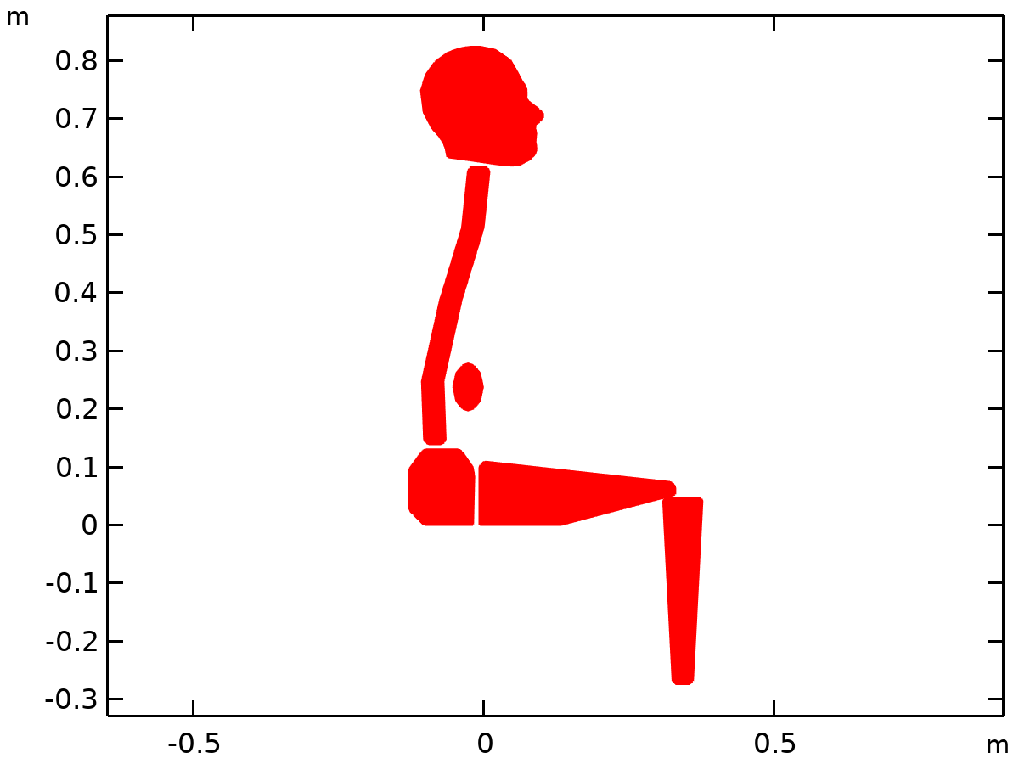

Dataset: Study 1: Eigenfrequency/Solution 1

### Study 1: Eigenfrequency/Parametric Solutions 1

Solution

| **Description** | **Value** |
| --- | --- |
| Solution | Parametric Solutions 1 (sol2) |
| Component | Component 1 (comp1) |



Dataset: Study 1: Eigenfrequency/Parametric Solutions 1

### Study 2/Solution 5

Solution

| **Description** | **Value** |
| --- | --- |
| Solution | Solution 5 (sol5) |
| Component | Component 1 (comp1) |



Dataset: Study 2/Solution 5

## Plot Groups

### Mode Shape (mbd)

[COMSOLlink[]]

Surface: Displacement magnitude (m)

### Displacement (mbd)

[COMSOLlink[]]

Surface: Displacement magnitude (m)

### Vertical Transmissibility

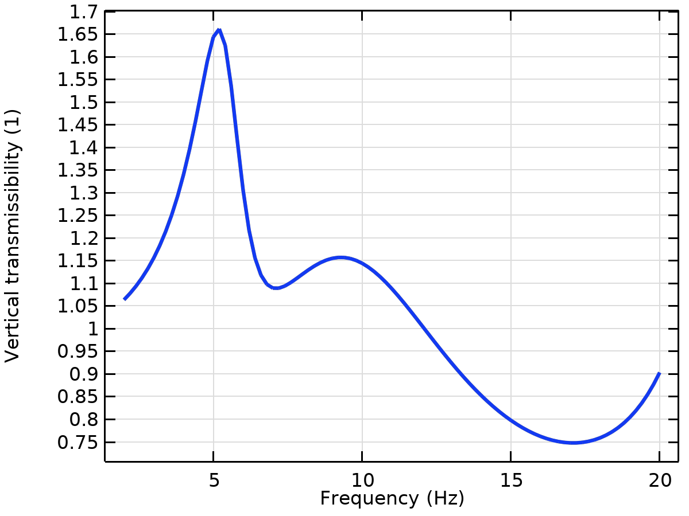

### Rotational Transmissibility

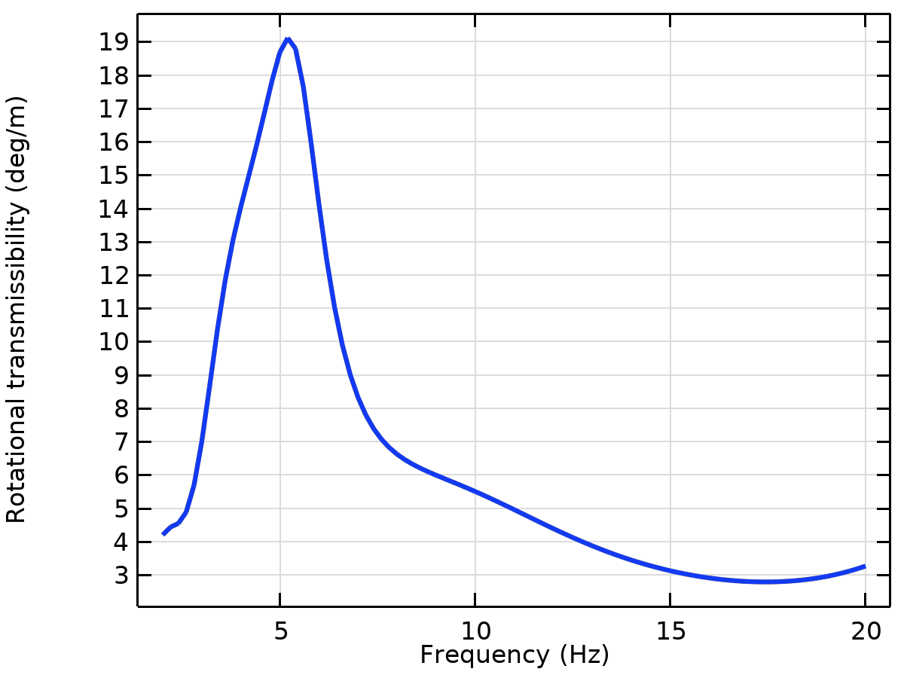

### Apparent Mass

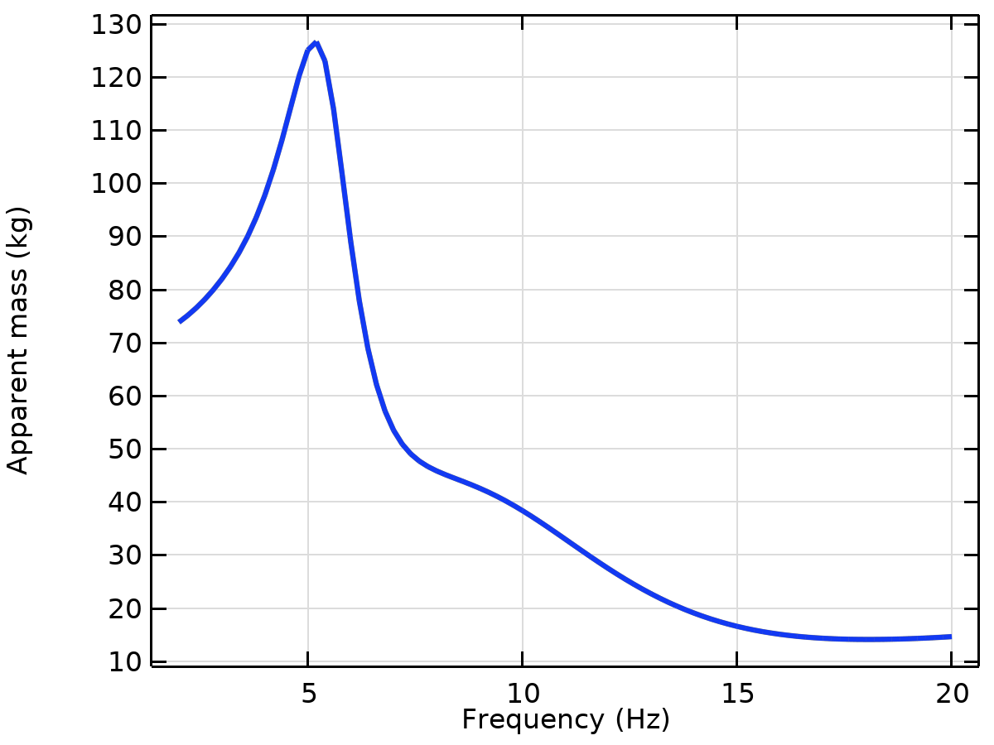

## Evaluation Groups

### Eigenfrequencies (Study 1: Eigenfrequency)

Data

| **Description** | **Value** |
| --- | --- |
| Dataset | Study 1: Eigenfrequency/Parametric Solutions 1 (sol2) |

Features

| **Feature** | **Column** |
| --- | --- |
| Global Evaluation 1 | i_c |

Results

| **i_c** | **Eigenfrequency (Hz)** | **Angular frequency (rad/s)** | **Damping ratio (1)** | **Quality factor (1)** |
| --- | --- | --- | --- | --- |
| 0 | 0.36698 | 2.3058 | 0 | Inf |
| 0 | 0.52677 | 3.3098 | 0 | Inf |
| 0 | 1.0389 | 6.5278 | 0 | Inf |
| 0 | 2.6445 | 16.616 | 0 | Inf |
| 0 | 3.5039 | 22.016 | 0 | Inf |
| 0 | 4.2283 | 26.567 | 0 | Inf |
| 0 | 4.9304 | 30.978 | 0 | Inf |
| 0 | 5.5888 | 35.116 | 0 | Inf |
| 0 | 6.5442 | 41.119 | 0 | Inf |
| 0 | 7.2321 | 45.44 | 0 | Inf |
| 0 | 8.2325 | 51.726 | 0 | Inf |
| 0 | 18.501 | 116.25 | 0 | Inf |
| 1 | 0.026653i | 0.16746i | 1 | 0.5 |
| 1 | 0.026685i | 0.16767i | 1 | 0.5 |
| 1 | 0.072343i | 0.45455i | 1 | 0.5 |
| 1 | 0.43009i | 2.7023i | 1 | 0.5 |
| 1 | 0.43134i | 2.7102i | 1 | 0.5 |
| 1 | 0.67865i | 4.2641i | 1 | 0.5 |
| 1 | 2.069i | 13i | 1 | 0.5 |
| 1 | 15.401i | 96.765i | 1 | 0.5 |
| 1 | 35.571i | 223.5i | 1 | 0.5 |
| 1 | 53.767i | 337.83i | 1 | 0.5 |
| 1 | 0.61301 + 0.24466i | 3.8516 + 1.5372i | 0.37068 | 1.3489 |
| 1 | 1.7671 + 0.494i | 11.103 + 3.1039i | 0.26923 | 1.8572 |
| 1 | 3.2854 + 0.92005i | 20.643 + 5.7809i | 0.26967 | 1.8541 |
| 1 | 5.4106 + 0.86504i | 33.996 + 5.4352i | 0.15787 | 3.1671 |
| 1 | 9.3347 + 4.4043i | 58.652 + 27.673i | 0.42671 | 1.1718 |
| 1 | 22.587 + 2.0235i | 141.92 + 12.714i | 0.089229 | 5.6036 |
| 1 | 22.823 + 1.2256i | 143.4 + 7.7006i | 0.053623 | 9.3243 |

#### Global Evaluation 1

Expressions

| **Expression** | **Unit** | **Description** |
| --- | --- | --- |
| 2*pi*freq | rad/s | Angular frequency |
| imag(freq)/abs(freq) | 1 | Damping ratio |
| abs(freq)/imag(freq)/2 | 1 | Quality factor |

Expressions

| **Name** | **Value** | **Unit** | **Description** |
| --- | --- | --- | --- |
| mbd.refpntx | 0 |  | Reference point for moment computation, x-component |
| mbd.refpnty | 0 |  | Reference point for moment computation, y-component |
| mbd.refpntz | 0 |  | Reference point for moment computation, z-component |

### Participation Factors (Study 1: Eigenfrequency)

Data

| **Description** | **Value** |
| --- | --- |
| Dataset | Study 1: Eigenfrequency/Parametric Solutions 1 (sol2) |

Features

| **Feature** | **Column** |
| --- | --- |
| Global Evaluation 1 | i_c |

Results

| **i_c** | **Eigenfrequency (Hz)** | **Participation factor, normalized, X-translation (1)** | **Participation factor, normalized, Y-translation (1)** | **Participation factor, normalized, Z-translation (1)** | **Participation factor, normalized, X-rotation (1)** | **Participation factor, normalized, Y-rotation (1)** | **Participation factor, normalized, Z-rotation (1)** | **Effective modal mass, X-translation (kg)** | **Effective modal mass, Y-translation (kg)** | **Effective modal mass, Z-translation (kg)** | **Effective modal mass, X-rotation (kg*m^2)** | **Effective modal mass, Y-rotation (kg*m^2)** | **Effective modal mass, Z-rotation (kg*m^2)** |
| --- | --- | --- | --- | --- | --- | --- | --- | --- | --- | --- | --- | --- | --- |
| 0 | 0.36698 | -6.3254 | -0.0023066 | 0 | 0 | 0 | 1.211 | 40.01 | 5.3204E-6 | 0 | 0 | 0 | 1.4666 |
| 0 | 0.52677 | -0.055212 | -5.2247 | 0 | 0 | 0 | 0.24639 | 0.0030484 | 27.297 | 0 | 0 | 0 | 0.06071 |
| 0 | 1.0389 | 1.1991 | -0.20485 | 0 | 0 | 0 | 1.6108 | 1.4378 | 0.041965 | 0 | 0 | 0 | 2.5946 |
| 0 | 2.6445 | 0.21981 | -0.19712 | 0 | 0 | 0 | 0.26676 | 0.048315 | 0.038856 | 0 | 0 | 0 | 0.071159 |
| 0 | 3.5039 | -4.4353 | -0.50347 | 0 | 0 | 0 | -0.63916 | 19.672 | 0.25348 | 0 | 0 | 0 | 0.40852 |
| 0 | 4.2283 | 1.442 | -1.8154 | 0 | 0 | 0 | 0.82605 | 2.0795 | 3.2957 | 0 | 0 | 0 | 0.68236 |
| 0 | 4.9304 | -0.26581 | -1.7925 | 0 | 0 | 0 | 0.20048 | 0.070657 | 3.2131 | 0 | 0 | 0 | 0.040193 |
| 0 | 5.5888 | -0.02849 | -3.8008 | 0 | 0 | 0 | 0.040319 | 8.1167E-4 | 14.446 | 0 | 0 | 0 | 0.0016257 |
| 0 | 6.5442 | 2.8418 | -0.26499 | 0 | 0 | 0 | 0.55643 | 8.0759 | 0.070219 | 0 | 0 | 0 | 0.30961 |
| 0 | 7.2321 | 0.050943 | -0.1083 | 0 | 0 | 0 | -0.0050005 | 0.0025951 | 0.011729 | 0 | 0 | 0 | 2.5005E-5 |
| 0 | 8.2325 | -0.13713 | -3.9569 | 0 | 0 | 0 | -0.9571 | 0.018804 | 15.657 | 0 | 0 | 0 | 0.91604 |
| 0 | 18.501 | -7.4016E-4 | -2.6635 | 0 | 0 | 0 | 0.10403 | 5.4783E-7 | 7.0944 | 0 | 0 | 0 | 0.010823 |
| 1 | 0.026653i | -5.2919E-4 | 5.2096 | 0 | 0 | 0 | -0.24588 | 2.8005E-7 | 27.14 | 0 | 0 | 0 | 0.060458 |
| 1 | 0.026685i | 6.3286 | 4.5274E-4 | 0 | 0 | 0 | -0.8827 | 40.052 | 2.0497E-7 | 0 | 0 | 0 | 0.77916 |
| 1 | 0.072343i | 4.5246 | -0.66528 | 0 | 0 | 0 | -1.6916 | 20.472 | 0.4426 | 0 | 0 | 0 | 2.8613 |
| 1 | 0.43009i | 1.9466 | -0.7979 | 0 | 0 | 0 | 0.76372 | 3.7891 | 0.63664 | 0 | 0 | 0 | 0.58327 |
| 1 | 0.43134i | 5.2487 | -1.5696 | 0 | 0 | 0 | 1.5734 | 27.549 | 2.4637 | 0 | 0 | 0 | 2.4756 |
| 1 | 0.67865i | 5.7273 | 3.0636 | 0 | 0 | 0 | -0.15293 | 32.802 | 9.3859 | 0 | 0 | 0 | 0.023388 |
| 1 | 2.069i | -0.74265 | 0.77949 | 0 | 0 | 0 | -0.49734 | 0.55152 | 0.6076 | 0 | 0 | 0 | 0.24734 |
| 1 | 15.401i | 1.6297 | -0.016991 | 0 | 0 | 0 | -0.44431 | 2.6559 | 2.8868E-4 | 0 | 0 | 0 | 0.19741 |
| 1 | 35.571i | -0.0065193 | 0.44438 | 0 | 0 | 0 | -0.029157 | 4.2501E-5 | 0.19747 | 0 | 0 | 0 | 8.5014E-4 |
| 1 | 53.767i | 0.088769 | 0.005472 | 0 | 0 | 0 | 0.013588 | 0.00788 | 2.9943E-5 | 0 | 0 | 0 | 1.8463E-4 |
| 1 | 0.61301 + 0.24466i | -5.4607 - 0.12498i | -0.22019 + 0.019905i | 0 | 0 | 0 | 1.7551 - 0.014072i | 29.804 + 1.3649i | 0.048087 - 0.0087658i | 0 | 0 | 0 | 3.0803 - 0.049397i |
| 1 | 1.7671 + 0.494i | -3.1732 + 0.85014i | 0.1239 + 0.015656i | 0 | 0 | 0 | -0.93279 - 0.23801i | 9.3463 - 5.3953i | 0.015107 + 0.0038797i | 0 | 0 | 0 | 0.81345 + 0.44403i |
| 1 | 3.2854 + 0.92005i | -3.1676 + 1.1555i | 0.22745 + 0.0012549i | 0 | 0 | 0 | -0.89173 - 0.13679i | 8.6984 - 7.3205i | 0.051734 + 5.7085E-4i | 0 | 0 | 0 | 0.77647 + 0.24395i |
| 1 | 5.4106 + 0.86504i | -0.03397 + 0.0018148i | -5.21 + 0.19716i | 0 | 0 | 0 | 0.18095 - 0.02975i | 0.0011507 - 1.233E-4i | 27.105 - 2.0545i | 0 | 0 | 0 | 0.031858 - 0.010767i |
| 1 | 9.3347 + 4.4043i | -0.0075544 + 0.041202i | -5.7513 + 0.53304i | 0 | 0 | 0 | 0.20901 - 0.042842i | -0.0016405 - 6.2251E-4i | 32.794 - 6.1314i | 0 | 0 | 0 | 0.041851 - 0.017909i |
| 1 | 22.587 + 2.0235i | 0.030327 - 0.01081i | -0.057061 + 0.03796i | 0 | 0 | 0 | 8.1268E-4 - 0.0054015i | 8.0286E-4 - 6.5565E-4i | 0.001815 - 0.0043321i | 0 | 0 | 0 | -2.8516E-5 - 8.7794E-6i |
| 1 | 22.823 + 1.2256i | 2.8633E-4 + 0.006835i | -0.53171 + 0.10593i | 0 | 0 | 0 | 0.018052 - 0.0053761i | -4.6635E-5 + 3.9141E-6i | 0.2715 - 0.11265i | 0 | 0 | 0 | 2.9696E-4 - 1.941E-4i |

#### Global Evaluation 1

Expressions

| **Expression** | **Unit** | **Description** |
| --- | --- | --- |
| mpf1.pfLnormX | 1 | Participation factor, normalized, X-translation |
| mpf1.pfLnormY | 1 | Participation factor, normalized, Y-translation |
| mpf1.pfLnormZ | 1 | Participation factor, normalized, Z-translation |
| mpf1.pfRnormX | 1 | Participation factor, normalized, X-rotation |
| mpf1.pfRnormY | 1 | Participation factor, normalized, Y-rotation |
| mpf1.pfRnormZ | 1 | Participation factor, normalized, Z-rotation |
| mpf1.mEffLX | kg | Effective modal mass, X-translation |
| mpf1.mEffLY | kg | Effective modal mass, Y-translation |
| mpf1.mEffLZ | kg | Effective modal mass, Z-translation |
| mpf1.mEffRX | kg*m^2 | Effective modal mass, X-rotation |
| mpf1.mEffRY | kg*m^2 | Effective modal mass, Y-rotation |
| mpf1.mEffRZ | kg*m^2 | Effective modal mass, Z-rotation |

Expressions

| **Name** | **Value** | **Unit** | **Description** |
| --- | --- | --- | --- |
| mbd.refpntx | 0 |  | Reference point for moment computation, x-component |
| mbd.refpnty | 0 |  | Reference point for moment computation, y-component |
| mbd.refpntz | 0 |  | Reference point for moment computation, z-component |